Central florida assessment collaborative
Individual Test Item Specifications
Technical Design 1
2014

The contents of this document were developed under a grant from the United States Department of Education. However, the content does not necessarily represent the policy of the United States Department of Education, and you should not assume endorsement by the federal government.
Table of Contents

I. Guide to the Individual Benchmark Specifications 1
Benchmark Classification System 1
Definitions of Benchmark Specifications 3
II. Individual Benchmark Specifications 4

I. Guide to the Individual Benchmark Specifications

Content specific guidelines are given in the Individual Benchmark Specifications for each course. The Specifications contains specific information about the alignment of items with the NGSSS and MAFS. It identifies the manner in which each benchmark is assessed, provides content limits and stimulus attributes for each benchmark, and gives specific information about content, item types, and response attributes.

Benchmark Classification System
- Each Career and Technical Education course has its own set of course standards. The benchmarks are organized numerically, with two numbers separated by a decimal point. The first number is the standard number, and the second number is the benchmark number. You will see these numbers on the Item Specifications for each course.

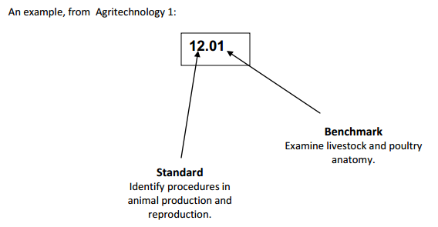

Each MAFS benchmark is labeled with a system of letters and numbers.
- The four letters in the first position of the label identify the Subject.
- The number(s) in the second position represents the Grade Level.
- The letter(s) in the third position represents the Category.
- The number in the fourth position shows the Domain.
- The number in the fifth position identifies the Cluster.
- The number in the last position identifies the specific Standard.

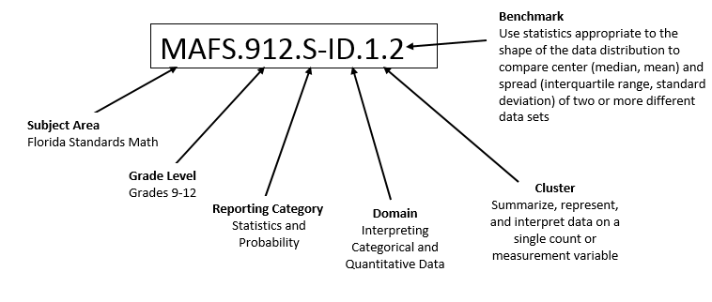

Definitions of Benchmark Specifications
The Individual Benchmark Specifications provides standard-specific guidance for assessment item development for CFAC item banks. For each benchmark assessed, the following information is provided.

Reporting Category | is a grouping of related benchmarks that can be used to summarize and report achievement.
Standard | refers to the standard statement presented in the NGSSS or domain in the MAFS.
Benchmark | refers to the benchmark statement presented in the NGSSS or standard statement in the MAFS. In some cases, two or more related benchmarks are grouped together because the assessment of one benchmark addresses another benchmark. Such groupings are indicated in the Also Assesses statement.
Item Types  Cognitive  Complexity | are used to assess the benchmark or group of benchmark.  ideal level at which item should be assessed.
Benchmark Clarifications | explain how achievement of the benchmark will be demonstrated by students. In other words, the clarification statements explain what the student will do when responding to questions.
Content Limits | define the range of content knowledge and that should be assessed in the items for the benchmark.
Stimulus Attributes | define the types of stimulus materials that should be used in the items, including the appropriate use of graphic materials and item context or content.
Response Attributes | define the characteristics of the answers that a student must choose or provide.
Sample Items | are provided for each type of question assessed. The Correct Answer for all sample items is provided.

II. Individual Benchmark Specifications
Benchmark Number | 8.01
Standard | Demonstrate an understanding of the attributes of design.
Benchmark | Describe the essential activities that comprise the design process.
Also Assesses | N/A
(K)nowledge, (P)erformance, or (B)oth | (K)nowledge
Item Types | Multiple Choice, Short Response, Extended Response
Cognitive Complexity | Low, Medium
Benchmark Clarifications | Students will be able to describe the essential activities that compromise the design process.
Content Limits | For this benchmark, the engineering design process is defined as:  - Identify the Problem  - Identify Criteria and Constraints  - Research and Generate Ideas  - Brainstorm Solutions  - Analyze Potential Solutions  - Develop and Test Models  - Make the Decision  - Communicate and Specify  - Implement and Commercialize  - Post-Implementation Review and Assessment
Stimulus Attribute | May include images.
Response Attributes | None Specified
Sample Item | Which best describes what occurs during the ‘Identify Criteria and Constraints’ step of the engineering design process?  - requirements of the design problem are identified  - a list of solutions to the design problem are identified  - models of possible solutions to the design problem are built  - solutions to the design problem are packaged and commercialized  Correct Answer: A

Benchmark Number | 9.01
Standard | Apply the principles of engineering design in the creation and evaluation of a prototype.
Benchmark | Describe the fundamental principles of design (i.e., flexibility, balance, function, and proportion) and how each guides the design process.
Also Assesses | N/A
(K)nowledge, (P)erformance, or (B)oth | (K)nowledge
Item Types | Multiple Choice, Short Response, Extended Response
Cognitive Complexity | Low, Medium, High
Benchmark Clarifications | Students will be able to describe, identify, list, level, and recognize the principles of engineering design.
Content Limits | Design principles tested should be limited to flexibility, balance, function, and proportion.
Stimulus Attribute | Stimulus may include real world scenarios.
Response Attributes | None Specified
Sample Item | The criteria used to assess the quality of a pump should be based on which of the following?  - cost  - design  - function  - noise level  Correct Answer: C

Benchmark Number | 10.04
Standard | Be able to select and use information and communication technologies.
Benchmark | Compare and contrast the means of communicating visual messages (i.e., graphically, electronically) and associated forms (e.g., digital, analog, and multimedia).
Also Assesses | N/A
(K)nowledge, (P)erformance, or (B)oth | (K)nowledge
Item Types | Multiple Choice, Short Response, Extended Response
Cognitive Complexity | Medium, High
Benchmark Clarifications | Students will be able to compare and contrast means of communicating visual media and the forms taken by these means of communication (e.g., digital, analog, and multimedia).
Content Limits | Means of communicating visual messages should be limited to graphically and electronically.
Stimulus Attribute | Stimulus items may include visual images.
Response Attributes | None Specified
Sample Item | Which statement is true concerning analog and digital systems?  - Analog and digital signals record waveforms as they are.  - Analog and digital signals are represented by square waves.  - Analog and digital signals can both carry messages and data.  - Analog and digital signals represent data using a continuous range of values.  Correct Answer: C

Benchmark Number | 10.05
Standard | Be able to select and use information and communication technologies.
Benchmark | Compare and contrast the forms for communicating technological information (e.g., symbols, icons, graphic, measurement, et al).
Also Assesses | N/A
(K)nowledge, (P)erformance, or (B)oth | (K)nowledge
Item Types | Multiple Choice, Short Response, Extended Response
Cognitive Complexity | Medium, High
Benchmark Clarifications | Students will be able to compare and contrast the forms of communicating technological information (e.g., symbols, icons, graphic, measurement, et al).
Content Limits | Forms of communicating technological information is limited to symbols, icons, graphics, and measurement.
Stimulus Attribute | Stimulus may include examples of forms of communication.
Response Attributes | None Specified
Sample Item | Which is true about symbols and icons?  - Icons can represent feelings or ideas.  - Symbols must be eye catching and bold.  - Icons are patterns that resemble what they represent.  - Symbols are universally understood and do not need to be learned.  Correct Answer: C

Benchmark Number | 11.01
Standard | Demonstrate an understanding of the processes and technologies employed in the design and production of technical illustrations and drawings.
Benchmark | Differentiate between the types of computer-generated illustrations (i.e., renderings, images, collages, and animations) and their appropriateness.
Also Assesses | N/A
(K)nowledge, (P)erformance, or (B)oth | (K)nowledge
Item Types | Multiple Choice, Short Response
Cognitive Complexity | Low
Benchmark Clarifications | Students will be able to differentiate between types of computer-generated illustrations and their appropriateness.
Content Limits | Types of computer-generated illustrations should be limited to renderings, images, collages, and animations.
Stimulus Attribute | Stimulus could include renderings, images, collages, and animations.
Response Attributes | None Specified
Sample Item | 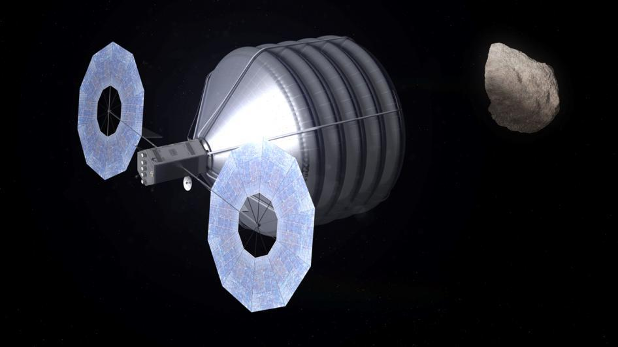  Image Credit: NASA/Advanced Concepts Lab  http://www.nasa.gov/multimedia/imagegallery/image_feature_2520.html#.U0p2CVd9KSo  The illustration above represents which type of computer generated illustration?  - animation  - collage  - image  - rendering  Correct Answer: D

Benchmark Number | 11.02
Standard | Demonstrate an understanding of the processes and technologies employed in the design and production of technical illustrations and drawings.
Benchmark | Describe the activities and rationale for each step in the technical illustration process (i.e., information gathering, model creation, scene creation, rendering, and post production).
Also Assesses | N/A
(K)nowledge, (P)erformance, or (B)oth | (K)nowledge
Item Types | Multiple Choice, Short Response, Extended Response
Cognitive Complexity | Low, Medium
Benchmark Clarifications | Students will be able to describe the steps and rationale for creating a technical illustration.
Content Limits | Steps in the technical illustration process will be defined as information gathering, model creation, scene creations, rendering, and post production.
Stimulus Attribute | None Specified
Response Attributes | None Specified
Sample Item | Which step of the technical illustration process is computationally intensive when performed digitally?  - information gathering  - post production  - rendering  - scene creation  Correct Answer: C

Benchmark Number | 11.03
Standard | Demonstrate an understanding of the processes and technologies employed in the design and production of technical illustrations and drawings.
Benchmark | Describe the range of activities involved in producing technical drawings, from rough sketch to final rendering.
Also Assesses | N/A
(K)nowledge, (P)erformance, or (B)oth | (K)nowledge,(P)erformance
Item Types | Multiple Choice, Short Response
Cognitive Complexity | Low, Medium
Benchmark Clarifications | Students will be able to describe and explain the process to produce technical drawings.  For this benchmark, the activities to produce a technical drawing are defined as:  - Rough Sketch  - Finalize the sketch or transfer to computer  - Create 3D model and camera angle  - Apply background, lighting and shadowing  - Review the composition, lighting and shadowing  - Render plan: test lighting, shadows & composition  - Final render: The complete scene is rendered and ready for post-production.
Content Limits | None Specified
Stimulus Attribute | Scenario of drawings could be used as question stimulus.
Response Attributes | None Specified
Sample Item | Which of the following steps in the technical drawing process would you do first?  A. create a 3D model  B. create a rendering plan  C. create a rough sketch  D. review the composition  Correct Answer: C

Benchmark Number | 12.02
Standard | Demonstrate technical knowledge and skills about the use and care of drafting instruments, equipment, and materials.
Benchmark | Demonstrate technical knowledge and skills about the properties, specifications, and use of drafting materials and supplies.
Also Assesses | N/A
(K)nowledge, (P)erformance, or (B)oth | (B)oth
Item Types | Multiple Choice, Short Response
Cognitive Complexity | Low, Medium
Benchmark Clarifications | Students will be able to use of drafting materials and supplies to demonstrate the knowledge and skills to create technical drawings.  Students will need to have an understanding of 30/60/90 and 45/45/90 degree triangles.  Students will need to have an understanding about scales used in both architectural and engineering fields.  The tools that students should have familiarity with include:  rulers  drafting machines  parallel bars  T-squares  mechanical pencils  protractors  compasses  erasing shields  tracing paper  vellum/bond paper
Content Limits | None Specified
Stimulus Attribute | None Specified
Response Attributes | None Specified
Sample Item | Which tool is used to create free form curves?  - french curve  - protractor  - T-square  - triangle  Correct Answer: A

Benchmark Number | 13.03
Standard | Demonstrate technical skills and applications common to all types of drafting.
Benchmark | Use drafting symbols and alphabet of lines in accordance with technical standards and practices.
Also Assesses | N/A
(K)nowledge, (P)erformance, or (B)oth | (K)nowledge
Item Types | Multiple Choice
Cognitive Complexity | Low, Medium
Benchmark Clarifications | Students will be able to use the alphabet of line and drafting symbols to appropriately according to technical standards.
Content Limits | Content should be limited to the national standards for Technical Drawings.
Stimulus Attribute | Questions could include drawings and images of drafting symbols and lines.
Response Attributes | None Specified
Sample Item | The line above would most likely be used when drawing what kind of object?  - a thin object  - a symmetrical object  - an object made of steel  - an object with interior details  Correct Answer: B

Benchmark Number | 13.04
Standard | Demonstrate technical skills and applications common to all types of drafting
Benchmark | Apply measuring techniques.
Also Assesses | N/A
(K)nowledge, (P)erformance, or (B)oth | (B)oth
Item Types | Multiple Choice
Cognitive Complexity | Low, Medium
Benchmark Clarifications | Students will be able to apply measuring techniques using common drafting tools. The tools that students should have familiarity with include: rulers, protractors.  Students will need to have an understanding about scales used in both architectural and engineering fields.
Content Limits | None Specified
Stimulus Attribute | Stimulus may include images and graphics.
Response Attributes | None Specified
Sample Item | Which scale would be most appropriate for a site plan drawing?  - 1:¼”  - 1:3/32”  - 1:1  - 1:50  Correct Answer: D

Benchmark Number | 13.05
Standard | Demonstrate technical skills and applications common to all types of drafting.
Benchmark | Apply industry standard dimensioning techniques.
Also Assesses | N/A
(K)nowledge, (P)erformance, or (B)oth | (B)oth
Item Types | Multiple Choice
Cognitive Complexity | Low
Benchmark Clarifications | Students will be able to analyze a drawing and apply dimensions appropriate for techniques followed in nationally recognized organizations.
Content Limits | Items should be limited to industry standard dimensioning techniques followed in the following nationally recognized organizations.  U.S. National CAD Standard for Architecture, Engineering, & Construction  American Society of Mechanical Engineers  International Organization for Standardization  American National Standard
Stimulus Attribute | None Specified
Response Attributes | None Specified
Sample Item | Which scale would be most appropriate for a floor plan drawing of a residential structure?  - 1:3/32”  - 1:¼”  - 1:1  - 1:50  Correct Answer: B

Benchmark Number | 13.07
Standard | Demonstrate technical skills and applications common to all types of drafting.
Benchmark | Interpret information from drawings, prints, and sketches.
Also Assesses | N/A
(K)nowledge, (P)erformance, or (B)oth | (B)oth
Item Types | Multiple Choice
Cognitive Complexity | Medium, High
Benchmark Clarifications | Students will be able to interpret information from drawings, prints, and sketches.
Content Limits | None Specified
Stimulus Attribute | Questions should include drawings, prints, and sketches relevant to drafting.
Response Attributes | None Specified
Sample Item | 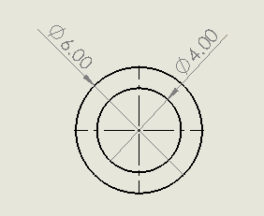  What is the interior diameter of the pipe in the drawing above?  - 4 inches  - 6 inches  - 8 inches  - 12 inches  Correct Answer: A

Benchmark Number | 14.01
Standard | Demonstrate technical knowledge and skills for making basic orthographic drawings.
Benchmark | Explain the theory of orthographic projection.
Also Assesses | N/A
(K)nowledge, (P)erformance, or (B)oth | (K)nowledge
Item Types | Multiple Choice, Short Response, Extended Response
Cognitive Complexity | Low, Medium
Benchmark Clarifications | Students will be able to explain the theory of orthographic projection.
Content Limits | None Specified
Stimulus Attribute | None Specified
Response Attributes | None Specified
Sample Item | In an orthographic projection, the point of view is always at what angle from the image?  - 15 degrees  - 30 degrees  - 45 degrees  - 90 degrees  Correct Answer: D

Benchmark Number | 14.02
Standard | Demonstrate technical knowledge and skills for making basic orthographic drawings.
Benchmark | Identify the six principal views of an object.
Also Assesses | N/A
(K)nowledge, (P)erformance, or (B)oth | (K)nowledge
Item Types | Multiple Choice
Cognitive Complexity | Low
Benchmark Clarifications | Student will be able to identify the six views of an orthographic object.
Content Limits | None Specified
Stimulus Attribute | May include isometric or orthographic views of an object.
Response Attributes | None Specified
Sample Item | What are the six views of an orthographic object?  - back, bottom, left side, rear, right side, top  - bottom, front, left side, rear, right side, top  - above, bottom, front, left side, right side, top  - above, below, bottom, front, left side, right side  Correct Answer: B

Benchmark Number | 15.01
Standard | Demonstrate technical knowledge and skills for making pictorial drawings.
Benchmark | Explain methods of pictorial drawing.
Also Assesses | N/A
(K)nowledge, (P)erformance, or (B)oth | (K)nowledge
Item Types | Multiple Choice, Short Response, Extended Response
Cognitive Complexity | Low, Medium
Benchmark Clarifications | Students will be able to explain the methods of creating or deciphering pictorial drawings.
Content Limits | Content should be limited to the specific purpose of pictorial drawings.
Stimulus Attribute | May include real world scenarios.
Response Attributes | None Specified
Sample Item | Which projection can use any angle to create the image?  - axonometric projection  - oblique projection  - orthographic projection  - perspective projection  Correct Answer: D

Benchmark Number | 16.01
Standard | Demonstrate technical knowledge and skills for making auxiliary view drawings.
Benchmark | Explain terminology and concepts associated with auxiliary view drawings.
Also Assesses | N/A
(K)nowledge, (P)erformance, or (B)oth | (K)nowledge
Item Types | Multiple Choice, Short Response, Extended Response
Cognitive Complexity | Low, Medium
Benchmark Clarifications | Students will be able to explain terminology and concepts associated with auxiliary view drawings.  Students will be familiar with the following terminology and concepts: auxiliary plane  auxiliary section  auxiliary view  center-plan construction  edge view  front auxiliary view  line of sigh  primary auxiliary view  partial auxiliary view  reference planes  right-side auxiliary view  secondary auxiliary view  top auxiliary view
Content Limits | Questions should be limited to terminology and concepts associated with auxiliary view drawings.
Stimulus Attribute | Questions could include scenarios, drawings, and images.
Response Attributes | None Specified
Sample Item | An auxiliary view would most likely be used for a detailed drawing of what?  - the top of an object  - the interior of an object  - an angled face on an object  - a feature on the front face of an object  Correct Answer: C

Benchmark Number | 17.01
Standard | Demonstrate technical knowledge and skills for making sectional view drawings.
Benchmark | Define sectional view and types of sectional views.
Also Assesses | N/A
(K)nowledge, (P)erformance, or (B)oth | (K)nowledge
Item Types | Multiple Choice, Short Response
Ideal Cognitive Complexity | Low, Medium
Benchmark Clarifications | Students will be able to define and identify sectional views and types of sectional views.
Content Limits | None Specified
Stimulus Attribute | Questions could include section view drawings and object images or renderings.
Response Attributes | None Specified
Sample Item | Which section view is characterized by an irregular shaped cutting plane?  - full section view  - half view  - offset view  - revolving view  Correct Answer: C

Benchmark Number | 17.02
Standard | Demonstrate technical knowledge and skills for making sectional view drawings.
Benchmark | Illustrate the types of breaks and symbols used in drawing sectional views.
Also Assesses | N/A
(K)nowledge, (P)erformance, or (B)oth | (B)oth
Item Types | Multiple Choice, Portfolio
Cognitive Complexity | Low
Benchmark Clarifications | Students will be able to identify and give examples of the breaks and symbols used in drawing sectional views.
Content Limits | None Specified
Stimulus Attribute | Questions could drawings of the breaks and symbols used in sectional view drawings as well as the drawings themselves.
Response Attributes | None Specified
Sample Item | 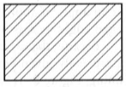  The section line symbol above represents an object of what type of material?  - brass  - concrete  - steel  - wood  Correct Answer: C

Benchmark Number | 27.08
Standard | Demonstrate an understanding of color theory and its role in technical design
Benchmark | Demonstrate a working knowledge and technical skills relating to application of color theory to design practices.
Also Assesses | N/A
(K)nowledge, (P)erformance, or (B)oth | (B)oth
Item Types | Multiple Choice, Short Response, Extended Response, Portfolio
Cognitive Complexity | Low, Medium
Benchmark Clarifications | Students will be able demonstrate knowledge of color theory as it applies to design practices.
Content Limits | None Specified
Stimulus Attribute | May include real life scenarios or situations.
Response Attributes | None Specified
Sample Item | Which color has a calming effect and is suggested for use in bedrooms?  - brown  - green  - pink  - red  Correct Answer: B

Benchmark Number | 28.01
Standard | Demonstrate an understanding of the elements and principles of graphic design.
Benchmark | Describe the elements of graphic design (e.g., line, shape, mass, texture, color, lighting).
Also Assesses | N/A
(K)nowledge, (P)erformance, or (B)oth | (K)nowledge
Item Types | Multiple Choice, Short Response
Cognitive Complexity | Low, Medium
Benchmark Clarifications | Students will be able to describe the elements of graphic design, including line, shape, mass, texture, color, and lighting.
Content Limits | None Specified
Stimulus Attribute | Questions could include scenarios, images, and graphics.
Response Attributes | None Specified
Sample Item | What design element gives the eye a rest and is used to produce a light and open feeling in the target audience?  - color  - mass  - space  - texture  Correct Answer: C

Benchmark Number | 28.02
Standard | Demonstrate an understanding of the elements and principles of graphic design.
Benchmark | Describe the principles of graphic design (e.g., balance, unity, contrast, rhythm, proportion, scaling).
Also Assesses | N/A
(K)nowledge, (P)erformance, or (B)oth | (K)nowledge
Item Types | Multiple Choice, Short Response
Cognitive Complexity | Low, Medium
Benchmark Clarifications | Students will be able to describe and identify the principles of graphic design.
Content Limits | The principles of graphic design should be limited to balance, unity, contrast, rhythm, proportion, and scaling.
Stimulus Attribute | Questions could include images and drawings
Response Attributes | None Specified
Sample Item | Which of the following is not one of the principles of design?  - balance  - scale  - shape  - unity  Correct Answer: C

Benchmark Number | 29.01
Standard | Develop a design portfolio.
Benchmark | Identify the proper elements of a fully developed portfolio.
Also Assesses | N/A
(K)nowledge, (P)erformance, or (B)oth | (B)oth
Item Types | Multiple Choice, Short Response, Extended Response, Performance Assessment
Cognitive Complexity | Low, Medium
Benchmark Clarifications | Students will be able to identify the items needed to develop a portfolio.  Students will be familiar with the following terminology and concepts: documentation of a prototype  technical illustrations  basic orthographic drawings  pictorial drawings  auxiliary drawings  sectional drawings  working drawings  basic residential drawings  word processing documentation  spreadsheet documentation  demonstrating color theory knowledge  demonstrating principles of graphic design knowledge
Content Limits | None Specified
Stimulus Attribute | Stimulus should be specific to developing the portfolio and the viewer
Response Attributes | None Specified

Sample Item | Performance Assessment  Create the technical drawings for a single-family home on a 100 ft² lot. Include site plan, floor plans, elevations, HVAC, roof, section views, and general notes and details.  Performance assessment items require more detailed instructions and a scoring rubric. The scoring rubric should have elements that will need to be included for students to earn credit. Will grammar/spelling count? What software if any should they use for this project?  This standard should be used in conjunction with the portfolios that students will be creating. Software is based on the individual school/county availability.
 | 1 | 2 | 3 | 4
Thumbnail drawings | The drawing demonstrates the student did the minimum or the drawing are not completed. | The drawing demonstrates the student did the assignment in a satisfactory manner but lack of planning was evident. | The drawing demonstrates the student applied drawing techniques adequately. | The drawing demonstrates the student applied drawing techniques proficiently.
Mechanical and/or Architectural Drawing(s) | The drawing demonstrates the student did the minimum or the drawing are not completed per industry standards. | The drawing demonstrates the student did the assignment in a satisfactory manner but lack of planning was evident per industry standards. | The drawing demonstrates the student applied drawing techniques and principles per industry standards adequately. | The drawing demonstrates the student applied drawing techniques and principles per industry standards.
Drawing Techniques | The drawing demonstrates the student did the minimum or the drawing are not completed per industry standards. | The drawing demonstrates the student did the assignment in a satisfactory manner but lack of planning was evident per industry standards. | The drawing demonstrates the student applied drawing techniques and principles per industry standards adequately. | The drawing demonstrates the student applied drawing techniques and principles per industry standards.
Rendering (Computer or pen and paper) | The drawing demonstrates the student did the minimum or the drawing are not completed. | The drawing demonstrates the student did the assignment in a satisfactory manner. | The drawing demonstrates the student applied drawing techniques adequately. | The drawing demonstrates the student applied drawing techniques proficiently.
3D Computer Model/ Evidence of a Physical Model and testing where applicable. | The model demonstrates the student did the minimum and testing did not occur. | The model demonstrates the student did the assignment in a satisfactory manner and testing may have occurred. | The model demonstrates the student applied drawing techniques and testing may have occurred. | The model demonstrates the student applied drawing techniques and principles per industry standards and testing model occured..
Use of Principles and industry standards | The student used the principles of technical drawings and industry standards but missed major components. | The student used the principles of technical drawings and industry standards missing a components. | The student used the principles of technical drawings and industry standards missing a few components. | The student used the principles of technical drawings and industry standards effectively.
Grammar/Punctuation | Some wordings correctly spelled, grammatically correct with many errors in sentence structure, and proper use of punctuation. Few errors in capitalization. | More wordings correctly spelled, grammatically correct with a few errors in sentence structure, and proper use of punctuation. Few errors in capitalization. | Most wordings correctly spelled, grammatically correct with little errors in sentence structure, and proper use of punctuation. Few errors in capitalization. | Correct spelling, grammatically correct sentence, and proper use of punctuation. No errors in capitalization.
Application | The student has partially prepared a portfolio. | The student has prepared a portfolio with less than 10% of the components missing. | The student has substantially prepared a portfolio. | The student has fully prepared a portfolio.

Benchmark Number | 29.02
Standard | Develop a design portfolio.
Benchmark | Identify and discuss the ethical issues surrounding portfolio artifacts.
Also Assesses | N/A
(K)nowledge, (P)erformance, or (B)oth | (B)oth
Item Types | Multiple Choice, Short Response, Extended Response, Performance Assessment
Cognitive Complexity | Low, Medium, High
Benchmark Clarifications | Students will be able to identify and discuss the choices of artifacts selected for their portfolio and the ethical issues surrounding them.
Content Limits | Items should be limited to copyright law, ownership of pieces, media release, and personal privacy.
Stimulus Attribute | None Specified
Response Attributes | Students will be able to identify, discuss and defend their position on the ethical implications of your chosen artifacts.
Sample Item | Which is not an ethical concern surrounding portfolio artifacts?  A. You and your partner find a wonderful image online and decide to include it in your portfolio.  B. You and a partner complete a project for class; you use the project in your portfolio without your partner’s knowledge.  C. You and your partner recover digital still images from a cell phone and proceed to collect the required information on different media.  D. You and a partner complete a project for class; you credit your partner and use the project in your portfolio with your partner’s permission.  Correct Answer: D

Benchmark Number | 29.03
Standard | Develop a design portfolio.
Benchmark | Create a design portfolio that is well organized and displays their work.
Also Assesses | N/A
(K)nowledge, (P)erformance, or (B)oth | (B)oth
Item Types | Performance Assessment
Cognitive Complexity | Low, Medium, High
Benchmark Clarifications | Students will be able to document, organize and display their technical drawings in a formal portfolio.  Students will be familiar with the following terminology and concepts: documentation of a prototype  technical illustrations  basic orthographic drawings  pictorial drawings  auxiliary drawings  sectional drawings  working drawings  basic residential drawings  word processing documentation  spreadsheet documentation  demonstrating color theory knowledge  demonstrating principles of graphic design knowledge
Content Limits | Contents should be organized depending on the needs of the portfolio.
Stimulus Attribute | None Specified
Response Attributes | None Specified
Sample Item | Performance Assessment  Create a table of contents for your design portfolio that organizes and catalogs your portfolio artifacts based on project.  Performance assessment items require more detailed instructions and a scoring rubric. The scoring rubric should have elements that will need to be included for students to earn credit. Will grammar/spelling count? What software should they use for this project?  This standard should be used in conjunction with the portfolios that students will be creating. Software is based on the individual school/county availability.  Sample Full Credit Response:  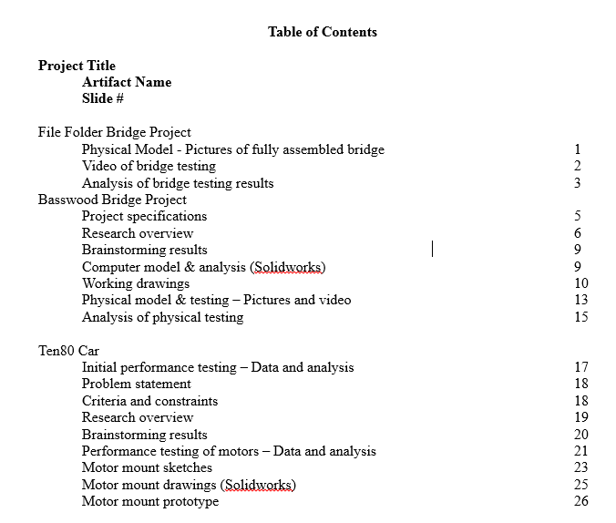  Rubric  4 – Table of content includes project names, artifacts included for each project, and correct page/slide number for each of these items.  3 – Table of content includes project names and artifacts included for each project but correct page/slide number are not provided for these items.  2 – Table of content includes project names OR artifact names and correct page/slide number for each of these items. Artifacts are not clearly grouped by and identified as being part of specific projects.  1 – Table of contents lists individual artifacts or projects but does not indicate a page/slide for these items or numbers listed are incorrect. If artifacts are listed they are not grouped by project.  0 – No table of contents is provided.

