central florida assessment collaborative
Individual Test Item Specifications
Probability & Statistics with Applications
2013

Table of Contents

I. Guide to the Individual Benchmark Specifications 1
Benchmark Classification System 1
Definitions of Benchmark Specifications 3
II. Individual Benchmark Specifications 4

- Guide to the Individual Benchmark Specifications
Content specific guidelines are given in the Individual Benchmark Specifications for each course. The Specifications contains specific information about the alignment of items with the Florida Standards. It identifies the manner in which each benchmark is assessed, provides content limits and stimulus attributes for each benchmark, and gives specific information about content, item types, and response attributes.
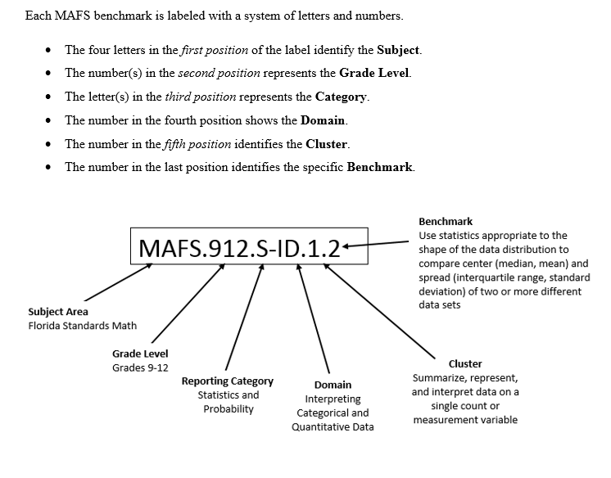

Definitions of Benchmark Specifications
The Individual Benchmark Specifications provides standard-specific guidance for assessment item development for CFAC item banks. For each benchmark assessed, the following information is provided:

Reporting Category | is a grouping of related benchmarks that can be used to summarize and report achievement.
Standard | refers to the standard statement presented in the Florida Standards.
Benchmark  Also Assesses | refers to the benchmark statement presented in the standard statement in the Florida Standards. In some cases, two or more related benchmarks are grouped together because the assessment of one benchmark addresses another benchmark. Such groupings are indicated in the Also Assesses statement.  refers to the benchmarks that are closely related to the benchmark (see description above).
Item Types  Cognitive Complexity Level | are used to assess the benchmark or group of benchmark.  ideal level at which the item should be assessed.
Benchmark Clarifications | explain how achievement of the benchmark will be demonstrated by students. In other words, the clarification statements explain what the student will do when responding to questions.
Content Limits | define the range of content knowledge and that should be assessed in the items for the benchmark.
Stimulus Attributes | define the types of stimulus materials that should be used in the items, including the appropriate use of graphic materials and item context or content.
Response Attributes | define the characteristics of the answers that a student must choose or provide.
Sample Items | are provided for each type of question assessed. The correct answer for all sample items is provided.

II. Individual Benchmark Specifications

Reporting Category | Statistics and Probability
Standard | Conditional Probability & the Rules of Probability
Benchmark Number | MAFS.912.S-CP.1.1
Benchmark | Describe events as subsets of a sample space (the set of outcomes) using characteristics (or categories) of the outcomes, or as unions, intersections, or complements of other events (“or,” “and,” “not”).
Also Assesses | MAFS.K12.MP.4.1
Item Types | Selected Response (Multiple Choice), Gridded Response, Short Answer
Benchmark Clarification | Students will determine all possible outcomes of events.
Content Limits | Limit to real world contexts and age appropriate situations.
Stimulus Attributes | Test items may include illustrations of the following: tables, lists, tree diagrams, and other forms.
Response Attributes | Responses may be in decimal or reduced fraction form.
Sample Item | What is the sample space of flipping a coin and rolling a die?  Answer:  {H1, H2, H3, H4, H5, H6, T1, T2, T3, T4, T5, T6}

Reporting Category | Statistics and Probability
Standard | Conditional Probability & the Rules of Probability
Benchmark Number | MAFS.912.S-CP.1.2
Benchmark | Understand that two events A and B are independent if the probability of A and B occurring together is the product of their probabilities, and use this characterization to determine if they are independent.
Also Assesses | MAFS.K12.MP.2.1
Item Types | Selected Response (Multiple Choice), Short Answer
Benchmark Clarification | Students will determine probable outcomes of events using the multiplication rule.
Content Limits | Limit to real world contexts and age appropriate situations.
Stimulus Attributes | Test items may include illustrations of the following: tables, lists, tree diagrams, and other forms.
Response Attributes | Responses may be in decimal or reduced fraction form.

Sample Item | Toss two balanced coins. Let A = head on the first toss, and let B = both tosses have the same outcome. Are events A and B independent? Explain your reasoning clearly.  Solution: Yes, A and B are independent since P(A and B) is (.5)(.5)-0=0.25 and P(A)P(B)= (.5)(.5)=0.25  Anthony attends a high school that has four periods in the school day. Last semester, his friend took the same classes and recorded how often the teachers were absent. The data are shown in the table below. There were 2 quarters in the semester and 45 teacher work days in each quarter. Based on this data, what is the probability that all four of Anthony’s teachers will be absent on any given day?  Period Teacher Name Subject 1st Quarter Absences 2nd Quarter Absences  1 Mrs. Rodriguez Algebra 5 4  2 Ms. Williams English 1 2  3 Mr. Keene US History 0 10  4 Mrs. Medina Earth Science 3 1  - $\frac{1}{60750}$  - $\frac{2}{45}$  - $\frac{26}{90}$  - $\frac{1}{56782}$  Answer: A

Reporting Category | Statistics and Probability
Standard | Conditional Probability & the Rules of Probability
Benchmark Number | MAFS.912.S-CP.1.3
Benchmark | Understand the conditional probability of A given B as P(A and B)/P(B), and interpret independence of A and B as saying that the conditional probability of A given B is the same as the probability of A, and the conditional probability of B given A is the same as the probability of B.
Also Assesses | MAFS.K12.MP.7.1
Item Types | Selected Response (Multiple Choice), Short Answer
Benchmark Clarification | Students will determine probable outcomes of events using the multiplication rule.
Content Limits | Limit to real world contexts and age appropriate situations.
Stimulus Attributes | Test items may include illustrations of the following: tables, lists, tree diagrams, and other forms.
Response Attributes | Responses may be in decimal or reduced fraction form.

Sample Item | Is the probability of being dealt a queen, given that the card is red, the same as the probability of being dealt a queen? Use the conditional probability formula to support your answer.  Answer: Yes; P(queen|red) = P (queen)·P(red) / P (red)  (4/52)·(26/52)/(26/52) = 4/52 = 1/13  P(queen) = 4/52 = 1/13  2 Points:  - The response indicates that the student has a complete understanding of the concept embodied in the task.  - The student has provided a response that is accurate, complete, and fulfills all the requirements of the task.  - Necessary support and/or examples are included, and the information given is clearly text-based.  1 Point:  - The response indicates that the student has a partial understanding of the concept embodied in the task.  - The student has provided a response that includes information that is essentially correct and text-based but the information is too general or too simplistic.  - Some of the support and/or examples may be incomplete or omitted.  0 Points:  - The response indicates that the student does not demonstrate and understanding of the reading concept embodied in the task.  - The student has provided a response that is inaccurate or contains only irrelevant text-based information.  - The response has an insufficient amount of information to determine the student’s understanding of the task or the student has failed to respond to the task.

Reporting Category | Statistics and Probability
Standard | Conditional Probability & the Rules of Probability
Benchmark Number | MAFS.912.S-CP.1.4
Benchmark | Construct and interpret two-way frequency tables of data when two categories are associated with each object being classified. Use the two-way table as a sample space to decide if events are independent and to approximate conditional probabilities.  For example, collect data from a random sample of students in your school on their favorite subject among math, science, and English. Estimate the probability that a randomly selected student from your school will favor science given that the student is in tenth grade. Do the same for other subjects and compare the results.
Also Assesses | MAFS.K12.MP.2.1, MAFS.K12.MP.4.1
Item Types | Selected Response (Multiple Choice), Gridded Response, Short Answer
Benchmark Clarification | Students will determine probable outcomes of events using tables, lists, or tree diagrams.
Content Limits | Limit to real world contexts and age appropriate situations.
Stimulus Attributes | Test items may include illustrations of the following: tables, lists, tree diagrams, and other forms.
Response Attributes | Responses may be in decimal or reduced fraction form.
Sample Item | Here are the counts (in thousands) of earned degrees in the United States in a recent year, classified by level and by the sex of the degree recipient:  Bachelor’s Master’s Professional Doctorate Total  Female 616 194 30 16 856  Male 529 171 44 26 770  Total 1145 365 74 42 1626  1. If you choose a degree recipient at random, what is the probability that the person you choose is a woman?  Answer : $\frac{856}{1626}$

Reporting Category | Statistics and Probability
Standard | Conditional Probability & the Rules of Probability
Benchmark Number | MAFS.912.S-CP.1.5
Benchmark | Recognize and explain the concepts of conditional probability and independence in everyday language and everyday situations.  For example, compare the chance of having lung cancer if you are a smoker with the chance of being a smoker if you have lung cancer.
Also Assesses | MAFS.912.S-CP.1.3 & MAFS.912.S-CP.1.4
Item Types | Selected Response (Multiple Choice), Gridded Response, Short Answer
Benchmark Clarification | Students will determine probable outcomes of events using the multiplication rule.  Students will explain, in words, the concept of conditional probability (see example in Benchmark)
Content Limits | Limit to real world contexts and age appropriate situations.
Stimulus Attributes | Test items may include illustrations of the following: tables, lists, tree diagrams, and other forms.
Response Attributes | Responses may be in decimal or reduced fraction form.

Sample Item | Researchers are interested in the relationship between cigarette smoking and lung cancer. Suppose an adult male is randomly selected from a particular population. Assume that the following table shows some probabilities involving the compound event that the individual does or does not smoke and the person is or is not diagnosed with cancer:  Event Probability  smokes and gets cancer 0.08  smokes and does not get cancer 0.17  does not smoke and gets cancer 0.04  does not smoke and does not get cancer 0.71  Suppose further that the probability that the randomly selected individual is a smoker is 0.25.  (1) What is the probability that the individual gets cancer, given that he is a smoker?  Answer : 0.08/0.25 = 0.32  (2) What is the probability that the individual does not get cancer, given that he is a smoker?  Answer : 0.17/0.25 = 0.68  (3) What is the probability that the individual gets cancer, given that he does not smoke?  Answer : 0.04/0.75 = 0.053  (4) What is the probability that the individual does not get cancer, given that he does not smoke?  Answer : 0.71/0.75 = 0.947

Reporting Category | Statistics and Probability
Standard | Conditional Probability & the Rules of Probability
Benchmark  Number | MAFS.912.S-CP.2.6
Benchmark | Find the conditional probability of A given B as the fraction of B’s outcomes that also belong to A, and interpret the answer in terms of the model.
Item Types | Selected Response (Multiple Choice), Gridded Response, Short Answer
Benchmark Clarification | Students will find the conditional probability of an event given frequency data by identifying the possible outcomes and determining their respective probabilities.
Content Limits | Limit to real world contexts and age appropriate situations.
Stimulus Attribute | Tables and charts may be used.  Items may be set in either real-world or mathematical contexts.
Response Attributes | Gridded response items will have fractional answers.  The odds of an event must be expressed as a fraction.  Fractional answers must be in simplified form.

Sample Item | The state results for the FCAT 2.0 are shown in the table below.  FCAT 2.0 Mathematics – Next Generation Sunshine State Standards  Grade Year Number of Students Mean Developmental Scale Score Percentage of Students by Achievement Level  1 2 3 4 5  3 2011 202,719 201 19 25 31 16 9  2012 203,207 202 18 24 30 18 10  4 2011 198,969 214 19 23 28 20 10  4 2012 193,802 215 18 22 27 20 12  5 2011 198,520 221 19 25 28 18 10  2012 199,844 222 19 24 27 18 11  6 2011 197,668 227 22 24 26 18 9  6 2012 199,076 227 23 25 25 18 10  7 2011 194,484 236 20 24 28 18 10  2012 198,277 236 20 24 27 18 10  8 2011 195,479 243 22 22 30 16 10  8 2012 194,346 243 22 21 30 16 11  A student is considered proficient if he obtains an Achievement Level of 3 or higher.  Part 1. What is the probability that an 8th grade student was proficient on the math test in 2012?  Part 2. What are the odds that the student was NOT proficient?  Answer, part 1:  $$\frac{30}{100}+ \frac{16}{100}+ \frac{11}{100 }= \frac{57}{100}$$  Answer, part 2:  $\frac{22}{100}+ \frac{21}{100}= \frac{43}{100}$ ; answer is $\frac{43}{57}$

Reporting Category | Statistics and Probability
Standard | Conditional Probability & the Rules of Probability
Benchmark Number | MAFS.912.S-CP.2.7
Benchmark | Apply the Addition Rule, P(A or B) = P(A) + P(B) – P(A and B), and interpret the answer in terms of the model.
Also Assesses | MAFS.912.S-CP.1.2
Item Types | Selected Response (Multiple Choice), Gridded Response, Short Answer
Benchmark Clarification | Students will determine probable outcomes of events using the addition rule.
Content Limits | Limit to real world contexts and age appropriate situations.
Stimulus Attributes | Test items may include illustrations of the following: tables, lists, tree diagrams, and other forms.
Response Attributes | Responses may be in decimal or reduced fraction form.
Sample Item | If P(A) = 0.24 and P(B) = 0.52, and A and B are independent, what is P(A or B)?  A. 0.1248  B. 0.28  C. 0.6352  D. 0.76  Solution: 0.24 + 0.52 – (0.24)(0.52)  Answer: C

Reporting Category | Statistics and Probability
Standard | Conditional Probability & the Rules of Probability
Benchmark Number | MAFS.912.S-CP.2.8
Benchmark | Apply the general Multiplication Rule in a uniform probability model, P(A and B) = P(A)P(B|A) = P(B)P(A|B), and interpret the answer in terms of the model.
Also Assesses | MAFS.912-CP.2.6/2.7  MAFS.K12.MP.7.1
Item Types | Selected Response (Multiple Choice), Gridded Response, Short Answer
Benchmark Clarification | Students will determine probabilities of single or multiple events using probability addition and multiplication formulas.
Content Limits | Items may include multiple events or repeats of one event.
Stimulus Attributes | Items may be set in either real world or mathematical contexts.  Items may be a single event, multiple events, or a combination.
Response Attributes | Responses will be in fraction or decimal form and should be in simplest form. Responses may be comprised of more than one answer. (find probabilities of more than one item in a question)
Sample Item | Questions 1 and 2 relate to the following: An event A will occur with probability 0.5. An event B will occur with probability 0.6. The probability that both A and B will occur is 0.1.  1. What is the conditional probability of A, given B?  A. is 0.5. B. is 0.3.  C. is 0.2. D. is 1/6.  Answer: D  2. The Saffir-Simpson Hurricane Scale labels hurricanes with a 1-5 rating based on their intensity. The overall probability that a hurricane is rated 1-4 is 0.985. The probability of a hurricane hitting Florida is 0.32. The probability that a hurricane is rated a 5 and misses Florida is 0.01. Given this information, construct a completed two-way frequency table, and the calculation of the probability that a hurricane hits Florida given that it has a category 5 rating.  Pictured: two-way frequency table  Answer:  5 Rating 4 3  Hits Florida 0.005 0.315 0.32  Misses Florida 0.01 0.67 0.68  0.015 0.985 1  Defining A₁ = hits Florida  A₂ = misses Florida  B = has rating of 5  Then  P(A₁)P(B│A₁)  P(A₁│B) = -----------------------------------------  P(A₁)P(B│A₁) + P(A₂)P(B│A₂)  (.32)(.005/.32)  P(A₁│B) = ----------------------------------------- = 0.333  (.32)(.005/.32) + (.68)(.01/.68)  Or  P(A₁│B) = (.005/.015) = 0.333  Answer:  The probability that a hurricane hits Florida given that it has a category 5 rating is 0.333

Reporting Category | Statistics and Probability
Standard | Conditional Probability & the Rules of Probability
Benchmark Number | MAFS.912.S-CP.2.9
Benchmark | Use permutations and combinations to compute probabilities of compound events and solve problems.
Also Assesses | MAFS.K12.MP.1.1  MAFS.K12.MP.8.1
Item Types | Selected Response (Multiple Choice), Gridded Response, Short Answer
Benchmark Clarification | Students will determine probable outcomes of events using the permutation and combination formulas.
Content Limits | Items shall be limited to no more than five different sets.  Limit to real world contexts and age appropriate situations.
Stimulus Attributes | Test items may include illustrations of the following: tables, lists, tree diagrams, and other forms.
Response Attributes | Multiple Choice items of permutations should include answers using combination formula.
Sample Item | 1. Students are celebrating their academic success with ice cream sundaes. There are 4 toppings available for their ice cream. Students may choose 2 out of the 4 toppings for their ice cream. This includes an option for a double helping of one topping. How many two-topping combinations can students choose?  Answer : 4C2 + 4= 6 + 4 =10  2. The school is going to hold an Algebra competition. Each teacher is to randomly select 2 students to represent their class. If Ms. Brown’s class has 10 boys and 14 girls, what is the probability that one boy and one girl will be chosen to represent her class?  Answer : (10C1) (14C1) / 24C2 = (10) (14) / 276 = 35/69

Reporting Category | Probability and Statistics
Standard | Making Inferences & Justifying Conclusions
Benchmark Number | MAFS.912.S-IC.1.1
Benchmark | Understand statistics as a process for making inferences about population parameters based on a random sample from that population.
Also Assesses | MAFS.K12.MP.5.1  MAFS.K12.MP.6.1
Item Types | Selected Response (Multiple Choice), Gridded Response, Short Answer
Benchmark  Clarification | Students will calculate, summarize, and interpret data using measures of center including mean and median and measures of spread including range, standard deviation, and variance.  Students will use these measures to make comparisons and draw conclusions about data sets.  Students will calculate, summarize, and interpret data using measures of center and spread.
Content Limits | Items may include calculations for mean, median, variance, and standard deviation.  Items may include the choice of which measure of center is the best representation of a data set.
Stimulus Attributes | Items must be set in mathematical or real-world context.
Response Attributes | Responses will be rational numbers.

Sample Item | Sample Item 1  The average grade point average (GPA) for 25 top-ranked students at a local college is listed below. (Use the rounding rule for the mean).  3.80 3.77 3.70 3.74 3.70  3.86 3.76 3.68 3.67 3.57  3.83 3.70 3.80 3.73 3.67  3.78 3.75 3.73 3.65 3.66  3.75 3.64 3.78 3.73 3.64  What is the mean of the GPAs?  A. 3.7236  B. 3.764  C. 3.724  D. 3.887  Answer: C  Sample Item 2  The average grade point average (GPA) for 25 top-ranked students at a local college is listed below. (Use the rounding rule for the mean).  3.80 3.77 3.70 3.74 3.70 3.86 3.76 3.68 3.67 3.57  3.83 3.70 3.80 3.73 3.67 3.78 3.75 3.73 3.65 3.66  3.75 3.64 3.78 3.73 3.64  What is the median of the GPAs?  A. 3.7  B. 3.73  C. 3.74  D. 3.75  Answer: B

Reporting Category | Statistics and Probability
Standard | Making Inferences & Justifying Conclusions
Benchmark Number | MAFS.912.S-IC.2.3
Benchmark | Recognize the purposes of and differences among sample surveys, experiments, and observational studies; explain how randomization relates to each.
Also Assesses | MAFS.K12.MP.3.1
Item Types | Selected Response (Multiple Choice)
Benchmark Clarification | Students will use and compare surveys, experiments, and observational studies and decide which questions each is designed to answer.  Student will use qualitative and quantitative measures to collect data.  Students will choose the type of sampling from a variety of situations as well as understand the reasoning behind random sampling.  Students will identify sources of bias, including sampling and non-sampling errors.
Content Limits | Items may include research questions from surveys, observational studies, or experiments.  Items may include sampling methods such as simple random, systematic, stratified, or cluster.
Stimulus Attributes | Items must be set in real-world context.
Response Attributes | Answers need to be situations that are possible.

Sample Item | 1. After a class receives the same lesson from the same teacher the class is divided randomly into two equal sized groups. One group is given a multiple choice test and the other group is given an essay test. Then the averages of the test scores from each group are compared.  What is the technique for gathering data in this situation?  A. experiment  B. observational study  C. survey  D. survey/experiment  Answer: A  2. Group businesses in Orlando, FL according to type: medical, shipping, retail, manufacturing, financial, construction, restaurant, hotel, tourism, other. Then select a random sample of 10 businesses from each business type to survey.  What type of sampling is being used in this situation?  A. cluster sampling  B. simple random sampling  C. stratified sampling  D. systematic sampling  Answer: C  3. Students in grades 9-12 at an area high school were asked whether or not they should have tougher classes to help improve their testing performance on state assessments?  What form of bias was used in this situation?  A. language  B. misleading  C. sample  D. type of question  Answer: C

Reporting Category | Probability and Statistics
Standard | Making Inferences & Justifying Conclusions
Benchmark Number | MAFS.912.S-IC.2.4
Benchmark | Use data from a sample survey to estimate a population mean or proportion; develop a margin of error through the use of simulation models for random sampling.
Also Assesses | MAFS.K12.MP.5.1  MAFS.K12.MP.6.1
Item Types | Selected Response (Multiple Choice), Gridded Response, Short Answer
Benchmark Clarification | Students will create, explain and interpret confidence intervals of a mean or proportion by understanding point estimate, confidence levels and sample size when the population standard deviation is known and when the population standard deviation is not known.  Students will also interpret and apply the maximum error of the estimate ("margin of error").
Content Limits | Items may include confidence level and/or confidence interval. Items may include intervals for the mean when the population standard deviation is known and when the population standard deviation is not known.  Items may include confidence intervals for proportions also. Items may include finding sample size needed for specific results.
Stimulus Attributes | Items must be set in mathematical or real-world context.
Response Attributes | Answers will include confidence levels in percentages, confidence intervals with a mean or proportion estimate or sample sizes in whole numbers.
Sample Item | 1. When people smoke, the nicotine they absorb is converted to cotinine, which can be measured. A sample of 40 smokers has a mean cotinine level of 172.5. Assuming the population standard deviation is known to be 119.5, what is the 90% confidence interval estimate of the mean cotinine level of all smokers?  A. 74.64 < $\overline{x}$ < 164.36  B. 141.42 < $\overline{x}$ < 203.58  C. 166.49 < $\overline{x}$ < 178.51  D. 141.42 < $\overline{x}$ < 178.51  Answer: B

Reporting Category | Statistics and Probability
Standard | Making Inferences & Justifying Conclusions
Benchmark  Number | MAFS.912.S-IC.2.5
Benchmark | MAFS.912.S-IC.2.5: Use data from a randomized experiment to compare two treatments; use simulations to decide if differences between parameters are significant.
Also Assesses | MAFS.912.S-IC.2.6  LAFS.910.WHST.1.1  LAFS.910.WHST.2.4  LAFS.910.WHST.3.9  MAFS.K12.MP.3.1  MAFS.912.S-IC.1.1
Item Types | Selected Response (Multiple Choice), Gridded Response, Short Answer
Benchmark Clarification | Students will understand, create and analyze the null hypothesis and the alternative hypothesis (basics of hypothesis testing).  Students will understand the p-value is the probability of getting a sample statistic in the direction of the alternative hypothesis when the null hypothesis is true.  Students will understand p-value rules for decisions to reject or not to reject the null hypothesis.  Students will decide whether a Type I error (occurs when you reject the null hypothesis when it is true) and a Type II error (occurs if you do not reject the null hypothesis when it is false) have occurred in the outcome of the hypothesis testing.
Content Limits | Items may include writing a null and alternative hypothesis for data or interpreting a given null and alternative hypothesis.  Items may include stating the hypothesis, identifying the claim, computing the test value, finding the p-value, making a decision on given information and/or summarizing the results.
Stimulus Attribute | Items must be set in mathematical or real-world context.
Response Attributes | Items may be writing the null and alternative hypothesis or analyzing the given null and alternative hypothesis.  Answers may include the p-value and/or a decision to be made based on the p-value.
Sample Item | Sample Item 1  The average undergraduate cost for tuition, fees, room, and board for all accredited universities was $26,025. A random sample in 2009 of 40 of these accredited universities indicated that the mean tuition, fees, room, and board for the sample was $27,690 with a population standard deviation of $5492.  What is the null and alternative hypothesis for the conjecture?  A. H˳: µ= $26,025 and Ң: µ > $26,025  B. H˳: µ < $26,025 and Ң: µ = $26,025  C. H˳: µ =$26,025 and Ң: µ < $26,025  * D. H˳: µ = $26,025 and Ң: µ ≠ $26,025  Answer: B  Sample Item 2  Using the statistics from sample item 1 and a 0.05 level of significance, what is the p-value of this sample?  Answer: 0.0274  Sample Item 3  The average undergraduate cost for tuition, fees, room, and board for all accredited universities was $26,025. A random sample in 2009 of 40 of these accredited universities indicated that the mean tuition, fees, room, and board for the sample was $27,690 with a population standard deviation of $5492. At a 0.05 level of significance, which of these statements is the correct conclusion for the hypothesis test using the p-value?  - Reject the null hypothesis with p-value of 0.0274 with a significance level of 0.05.  - Accept the null hypotheses with p-value of 0.0274 with a significance level of 0.05.  - Do not reject the null hypothesis with p-value of 0.0274 with a significance level 0.05.  - Not enough information to formulate a conclusion.  Answer: A  Item

Reporting Category | Statistics and Probability
Standard | Interpreting Categorical & Quantitative Data
Benchmark Number | MAFS.912.S-ID.1.1
Benchmark | Represent data with plots on the real number line (dot plots, histograms, and box plots).
Also Assesses | MAFS.K12.MP.4.1
Item Types | Selected Response (Multiple Choice), Gridded Response, Short Answer
Benchmark Clarification | Students will create a data distribution in the form of: dot plots, histograms, or box plots.
Content Limits | Items will be limited to use of raw data.
Stimulus Attributes | Data must be rational numbers.
Response Attributes | Graphs must be appropriately labeled and draw to scale.

Sample Item | Wendy collected data about the number of children in her neighborhood, as shown below. She grouped her data by grade as shown in this table.  Grade Pre K K 1 2 3 4 5  Number 4 3 5 3 2 3 4  Grade 6 7 8 9 10 11 12  Number 3 2 1 2 3 2 1  Wendy created the following histogram.  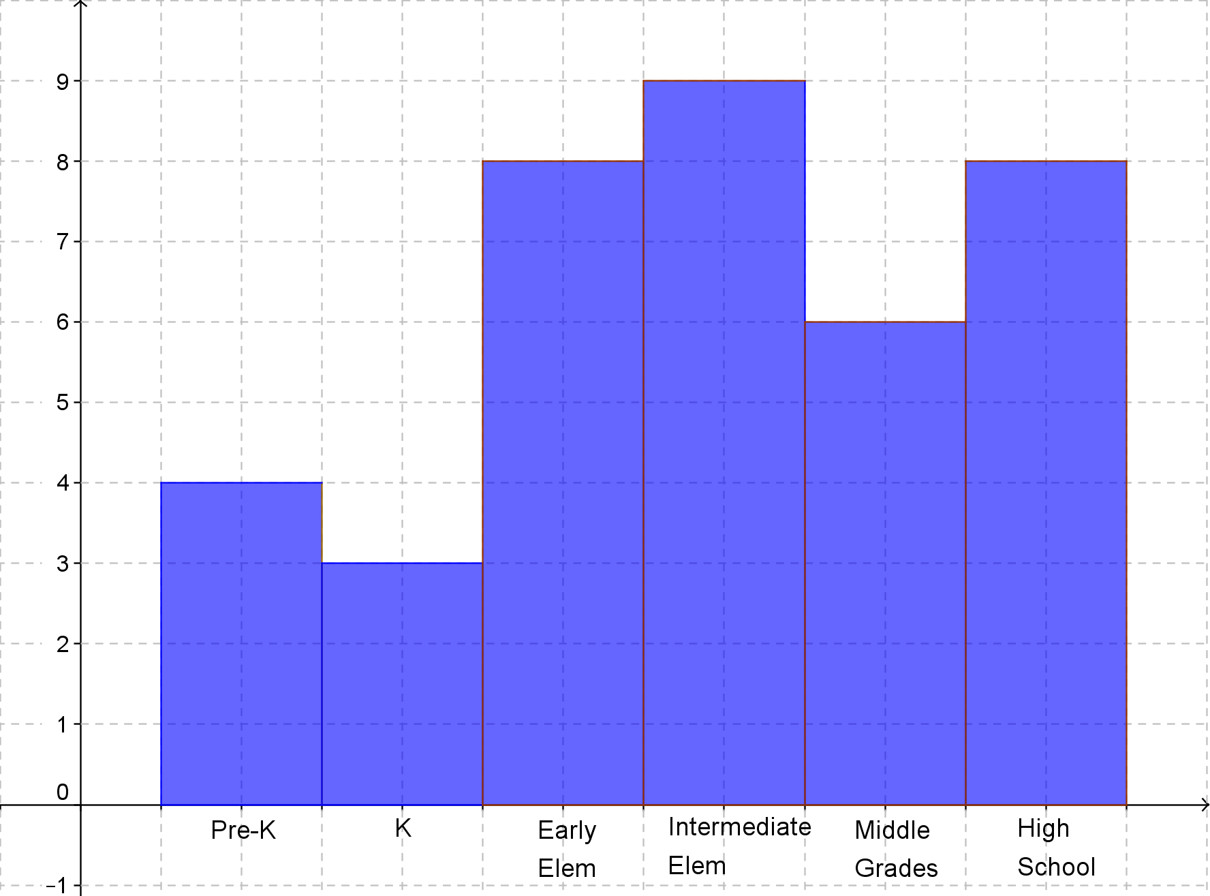  What errors did she make? How could she fix it when she does it again?  First, Her grades are not the same number for each bar. She must either use one bar per grade or group the grades so that there is the same number for each bar.  Second, she seems to have left off a label for the axis – especially the y-axis. She needs to let us know that the numbers on the axis show numbers of students. She needs to add labels to each axis.  2 Points:  - The response indicates that the student has a complete understanding of the concept embodied in the task.  - The student has provided a response that is accurate, complete, and fulfills all the requirements of the task.  - Necessary support and/or examples are included, and the information given is clearly text-based.  1 Point:  - The response indicates that the student has a partial understanding of the concept embodied in the task.  - The student has provided a response that includes information that is essentially correct and text-based but the information is too general or too simplistic.  - Some of the support and/or examples may be incomplete or omitted.  0 Points:  - The response indicates that the student does not demonstrate and understanding of the reading concept embodied in the task.  - The student has provided a response that is inaccurate or contains only irrelevant text-based information.  - The response has an insufficient amount of information to determine the student’s understanding of the task or the student has failed to respond to the task.

Reporting Category | Statistics and Probability
Standard | Interpreting Categorical & Quantitative Data
Benchmark Number | MAFS.912.S-ID.1.2
Benchmark | Use statistics appropriate to the shape of the data distribution to compare center (median, mean) and spread (interquartile range, standard deviation) or five number summaries of two or more different data sets.
Also Assesses | MAFS.912.S-ID.1.1, MAFS.K12.MP.5.1
Item Types | Selected Response (Multiple Choice), Gridded Response, Short Answer
Benchmark Clarification | Students will calculate measures of center and spread of multiple data sets and compare the results.
Content Limits | Items may include calculating measures of center and spread.
Stimulus Attributes | Items must be set in real-world context.
Response Attributes | Answers may include mean, median, IQR, and standard deviation.
Sample Item | Sample Item 1  The average grade point average (GPA) for 25 top-ranked students at a local college is listed below.  3.80 3.77 3.70 3.74 3.70 3.86 3.76 3.68 3.67 3.57  3.83 3.70 3.80 3.73 3.67 3.78 3.75 3.73 3.65 3.66  3.75 3.64 3.78 3.73 3.64  What is the correct five-number summary for the GPAs?  A. 3.64, 3.675, 3.73, 3.775, 3.86  B. 3.57, 3.67, 3.73, 3.775, 3.86  C. 3.64, 3.67, 3.73, 3.775, 3.80  D. 3.57, 3.67, 3.73, 3.775, 3.9  Answer: B  2. How are the following three data sets similar and how they are different?  A: 5, 7, 9, 11, 13, 15, 17  B: 5, 6, 7, 11, 15, 16, 17  C: 5, 5, 5, 11, 17, 17, 17  Answer:  Similar- Each set has the same mean of 11 and the same median of 11 all three sets are symmetric. All three sets have the same minimum value of 5 and maximum value of 17.  Different – They all have different standard deviations (spread)  A. 4.32, B. 5.07, C. 6.0.  3.  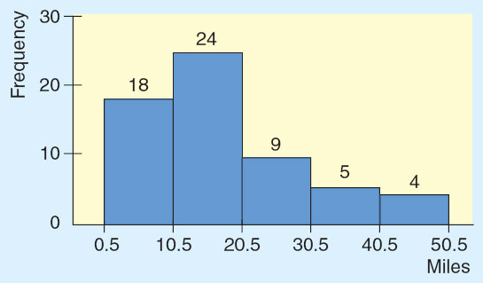  Which statement describes the histogram appropriately?  A. The histogram is skewed to the right (positively skewed).  B. The histogram is skewed to the left (negatively skewed).  C. The histogram is a normal distribution.  D. The histogram is bimodal.  Answer: A

Reporting Category | Statistics and Probability
Standard | Interpreting Categorical & Quantitative Data
Benchmark Number | MAFS.912.S-ID.1.3
Benchmark | Interpret differences in shape, center, and spread in the context of the data sets, accounting for possible effects of extreme data points (outliers).
Also Assesses | MAFS.K12.MP.4.1  MAFS.912.S-ID.1.2
Item Types | Selected Response (Multiple Choice), Gridded Response, Short Answer
Benchmark Clarification | Students will identify outliers, the possible reasons for them and what effect they have on the mean, median, mode and range of data.
Content Limits | Items may include identifying outliers from a set of data in a graph such as a histogram or box-and-whisker plot.  Items may also include what effect adding a higher or lower value have on a particular mean, median, mode or range.
Stimulus Attributes | Items must be set in real-world context.
Response Attributes | Answers will include numerical outliers, reasons for outliers, or effect of specific outlier on mean, median, mode or range of data.
Sample Item | Summer income for 14 high school students is listed below:  1,208 2,400 1,337 3,020  1,055 456 810 1,765  1,208 987 2,343 1,654  734 1,356  Which of these statements is true?  - 456 is an outlier.  B. 3020 is an outlier.  C. 456 and 3020 are outliers.  D. There are no outliers.  Answer: B

Reporting Category | Statistics and Probability
Standard | Interpreting Categorical & Quantitative Data
Benchmark Number | MAFS.912.S-ID.1.4
Benchmark | Use the mean and standard deviation of a data set to fit it to a normal distribution and to estimate population percentages. Recognize that there are data sets for which such a procedure is not appropriate. Use calculators, spreadsheets, and tables to estimate areas under the normal curve.
Also Assesses | MAFS.K12.MP.6.1
Item Types | Selected Response (Multiple Choice), Gridded Response, Short Answer
Benchmark Clarification | Students will identify the properties of a normal distribution.  Students will find area under the standard normal distribution.  Students will find probabilities of a variable under a normal distribution.  Students will find specific data values for given percentages using the standard normal distribution.
Content Limits | Items may include finding area under a curve between z-scores, finding z-scores with given probability or finding specific data values with given probability.  Items may include students analyzing graphs with z-sores, data values or probabilities.
Stimulus Attributes | Items must be set in real-world context.
Response Attributes | Items may be in decimal or percentage form.  Items should specify whether the answer expected is in decimal or percentage form.  Z-scores may be negative.
Sample Items | What is the probability (in decimal form) for the given information using the standard normal distribution?  P (-2.46 < z < 1.74)  Answer: 0.9521

Reporting Category | Statistics and Probability
Standard | Interpreting Categorical & Quantitative Data
Benchmark Number | MAFS.912.S-ID.2.5
Benchmark | Summarize categorical data for two categories in two-way frequency tables. Interpret relative frequencies in the context of the data (including joint, marginal, and conditional relative frequencies). Recognize possible associations and trends in the data.
Also Assesses | MAFS.K12.MP.4.1  LAFS.910WHST.3.9
Item Types | Selected Response (Multiple Choice), Gridded Response, Short Answer
Benchmark Clarification | Students will calculate and interpret frequencies found in two-way tables.
Content Limits | Items will be presented in two-way frequency tables.
Stimulus Attributes | Items must be set in real-world context.
Response Attributes | Answers may be in decimal or percentage form. Answer may require written statements.
Sample Item | In 2006, an electronic replay system debuted in both men’s and women’s professional tennis. Each player is allowed two unsuccessful challenges per set. Here are some data on the results of challenges made during the first few months of the new system.  Successful Unsuccessful  Men 201 288  Women 126 224  1. What is the marginal distribution (in percent) for each of the two variables?  Answer: Gender- Men 489/839 = 58.28%,  Women 350/839 =41.72%  Challenge results- Successful : 327/839 = 38.97%,  Unsuccessful- 512/839 = 61.03%  2 Points:  - The response indicates that the student has a complete understanding of the concept embodied in the task.  - The student has provided a response that is accurate, complete, and fulfills all the requirements of the task.  - Necessary support and/or examples are included, and the information given is clearly text-based.  1 Point:  - The response indicates that the student has a partial understanding of the concept embodied in the task.  - The student has provided a response that includes information that is essentially correct and text-based but the information is too general or too simplistic.  - Some of the support and/or examples may be incomplete or omitted.  0 Points:  - The response indicates that the student does not demonstrate and understanding of the reading concept embodied in the task.  - The student has provided a response that is inaccurate or contains only irrelevant text-based information.  - The response has an insufficient amount of information to determine the student’s understanding of the task or the student has failed to respond to the task.

Reporting Category | Statistics and Probability
Standard | Using Probability to Make Decisions
Benchmark Number | MAFS.912.S-MD.2.5
Benchmark | Weigh the possible outcomes of a decision by assigning probabilities to payoff values and finding expected values.  a. Find the expected payoff for a game of chance. For example, find the expected winnings from a state lottery ticket or a game at a fast-food restaurant.  b. Evaluate and compare strategies on the basis of expected values. For example, compare a high-deductible versus a low-deductible automobile insurance policy using various, but reasonable, chances of having a minor or a major accident.
Also Assesses | MAFS.912.S-MD2.6  MAFS.K12.MP.4.1
Item Types | Selected Response (Multiple Choice), Gridded Response, Short Answer
Benchmark Clarification | Students will use the formula to calculate the expected value (mean) of a random variable.
Content Limits | Items may include probability distributions or raw data. Items may include discrete random variables, discrete uniform variables, binomial or exponential data.
Stimulus Attribute | Items must be set in mathematical or real-world context.
Response Attributes | Items may be in fraction or decimal form.
Sample Item | A box contains ten $1 bills, five $2 bills, three $5 bills, one $10 bill, and one $100 bill. A person is charged $20 to select one bill.  What is the expected value, and interpret this value in the context of this problem?  Answer: $7.25

Reporting Category | Statistics and Probability
Standard | Using Probability to Make Decisions
Benchmark Number | MAFS.912.S-MD.2.7
Benchmark | Analyze decisions and strategies using probability concepts (e.g., product testing, medical testing, pulling a hockey goalie at the end of a game).
Also Assesses | MAFS.912.S-ID.1.4  MAFS.K12.MP.1.1
Item Types | Selected Response (Multiple Choice), Gridded Response, Short Answer
Benchmark Clarification | Students will analyze decisions and strategies using the probability formulas, and/or z-scores to solve real world statistics problems.
Content Limits | Items may include finding z-scores, confidence intervals, or p-values from hypothesis test.
Stimulus Attribute | Items must be set in mathematical or real-world context.
Response Attributes | Items may be in fraction or decimal form.
Sample Item | Engineers must consider the breadths of male heads when designing motorcycle helmets. Men have head breadths that are normally distributed with a mean of 6.0 inches and a standard deviation of 1.0 inch (survey data from Gordon Churchill). 100 men are randomly selected. What is the probability that the men have a mean head breadth less than 6.2?  Answer: 0.9772

