Guide for Level 2 Reviewing in Eduphoria
Link for Guide for Writing and Reviewing in Eduphoria: http://cfacteam.weebly.com/eduphoria-non-grant-resources--test-item-specs.html
NOTE: The Bias and Sensitivity Guide can also be found at this web address. Scroll down on the page, look at the bottom left under “Other Resources Not Included in the Guide” and you will see the link for the Bias and Sensitivity Guide listed first.
- The course being reviewed must show up in the SDOC Gap Courses spreadsheet.
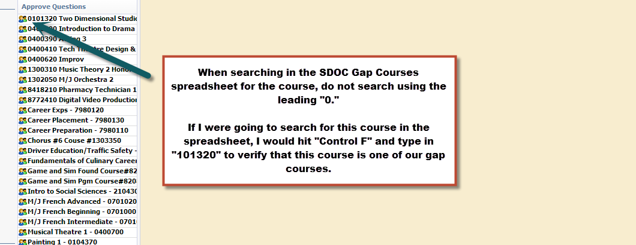

- Once the course has been verified in the SDOC Gap Courses spreadsheet, open the Item Writer Sign Up Sheet associated with the course. If you do not have access to the appropriate sign up sheet, please email Justin Seabolt at seaboltj@osceola.k12.fl.us.
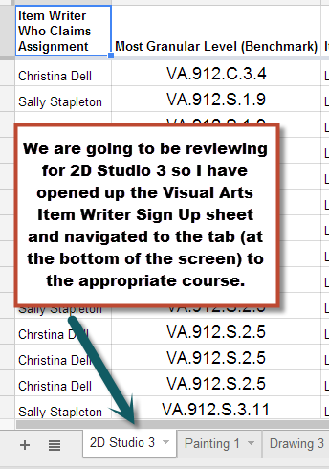
- When reviewing items at level 2, you will be cross checking the items in Eduphoria with the Item Writer Sign Up sheet. You will need to locate the UIN in Eduphoria as well as the Item Writer Sign Up sheet.
- To find the UIN/Item Number in Eduphoria, hover over the top right of the question until the “green pencil” icon appears. Click the “green pencil icon” to “edit the question.” You will see the UIN in the top right hand corner of the screen.
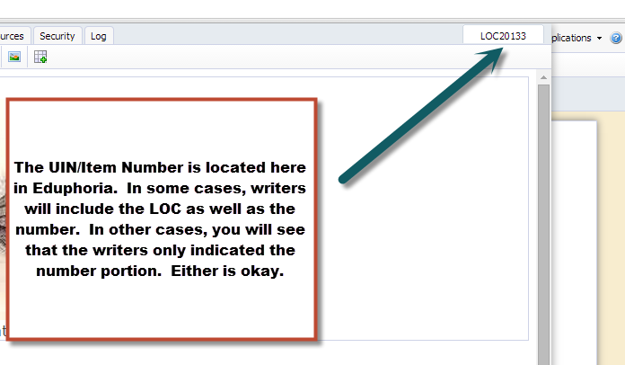
- To find the UIN/Item Number quickly in the sign up sheet, hit “Control F” and type in the Number Portion of the UIN/Item Number you wish to find.
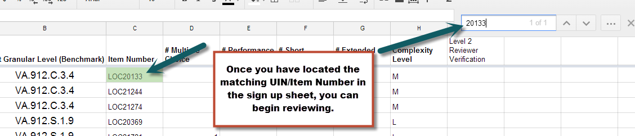

- Once you have found the corresponding UIN/Item Number in Eduphoria, you can use the checklist below to review the item.
NOTE: If you are reviewing an item in Eduphoria and you cannot find the UIN/Item Number in the Item Writer Sign Up sheet, please email the writer (and CC) Justin Seabolt immediately. Usually this means that the item writer has forgotten to update the sign up sheet to include the UIN/Item Number. But this must be done first before reviewing the item.

Considerations/Checklist | Yes | No
Does the item written in Eduphoria match the item type signed up for in the sign up sheet? If not, you will need to reject the item back to the writer. If you need to reject the item, please provide your comments (please see the Guide for Writing and Reviewing in Eduphoria on how to provide comments) AND follow up with an email to the item writer to let them know why you have rejected their item. | X
Click on the “Options” tab. Does the Complexity chosen match the Item Writer Sign Up sheet? If it doesn’t, please use the item writer sign up sheet as the basis. You will need to email the item writer and ask them about the question. In a lot of cases, the item writers will forget to click on the Options tab and change to the appropriate complexity level.  For example, a writer may have signed up for AND written a moderate complexity question but left the complexity level indicated as low (the default for Eduphoria).  In addition, use the Webb’s DOK if there is a discrepancy before emailing the writer. There will be a DOK Chart you can use at the end of this document. Remember, Level 1 = Low Complexity, Level 2 = Moderate Complexity, and Level 3/4 = High Complexity.  *You can locate who the writer is by clicking on the “Log” tab. | X
Click on the Standards tab. Does the standard chosen match the Item Writer Sign Up sheet? If not, you will need to reject the item back to the writer. If you need to reject the item, please provide your comments (please see the Guide for Writing and Reviewing in Eduphoria on how to provide comments) AND follow up with an email to the item writer to let them know why you have rejected their item. | X
Are grammar, punctuation, and spelling correct? If not, fix it and approve the item. Items should never be rejected for anything regarding grammar, punctuation, spelling, etc. | X
If you are reviewing a multiple choice item, are the answer choices in the correct order? If not, fix it. You can use the Multiple Choice Answer Choice Guidelines at the end of this document to help you with this. | X
If you are reviewing a multiple choice item, are rationales provided for the three incorrect answer choices? If not, you will need to reject the item back to the writer. If you need to reject the item, please provide your comments (please see the Guide for Writing and Reviewing in Eduphoria on how to provide comments) AND follow up with an email to the item writer to let them know why you have rejected their item.
If you are reviewing a short answer item, is there a three point (score range 0-2) rubric provided? In addition, is there a sample full credit response provided? If either one of these are missing, you must reject the item. If you need to reject the item, please provide your comments (please see the Guide for Writing and Reviewing in Eduphoria on how to provide comments) AND follow up with an email to the item writer to let them know why you have rejected their item. | X
If you are reviewing a short answer item, click the “Options” tab again. Is the score range listed as “0 to 2?” If not, fix it. Eduphoria defaults the minimum score to a “1” so a lot of writers forget to change this when writing their items. | X
If you are reviewing a performance task or extended response, is there a five point (score range 0-4) rubric provided? Keep in mind that a sample full credit response is NOT required for performance tasks or extended responses…only a rubric. If the rubric is missing, you will need to reject the item back to the writer. If you need to reject the item, please provide your comments (please see the Guide for Writing and Reviewing in Eduphoria on how to provide comments) AND follow up with an email to the item writer to let them know why you have rejected their item.  NOTE: For English/Language Arts courses, you may see some rubrics that are 1-6 instead of 0-4. This is okay. But this is only okay for English/Language Arts courses. | X
If you are reviewing a performance task or extended response, click the “Options” tab again. Is the score range listed as “0 to 4?” If not, fix it. Eduphoria defaults the the score range to “1 to 2” so a lot of writers forget to change this when writing their items. | X
Does the question written exhibit any bias or sensitivity that may be unfair to any student according to the Bias and Sensitivity Guide? If it does, you will need to reject the item back to the writer. If you need to reject the item, please provide your comments (please see the Guide for Writing and Reviewing in Eduphoria on how to provide comments) AND follow up with an email to the item writer to let them know why you have rejected their item. |  | X

- Once you have been able to approve an item, please initial in the Item Writer Sign Up Sheet under the column labeled “Level 2 Reviewer Verification.”
Note: If no such column exists, that means you are the first level 2 reviewer to review an item in this course. Please create this new column and initial accordingly.
Double Note: Do not forget the UIN/Item Number that you were just working on because as soon as you hit approve, it will disappear and you will not be able to find it again.
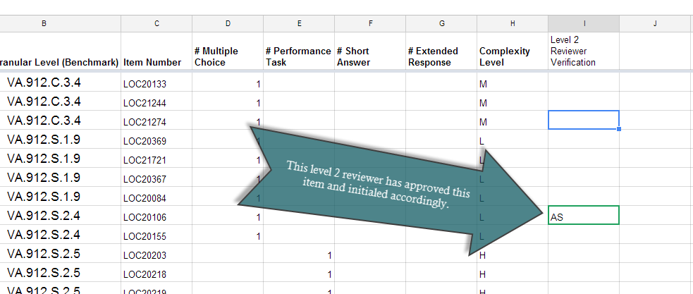

Multiple Choice Answer Choice Guidelines
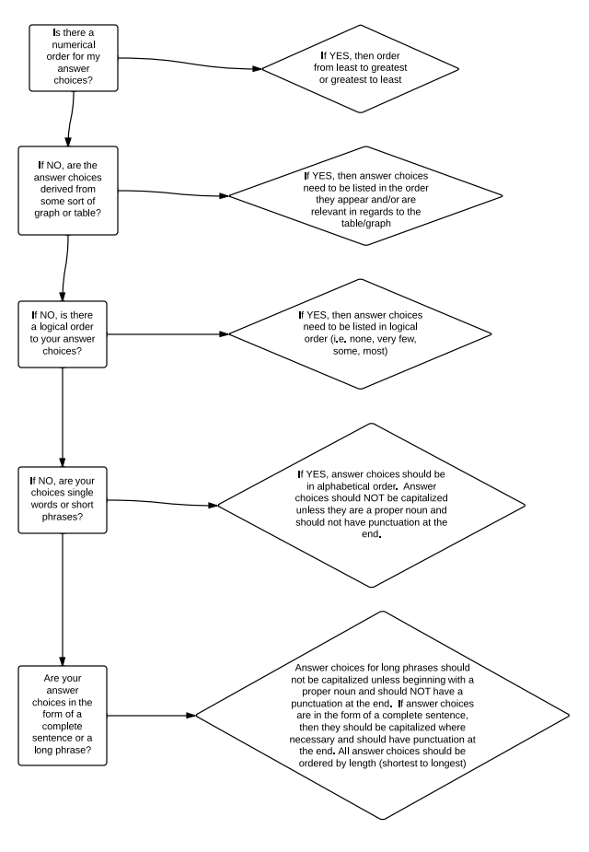

Webb’s Depth of Knowledge Wheel
