CENTRAL FLORIDA ASSESSMENT COLLABORATIVE

Individual Test Item

Specifications

Informal Geometry

NOTE: The contents of this document were developed under a grant from the U.S. Department of Education. However, the content does not necessarily represent the policy of the U.S. Department of Education, and you should not assume endorsement by the Federal Government.

2014

**Table of Contents**

I. Guide to the Individual Benchmark Specifications ..................................................................... 1

Benchmark Classification System............................................................................................... 1

Definitions of Benchmark Specifications ................................................................................... 3

II. Individual Benchmark Specifications for Informal Geometry................................................... 4

MAFS.912.G-CO.1.5 ................................................................................................................. 5

MAFS.912.G-CO.2.6 ................................................................................................................. 8

MAFS.912.G-CO.2.7 ............................................................................................................... 10

MAFS.912.G-CO.2.8 ............................................................................................................... 12

MAFS.912.G-SRT.1.1 ............................................................................................................. 14

MAFS.912.G-SRT.1.2 ............................................................................................................. 16

MAFS.912.G-SRT.2.5 ............................................................................................................. 18

MAFS.912.G-GPE.2.4 ............................................................................................................. 20

MAFS.912.G-GPE.2.6 ............................................................................................................. 22

MAFS.912.G-GPE.2.7 ............................................................................................................. 24

MAFS.912.G-C.1.2 .................................................................................................................. 27

MAFS.912.G-GMD.1.3............................................................................................................ 29

MAFS.912.G-GMD.2.4............................................................................................................ 31

MAFS.912.G-MG.1.2 .............................................................................................................. 33

MAFS.912.G-MG.1.3 .............................................................................................................. 35

**I. Guide to the Individual Benchmark Specifications**

Content specific guidelines are given in the *Individual Benchmark Specifications* for each course. The *Specifications* contains specific information about the alignment of items with the Florida Standards. It identifies the manner in which each benchmark is assessed, provides content limits and stimulus attributes for each benchmark, and gives specific information about content, item types, and response attributes.

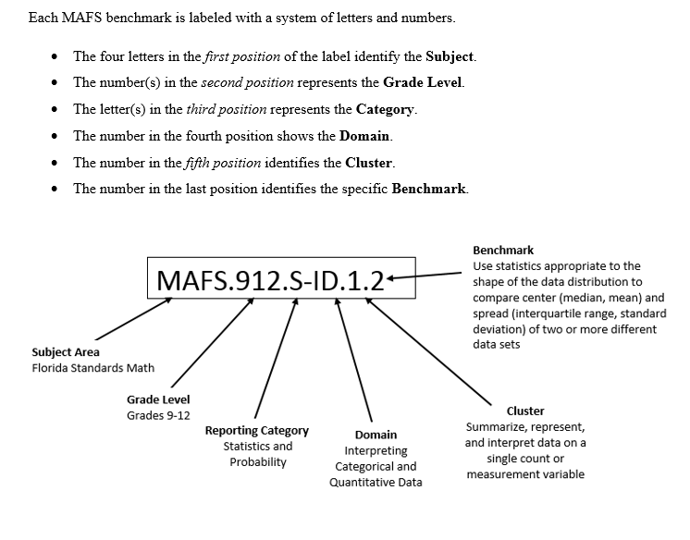

**Definitions of Benchmark Specifications**

The *Individual Benchmark Specifications* provides standard-specific guidance for assessment item development for CFAC item banks. For each benchmark assessed, the following information is provided:

|  |  |
| --- | --- |
| **Reporting Category** | is a grouping of related benchmarks that can be used to summarize and report achievement. |
| **Standard** | refers to the standard statement presented in the Florida Standards. |
| **Benchmark**  **Also Assesses** | refers to the benchmark statement presented in the standard statement in the Florida Standards. In some cases, two or more related benchmarks are grouped together because the assessment of one benchmark addresses another benchmark. Such groupings are indicated in the Also Assesses statement.  refers to the benchmarks that are closely related to the benchmark (see description above). |
| **Item Types**  **Cognitive Complexity Level** | are used to assess the benchmark or group of benchmark.  ideal level at which the item should be assessed. |
| **Benchmark Clarifications** | explain how achievement of the benchmark will be demonstrated by students. In other words, the clarification statements explain what the student will do when responding to questions. |
| **Content Limits** | define the range of content knowledge and that should be assessed in the items for the benchmark. |
| **Stimulus Attributes** | define the types of stimulus materials that should be used in the items, including the appropriate use of graphic materials and item context or content. |
| **Response Attributes** | define the characteristics of the answers that a student must choose or provide. |
| **Sample Items** | are provided for each type of question assessed. The correct answer for all sample items is provided. |

**II. Individual Benchmark Specifications for Informal Geometry**

Course Number: 1206300

The fundamental purpose of the course in Informal Geometry is to extend students’ geometric experiences from the middle grades. Students explore more complex geometric situations and deepen their explanations of geometric relationships. The Mathematical Practice Standards apply throughout each course and, together with the content standards, prescribe that students experience mathematics as a coherent, useful, and logical subject that makes use of their ability to make sense of problem situations.

**MAFS.912.G-CO.1.5**

|  |  |
| --- | --- |
| **Reporting**  **Category** | Two-Dimensional Geometry |
| **Standard** | Congruence |
| **Benchmark**  **Number** | MAFS.912.G-CO.1.5 |
| **Benchmark** | Given a geometric figure and a rotation, reflection, or translation, draw the transformed figure using, e.g., graph paper, tracing paper, or geometry software. Specify a sequence of transformations that will carry a given figure onto  another. |
| **Also Assesses** | MAFS.912.G-CO.1.2 Represent transformations in the plane using, e.g., transparencies and geometry software; describe transformations as functions  that take points in the plane as inputs and give other points as outputs. Compare transformations that preserve distance and angle to those that do not (e.g., translation versus horizontal stretch).  MAFS.K12.MP.1.1, 2.1, 5.1, 6.1, 7.1 |
| **Item Types** | Selected-Response, Gridded-Response, Short-Response |
| **Benchmark**  **Clarification** | Students will identify a sequence of transformations that will carry a given figure onto another.  Students will describe function transformations on a set of points as inputs to produce another set of points as outputs. |
| **Content**  **Limits** | Angle measures will be in degrees.  Figures should have no more than six vertices.  Transformation sequences will have at most three transformations. |
| **Stimulus**  **Attributes** | Items may assess only translations, reflections, or rotations. Graphics should be used for most of these items, as appropriate.  Items may be set in either real-world or mathematical contexts. |
| **Response**  **Attributes** | Gridded-Response items may require that students provide the length of a segment or the x-coordinate (or y-coordinate) of a point of interest. |

5 | P a g e

**Sample Item 1** Given: *ABC* shown on the coordinate plane below.

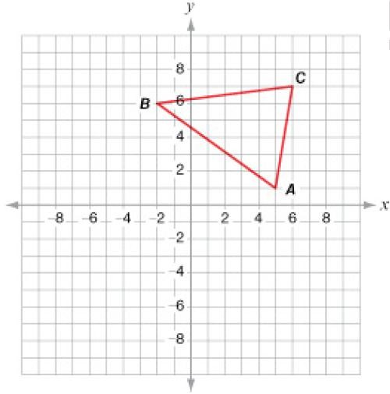

A sequence of transformations yields *A* ' *B* ' *C* ‘. If the coordinates of

(4, 6), which sequence of transformations was applied?

*B* ' are

A. a reflection across the *y*-axis followed by a translation of 2 units left

B. a reflection across the *x*-axis followed by a translation of 2 units left*

C. a reflection across the line *y*  *x*

followed by a translation of 4 units left

D. a reflection across the line *y*  *x*

left

followed by a translation of 4 units

6 | P a g e

**Sample Item 2** Given: *ABC* shown on the coordinate plane below.



*ABC* is translated 3 units left and 4 units down to yield

*A* ' *B* ' *C* ‘. Using this

translation, what is the general rule that will map *ABC* onto *A* ' *B* ' *C* ‘?

A. (*x*, *y*)  (3*x*, 4 *y*)

B. (*x*, *y*)  (4*x*, 3*y*)

C. (*x*, *y*)  (*x*  3, *y*  4) * D. (*x*, *y*)  (*x*  4, *y*  3)

7 | P a g e

**MAFS.912.G-CO.2.6**

|  |  |
| --- | --- |
| **Reporting**  **Category** | Two-Dimensional Geometry |
| **Standard** | Congruence |
| **Benchmark**  **Number** | MAFS.912.G-CO.2.6 |
| **Benchmark** | Use geometric descriptions of rigid motions to transform figures and to predict the effect of a given rigid motion on a given figure; given two figures, use the definition of congruence in terms of rigid motions to decide if they are congruent. |
| **Also Assesses** | MAFS.912.G-CO.1.3 Given a rectangle, parallelogram, trapezoid, or regular polygon, describe the rotations and reflections that carry it onto itself.  MAFS.K12.MP.1.1, 2.1, 5.1, 6.1, 7.1 |
| **Item Types** | Selected-Response, Gridded-Response, Short-Response |
| **Benchmark**  **Clarification** | Students will apply rigid transformations to rectangles, trapezoids, or regular polygons to determine congruence.  Students will solve problems involving congruent figures. |
| **Content**  **Limits** | Angle measures will be in degrees.  Figures should have no more than six vertices.  Transformation sequences will have at most three transformations. |
| **Stimulus**  **Attributes** | Students may be asked to find missing angle measures or side lengths. Items may be set in either real-world or mathematical contexts.  Graphics should be used in most of these items, as appropriate. |
| **Response**  **Attributes** | Gridded-Response items may require that students provide the length of a segment or the x-coordinate (or y-coordinate) of a point of interest. |

8 | P a g e

|  |  |
| --- | --- |
| **Sample Item 1** | *ABC* is rotated 155° about the origin, translated up two units, and reflected  across the line *y*  *x* to yield *A*' *B* '*C* ‘. What is the relationship between  *ABC* and *A*' *B* '*C* ‘?  A. similar but not congruent B. congruent but not similar C. similar and congruent*  D. neither similar nor congruent |
| **Sample Item 2** | A trapezoid is rotated as shown below.  What is the value of *r*? Sample Answer: r = 9 |

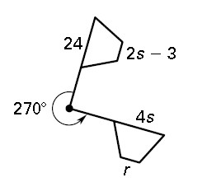9 | P a g e

**MAFS.912.G-CO.2.7**

|  |  |
| --- | --- |
| **Reporting**  **Category** | Two-Dimensional Geometry |
| **Standard** | Congruence |
| **Benchmark**  **Number** | MAFS.912.G-CO.2.7 |
| **Benchmark** | Use the definition of congruence in terms of rigid motions to show that two triangles are congruent if and only if corresponding pairs of sides and corresponding pairs of angles are congruent. |
| **Also Assesses** | MAFS.K12.MP.1.1, 2.1, 5.1, 6.1, 7.1 |
| **Item Types** | Selected-Response, Gridded-Response, Short-Response |
| **Benchmark**  **Clarification** | Students will use geometric properties to justify measures and characteristics of triangles. |
| **Content Limits** | Items will NOT require students to provide statements and/or justifications to complete formal or informal proofs. |
| **Stimulus**  **Attributes** | Students may be asked to find missing angle measures or side lengths. Items may be set in either real-world or mathematical contexts.  Graphics should be used in these items, as appropriate. |
| **Response**  **Attributes** | Not Applicable |

10 | P a g e

**Sample Item**

Given: *LMO*  *PQR*

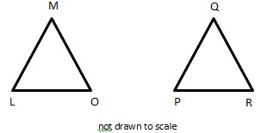

If *L*  62 and *M*  57, what is the measure of *R,* in degrees? Sample answer: 61

11 | P a g e

**MAFS.912.G-CO.2.8**

|  |  |
| --- | --- |
| **Reporting**  **Category** | Two-Dimensional Geometry |
| **Standard** | Congruence |
| **Benchmark**  **Number** | MAFS.912.G-CO.2.8 |
| **Benchmark** | Explain how the criteria for triangle congruence (ASA, SAS, and SSS) follow from the definitions of congruence in terms of rigid motions. |
| **Also Assesses** | MAFS.K12.MP.1.1, 3.1, 6.1 |
| **Item Types** | Selected-Response |
| **Benchmark**  **Clarification** | Students will use triangle congruence criteria (SSS, ASA, and SAS) to determine triangle congruence. |
| **Content**  **Limits** | Items may require justifications to complete formal and/or informal proofs. |
| **Stimulus**  **Attributes** | Proofs requiring completion may only be written in a two-column or flow format.  Proofs requiring completion may only ask students to provide the triangle congruence criteria (AAA, ASA, or SAS) necessary to prove the specified triangles congruent.  Items may be set in either real-world or mathematical contexts. Graphics should be used in most of these items, as appropriate. |
| **Response**  **Attributes** | Not Applicable |

12 | P a g e

**Sample Item** Given: *ZX is* the perpendicular bisector of *WY*

Prove:

*WXZ*  *YXZ*

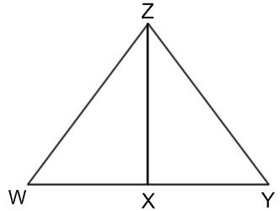

______



|  |  |
| --- | --- |
| **Statements** | **Reasons** |
| 1) *ZX* is the perpendicular bisector of  *WY*  2) *m**WXZ*  *m**YXZ*  90 ;  *WX*  *YX*  3) *WXZ*  *YXZ*  4) *XZ*  *XZ*  5) *WXZ*  *YXZ* | 1) Given  2) Definition of perpendicular bisector  3) All right angles are congruent.  4) Reflexive Property  5) |

What is the reason missing from the proof shown above?

A. SAS* B. SSS C. ASA

D. AAS

13 | P a g e

**MAFS.912.G-SRT.1.1**

|  |  |
| --- | --- |
| **Reporting**  **Category** | Two-Dimensional Geometry |
| **Standard** | Similarity, Right Triangles, and Trigonometry |
| **Benchmark**  **Number** | MAFS.912.G-SRT.1.1 |
| **Also Assesses** | MAFS.K12.1.1, 6.1, 8.1 |
| **Benchmark** | Verify experimentally the properties of dilations given by a center and a scale factor; a) A dilation takes a line not passing through the center of the dilation to a parallel line, and leaves a line passing through the center unchanged. b) The dilation of a line segment is longer or shorter in the ratio given by the scale factor. |
| **Item Types** | Selected-Response, Gridded-Response, Short-Response |
| **Benchmark**  **Clarification** | Students will use dilations to solve problems. |
| **Content**  **Limits** | Figures should have no more than six vertices. |
| **Stimulus**  **Attributes** | Students may be asked to identify the scale factor of and/or find missing side lengths.  Items may be set in either real-world or mathematical contexts. Graphics should be used in most of these items, as appropriate. |
| **Response**  **Attributes** | Not Applicable |

14 | P a g e

**Sample Item** Dilations are used to get films to fit onto a movie screen as shown below.

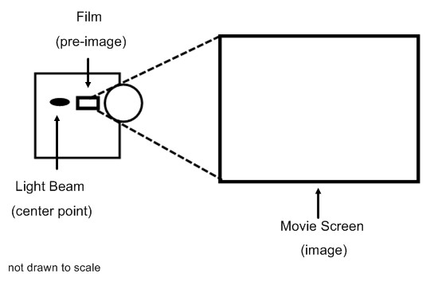

The width of the film is 3 inches. The width of the movie screen is 52 feet. What is the scale factor of the dilation?

Sample Answer: 208

15 | P a g e

**MAFS.912.G-SRT.1.2**

|  |  |
| --- | --- |
| **Reporting**  **Category** | Two-Dimensional Geometry |
| **Standard** | Similarity, Right Triangles, and Trigonometry |
| **Benchmark**  **Number** | MAFS.912.G-SRT.1.2 |
| **Benchmark** | Given two figures, use the definition of similarity in terms of similarity transformations to decide if they are similar; explain using similarity transformations the meaning of similarity for triangles as the equality of all corresponding pairs of angles and the proportionality of all corresponding pairs of sides. |
| **Also Assesses** | MAFS.912.G-SRT.1.3 Use the properties of similarity transformations to establish the AA criterion for two triangles to be similar.  MAFS.K12.1.1, 6.1, 8.1 |
| **Item Types** | Selected-Response |
| **Benchmark**  **Clarification** | Students will use the definition of similarity to determine if two figures are similar. |
| **Content**  **Limits** | Figures should have no more than six vertices. |
| **Stimulus**  **Attributes** | Students may be asked to determine what additional information is required to prove that two figures to be similar.  Items may be set in either real-world or mathematical contexts. Graphics should be used in most of these items, as appropriate. |
| **Response**  **Attributes** | Not Applicable |

16 | P a g e

**Sample Item**

*PQR*

and *TUV*

are show below.

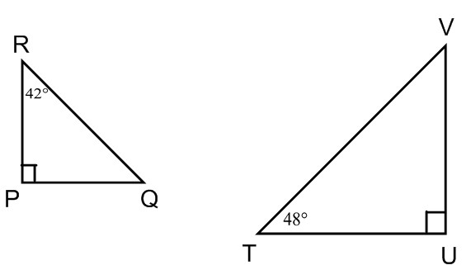

Based on the drawing, which statement is true?

A. *PQR*

B. *PQR*

C. *PQR*

by the Angle-Angle Similarity Postulate*

by the Side-Angle-Side Similarity Theorem by the Side-Side-Side Similarity Theorem

*TUV*

*TUV*

*TUV*



D. *PQR* and *TUV* are not similar.

17 | P a g e

**MAFS.912.G-SRT.2.5**

|  |  |
| --- | --- |
| **Reporting**  **Category** | Two-Dimensional Geometry |
| **Standard** | Similarity, Right Triangles, and Trigonometry |
| **Benchmark**  **Number** | MAFS.912.G-SRT.2.5 |
| **Also Assesses** | MAFS.K12.MP.1.1, 6.1, 7.1 |
| **Benchmark** | Use congruence and similarity criteria for triangles to solve problems and to prove relationships in geometric figures. |
| **Item Types** | Selected-Response, Gridded-Response, Short-Response |
| **Benchmark**  **Clarification** | Students will solve problems involving congruent and similar triangles. |
| **Content**  **Limits** | Students may be asked to find missing angle measures or side lengths. Angles will be measured in degrees.  Items will NOT require students to provide statements and/or justifications to complete formal or informal proofs. |
| **Stimulus**  **Attributes** | Items may be set in either real-world or mathematical contexts.  Graphics should be used in most of these items, as appropriate. |
| **Response**  **Attributes** | Not Applicable |

18 | P a g e

|  |  |
| --- | --- |
| **Sample Item 1** | Two adjoining triangles, *ABE and* *CDE,* are shown below.    Based on the drawing, what is the length of *AB?*  A. 3  B. 3.5* C. 4  D. 4.5 |
| **Sample Item 2** | Brian runs on the trails in the park. He normally runs one complete lap around trail ABC. The length of each side of trail ABC is shown in meters (m) in the diagram below.    If trail EFG is similar to trail ABC, what is the distance, in meters, Brian would have to run to complete one lap around trail EFG?  Sample Answer: 226 |

19 | P a g e

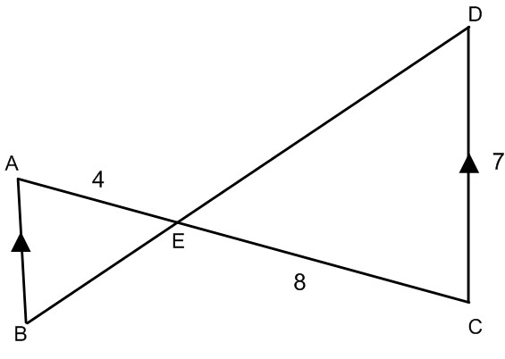

**MAFS.912.G-GPE.2.4**

|  |  |
| --- | --- |
| **Reporting**  **Category** | Two-Dimensional Geometry |
| **Standard** | Similarity, Right Triangles, and Trigonometry |
| **Benchmark**  **Number** | MAFS.912.G-GPE.2.4 |
| **Also Assesses** | MAFS.K12.MP.1.1, 2.1, 3.1, 6.1, 7.1 |
| **Benchmark** | Use coordinates to prove simple geometric theorems algebraically. For example, prove or disprove that a figure defined by four given points in the coordinate plane is a rectangle; prove or disprove that the point (1, √3) lies on the circle centered at the origin and containing the point (0, 2). |
| **Item Types** | Selected-Response, Gridded-Response, Short-Response |
| **Benchmark**  **Clarification** | Students will use coordinates to prove geometric theorems or to determine properties of figures on the coordinate plan. |
| **Content**  **Limits** | Figures should have no more than six vertices. |
| **Stimulus**  **Attributes** | Items may be set in either real-world or mathematical contexts.  Graphics should be used in most of these items, as appropriate. |
| **Response**  **Attributes** | Gridded-Response items may require that students provide the length of a segment or the x-coordinate (or y-coordinate) of a point of interest. |

20 | P a g e

**Sample Item** Three students are playing a game and their starting positions are shown on the coordinate plane below.

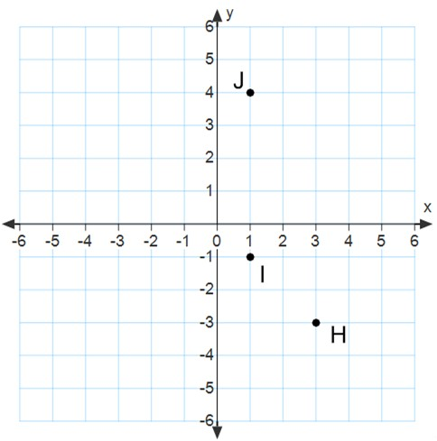

A fourth student is joining the game and will be starting in position K. What should the *y*-coordinate of K be to make *HIJK* a parallelogram?

Sample Answer: 2

21 | P a g e

**MAFS.912.G-GPE.2.6**

|  |  |
| --- | --- |
| **Reporting**  **Category** | Two-Dimensional Geometry |
| **Standard** | Geometric Properties with Equations |
| **Benchmark**  **Number** | MAFS.912.G-GPE.2.6 |
| **Also Assesses** | MAFS.K12.MP.1.1, 2.1, 6.1 |
| **Benchmark** | Find the point on a directed line segment between two given points that partitions the segment in a given ratio. |
| **Item Types** | Selected-Response, Gridded-Response, Short-Response |
| **Benchmark**  **Clarification** | Students will find a point on a line segment that divides the segment into a given ratio.  Students will find midpoints and/or endpoints of line segments. |
| **Content**  **Limits** | Ratios should be expressed in the form A:B or A to B. The value of B is limited to 1, 2, or 3. |
| **Stimulus**  **Attributes** | Student may NOT be asked to find a missing endpoint unless they are given a midpoint.  Items involving midpoints should be use the term midpoint (vs. referring to a  1:1 ratio).  Items must be set in a mathematical context. |
| **Response**  **Attributes** | Gridded-Response items may require that students provide the *x*-coordinate (or  *y*-coordinate) of a point of interest. |
| **Sample Item 1** | The endpoints of *AD are* *A*(0, 2) and *D*(0, 1). What are the coordinates of the point *C* that divides the segment *AD* such that *AC* : *CD* is equal to 2 : 3 ?  A. (1, 1) B. (1, 0) C. (0,1)  D. (0, 0) * |

22 | P a g e

**Sample Item 2** On a coordinate grid, *XY* has endpoint *X* at (4, 2). The midpoint of *XY* is

(3, 1). What is the x-coordinate of point *Y?*

Sample Answer: -10

23 | P a g e

**MAFS.912.G-GPE.2.7**

|  |  |
| --- | --- |
| **Reporting**  **Category** | Two-Dimensional Geometry |
| **Standard** | Geometric Properties with Equations |
| **Benchmark**  **Number** | MAFS.912.G-GPE.2.7 |
| **Also Assesses** | MAFS.K12.MP.1.1, 6.1 |
| **Benchmark** | Use coordinates to compute perimeters of polygons and areas of triangles and rectangles, e.g., using the distance formula. |
| **Item Types** | Selected-Response, Gridded-Response, Short-Response |
| **Benchmark**  **Clarification** | Students will use Geometric Properties with Equations and the distance formula to find the perimeters of polygons and the areas of triangles and rectangles. |
| **Content**  **Limits** | Computation of area is limited to triangles and rectangles. |
| **Stimulus**  **Attributes** | Items will not require students to use the distance formula more than two times.  Items may require students to find the midpoint of a segment in order to calculate area (e.g. to find the height of an isosceles triangle).  Items may be set in either real-world or mathematical contexts.  Figures should be situated in the coordinate plane, or coordinates of the vertices should be given. |
| **Response**  **Attributes** | Not Applicable |
| **Sample Item 1** | *XYZ* is an isosceles triangle with vertices *X* (1,1), *Y* (5,1), and *Z* (4, 3). What is the area of *XYZ*?  Sample Answer: 6 |

24 | P a g e

**Sample Item 2** Trapezoid *QRST* is graphed on a coordinate plane as shown below.

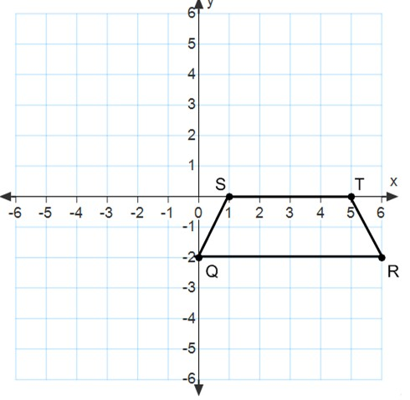Rounded to the nearest tenth, what is the perimeter of trapezoid *QRST*? Sample Answer: 12.2

25 | P a g e

**Sample Item 3** Amanda is planning a rectangular garden. She created a scale drawing of the garden where 1 unit on the graph represents 2 feet in the garden as shown below.

1 unit = 2 feet

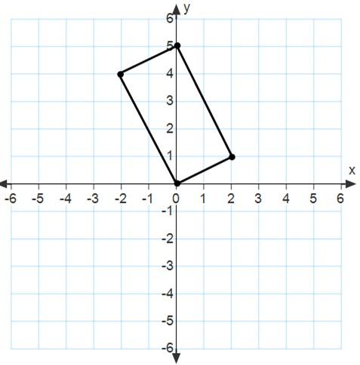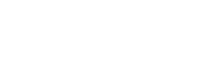

One flat of flowers will cover 2.5 square feet in the garden. What is the minimum number of flats that Amanda needs to buy to cover the entire garden with flowers?

A. 4

B. 8* C. 10

D. 20

26 | P a g e

**MAFS.912.G-C.1.2**

|  |  |
| --- | --- |
| **Reporting**  **Category** | Two-Dimensional Geometry |
| **Standard** | Circles |
| **Benchmark**  **Number** | MAFS.912.G-C.1.2 |
| **Also Assesses** | MAFS.K12.MP.1.1,6.1 |
| **Benchmark** | Identify and describe relationships among inscribed angles, radii, and chords. Include the relationship between central, inscribed, and circumscribed angles; inscribed angles on a diameter are right angles; the radius of a circle is perpendicular to the tangent where the radius intersects the circle. |
| **Item Types** | Selected-Response, Gridded-Response, Short-Response |
| **Benchmark**  **Clarification** | Students will solve problems involving circles. |
| **Content**  **Limits** | Angle measures will be in degrees. |
| **Stimulus**  **Attributes** | Items may be set in either real-world or mathematical contexts.  Graphics should be used in most of these items, as appropriate. |
| **Response**  **Attributes** | Not Applicable |

27 | P a g e

|  |  |
| --- | --- |
| **Sample Item** | *XY* is tangent to circle *Z* at Point *X* as shown below.    To the nearest tenth, what is the length of *WY?* Sample Answer: 4.1 |

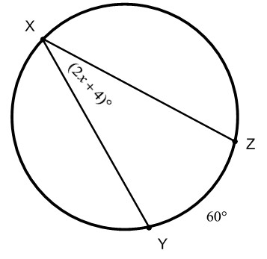28 | P a g e

**MAFS.912.G-GMD.1.3**

|  |  |
| --- | --- |
| **Reporting**  **Category** | Three-Dimensional Geometry |
| **Standard** | Geometric Measurement and Dimension |
| **Benchmark**  **Number** | MAFS.912.G-GMD.1.3 |
| **Also Assesses** | MAFS.K12.MP.1.1, 2.1, 4.1, 6.1 |
| **Benchmark** | Use volume formulas for cylinders, pyramids, cones, and spheres to solve problems. |
| **Item Types** | Selected-Response, Gridded-Response, Short-Response |
| **Benchmark**  **Clarification** | Students will apply formulas to determine volume of solids. |
| **Content**  **Limits** | Solids will be limited to right prisms, right-circular cylinders, spheres, right pyramids, right-circular cones, and/or composites of these solids.  Items may not include oblique figures.  Items may ask students to apply knowledge of congruent and similar solids. |
| **Stimulus**  **Attributes** | Items may be set in either real-world or mathematical contexts.  Graphics should be used in most of these items, as appropriate. |
| **Response**  **Attributes** | Not Applicable |

29 | P a g e

|  |  |
| --- | --- |
| **Sample Item 1** | A cylindrical glass of water with a diameter of 10 centimeters is partially filled  as shown below.  A solid cube with sides that measure 6 centimeters is dropped into the glass. To the nearest tenth, what is the new height of the water?  A. 12.8 centimeters B. 13.8 centimeters C. 14.8 centimeters* D. 15.8 centimeters |
| **Sample Item 2** | A silo is composed of a cylinder and a hemisphere as shown below.  Not drawn to scale.  To the nearest cubic foot, what is the volume of the silo? Use 3.14 for π.  A. 42,390  B. 35,325  C. 8,831  D. 7,948* |

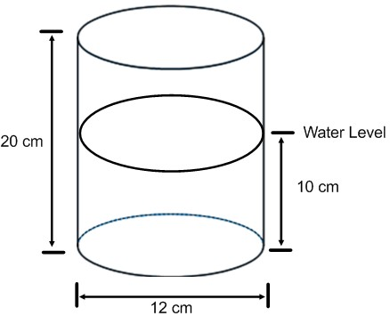30 | P a g e

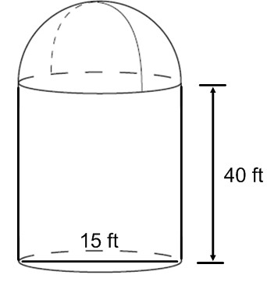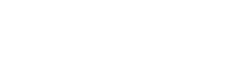

**MAFS.912.G-GMD.2.4**

|  |  |
| --- | --- |
| **Reporting**  **Category** | Three-Dimensional Geometry |
| **Standard** | Geometric Measurement and Dimension |
| **Benchmark**  **Number** | MAFS.912.G-GMD.2.4 |
| **Also Assesses** | MAFS.K12.MP.1.1, 2.1, 4.1, 6.1 |
| **Benchmark** | Identify the shapes of two-dimensional cross-sections of three-dimensional objects, and identify three-dimensional objects generated by rotations of two- dimensional objects. |
| **Item Types** | Selected-Response |
| **Benchmark**  **Clarification** | Students will identify cross sections of three-dimensional shapes.  Students will identify three-dimensional shapes created by rotating two- dimensional shapes. |
| **Content**  **Limits** | Solids will be limited to right prisms, right-circular cylinders, right pyramids, and right-circular cones. |
| **Stimulus**  **Attributes** | Items may be set in either real-world or mathematical contexts.  Graphics should be used in most of these items, as appropriate. |
| **Response**  **Attributes** | Not Applicable |

31 | P a g e

|  |  |
| --- | --- |
| **Sample Item 1** | A plane intersects a right prism as shown below.    What shape is the cross-section?  A. ellipse  B. pentagon* C. rectangle D. trapezoid |
| **Sample Item 2** | Rectangle *ABCD* is graphed on the coordinate plane as shown below.  If rectangle *ABCD* is rotated about the *y*-axis, what three-dimensional shape is created?  A. cone  B. cylinder*  C. rectangular prism  D. rectangular pyramid |

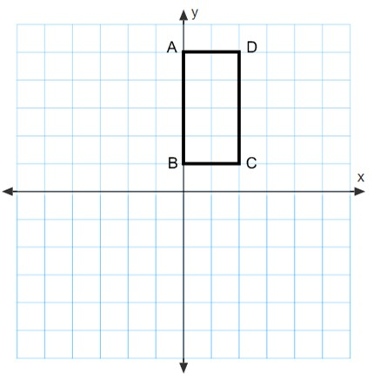32 | P a g e

**MAFS.912.G-MG.1.2**

|  |  |
| --- | --- |
| **Reporting**  **Category** | Three-Dimensional Geometry |
| **Standard** | Modeling with Geometry |
| **Benchmark**  **Number** | MAFS.912.G-MG.1.2 |
| **Also Assesses** | MAFS.912.G-MG.1.1 Use geometric shapes, their measures, and their properties to describe objects (e.g., modeling a tree trunk or a human torso as a cylinder).  MAFS.K12.MP.1.1, 2.1, 4.1, 6.1, 8.1 |
| **Benchmark** | Apply concepts of density based on area and volume in modeling situations  (e.g., persons per square mile, BTUs per cubic foot). |
| **Item Types** | Selected-Response, Gridded-Response, Short-Response |
| **Benchmark**  **Clarification** | Students will calculate density by calculating the volume or area of a figure.  Students will find another measure when given density (e.g., when given a population density, students can calculate population. |
| **Content**  **Limits** | Solids will be limited to right prisms, right-circular cylinders, right pyramids, and right-circular cones.  Two-dimensional figures will be limited to circles, triangles, squares, rectangles, parallelograms, and trapezoids. |
| **Stimulus**  **Attributes** | Contexts that may be unfamiliar to Florida students (e.g. snow) should be avoided.  Items must be set in a real-world context.  Items may require that students use a geometric shape to describe an object (e.g. modeling a tree trunk or a human torso as a cylinder). |
| **Response**  **Attributes** | Not Applicable |

33 | P a g e

**Sample Item** A circle with a radius of 6 miles can be used to model a small city. Only 75% of the city is zoned for residential use. If 240,000 people live in the city, what is the average population density per square mile?

A. 1592

B. 2123

C. 2831* D. 8493

34 | P a g e

**MAFS.912.G-MG.1.3**

|  |  |
| --- | --- |
| **Reporting**  **Category** | Three-Dimensional Geometry |
| **Standard** | Modeling with Geometry |
| **Benchmark**  **Number** | MAFS.912.G-MG.1.3 |
| **Also Assesses** | MAFS.912.G-MG.1.1 Use geometric shapes, their measures, and their properties to describe objects (e.g., modeling a tree trunk or a human torso as a cylinder).  MAFS.K12.MP.1.1, 2.1, 4.1, 6.1, 8.1 |
| **Benchmark** | Apply geometric methods to solve design problems (e.g., designing an object or structure to satisfy physical constraints or minimize cost; working with typographic grid systems based on ratios) |
| **Item Types** | Selected-Response, Gridded-Response, Short-Response |
| **Benchmark**  **Clarification** | Students will apply geometric methods to solve modeling and design problems, such as optimization problems or using a scale grid (e.g. the enlargement of a picture using a grid and ratios and proportions). |
| **Content**  **Limits** | Not Applicable |
| **Stimulus**  **Attributes** | Contexts that may be unfamiliar to Florida students (e.g. snow) should be avoided.  Items must be set in a real-world context. |
| **Response**  **Attributes** | Not Applicable |

35 | P a g e

**Sample Item** As part of her job at a packaging company, Jeanne puts items into boxes. She can only use cubed-shaped boxes, as shown below. These boxes are available in different sizes with whole-inch edge lengths.

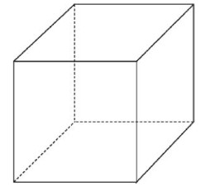

Jeanne needs to select a box for an order that contains three cube shaped items. Two items have a volume of 8 cubic inches. One item has a volume of 27 cubic inches. What is the minimum edge length, in inches, of a box that will hold the order?

Sample Answer: 5

36 | P a g e