Creating a simple chart using Microsoft Word

1. Click on Insert and select “Table”
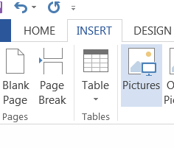
2. Open the Table and highlight the number of columns and rows 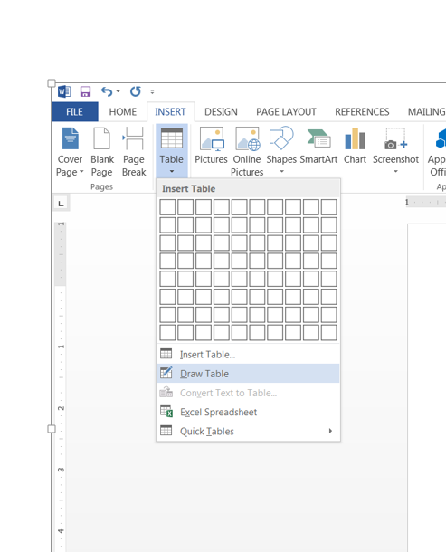2.

3. The table will be inserted according to the columns and rows highlighted. Click on the “borders” tab and select “All borders”
