central florida assssment collaborative

Individual Test Item Specifications
Chinese 1
2014

The contents of this document were developed under a grant from the United States Department of Education. However, the content does not necessarily represent the policy of the United States Department of Education, and you should not assume endorsement by the federal government.
Table of Contents

I. Guide to the Individual Benchmark Specifications 1
Benchmark Classification System 1
Definitions of Benchmark Specifications 3
II. Individual Benchmark Specifications 4

I. Guide to the Individual Benchmark Specifications

Content specific guidelines are given in the Individual Benchmark Specifications for each course. The Specifications contains specific information about the alignment of items with the Florida Standards. It identifies the manner in which each benchmark is assessed, provides content limits and stimulus attributes for each benchmark, and gives specific information about content, item types, and response attributes.

Benchmark Classification System
- Each Career and Technical Education course has its own set of course standards. The benchmarks are organized numerically, with two numbers separated by a decimal point. The first number is the standard number, and the second number is the benchmark number. You will see these numbers on the Item Specifications for each course.

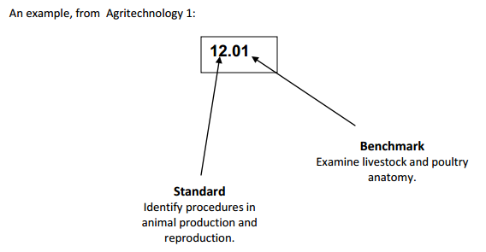

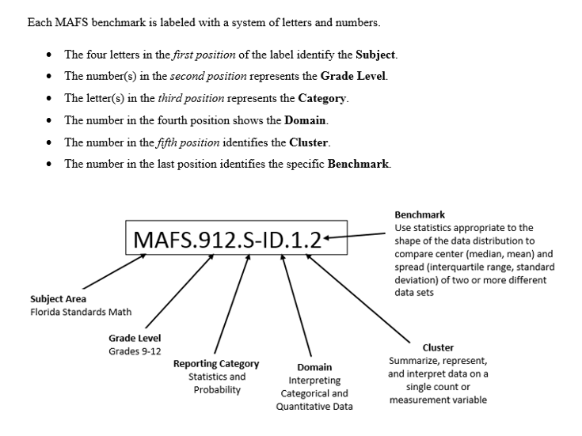

Definitions of Benchmark Specifications

The Individual Benchmark Specifications provides standard-specific guidance for assessment item development for CFAC item banks. For each benchmark assessed, the following information is provided.

Reporting Category | is a grouping of related benchmarks that can be used to summarize and report achievement.
Standard | refers to the standard statement presented in the Florida Standards.
Benchmark | refers to the benchmark statement presented in the standard statement in the Florida Standards. In some cases, two or more related benchmarks are grouped together because the assessment of one benchmark addresses another benchmark. Such groupings are indicated in the Also Assesses statement.
Item Types  Cognitive  Complexity | are used to assess the benchmark or group of benchmark.  ideal level at which item should be assessed.
Benchmark Clarifications | explain how achievement of the benchmark will be demonstrated by students. In other words, the clarification statements explain what the student will do when responding to questions.
Content Limits | define the range of content knowledge and that should be assessed in the items for the benchmark.
Stimulus Attributes | define the types of stimulus materials that should be used in the items, including the appropriate use of graphic materials and item context or content.
Response Attributes | define the characteristics of the answers that a student must choose or provide.
Sample Items | are provided for each type of question assessed. The correct answer for all sample items is provided.  II. Individual Benchmark Specifications
Reporting Category | Modes of Communication
Standard | Interpretive Listening
Benchmark Number | WL.K12.NH.1.1
Benchmark | Demonstrate understanding of familiar topics and frequently used expressions supported by a variety of actions.
Item Types | Selected Response
Cognitive Complexity Level | Low, Moderate
Benchmark Clarification | The student will identify and interpret information, concepts, and ideas presented orally in culturally authentic sources.
Content Focus | The content should include familiar expressions.
Content Limits | The content may include, but is not limited to, expressions related to food and drink as well as familiar expressions related to scenarios inside and outside the classroom.
Stimulus Attributes | A stimulus should be appropriate in length and pace to the Proficiency Level:  - video or audio segments  - item stems and directions provided in English
Distractor Attributes | Distractors may include, but are not limited to:  - phrases that are not appropriate to the scenario described and  - phrases that relate to scenarios outside the scenario described

Sample Item | Read the following passage; select the correct answer to the question.  我叫白玛丽, 我今年十五岁。我上大华高中十年级。 我家有四口人， 爸爸，妈妈，弟弟和我。我的生日是四月六日。 我的弟弟叫白大卫， 他今年九岁，他的生日是五月七日。  How old is 白大卫？  - 十五岁  - 十岁  - 四岁  - 九岁  Correct Answer: A

Reporting Category | Modes of Communication
Standard | Interpretive Listening
Benchmark Number | WL.K12.NH.1.2
Benchmark | Demonstrate understanding of short conversations in familiar contexts.
Item Types | Selected Response
Cognitive Complexity Level | Moderate, High
Benchmark Clarification | The student will identify, describe, and explain the content of conversations about familiar topics inside and outside the classroom.
Content Focus | Understand short conversations.
Content Limits | The content may include, but is not limited to, vocabulary related to food, weather, family, descriptions of people, school related activities, and other appropriate topics familiar to the student.
Stimulus Attributes | A stimulus should be appropriate in length and pace to the Proficiency Level:  - video or audio segment  - item stems and directions provided in English
Distractor Attributes | Distractors may include, but are not limited to:  - responses that do not relate to the conversation  - responses that refer to the conversation inappropriately

Sample Item | Read the following conversation and select the correct answer.  A: 请问， 你要买什么？  B: 我要买一个书包，这个书包多少钱？  A: 二十块钱。  B: 太贵了， 十块钱可以吗？  A: 不可以，十五块钱卖给你。  B: 好吧！谢 谢。  A: 不客气。  Where are these two people?  - in the park  - in the restaurant  - in the school  - in the store  Correct Answer: D

Reporting Category | Modes of Communication
Standard | Interpretive Listening
Benchmark Number | WL.K12.NH.1.3
Benchmark | Demonstrate understanding of short, simple messages and announcements on familiar topics.
Item Types | Selected Response
Cognitive Complexity Level | Moderate
Benchmark Clarification | The student will recognize content of simple messages and announcements on familiar topics.
Content Focus | Understand simple messages.
Content Limits | The content may include, but is not limited to, basic personal and social interactions that use familiar vocabulary and expressions.
Stimulus Attributes | A stimulus should be appropriate in length and pace to the Proficiency Level:  - video or audio segments  - item stems and directions provided in English
Distractor Attributes | Distractors may include, but are not limited to:  - responses that incorrectly reference the stimulus

Sample Item | Read the following announcement; select the correct answer to the question.  这是我的家,我家有客厅, 起居室, 饭厅, 厨房和洗衣房.我家还有三个卧室和一个房间, 两个卫生间。(A/M)  What is the passage about?  - hospital tour  - house tour  - park tour  - school tour  Correct Answer: B

Reporting Category | Modes of Communication
Standard | Interpretive Listening
Benchmark Number | WL.K12.NH.1.5
Benchmark | Demonstrate understanding of simple stories or narratives.
Item Types | Selected Response
Cognitive Complexity Level | Moderate
Benchmark Clarification | Identify, describe and explain the content of simple stories and narratives.
Content Focus | Understand simple stories and narratives.
Content Limits | The content may include, but is not be limited to, answering literal or simple inferential questions about simple stories that use repetitive language and are familiar to students, including classics.
Stimulus Attributes | A stimulus should be appropriate in length and pace to the Proficiency Level:  - video or audio segments  - item stem and directions provided in English
Distractor Attributes | Distractors may include, but are not limited to:  - responses that do not relate to understanding simple stories and narratives  - responses that relate to common misconceptions

Sample Item | Today is the first day of school. The person is going to introduce himself in front of the class. Please read to following passage and select the correct answer.  大家好，我叫白大卫。 我今年十四岁，今天是我的生日，今天是三月八日星期一。 我家有三口人， 爸爸，妈妈和我。 我的爸爸是美国人，我的妈妈是中国人。我爱我的爸爸妈妈，我爱我的家。  When is 白大卫’s birthday?  - August 3rd, Monday  - August 3rd, Wednesday  - March 8, Monday  - March 8, Wednesday  Correct Answer: C

Reporting Category | Modes of Communication
Standard | Interpretive Listening
Benchmark Number | WL.K12.NH.1.6
Benchmark | Follow directions or instructions to complete a task when expressed in short conversations.
Item Types | Selected Response
Cognitive Complexity Level | Moderate
Benchmark Clarification | The student will follow directions to complete a task presented in a conversation.
Content Focus | Follow instructions.
Content Limits | The content may include, but is not be limited to, following formal and informal commands expressed in a conversational format.
Stimulus Attributes | A stimulus should be appropriate in length and pace to the Proficiency Level:  - video or audio segments  - item stems and directions provided in English
Distractor Attributes | Distractors may include, but are not limited to:  - responses that show the steps of the directions out of order and do not relate to the directions  - responses that relate to common misconceptions

Sample Item | Today is your first day in school. The following is the conversation you have with your classmates.  A: 你好！我叫李大中。你叫什么名字？  B: 你好！我叫白大卫。 你多大？  A: 我十二岁。  B: 我也十二岁。你的生日是几月几号？  A: ___________  Which of the following answer choices best completes this conversation?  - 我十四岁  - 我上七年级  - 她的生日是五月四号  - 我的生日是五月四号  Correct Answer: D

Reporting Category | Modes of Communication
Standard | Interpretive Reading
Benchmark Number | WL.K12.NH.2.1
Benchmark | Determine the main idea from simple texts that contain familiar vocabulary used in context.
Item Types | Selected Response
Cognitive Complexity Level | Low, Moderate, High
Benchmark Clarification | The student will engage with a simple text while employing learned target language reading strategies.
Content Focus | Identify the main idea.
Content Limits | The content may include, but is not limited to, topics familiar to the student, such as home, family, or school.
Stimulus Attributes | A stimulus should be appropriate in length and pace to the Proficiency Level:  - written passage or advertisement
Distractor Attributes | Distractors may include, but are not limited to:  - responses that do not relate to the main idea  - responses that are common misconceptions
Sample Item | Read the following passage, select the best answer.  这是我的家。 我有爸爸，妈妈，一个哥哥，一个妹妹和一个弟弟。我爱我的爸爸和妈妈。我爱我的哥哥，妹妹和弟弟。他们也爱我。我爱我的家。  What is this passage about?  - acquaintances  - classmates  - family members  - friends  Correct Answer: C

Reporting Category | Modes of Communication
Standard | Interpretive Reading
Benchmark Number | WL.K12.NH.2.2
Benchmark | Identify the elements of story such as setting, theme, and characters.
Item Types | Selected Response
Cognitive Complexity Level | Low, Moderate, High
Benchmark Clarification | The student will engage with the text while employing learned target language reading strategies and identify story elements.
Content Focus | Identify story elements.
Content Limits | The content may include, but is not limited to, topics familiar to the student, such as home, family, and the school day or stories familiar to the student.
Stimulus Attributes | A stimulus should be appropriate in length and pace to the Proficiency Level:  - written passage
Distractor Attributes | Distractors may include, but are not limited to:  - responses that are not related to the setting, theme, and characters  - responses that are common misconceptions

Sample Item | Read the following story; select the correct to the question.  很久以前（Long time ago）, 中国有一个女孩，她叫花木兰。 她喜欢骑马（horse riding） 和武术（martial arts）。一天， 皇帝（the king）要她的爸爸去打仗(fight for the country)，可是(but)她的爸爸又老（too old）又有病(and sick)。 花木兰就代替(take place of)她的爸爸去打仗。她打败了敌人（win the battle），人们都叫她 英雄( hero)。  What is the girl’s name?  - 花木兰  - 女孩  - 皇帝  - 英雄  Correct Answer: A

Reporting Category | Modes of Communication
Standard | Interpretive Reading
Benchmark Number | WL.K12.NH.2.3
Benchmark | Demonstrate understanding of signs and notices in public places.
Item Types | Selected Response
Cognitive Complexity Level | Low, Moderate, High
Benchmark Clarification | The student will engage with the text while employing learned target language reading strategies and identify, explain and describe key information in signs and notices.
Content Focus | Determine the meaning and purpose of public notices.
Content Limits | The content may include, but is not limited to, topics familiar to the student, such as home, family life, and school.
Stimulus Attributes | A stimulus should be appropriate in length and pace to the Proficiency Level:  - photographs (color, black and white)  - illustrations (color, black and white)
Distractor Attributes | Distractors may include, but are not limited to:  - responses that are common misconceptions.

Sample Item | 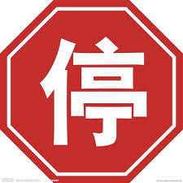  What is the meaning of the sign above?  - Danger  - Go  - Slow  - Stop  Correct Answer: D

Reporting Category | Modes of Communication
Standard | Interpretive Reading
Benchmark Number | WL.K12.NH.2.4
Benchmark | Identify key detailed information needed to fill out forms.
Item Types | Selected Response
Cognitive Complexity Level | Moderate
Benchmark Clarification | The student will engage with the text while employing learned target language reading strategies and identify vocabulary necessary to filling out forms.
Content Focus | Identifying key information commonly solicited on forms.
Content Limits | Key information may include, but not be limited to, details such as name, birth date, city and state.
Stimulus Attributes | A stimulus should be appropriate in length and pace to the Proficiency Level:  - written text
Distractor Attributes | Distractors may include, but are not limited to:  - responses that are common misconceptions
Sample Item | Supposed you are 王小文, you are a girl and 15 years old. Red is your favorite color. You want to fill out the survey form for Chinese club.  名字 年龄 性别 你喜欢什么颜色？  Which of the following is the best answer to complete the form?  - 王小文，五十，女，红色  - 王小文, 十五岁,女，红色  - 王小文，十五，男，红色  - 王小文，五十，女，红色  Correct Answer: B

Reporting Category | Modes of Communication
Standard | Interpersonal Communication
Benchmark Number | WL.K12.NH.3.1
Benchmark | Engage in short social interactions using phrases and simple sentences.
Item Types | Selected Response, Written Response
Cognitive Complexity Level | Moderate, High
Benchmark Clarification | The student will use simple sentences and phrases to engage in short social interactions.
Content Focus | The student will engage in social interactions.
Content Limits | The content may include, but is not limited to, simple interactions using familiar vocabulary and phrases.
Stimulus Attributes | A stimulus should be appropriate in length and pace to the Proficiency Level:  - photographs (color, black and white)  - illustrations (color, black and white)  - video or audio segment
Distractor Attributes | Distractors may include, but are not limited to:  - responses that are not related to phrases and simple sentences  - responses that are common misconceptions

Sample Item | You are in the shopping center and planning to buy some outfits for yourself. You have the following conversation with the sales associate.  - 你好，你要买什么？  - 我想买一件上衣。  - 你想要买什么颜色的上衣。  - _____________.  Which of the following answer choices best completes this conversation?  - 我不喜欢蓝色的裤子  - 我想买蓝色的裤子  - 我不喜欢蓝色的上衣  - 我想买蓝色的上衣  Correct Answer: D

Reporting Category | Modes of Communication
Standard | Interpersonal Communication
Benchmark Number | WL.K12.NH.3.2
Benchmark | Exchange information about familiar tasks, topics, and activities including personal information.
Item Types | Audio Response
Cognitive Complexity Level | Low, Moderate
Benchmark Clarification | The student will exchange information about familiar tasks, topics and activities.
Content Focus | Orally exchange information with others.
Content Limits | The content may include, but is not limited to topics centering on every day, familiar subjects.
Stimulus Attributes | A stimulus should be appropriate in length and pace to the Proficiency Level:  - photographs (color, black and white)  - illustrations (color, black and white)  - video or audio segment
Distractor Attributes | Distractors may include, but are not limited to:  - responses that do not relate to exchanging information about familiar tasks, topics, activities  - responses that relate to common misconceptions/ misunderstandings

Sample Item | Two students are talking about the class schedule. Read the following conversation and select the correct answer to the question.  A: 你今天上了什么课？(C/M)  B: 今天是星期三。我上午有英文，历史，数学。下午上了中文。  A: 你每天 (everyday) 的课都不一样吗？  B: 对，我一，三的课一样，二，四的课一样，但是星期五的课不一样。  What classes does the person have on Monday?  - English, history, math, and Chinese  - English, history, math, and Spanish  - English, science, math, and Chinese  - They do not have any classes on Monday.  Correct Answer: B

Reporting Category | Modes of Communication
Standard | Interpersonal Communication
Benchmark Number | WL.K12.NH.3.3
Benchmark | Exchange information using simple language about personal preferences, needs, and feelings.
Item Types | Written Response
Cognitive Complexity Level | Moderate
Benchmark Clarification | The student will use simple language to exchange information about personal likes and dislikes in a dialogue.
Content Focus | Converse about personal likes and dislikes.
Content Limits | The content may include, but is not limited to expressing personal opinion related to likes and dislikes, needs, and feelings of everyday life using familiar vocabulary and expressions; content does not include advanced idiomatic expressions such as “raining cats and dogs.”
Stimulus Attributes | A stimulus should be appropriate in length and pace to the Proficiency Level:  - photographs (color, black and white)  - illustrations (color, black and white)  - video or audio segment
Distractor Attributes | Distractors may include, but are not limited to:  - responses that do not relate to exchanging information about personal likes and dislikes  - responses that relate to common misconceptions

Sample Item | There are two people talking about their favorite colors. Their conversations is as follows:  A: 你喜欢不喜欢蓝色？  B: 喜欢，蓝色是我最喜欢的颜色。你呢？  A: 我喜欢很多颜色，有红色，黄色和白色。白色是我最喜欢的颜色。  B: 蓝色呢？你今天穿了蓝色的裙子。  A: ____________  Which of the following answer choices best completes this conversation?  - 蓝色是我妈妈最喜欢的颜色，我不喜欢蓝色。  - 蓝色是我妈妈最喜欢的颜色，我不要穿蓝色的裙子。  - 蓝色是我妈妈最喜欢的颜色，我不喜欢穿蓝色的裙子。  - 蓝色是我妈妈最喜欢的颜色，我没有穿蓝色的裙子。  Correct Answer: A

Reporting Category | Modes of Communication
Standard | Interpersonal Communication
Benchmark Number | WL.K12.NH.3.4
Benchmark | Ask and answer a variety of questions about personal information.
Item Types | Audio Response
Cognitive Complexity Level | Moderate
Benchmark Clarification | The student will ask and answer question about personal information.
Content Focus | Converse about personal information.
Content Limits | Students are limited by their depth of knowledge of vocabulary and syntax, as well as by their speaking and listening in the target language.
Stimulus Attributes | A stimulus should be appropriate in length and pace to the Proficiency Level:  - photographs (color, black and white)  - illustrations (color, black and white)  - video or audio segment
Distractor Attributes | None Specified

Sample Item | Today is your first day in school. You would like to communicate with your new classmates.  A: 你好！我叫李大中。你叫什么名字？  B: 你好！我叫白大卫。 你多大？  A: 我十二岁。  B: 我也十二岁。你的生日是几月几号？  A: ___________  Which of the following answer choices best completes this conversation?  - 我十四岁  - 我上七年级  - 她的生日是五月四号  - 我的生日是五月四号  Correct Answer: D

Reporting Category | Modes of Communication
Standard | Interpersonal Communication
Benchmark Number | WL.K12.NH.3.5
Benchmark | Exchange information about meeting someone, including where to go, how to get there, what to do, and why.
Item Types | Written Response
Cognitive Complexity Level | Moderate
Benchmark Clarification | The student will exchange information about meeting someone.
Content Focus | Converse about meeting someone.
Content Limits | The content may include, but is not limited to familiar vocabulary and expressions related to topics about school and leisure time activities.
Stimulus Attributes | A stimulus should be appropriate in length and pace to the Proficiency Level:  - photographs (color, black and white)  - illustrations (color, black and white)  - video or audio segments
Distractor Attributes | Distractors may include, but are not limited to:  - responses that do not relate to meeting someone  - responses that relate to common misconceptions

Sample Item | Today is Sunday. You want to go to the park with your big brother. You have the following conversation with him:  A: 今天是星期天，你想要做什么？  B: 我喜欢动物，我想要去_______.  A: 我们怎么去________?  B: 我们____________.  Which of the following answer choices best completes this conversation?  - 公园；公园；骑车去公园  - 商店；商店；骑车去商店  - 公园；商店；骑车去商店  - 商店；公园；骑车去公园  Correct Answer: A

Reporting Category | Modes of Communication
Standard | Interpersonal Communication
Benchmark Number | WL.K12.NH.3.7
Benchmark | Ask for and give simple directions to go somewhere or to complete a task.
Item Types | Audio Response
Cognitive Complexity Level | Moderate
Benchmark Clarification | The student will ask for and give simple directions to go somewhere or complete a task.
Content Focus | Give directions.
Content Limits | May include, but not limited to asking for and giving simple directions.
Stimulus Attributes | A stimulus should be appropriate in length and pace to the Proficiency Level:  - photographs (color, black and white)  - illustrations (color, black and white)  - video or audio segment
Distractor Attributes | None Specified

Sample Item | You were planning to go to Dahuan Middle School, but you are lost and do not know where to go. You have the following conversation with a person nearby:  A: __________________  B: 一直往东走，到公园路就到了。  Which of the following answer choices best completes this conversation?  - 请问，大华小学怎么走  - 请问，大华中学怎么走  - 请问，大华高中怎么走  - 请问，大华大学怎么走  Correct Answer: B

Reporting Category | Modes of Communication
Standard | Presentational Speaking
Benchmark Number | WL.K12.NH.4.1
Benchmark | Provide basic information on familiar topics using phrases and simple sentences.
Item Types | Audio Response
Cognitive Complexity Level | Moderate
Benchmark Clarification | The student will provide information on a given topic using standard phrases and simple, grammatically correct sentences.
Content Focus | Provide basic information.
Content Limits | Content may include, but is not limited to, familiar topics such as the cultures represented by the students themselves and the target language, their daily lives, and basic physical surroundings. A scenario may be presented to provide structure for the response.
Stimulus Attributes | A stimulus should be appropriate in length and pace to the Proficiency Level:  - written text  - written prompt in English  - illustrations  - audio prompt  - video prompt
Distractor Attributes | None Specified

Sample Item | Task  Introduce yourself with a brief statement in Chinese.  Rubric  Score Point 2 Good Fluency—accurate pronunciation of individual sounds; natural speech rate, intonation, and rhythm. Response is linguistically accurate—no or very few minor phonemic/phonetic or grammatical errors.  Score Point 1 Some Fluency—some problems with pronunciation of individual sounds, speech rate, intonation, and rhythm, but these do not cause serious problems in intelligibility. Response contains several linguistic errors—phonemic/phonetic or grammatical.  Score Point 0 No Fluency with insufficient information to score or unintelligible.  Sample Answer:  “我叫John。我姓Smith。我是学生。”

Reporting Category | Modes of Communication
Standard | Presentational Speaking
Benchmark Number | WL.K12.NH.4.2
Benchmark | Describe aspects of daily life using complete sentences.
Item Types | Audio Response
Cognitive Complexity Level | Moderate
Benchmark Clarification | The student will describe the aspects of daily life using grammatically correct, complete sentences.
Content Focus | Describe daily life.
Content Limits | Topics include culturally based situations that do not involve an extensive or detailed knowledge of the target language culture and may include daily life, such as what the student does or what a student in another culture does at home, in school, or for leisure activities.
Stimulus Attributes | A stimulus should be appropriate in length and pace to the Proficiency Level:  - written text  - illustrations  - audio prompt  - video prompt
Distractor Attributes | None Specified

Sample Item | Task:  Talk about your family in Chinese using brief sentences.  Rubrics:  Score Point 2 Good Fluency—accurate pronunciation of individual sounds; natural speech rate, intonation, and rhythm. Response is linguistically accurate—no or very few minor phonemic/phonetic or grammatical errors.  Score Point 1 Some Fluency—some problems with pronunciation of individual sounds, speech rate, intonation, and rhythm, but these do not cause serious problems in intelligibility. Response contains several linguistic errors—phonemic/phonetic or grammatical.  Score Point 0 No Fluency with insufficient information to score or unintelligible.  Sample Response:  “我家有四口人：我爸爸、我妈妈、我姐姐和我。我爸爸是老师。 我妈妈是律师。我姐姐和我是学生。”

Reporting Category | Modes of Communication
Standard | Presentational Speaking
Benchmark Number | WL.K12.NH.4.4
Benchmark | Present personal information about one’s self and others.
Item Types | Audio Response
Cognitive Complexity Level | Low, Moderate
Benchmark Clarification | The student will present information about themselves and others.
Content Focus | Present personal information.
Content Limits | Content should emphasize personal information such as age, physical description, personality characteristics, individual style preferences and interests, and preferences in friends and relations.
Stimulus Attributes | A stimulus should be appropriate in length and pace to the Proficiency Level:  - photographs (color, black and white)  - illustrations (color, black and white)  - 10- to 30-second video or audio segment
Distractor Attributes | None Specified

Sample Item | Task:  Introduce your friend in Chinese using brief sentences.  Rubric:  Score Point 2 Good Fluency—accurate pronunciation of individual sounds; natural speech rate, intonation, and rhythm. Response is linguistically accurate—no or very few minor phonemic/phonetic or grammatical errors.  Score Point 1 Some Fluency—some problems with pronunciation of individual sounds, speech rate, intonation, and rhythm, but these do not cause serious problems in intelligibility. Response contains several linguistic errors—phonemic/phonetic or grammatical.  Score Point 0 No Fluency with insufficient information to score or unintelligible.  Sample Response:  “我有一个好朋友。他叫James。他十六岁。他是学生。”

Reporting Category | Modes of Communication
Standard | Presentational Writing
Benchmark Number | WL.K12.NH.5.1
Benchmark | Write descriptions and short messages to request or provide information on familiar topics, using phrases and simple sentences.
Item Types | Written Response
Cognitive Complexity Level | Low, Moderate
Benchmark Clarification | The student will write descriptions and short messages to request or provide information on familiar topics, using phrases and simple sentences.
Content Focus | Write descriptions and messages.
Content Limits | Content may include, but is not limited to, previously learned familiar topics such as school, family, café food, or activities.
Stimulus Attributes | A stimulus should be appropriate in length and pace to the Proficiency Level:  - writing prompt
Distractor Attributes | None Specified

Sample Item | Task:  Write in several Chinese sentences about yourself, your friend, or your family.  Rubric:  Score Point 2 Good Fluency— Response is linguistically accurate—no or very few minor grammatical errors. Response is on the topic and conveys the meaning clearly.  Score Point 1 Some Fluency— Response contains several errors in grammar or spelling. However, response conveys meaning successfully to answer the question.  Score Point 0 No Fluency with insufficient information to score or unintelligible.  Sample Response:  “我家有五口人。我爸爸、我妈妈、我姐姐、我弟弟和我。我爸爸是老师。我妈妈是医生。我姐姐是大学生。我弟弟和我都是学生。”

Reporting Category | Modes of Communication
Standard | Presentational Writing
Benchmark Number | WL.K12.NH.5.2
Benchmark | Write simple statements to describe aspects of daily life.
Item Types | Written Response
Cognitive Complexity Level | Moderate
Benchmark Clarification | The student will write about daily life, using simple statements.
Content Focus | Writing simple statements
Content Limits | Content may include, but is not limited to, communicating what students do on a daily basis; describing what they do during a certain time of day; explaining what they do during a specific class or at school; and describing what they do to prepare for school or at home after school.
Stimulus Attributes | A stimulus should be appropriate in length and pace to the Proficiency Level:  - writing prompt
Distractor Attributes | None Specified

Sample Item | Task:  Write several Chinese sentences about activities you would like to do over the weekend.  Rubric:  Score Point 2 Good Fluency— Response is linguistically accurate—no or very few minor grammatical errors. Response is on the topic and conveys the meaning clearly.  Score Point 1 Some Fluency— Response contains several errors in grammar or spelling. However, response conveys meaning successfully to answer the question.  Score Point 0 No Fluency with insufficient information to score or unintelligible.  Sample Response:  “我喜欢打球。我的哥哥也喜欢打球。我周末常常和哥哥一起去打球。”

Reporting Category | Modes of Communication
Standard | Presentational Writing
Benchmark Number | WL.K12.NH.5.3
Benchmark | Write a description of a familiar experience or event.
Item Types | Written Response
Cognitive Complexity Level | Modern
Benchmark Clarification | The student will write about a familiar experience or event from the students’ personal experience.
Content Focus | Use descriptive writing.
Content Limits | Content may include, but is not limited to, school, family, friends, vacation time, and school events.
Stimulus Attributes | A stimulus should be appropriate in length and pace to the Proficiency Level:  - writing prompt
Distractor Attributes | None Specified.

Sample Item | Task:  Visiting someone’s house can be fun. Write a several sentences, in Chinese, about a recent visit you had to a friend’s house.  Rubric:  Score Point 2 Good Fluency— Response is linguistically accurate—no or very few minor grammatical errors. Response is on the topic and conveys the meaning clearly.  Score Point 1 Some Fluency— Response contains several errors in grammar or spelling. However, response conveys meaning successfully to answer the question.  Score Point 0 No Fluency with insufficient information to score or unintelligible.  Sample Response:  “今天我去我的朋友家。我的朋友叫Emmy。她的家很大。我们一起聊天。我晚上八点才回家。”

Reporting Category | Modes of Communication
Standard | Presentational Writing
Benchmark Number | WL.K12.NH.5.5
Benchmark | Request information in writing to obtain something needed.
Item Types | Written Response
Cognitive Complexity Level | Moderate
Benchmark Clarification | The student will request information in writing to obtain something needed.
Content Focus | Request information.
Content Limits | Content may include, but is not limited to school, family, after school activities, and other familiar topics.
Stimulus Attributes | A stimulus should be appropriate in length and pace to the Proficiency Level:  - writing prompt
Distractor Attributes | None Specified

Sample Item | Task:  You would like to make an appointment with your friend to do a joint activity such as watching a movie or playing a game of basketball. Write a text message in Chinese to your friend asking what time they are available.  Rubric:  Score Point 2 Good Fluency— Response is linguistically accurate—no or very few minor grammatical errors. Response is on the topic and conveys the meaning clearly.  Score Point 1 Some Fluency— Response contains several errors in grammar or spelling. However, response conveys meaning successfully to answer the question.  Score Point 0 No Fluency with insufficient information to score or unintelligible.  Sample Item:  “你好，小李。我想请你一起去看电影，怎么样？你什么时候有空？ 小王”

Reporting Category | Modes of Communication
Standard | Presentational Writing
Benchmark Number | WL.K12.NH.5.6
Benchmark | Prepare a draft of an itinerary for a personal experience or event (such as for a trip to a country where the target language is spoken).
Item Types | Written Response
Cognitive Complexity Level | Moderate
Benchmark Clarification | The student will prepare a draft of an itinerary for a personal experience or event.
Content Focus | Draft an itinerary.
Content Limits | Content may include, but is not limited to, travel plans, detailed personal life events, health events, birthday and activity planning, appropriate time markers, and every day events.
Stimulus Attributes | A stimulus should be appropriate in length and pace to the Proficiency Level:  - writing prompt  - illustration or graphic
Distractor Attributes | None Specified

Sample Item | The following is an itinerary for a flight to Shanghai to Beijing.  出发航班  日期 ?  航空公司 中国东方航空公司  航班号 MU 5151  出发地 上海  出发时间 上午8：30  到达地 北京  到达时间 上午10：40  登机口 46  Which of the following is the travel date of July 3rd, 2015 of the above itinerary?  - 7月3日2015年  - 2015年3日7月  - 2015年3月7日  - 2015年7月3日  Correct Answer: D

Reporting Category | Intercultural Standards
Standard | Culture
Benchmark Number | WL.K12.NH.6.1
Benchmark | Recognize basic practices and perspectives of cultures where the target language influences personal decision making.
Item Types | Selected Response
Cognitive Complexity Level | Low
Benchmark Clarification | The student will recognize basic similarities and/or differences between characteristics of practices and perspectives within the target language as compared to his/her own and will recognize how this understanding influences their personal perspectives and decisions.
Content Focus | Demonstrate fundamental cultural beliefs, practices and/or traditions.
Content Limits | The content may include, but it is not limited to, common or contrasting cultural behaviors, practices, traditions and/or perspectives of the target language and his/her own American culture.
Stimulus Attributes | A stimulus should be appropriate in length and pace to the Proficiency Level:  - photographs (color, black and white)  - illustrations (color, black and white)  - literary or historical documents  - video or audio segment
Distractor Attributes | Distractors may include, but are not limited to:  - responses that do not relate to correct interpretations, relationships or details  - responses that relate to common misconceptions

Sample Item | There is a Chinese festival that is similar to Thanksgiving. It is an occasion when all family members gather together to celebrate harvest. Which of the following is the name of the festival?  - 中秋节, Moon Festival  - 元宵节, Lantern Festival  - 清明节, Qingming Festival  - 重阳节, Chongyang Festival  Correct Answer: A

Reporting Category | Intercultural Standards
Standard | Culture
Benchmark Number | WL.K12.NH.6.2
Benchmark | Identify examples of common beliefs and attitudes and their relationship to practices in the cultures studied.
Item Types | Selected Response
Cognitive Complexity Level | Low, Moderate
Benchmark Clarification | The student will identify examples of common beliefs and values and how these cultural characteristics influence behaviors.
Content Focus | Identify common cultural beliefs, attitudes and behaviors.
Content Limits | The content may include, but is not limited to, examples of cultural beliefs and/or attitudes common to the culture and how these attributes are demonstrated though various practices.
Stimulus Attributes | A stimulus should be appropriate in length and pace to the Proficiency Level:  - photographs (color, black and white)  - illustration (color, black and white)  - literary or historical documents  - video or audio segment
Distractor Attributes | Distractors may include, but are not limited to:  - responses that do not relate to correct interpretations, relationships or details  - responses that are common misconceptions
Sample Item | The Chinese people put great emphasis on showing respect to others. Which of the following is the most appropriate and polite Chinese expression to ask for people’s last name?  - 你姓什么？  - 请问，你贵姓？  - 请问，您贵姓？  - 你叫什么名字？  Correct Answer: C

Reporting Category | Intercultural Standards
Standard | Culture
Benchmark Number | WL.K12.NH.6.3
Benchmark | Recognize different contributions from countries where the target language is spoken and how these contributions impact our global society (e.g., food, music, art, sports, recreation, famous international figures, movies, etc.).
Item Types | Selected Response
Cognitive Complexity Level | Low, Moderate
Benchmark Clarification | The student will be able to distinguish various contributions of the target language culture and will understand how these contributions impact global community (e.g., food, music, art, sports, recreation, famous international figures, movies, etc.).
Content Focus | Understand contributions to the global community.
Content Limits | The content may include, but is not limited to, food, music, art, sports, inventions, famous international figures, movies, and so on.).
Stimulus Attributes | A stimulus should be appropriate in length and pace to the Proficiency Level:  - photographs (color, black and white)  - illustration (color, black and white)  - literary or historical documents  - video or audio segment
Distractor Attributes | Distractors may include, but are not limited to:  - responses that do not relate to correct interpretations, relationships or details  - responses that are common misconceptions

Sample Item | Read the following statement in Chinese:  我喜欢吃中国菜。我喜欢吃饺子。我爸爸和妈妈也喜欢吃中国菜。  What aspect of Chinese contributions (e.g. food, music, sports, movies, etc,) is it about?  - food  - movies  - music  - sports  Correct Answer: A

Reporting Category | Intercultural Standards
Standard | Culture
Benchmark Number | WL.K12.NH.6.4
Benchmark | Identify cultural artifacts, symbols and images of the target culture(s).
Item Types | Selected Response
Cognitive Complexity Level | Low, Moderate
Benchmark Clarification | The student will identify cultural objects, artifacts, manufactured items, symbols, or images created by members of the target culture.
Content Focus | Identify cultural products.
Content Limits | The content may include, but is not limited to, authentic goods, services, identifiable artifacts, symbols or images which are relevant to the target culture.
Stimulus Attributes | A stimulus should be appropriate in length and pace to the Proficiency Level:  - photographs (color, black and white)  - illustration (color, black and white)  - literary or historical documents  - video or audio segment
Distractor Attributes | Distractors may include, but are not limited to:  - responses that do not relate to correct interpretations, relationships or details  - responses that relate to common misconceptions

Sample Item | 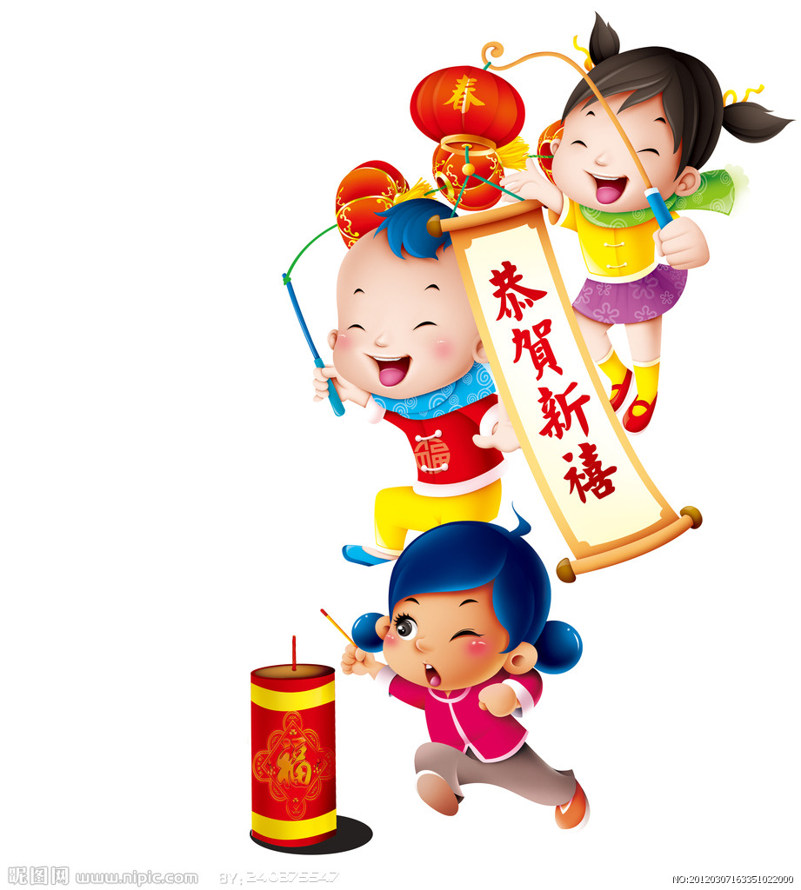  这是小王。她是女孩。  这是小王的照片。她和朋友一起过新年，庆祝春节。  According to the Chinese words and picture illustration, what is Xiao Wang（小王）doing?  - celebrating New Year  - playing hide and seek game  - playing a soccer game  - watching a Chinese movie  Correct Answer: A

Reporting Category | Intercultural Standards
Standard | Connections
Benchmark Number | WL.K12.NH.7.1
Benchmark | Use vocabulary acquired in the target language to access new knowledge from other disciplines.
Item Types | Audio Response, Written Response
Cognitive Complexity Level | Low, Moderate
Benchmark Clarification | Use target-language vocabulary to comprehend subject matter and new information from other disciplines.
Content Focus | Access information.
Content Limits | Content may include, but is not limited to cross-curricular subjects including but not limited to English, Mathematics, Music, Science, and Social Studies as well as extracurricular activities and sports.
Stimulus Attributes | A stimulus should be appropriate in length and pace to the Proficiency Level:  - literary or informational texts  - photographs (color, black and white)  - illustrations with captions, graphics, charts, etc. (color, black and white)  - two- to three-minute video segment  - two- to three-minute audio segment
Distractor Attributes | None Specified

Sample Item | Read the below mathematical equation.  34 – 25 = 9  What is the correct answer, in Chinese, for the equation of 34 minus 25?  - 四  - 七  - 九 (correct answer)  - 十  Correct Answer: C

Reporting Category | Intercultural Standards
Standard | Comparisons
Benchmark Number | WL.K12.NH.8.3
Benchmark | Compare and contrast specific cultural traits of the target culture and compare to own culture (typical dances, food, celebrations, etc.).
Item Types | Selected Response
Cognitive Complexity Level | High
Benchmark Clarification | The student will describe similarities or differences in cultural traits or traditions between the target culture and U.S. culture.
Content Focus | Compare and contrast cultural traits and traditions.
Content Limits | Content may include, but is not limited to, cultural traits and traditions such as typical dances, food, and celebrations.
Stimulus Attributes | A stimulus should be appropriate in length and pace to the Proficiency Level:  - written passage  - video/audio segment  - photographs (color, black and white)  - illustrations (color, black and white)
Distractor Attributes | Distractors may include, but are not limited to:  - responses that do not relate to comparing and contrasting cultural traits and traditions  - responses that relate to common misconceptions
Sample Item | Mash potatoes and bread are considered basic foods in American cuisine. What is the equivalent in Chinese cuisine?  - 炒饭和鸡肉, fried rice and chicken  - 土豆和炒饭, potation and fried rice  - 米饭和面条, rice and noodles  - 米饭和土豆, rice and potato  Correct answer: C

Reporting Category | Intercultural Standards
Standard | Communities
Benchmark Number | WL.K12.NH.9.1
Benchmark | Use key target language vocabulary to communicate with others within and beyond the school setting.
Item Types | Written Response
Cognitive Complexity Level | High
Benchmark Clarification | The student will use target language to communicate with others outside the target language classroom but inside or outside the school setting.
Content Focus | Communicate with others in the target language.
Content Limits | Content may include, but is not limited to communication with adults and peers within the school and community.
Stimulus Attributes | A stimulus should be appropriate in length and pace to the Proficiency Level:  - written texts  - illustrations  - photographs  - video segment  - audio segment  - electronic documentation
Distractor Attributes | None Specified

Sample Item | The following conversation is between Tom and Ann. They are talking about their weekend plans.  Tom: 你好！你周末喜欢做什么？  Ann: 我喜欢打球。  Tom: 我也喜欢打球！  Ann: 这个星期六我们一起打球，怎么样？  Tom: 太好了！星期六见。  What are they going to do together this coming Saturday?  - listen to music  - play ball  - read books  - watch a movie  Correct Answer: B

