Central Florida Assessment Collaborative
Individual Test Item Specifications
Zoology
2014

The contents of this document were developed under a grant from the United States Department of Education. However, the content does not necessarily represent the policy of the United States Department of Education, and you should not assume endorsement by the federal government.
Table of Contents

I. Guide to the Individual Benchmark Specifications 1
Benchmark Classification System 1
Definitions of Benchmark Sp ecifications 3
II. Individual Benchmark Specifications 4

I. Guide to the Individual Benchmark Specifications

Content specific guidelines are given in the Individual Benchmark Specifications for each course. The Specifications contains specific information about the alignment of items with the NGSSS and the Florida Standards. It identifies the manner in which each benchmark is assessed, provides content limits and stimulus attributes for each benchmark, and gives specific information about content, item types, and response attributes.

Benchmark Classification System
Each NGSSS benchmark is labeled with a system of letters and numbers.
- The two letters in the first position of the label identify the Subject Area.
- The number(s) in the second position represents the Grade Level.
- The letter in the third position represents the Strand or Body of Knowledge.
- The number in the fourth position represents the Standard.
- The number in the last position identifies the specific Benchmark.

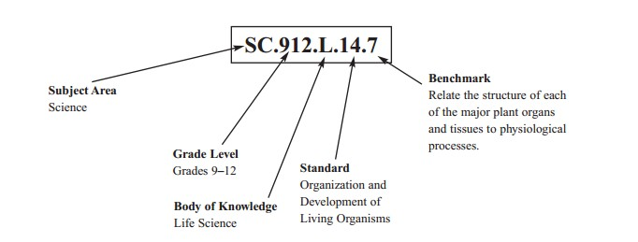

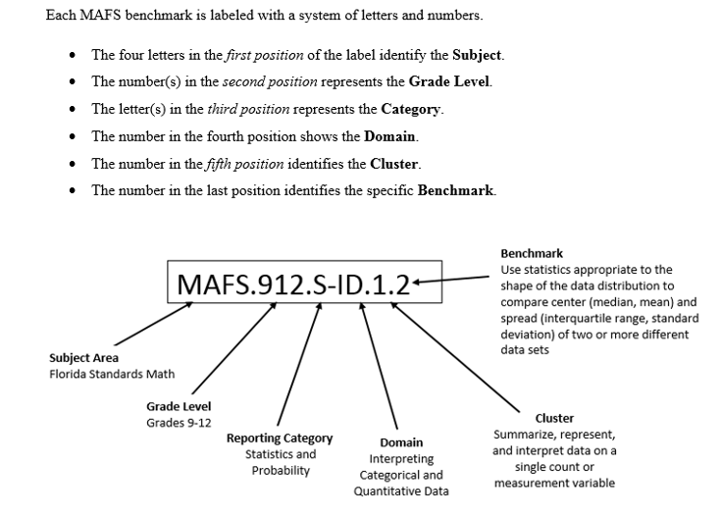

Definitions of Benchmark Specifications
The Individual Benchmark Specifications provides standard-specific guidance for assessment item development for CFAC item banks. For each benchmark assessed, the following information is provided:
 | Reporting Category |  | is a grouping of related benchmarks that can be used to summarize and report achievement.
 | Standard |  | refers to the standard statement presented in the NGSSS or in the Florida Standards.
 | Benchmark  Also Assesses |  | refers to the benchmark statement presented in the NGSSS or standard statement in the Florida Standards. In some cases, two or more related benchmarks are grouped together because the assessment of one benchmark addresses another benchmark. Such groupings are indicated in the Also Assesses statement.  refers to the benchmarks that are closely related to the benchmark (see description above)
 | Item Types  Cognitive  Complexity |  | are used to assess the benchmark or group of benchmark.  ideal level at which item should be assessed.
 | Benchmark Clarifications |  | explain how achievement of the benchmark will be demonstrated by students. In other words, the clarification statements explain what the student will do when responding to questions.
 | Content Limits |  | define the range of content knowledge and that should be assessed in the items for the benchmark.
 | Stimulus Attributes |  | define the types of stimulus materials that should be used in the items, including the appropriate use of graphic materials and item context or content.
 | Response Attributes  Content Focus |  | define the characteristics of the answers that a student must choose or provide.  defines the content measured by each test item. Content focus addresses the broad content and skills associated with the examples found in the standards, benchmarks, or benchmark clarifications.
 | Sample Items |  | are provided for each type of question assessed. The Correct Answer for all sample items is provided.

II. Individual Benchmark Specifications

Reporting Category | Nature of Science
Standard | Practice of Science
Benchmark Number | SC.912.N.1.2
Benchmark | Describe and explain what characterizes science and its methods.
Also Assesses | MAFS.K12.MP.3
Item Types | Selected Response, Performance Task
Cognitive Complexity | Low, Moderate, High
Benchmark  Clarifications | Students will explain the main steps in the scientific method.  Students will describe how observations are used to create hypotheses and how data is used to draw conclusions.  Students will identify the elements of a controlled experiment.
Content Limits | Limited to biological content and scientific statements.
Stimulus Attributes | May include charts, diagrams, models, and tables.
Response Attributes | None Specified
Content Focus | Items will focus real science versus psuedo-science, scientific method, purpose of science.
Sample Item | An osmosis investigation was conducted using chicken eggs to represent cells with semipermeable membranes. The eggs were first soaked in vinegar to dissolve the shell. The mass of each egg was measured. Each egg was then placed in one of three different solutions for 24 hours before the mass of each egg was measured again. The table below shows the results of the investigation.  Based on this experiment, what is the hypothesis being tested?  A. Substances other than water may also cross the cell membrane.  B. Substances other than water may block pores in the cell  membrane.  C. Water enters the cell when placed in environments  of high water concentration.  D. Water leaves the cell when placed in environments with a  low concentration of solutes.  Correct Answer: C
  Solution | Vinegar (95% water) | Corn Syrup  (5% water) | Distilled Water  (100% water)
  1) Average Mass of Eggs Before Soaking (grams) | 71.2 | 98.6 | 64.5
  2) Average Mass of Eggs After Soaking (grams) | 98.6 | 64.5 | 105.3
  3) Difference in Average Mass (grams) | 27.4 | 34.1 | 40.8
  4) Percent Change in Average Mass (%) | +38.5 | -34.6 | +63.3

Reporting Category | Molecular & Cellular Biology
Standard | Organization & Development of Living Organisms
Benchmark Number | SC.912.L.14.1
Benchmark | Describe the scientific theory of cells (cell theory) and relate the history of  its discovery to the process of science.
Also Assesses | SC.912.N.1.3, SC.912.N.3.1, SC.912.N.3.4, SC.912.L.14.4
Item Types | Selected Response, Short Response
Cognitive Complexity | Moderate
Benchmark  Clarification | Students will describe and/or explain the cell theory.  Students will describe how continuous investigations and/or new scientific information influenced the development of the cell theory.  Students will also be able to explain the development of a theory.  Students will recognize the differences between theories and laws.
Content Limits | Items may assess how contributions of scientists such as Van Leeuwenhoek, Hooke, Schwann, Schleiden, and/or Virchow aided in the development of the cell theory and what each scientist contributed.  Items assessing a scientific claim, the development of a theory, or the differences between theories and laws are limited to the cell theory.  Items regarding microscopes are limited to how the invention of the microscope contributed to the development of cell theory.
Stimulus Attributes | May include text content, diagrams, or graphs of a cell's life cycle.
Response Attributes | One choice includes principles from the cell theory while the other choices  include information that does not support the cell theory.
Content Focus | Cell theory and differences between theories and laws in science.
Sample Item | The following observations were recorded in a biology lab.  - Porifera use specialized cells called choanocytes to move water.  - Porifera do not exhibit cephalization.  III. Porifera are sessile.  - Porifera reproduce sexually when haploid gametes are  produced by meiosis.  Which observations support the cell theory?  A. I and III only  B. II and III only  C. I and IV only  D. III and IV only  Correct Answer: C

Reporting Category | Molecular & Cellular Biology
Standard | Organization & Development of Living Organisms
Benchmark Number | SC.912.L.14.3
Benchmark | Compare and contrast the general structures of plant and animal cells.  Compare and contrast the general structures of prokaryotic and eukaryotic cells.
Also Assesses | SC.912.L.14.2; SC.912.L.14.5
Item Types | Selected Response
Cognitive Complexity | Low, Moderate
Benchmark  Clarification | Students will compare and/or contrast the structures found in plant cells and in animal cells.  Students will compare and/or contrast the structures found in prokaryotic cells and in eukaryotic cells.  Students will describe how structures in cells are directly related to their function in the cell.  Students will explain the role of the cell membrane during active and passive transport.
Content Limits | Items will not address protists or fungi or assess cellular structures unique to protists or fungi.  Items referring to prokaryotic structures are limited to the cell wall, cell membrane (plasma membrane) cytoplasm, plasmid, ribosomes, and flagella.  Items referring to eukaryotic structures are limited to the cell wall, cell membrane (plasma membrane), cytoplasm, nucleus, nuclear envelope, nucleolus, chromatin, ribosomes, endoplasmic reticulum, microtubules, microfilaments, vacuoles, mitochondria, Golgi apparatus, chloroplasts, lysosomes, cilia, and flagella.  Items referring to the role of the cell membrane may address hypotonic, hypertonic, and/or isotonic solutions based on processes not terminology.  Functions of specific types of cells will not be described.
Stimulus Attributes | May include diagrams.
Response Attributes | None Specified
Content Focus | Comprehensive understanding of each cell organelle's function will be exhibited. Cell organelles students will be expected to discuss may be as follows: Cell wall, cell membrane, mitochondria, ribosome, endoplasmic reticulum, golgi body/apparatus, vacuole, cytoplasm, cytoskeleton.
Sample Item | Prokaryotic cells do not contain which structures?  A. cell membrane  B. cell wall  C. mitochondria  D. ribosomes  Correct Answer: C

Reporting Category | Molecular & Cellular Biology
Standard | Organization & Development of Living Organisms
Benchmark Number | SC.912.L.14.12
Benchmark | Describe the anatomy and histology of bone tissue.
Also Assesses | LAFS.910.2.2.3
Item Types | Selected Response
Cognitive Complexity | Low, Moderate
Benchmark  Clarification | Students will identify parts of a long bone; students will describe the four types of cells present in bone tissue; students will distinguish between compact and spongy bone tissue.
Content Limits | Items are limited to identifying the epiphysis, metaphysis, diaphysis,  articular cartilage, spongy bone, epiphyseal line (plate), endosteum, compact bone, periosteum, medullary (marrow) cavity.  Descriptions of bone cells are limited to osteogenic cells, osteoblasts, osteocytes, and osteoclasts.  Items may not address blood and nerve supply, skeletal function, bone formation, bone growth, or bone homeostasis in isolation.
Stimulus  Attributes | May include diagrams or illustrations.
Response  Attributes | None Specified
Content Focus | Students will be able to identify the parts of a bone. Parts of the bone covered may include: compact bone, spongy bone, red marrow, yellow marrow, periosteum, red blood cells.
Sample Item | Which of the following is produced by bone marrow?  A. spongy bone  B. calcium  C. red blood cells  D. compact bone  Correct Answer: C

Reporting Category |  | Life Science
Standard |  | Organization & Development of Living Organisms
Benchmark Number |  | SC.912.L.14.26
Benchmark |  | Identify the major parts of the brain on diagrams or models.
Also Assesses |  | MAFS.K12.MP.4
Item Types |  | Selected Response
Cognitive Complexity |  | Moderate
Cognitive Complexity Levels |  | Low, Moderate
Benchmark  Clarification |  | Students will identify the major parts of the brain on diagrams.
Content Limits |  | Items are limited to identifying the cerebrum, cerebellum, pons, medulla oblongata, brain stem, frontal lobe, parietal lobe, occipital lobe, and temporal lobe.  Items will not assess the functions of the major parts of the brain.
Stimulus Attributes |  | May include illustrations or diagrams.
Response Attributes |  | Diagram of brain with sections labeled.
Content Focus |  | Items will focus on use of a diagram to illustrate knowledge of the parts of the brain.
Sample Item | The illustration below shows four lobes of the human brain.  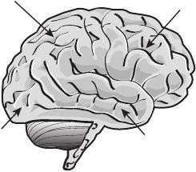  2 3  1  4  Which lobe is designated by label 2?  - frontal  - occipital  - parietal  - temporal  Correct Answer: C

Reporting Category | Life Science
Standard | Organization & Development of Living Organisms
Benchmark Number | SC.912.L.14.36
Benchmark | Describe the factors affecting blood flow through the cardiovascular system.
Also Assesses | Requires previous knowledge from SC.6.L.14.5
Item Types | Selected Response, Short Response
Cognitive Complexity | Moderate
Benchmark  Clarification | Students will identify factors that affect blood flow and/or describe how these factors affect blood flow through the cardiovascular system.
Content Limits | Students will not describe the actual cardiovascular system in this item.
Stimulus Attributes | May include diagram/model, narrative stem.
Response  Attributes | Specific heart disease scenarios will be presented.  Students will describe in short response how blood flow is affected.
Content Focus | Items will focus on factors such as blood pressure, blood volume, resistance, disease, and exercise.
Sample Item | Short Response -  Atherosclerosis occurs when fats, especially cholesterol, accumulate in the lining of arteries. Explain the relationship between too much cholesterol, plaque, and how blood flow is eventually affected.  Correct Answer:  Too much cholesterol produces fatty deposits called plaque. As plaque increases in size, it fills more and more of the artery, eventually constricting and reducing blood flow.  Short Response Rubric  2 Points:  The response indicates that the student has a thorough understanding of the concept embodied in the task. Response is accurate, complete, and fulfills all the requirements of the task. Necessary support and/or examples are included.  1 Point:  The response indicates that the student has a partial understanding of the concept embodied in the task. Some of the support and/or examples and requirements of the task may be incomplete or omitted.  0 Points:  The response indicates that the student does not demonstrate an understanding of the concept embodied in the task. The response has insufficient amount of information to determine the student’s understanding of the task or the student has failed to respond.

Reporting Category | Life Science
Standard | Organization & Development of Living Organisms
Benchmark  Number | SC.912.L.14.44
Benchmark | Describe the physiology of the respiratory system including the  mechanisms of ventilation, gas exchange, gas transport, and the mechanisms that control the rate of ventilation.
Also Assesses | LAFS.912.L.1.1
Item Types | Selected Response
Cognitive Complexity | Low, Moderate
Benchmark  Clarification | Students will identify parts of the respiratory system either structurally or functionally.  Students will describe the process of ventilation (breathing).
Content Limits | Identification items are limited to nose, pharynx, larynx, trachea, bronchi, lungs, bronchi, bronchioles, alveolar ducts, alveolar sacs, and alveoli.  Items addressing ventilation may reference Boyle's law but may not assess Boyle's law in isolation.  Items addressing gas exchange may reference Dalton's Law and Henry's Law but may not address those items in isolation.  Items identifying structure may be diagram-based.  Items identifying function may or may not be diagram-based.
Stimulus Attributes | May include diagrams or models.
Response Attributes | Choices refer to different methods of ventilation seen among the different.  animal groups.  Only one choice refers to the animal group in question.
Content Focus | Students will demonstrate the components of the respiratory system.  Different diseases of the respiratory system will not be discussed.
Sample Item | When carbon dioxide levels in the blood rise, how does the brain of a mammal initiate pulmonary ventilation?  A. stimulating alveoli to grow larger  B. stimulating the air sacs to compress decreasing blood volume  C. stimulating the diaphragm to contract increasing lung volume  D. stimulating the muscles of the pharynx to create a positive  pressure  Correct Answer: C

Reporting Category | Life Science
Standard | Organization & Development of Living Organisms
Benchmark Number | SC.912.L.14.50
Benchmark | Describe the structure of vertebrate sensory organs. Relate structure to function in vertebrate sensory systems.
Also Assesses | LAFS.912.L.1.1
Item Types | Selected Response, Short Response
Cognitive Complexity | Moderate, High
Benchmark  Clarification | Students will identify the major parts of the sensory organs including the eye and ear.  Students will explain how the parts allow the sensory organs to work efficiently.
Content Limits | Items will be limited to vertebrate (not invertebrate) sensory organs.  Items will not include infections or defects in the sensory systems.  Items will be limited to the major structures of the sensory organs.  Items will not include eye reflexes, or the five basic taste sensations.
Stimulus Attributes | May include diagrams.
Response Attributes | Choices refer to different methods of sensory perception seen among the different vertebrate groups.  Only one choice refers to the vertebrate group in question.
Content Focus | Items will focus on the sensory organs in vertebrates. Sensory organs in vertebrates may be: eyes, ears, nose, taste buds, nerve endings (such as those found in the pads of the fingers for the sense of touch).
Sample Items | Short Response  How is the mammalian eye protected?  Correct Answer:  The eye is protected externally by the eyebrow, eyelid, eyelashes, and glands, which keep foreign material out of the eye and lubricate the eye.  Short Response Rubric  2 Points:  Response is accurate, complete, and fulfills all the requirements of the task. Necessary support and/or examples are included.  1 Point:  The response indicates that the student has a partial understanding of the concept embodied in the task. Some of the support/ examples/ requirements of the task may be incomplete or omitted.  0 Points:  Student did not provide a response; student response is incorrect or off-topic.  Selected Response  When prey is hunted by a squamate (snake), what sensory organ aids in olfactory detection?  A. forked tongue  B. lateral line  C. median (parietal) eye  D. pit organ  Correct Answer: A

Reporting Category | Life Science
Standard | Organization & Development of Living Organisms
Benchmark Number | SC.912.L.14.51
Benchmark | Describe the function of the vertebrate integumentary system.
Also Assesses | N/A
Item Types | Selected Response
Cognitive Complexity Levels | Low, Moderate
Benchmark  Clarification | Students will describe how the integumentary system protects the body and regulates body temperature.  Students will describe how the integumentary system allows for sensory responses.
Content Limits | Items assessing thermoregulation are limited to healthy homeostatic functions of sweat and blood vessel constriction/ dilation.  Items may not address abnormalities in thermoregulation.  Items assessing sensation are limited to tactile sensations, thermal sensations and pain.
Stimulus Attributes | May include diagrams.
Response Attributes | Choices refer to methods of thermoregulation, which is one function of the integumentary system.
Content Focus | Items will focus on understanding of the thermoregulatory system will be demonstrated, including what triggers a body to warm itself, cool itself, and how those systems may be overcome.
Sample Item | What describes one of the functions of the integumentary system of a mammal?  A. Arrector pili may contract to cool the body.  B. The sweat glands may release sweat to warm the body.  C. Capillaries may dilate at the skin's surface to cool the body off.  D. Capillaries may constrict at the skin's surface to cool the body off.  Correct Answer: C

Reporting Category | Classification/Heredity/Evolution
Standard | Diversity & Evolution of Living Organisms
Benchmark Number | SC.912.L.15.1
Benchmark | Explain how the scientific theory of evolution is supported by the fossil record, comparative anatomy, comparative embryology, biogeography, molecular biology, and observed evolutionary change.
Also Assesses | SC.912.L.15.10; SC.912.N.1.3; SC.912.N.1.4; SC.912.N.1.6; SC.912.N.2.1; SC.912.N.3.1; and SC.912.N.3.4
Item Types | Selected Response, Short Response, Extended Response
Cognitive Complexity Levels | Moderate, High
Benchmark  Clarification | Students will identify different pieces of evidence the scientific community uses to help explain the validity of the theory of evolution.  Students may use the evidence of fossils, comparative anatomy, comparative embryology, biogeography, molecular biology, parallel evolution, and observed evolutionary changes to help discuss the theory of evolution.
Content Limits | Items assessing evolution will focus on a conceptual understanding of the supporting scientific evidence.  Items will not require memorization of the names of specific human fossils or the names of the different hominid species.  Items assessing the fossil record must focus on the fossil rather than geologic formations in isolation.  Items assessing the fossil record will not require understanding of the specific mechanisms used for relative dating and radioactive dating.  Items may require the memorization of the geologic time scale, including era, period, and/or epoch.  Items will not assess specific knowledge of the formation of microspheres or the evolution of RNA and DNA.  Items may assess the endosymbiotic theory but not in isolation.  Items referring to adaptive radiation, convergent evolution, coevolution, or punctuated equilibrium should focus on the concepts rather than on the definition of the terms.  Items referring to the development of language or the manufacturing of tools will relate this development to changes in the skull or brain size.  Items will not assess genetic mutations or how these mutations occur.  Items referring to comparative anatomy and comparative embryology will assess anatomical similarities such as homologous structures and vestigial organs but will not require specific knowledge of embryologic stages or structures.  Items will not require knowledge of changes to specific species or geographic location of those species.  Items will not assess genes, alleles, genetic drift, or gene flow.  Items may assess how the overall contributions of scientists such as Darwin, Lamarck, Lyell, Malthus, Mendel, or Wallace aided in the development of the scientific theory of evolution.  Items will not assess the differences among intelligent design, creationism, and the scientific theory of evolution.  Items assessing a scientific claim, the development of a theory, or the differences between theories and laws are limited to the scientific theory of evolution.

Stimulus  Attributes | Scenarios referring to specific species will include a description of the  species in relation to context of the item. Scenarios addressing scientific inferences are limited to the scientific theory of evolution and trends in hominid evolution. Diagrams may be used.
Response  Attributes | Students may provide their answer in the form of a short answer, essay, or possibly multiple-choice.
Content Focus | Students will demonstrate an understanding of the development of the theory of evolution. Test items will not assess the origin of Earth.
Sample Item | The scientific theory of evolution is supported by different types of  evidence. The diagrams below show the skeletons of two different animal species. (a diagram of a whale skeleton and an alligator skeleton) How does comparing the skeletons of these animals provide support for the scientific theory of evolution?  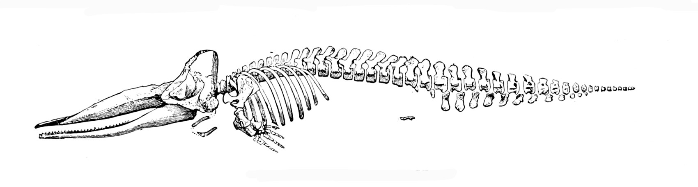  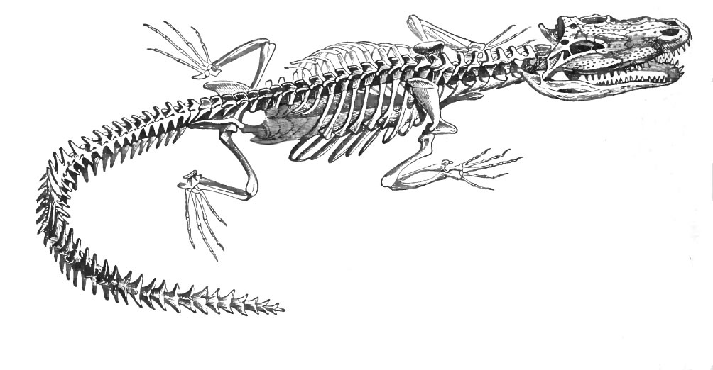  A. It provides information about the organisms’ habitats.  B. It shows possible common ancestry between organisms.  C. It provides information to determine the organisms’ ages.  D. It shows possible chromosomal similarities between organisms.  Correct Answer: B

Reporting Category | Classification/Heredity/Evolution
Standard | Diversity & Evolution of Living Organisms
Benchmark Number | SC.912.L.15.3
Benchmark | Describe how biological diversity is increased by the origin of new species and how it is decreased by the natural process of extinction.
Also Assesses | LAFS.912.L.1.1
Item Types | Selected Response, Short Response
Cognitive Complexity Levels | Low, Moderate, High
Benchmark  Clarification | Students will explain the mechanisms of speciation including the types of isolation that lead to new organisms in a given ecosystem.  Students will identify the causes of a loss of a species and the effects on a given ecosystem.
Content Limits | Items will not refer to the fundamental concept of the theory of evolution or the phylogeny of organisms.  Items will focus on natural selection as the primary mechanism leading to environmental change.  Items being addressed should only include environmental factors the impact species diversity and the effect on a given ecosystem.  Students will not discuss human impacts that lead to the more rapid extinction of species.
Stimulus Attributes | Scenarios referring to specific environmental factors will present a cause and effect relationship for an ecosystem and speciation of organisms.
Response Attributes | None Specified
Content Focus | Students will describe the natural instances (mutation, natural selection for shape, color, abilities to find food/mates) that surround the development of a new species or the decline of an existing species.
Sample Item | What would lead to a decrease in species diversity?  A. captive breeding programs  B. introduction of exotic species  C. establishment of more animal sanctuary areas  D. relocation of endangered animals to areas of less human  population  Correct Answer: B

Reporting Category | Classification/Heredity/Evolution
Standard | Diversity & Evolution of Living Organisms
Benchmark Number | SC.912.L.15.6
Benchmark | Discuss distinguishing characteristics of the domains and kingdoms of living.  organisms.
Also Assesses | SC.912.L.15.4 SC.912.L.15.5
Item Types | Selected Response, Short Response, Extended Response
Cognitive Complexity | Moderate, High
Benchmark  Clarification | Students will classify organisms based on the distinguishing characteristics of the domains and/or kingdoms of living organisms.  Students will identify and/or describe how and/or why organisms are hierarchically classified based on evolutionary relationships.  Students will identify and/or explain the reasons for changes in how organisms are classified.  Students will describe how scientific inferences are made from observations and identify examples from zoology.
Content Limits | Items referring to distinguishing characteristics of living organisms are  limited to the domains of Archaea, Bacteria, and Eukarya and the kingdoms of Protista, Fungi, Plantae, and Animalia.  Items will not require specific knowledge of organisms classified in any domain or kingdom; items should describe the characteristics of an organism and assess its classification.  Items may refer to prokaryotic, eukaryotic, unicellular and/or multicellular organisms, autotrophs, and/or heterotrophs, but they will not assess the definition of those terms.  Items referring to changes in classification systems should be conceptual and will not require specific knowledge of those changes.  Items may address evolutionary classification, phylogeny, and the use of cladograms, and may assess the definition of those terms.  Items assessing a scientific claim are limited to the classification of organisms.
Stimulus Attributes | Scenarios addressing scientific inferences are limited to classification.
Response  Attributes | None Specified
Content Focus | Students will demonstrate understanding of the different classification kingdoms (Archaea, Bacteria, Protista, Fungi, Plants, Animals) and how scientists classify organisms using taxonomy.
Sample Item | A scientist is using a compound light microscope to identity microscopic organisms in pond water. As the scientist studies the single celled organism the following characteristics are observed, cilia, an oral grove and a nucleus. These characteristics lead the researcher to classify the organism in which kingdom?  A. archaea  B. bacteria  C. fungi  D. protista  Correct Answer: D

Reporting Category | Classification/Heredity/Evolution
Standard | Diversity & Evolution of Living Organisms
Benchmark Number | SC.912.L.15.7
Benchmark | Discuss distinguishing characteristics of vertebrate and representative  invertebrate phyla, and chordate classes using typical examples.
Also Assesses | N/A
Item Types | Selected Response, Short Response, Extended Response
Cognitive Complexity | Moderate, High
Benchmark  Clarification | Students will identify different invertebrate and vertebrate phyla using  classification systems. Students will compare and contrast the body systems of each phyla including skeletal, circulatory, digestive, excretory, muscular, respiratory, nervous, and reproductive systems.
Content Limits | Items will not refer to the physiology of the skeletal, circulatory, digestive, excretory, muscular, respiratory, nervous and reproductive system.  Students will not be asked to discuss the differences between body systems within one group of organisms. (For example, students will be asked to describe the differences between a one-way digestive system and a two-way digestive system, but will not be asked to discuss the differences between a vertebrate's digestive and excretory system.)  Item will not refer to the process of mitosis or meiosis or how cellular division occurs.  Respiratory comparison will include gills, lungs and diffusion of oxygen but will not refer to the cellular process of diffusion or osmosis.
Stimulus Attributes | May include diagrams/ illustrations, or scenarios.
Response Attributes | None Specified
Content Focus | This item specifically asks students to describe the differences between vertebrate and invertebrate groups' body compositions.  Compare open and closed circulatory systems as well as the number  of heart chambers in vertebrates, endo- and exo- skeletons; comparison of lack of back bone to well-developed internal skeleton with spinal cords, notch cord, and well developed brain enclosed by skull.  Morphology comparing body symmetry, germ layers and body cavities.  Animal locomotion as related to muscular, skeletal and nervous system.  Types of reproductive processes including sexual and asexual processes including budding and regeneration.  Comparison on internal and external fertilization.  Digestive system comparison will address filter feeding, gastro vascular and water vascular system, and amebocytes.

Sample Item Compare the diagram of the flatworm, nematode, and annelid digestive systems.

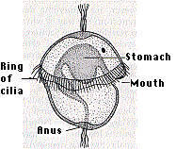
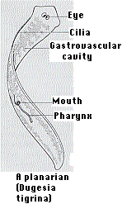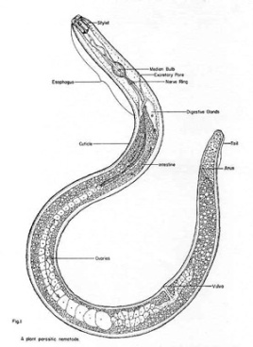
Flatworm Nematode Annelid

The flatworm's digestive tract is surrounded by a tissue-filled region and an outside-body-covering. This type of body cavity indicates that flatworms would be classified as which type of organism?

A. Acoelomates
B. Coelomates
C. Ectoderm
D. Mesoderm

Correct Answer: A

Reporting Category | Classification/Heredity/Evolution
Standard | Diversity & Evolution of Living Organisms
Benchmark Number | SC.912.L.15.11
Benchmark | Discuss specific fossil hominids and what they show about human  evolution.
Also Assesses | N/A
Item Types | Selected Response, Short Response, Extended Response
Cognitive Complexity | Moderate, High
Benchmark  Clarification | Students will identify traits that distinguish hominids from other primates.  Students will compare characteristics of different hominid groups known from fossils.  Students will identify which traits are unique to humans and which are shared with other hominids.
Content Limits | Items can address specific hominid species and chronological sequence of different species and their characteristics but not directly assess specific dates for each species.  Items will not ask specific dates of existences of hominid species, but may be asked to provide a correct timeline of order of evolution.  Items can address brain size and body stature of different species in relation to each other, but not directly assess size measurements.
Stimulus Attributes | May include diagrams (skeletons, skulls, fossils), charts (comparing different hominid species).
Response Attributes | None Specified
Content Focus | Items may include hominid characteristic comparisons. (Characteristics may include: Blunt canine teeth, upright stature, foramen magnum, S-shaped spine, forward-facing eye placement, well-developed foot arch, opposable thumbs but only on hands- no opposable thumbs on feet.)
Sample Item | Earliest primitive stone tool use was first seen around 2 million years ago. Which hominid was the first to exhibit stone tool use?  A. Australopithecus afarensis  B. Homohabilis  C. Homo erectus  D. Homo sapiens  Correct Answer : B

Reporting Category | Classification/Heredity/Evolution
Standard | Diversity & Evolution of Living Organisms
Benchmark Number | SC.912.L.15.13
Benchmark | Describe the conditions required for natural selection, including:  over-production of offspring, inherited variation, and the struggle to survive, which result in differential reproductive success.
Also Assesses | SC.912.L.15.14; SC.912.l.15.15
Item Types | Selected Response, Short Response
Cognitive Complexity | Low, Moderate, High
Benchmark  Clarification | Students will explain and/or describe the conditions required for natural  selection that result in differential reproductive success.  Students will explain and/or describe the scientific mechanisms, such as genetic drift, gene flow, and nonrandom mating, resulting in evolutionary change.  Students will explain and/or describe how mutation and genetic recombination increase genetic variation.
Content  Limits | Items may address descent with modification or common descent.  Items addressing mutation and genetic recombination in relation to increasing genetic variation must be assessed in the context of evolution.  Items may assess they Hardy-Weinberg principle or genetic equilibrium.  Items may address how meiosis contributes to genetic variation but may not assess the steps or stages of meiosis.  Items assessing a scientific claim are limited to the topics discussed in SC.912.L.15.14 and SC.912.L.15.15.
Stimulus Attributes | May include diagrams, graphs, or charts.
Response  Attributes | None Specified
Content Focus | Students may be asked to describe conditions that result in the evolution of certain species over another. (Conditions may include: mutations favorable for survival in the environment, selection for a mate that results in better protection/care of young, climate change that may be favorable for one species over another.) The Hardy-Weinberg principle is an aspect of this benchmark that will be prompted to show student's understanding of the favorable conditions listed above.
Sample Item | The Asian shore crab invaded parts of the eastern coast of the United States about 15 years ago. The Asian shore crab preys on blue mussels.  In the time since the Asian shore crab arrived, the average shell thickness has increased in the blue mussel population. Which is the most likely reason that this increase in shell thickness has occurred?  A. Blue mussels with thick shells attract more crabs than mussels  without thick shells.  B. Blue mussels with thick shells grow in larger colonies than mussels  without thick shells.  C. Blue mussels with thick shells catch more food per day than  mussels without thick shells.  D. Blue mussels with thick shells survive and reproduce more  successfully than mussels without thick shells.  Correct Answer: D

Reporting Category | Organisms/Populations/Ecosystems
Standard | Interdependence
Benchmark Number | SC.912.L.17.6
Benchmark | Compare and contrast the relationships among organisms, including  predation, parasitism, competition, commensalism, and mutualism.
Also Assesses | N/A
Item Types | Selected Response, Short Response
Cognitive Complexity | Low, Moderate, High
Benchmark Clarification | Students will identify characteristics that classify predators and prey, and parasites and hosts and determine types of adaptations that they display.  Students will identify possible causes and effects of interspecific competition.  Students will describe the benefits and disadvantages from symbiotic interactions.
Content Limits | Items will not assess the food web.  Items will not assess coevolution.
Stimulus Attributes | May include diagrams, charts.
Response Attributes | None Specified
Content Focus | Students may be asked to demonstrate knowledge of both  interspecies and intraspecies relationships.
Sample Items | Selected Response  Which type of relationship do a clownfish and a sea anemone have?  A. commensalism  B. mutualism  C. parasitism  D. predator-prey  Correct Answer: B  Short Response  Describe the differences between commensalism, mutualism, and parasitism.  Correct Answer:  In commensalism, one organism benefits and the other organism is not affected. In mutualism, both organisms benefit from each other. In parasitism, one organism benefits, and the other organism is harmed.  2 points - Student provides a complete, accurate, and clear response that demonstrates an understanding of the central idea and provides a Correct Answer using accurate explanations as support.  1 point - Student provides a partially Correct Answer to the question, demonstrates a partial understanding of the central idea.  0 points – Student did not provide a response; student response is incorrect or off-topic.

Reporting Category | Organisms/Populations/Ecosystems
Standard | Interdependence
Benchmark Number | SC.912.L.17.7
Benchmark | Characterize the biotic and abiotic components that define freshwater  systems, marine systems and terrestrial systems.
Also Assesses | N/A
Item Types | Selected Response, Short Response
Cognitive Complexity | Low, Moderate
Benchmark  Clarification | Students will identify the major terrestrial biomes and the major ocean zones.  Students will identify biotic and abiotic factors that influence a particular ecosystem.  Students will explain the importance of each factor in the environment.
Content Limits | Items referring to abiotic factors are limited to temperature, soil, humidity, sunlight, nutrients, and water.
Stimulus Attributes | May include diagrams or charts.
Response Attributes | None Specified
Content Focus | Item may ask students to describe the differences between biotic and abiotic components in an ecosystem.
Sample Item | As you move farther from the equator, which abiotic factor is most likely to limit the productivity of terrestrial ecosystems?  A. amount of carbon dioxide  B. amount of nitrogen and phosphorus  C. amount of oxygen and soil  D. amount of water and light  Correct Answer: D

Reporting Category | Organisms/Populations/Ecosystems
Standard | Interdependence
Benchmark Number | SC.912.L.17.9
Benchmark | Use a food web to identify and distinguish producers, consumers, and  decomposers.  Explain the pathway of energy transfer through trophic levels and the reduction of available energy at successive trophic levels.
Also Assesses | SC.912.L.17.6
Item Types | Selected Response, Short Response, Extended Response
Cognitive Complexity | Low, Moderate, High
Benchmark  Clarification | Students will describe the energy pathways through the different trophic levels of a food web or energy pyramid.  Students will analyze the movement of matter though different biogeochemical cycles.
Content Limits | Items referring to organisms in food webs are limited to the impact of  changes in matter or energy in trophic levels.  Items addressing food webs will require application of the knowledge of roles of organisms in a food web to describe energy pathways rather than the identification of producers, consumers (primary, secondary, tertiary), and decomposers.  Items will not require knowledge of specific organisms or their feeding habits.  Items assessing biogeochemical cycles are limited to the water cycle and the carbon cycle.  Items referring to the biogeochemical cycles may address but will not assess photosynthesis and cellular respiration in isolation.
Stimulus Attributes | Food webs, trophic pyramids.  Scenarios will express energy in joules (J).
Response Attributes | Selected Response
Content Focus | Items will focus on biogeochemical cycles and trophic levels.

Sample Item A team of ecologists observed feeding patterns of several populations in the desert. The energy pyramid shown below depicts the feeding patterns the ecologists observed.

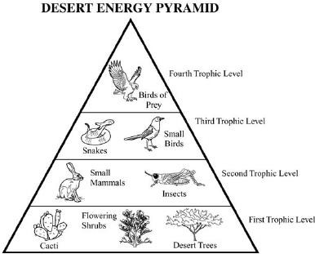

Which best explains the difference in the amount of available energy in the trophic levels of the desert ecosystem?

A. There is less energy available in the producers because their tissues are less dense than those at higher trophic levels.

B. There is more energy available in the second trophic level because less energy is needed for hunting compared to the higher trophic levels.

C. There is less available energy in the fourth trophic level because of the loss of energy through metabolism in each of the lower trophic levels.

D. There is more available energy in the birds of prey because they have greater muscle mass for storing energy than organisms in lower trophic levels.

Correct Answer: C

Reporting Category | Molecular & Cellular Biology
Standard | Matter & Energy Transformation
Benchmark Number | SC.912.L.18.1
Benchmark | Describe the basic molecular structures and primary functions of the four major categories of biological macromolecules.
Also Assesses | SC.912.L.18.1.1
Item Types | Selected Response
Cognitive Complexity | Low or Moderate
Benchmark  Clarification | Students will identify and/or describe the basic molecular structure of  carbohydrates, lipids, proteins, and/or nucleic acids.  Students will describe the primary functions of carbohydrates, lipids, proteins, and/or nucleic acids in organisms.  Students will explain how enzymes speed up the rate of a biochemical reaction by lowering the reaction's activation energy.  Students will identify and/or describe the effect of environmental factors on enzyme activity.
Content Limits | Items will not refer to intermolecular forces found in the four types of  macromolecules.  Items will not assess hydrolysis and dehydration synthesis. Items referring to the role of enzymes as catalysts will use a biological context and not require knowledge of specific enzymes.  Items referring to the factors that affect enzyme activity are limited to concentration, pH, and temperature.  Items will not require specific knowledge of how an enzyme reacts at a certain pH or temperature.  Items will not assess the enzyme- substrate complex.
Stimulus Attributes | May include diagrams or charts.
Response Attributes | None Specified
Content Focus | Identify the structural components or function of one of the biological macromolecules in this item. Biological macromolecules for this benchmark include: proteins, lipids, carbohydrates, and nucleic acids. Vocabulary will include: DNA, RNA, enzyme, substrate, catalysts, simple sugar, complex sugar, saturated fat, unsaturated fat, CHO, CHONPS.
Sample Item | A geneticist investigating the resistance of a particular type of bacteria to antibiotic drugs isolates a molecule present in the bacteria that is not present in other related species. The molecule is large, and made up of chains of fatty acids. Its major function in the bacteria is providing structural support. Which category of macromolecule would this isolated chemical most likely be classified as?  A. carbohydrate  B. lipid  C. nucleic acid  D. protein  Correct Answer: B

Reporting Category | Molecular & Cellular Biology
Standard | Matter & Energy Transformation
Benchmark  Number | SC.912.L.18.9
Benchmark | Explain the interrelated nature of photosynthesis and cellular respiration.
Also Assesses | SC.912.L.18.7; SC.912.L.18.8; SC.912.L.18.10
Item Types | Selected Response, Short Response
Cognitive Complexity | Moderate, High
Benchmark  Clarification | Students will identify the reactants and products of both photosynthesis and cellular respiration.  Students will summarize the two steps of each process and the main events involved.  Students will explain why almost all organisms depend on photosynthesis.
Content Limits | Items will not refer to the four basic categories of macromolecules, the  discussions of enzymes in the course of chemical reactions, or the unique properties of carbon and water.  Items will focus primarily on living organisms acquiring energy through photosynthesis and cellular respiration.  Other metabolic pathways such as fermentation will not be addressed. Items will not require the balancing of equations.
Stimulus Attributes | Diagram, model, or illustration of the two processes.  Scenarios referring to adenosine triphosphate should use the abbreviation ATP rather than the words adenosine triphosphate.
Response Attributes | None Specified
Content Focus | Demonstrate thorough knowledge of the photosynthetic process and the cellular respiration process, through comparisons, explanations, or essays.

Sample Item The diagram below shows the relationship between photosynthesis and cellular respiration and the organelles in which they occur.

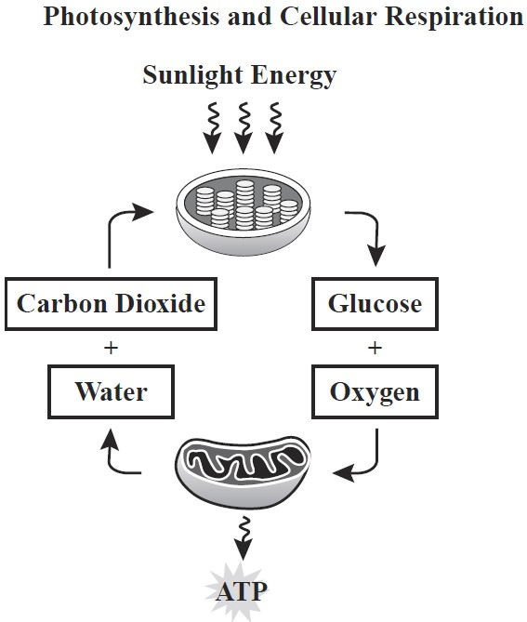

Which statement describes how photosynthesis and cellular respiration are interrelated?

A. Oxygen is produced during cellular respiration and stored during photosynthesis.
B. Photosynthesis releases the energy that is stored during the process of cellular respiration.
C. Carbon dioxide and water released by cellular respiration are used in the process of photosynthesis.
D. Glucose is used during cellular respiration to produce food that is
broken down during photosynthesis.

Correct Answer: C

