central florida assessment collaborative
Individual Test Item Specifications
Trigonometry
2013

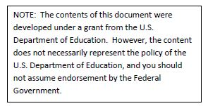

Table of Contents

I. Guide to the Individual Benchmark Specifications 1
Benchmark Classification System 1
Definitions of Benchmark Specifications 3
II. Individual Benchmark Specifications 4

I. Guide to the Individual Benchmark Specifications

Content specific guidelines are given in the Individual Benchmark Specifications for each course. The Specifications contains specific information about the alignment of items with the Florida Standards. It identifies the manner in which each benchmark is assessed, provides content limits and stimulus attributes for each benchmark, and gives specific information about content, item types, and response attributes.

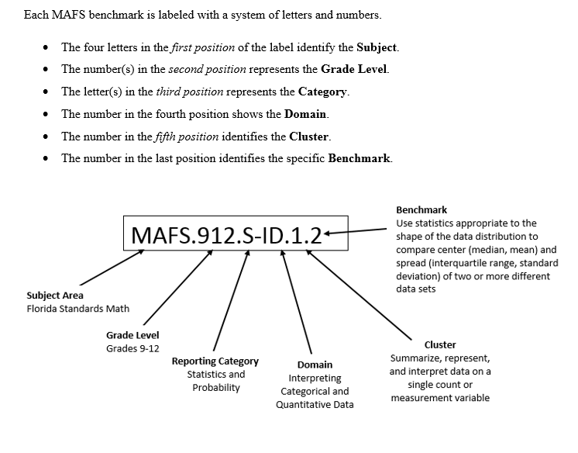

Definitions of Benchmark Specifications
The Individual Benchmark Specifications provides standard-specific guidance for assessment item development for CFAC item banks. For each benchmark assessed, the following information is provided:

Reporting Category | is a grouping of related benchmarks that can be used to summarize and report achievement.
Standard | refers to the standard statement presented in the Florida Standards.
Benchmark  Also Assesses | refers to the benchmark statement presented in the standard statement in the Florida Standards. In some cases, two or more related benchmarks are grouped together because the assessment of one benchmark addresses another benchmark. Such groupings are indicated in the Also Assesses statement.  refers to the benchmarks that are closely related to the benchmark (see description above).
Item Types  Cognitive Complexity Level | are used to assess the benchmark or group of benchmark.  ideal level at which the item should be assessed.
Benchmark Clarifications | explain how achievement of the benchmark will be demonstrated by students. In other words, the clarification statements explain what the student will do when responding to questions.
Content Limits | define the range of content knowledge and that should be assessed in the items for the benchmark.
Stimulus Attributes | define the types of stimulus materials that should be used in the items, including the appropriate use of graphic materials and item context or content.
Response Attributes | define the characteristics of the answers that a student must choose or provide.
Sample Items | are provided for each type of question assessed. The correct answer for all sample items is provided.

II. Individual Benchmark Specifications
Reporting Category | Functions
Standard | Trigonometric Functions
Benchmark Number | MAFS.912.F-TF.1.1
Benchmark | Understand radian measure of an angle as the length of the arc on the unit circle subtended by the angle.
Also Assesses | MAFS.K12.MP.5
Item Types | Selected Response (Multiple Choice), Gridded Response, Short Answer
Benchmark Clarification | Student will determine an arc length given an angle and radius, or find the angle measure given the arc length and radius.
Content Limits | Degrees must be stated as an integer.  Radians must be written in terms of π.
Stimulus Attributes | Items may be set in real world or mathematical context.
Response Attributes | Selected Response answer choices may be expressed as degrees or radians.  Responses must be in simplified form.
Sample Item | 1. What is the length of an arc on a circle of radius r intercepted by central angle θ? (Round answers to one decimal place.) r = 10.8 in, θ = 210°  A. 39.6 in  B. 39.7 in  C. 39.8 in  D. 39.9 in  Answer: A  2. What is the measure of a central angle on a circle of radius r and a given arc length s if r = 5 in, and s = $\frac{10π}{3}$ ?  Answer :$\frac{4π}{15}$

Reporting Category | Functions
Standard | Trigonometric Functions
Benchmark Number | MAFS.912.F-TF.1.2
Benchmark | Explain how the unit circle in the coordinate plane enables the extension of trigonometric functions to all real numbers, interpreted as radian measures of angles traversed counterclockwise around the unit circle.
Also Assesses | MAFS.K12.MP.5
Item Types | Selected Response (Multiple Choice), Gridded Response, Short Answer
Benchmark Clarification | Students will convert degrees to radians and vice versa.  Student should be able to explain how solving problems using radians is often simpler than using degrees.
Content Limits | Degrees must be stated as an integer.  Radians must be written in terms of π.
Stimulus Attributes | Items may be set in real world or mathematical context.
Response Attributes | Selected Response responses may be expressed as degrees or radians.  Gridded Response responses must be stated as degrees.  Responses must be in simplified form.
Sample Item | 1. In terms of π, what is the radian measure of 135 degrees?  A. 9π  B. $\frac{π}{4}$  C. $\frac{3π}{4}$  D. $\frac{4π}{3}$  Answer: C  2. What is the radian measure, - $\frac{11π}{12}$, in degrees? Answer: - 165 degrees  3. What is the radian measure of 270˚? Answer: $\frac{3π}{2}$

Reporting Category | Functions
Standard | Trigonometric Functions
Benchmark Number | MAFS.912.F-TF.1.3
Benchmark | Use special triangles to determine geometrically the values of sine, cosine, tangent for π/3, π/4 and π/6, and use the unit circle to express the values of sine, cosine, and tangent for π–x, π+x, and 2π–x in terms of their values for x, where x is any real number.
Also Assesses | MAFS.912.F-TF.1.1  MAFS.912.F-TF.1.2  MAFS.K12.MP.5 and 8
Item Types | Selected Response (Multiple Choice), Gridded Response, Short Answer
Benchmark Clarification | Students will determine the value of the 6 trigonometric functions in terms of degrees with in multiples of 30, 45, 60, 90, and 180 degrees or radians with in multiples of $\frac{π}{6}$, $\frac{π}{3}$ , $\frac{π}{4}$, $\frac{π}{2}$ and π.
Content Limits | Content is limited to determining the value of the 6 trigonometric functions in terms of degrees with in multiples of 30, 45, 60, 90, and 180 degrees or radians with in multiples of $\frac{π}{6}$, $\frac{π}{3}$ , $\frac{π}{4}$, $\frac{π}{2}$ and π.
Stimulus Attributes | Item should be set in mathematical context.
Response Attributes | None Specified

Sample Item | 1. What is the cosine of 300 ˚?  A. $\frac{1}{2}$  B. - $\frac{1}{2}$  C. $\frac{\sqrt{3}}{2}$  D. - $\frac{\sqrt{3}}{2}$  Answer: A  2. What is sin( - $\frac{2π}{3}$ ) ?  Answer: - $\frac{\sqrt{3}}{2}$

Reporting Category | Functions
Standard | Trigonometric Functions
Benchmark Number | MAFS.912.F-TF.1.4
Benchmark | Use the unit circle to explain symmetry (odd and even) and periodicity of trigonometric functions.
Also Assesses | MAFS.912.F-TF.1.2  MAFS.912.F-TF.1.3  MAFS.K12.MP.5, 7, 8
Item Types | Selected Response (Multiple Choice), Gridded Response, Short Answer
Benchmark Clarification | Students will determine the value of negative angles (symmetry) and describe how adding/subtracting 2π to a sine/cosine function, or π to a tangent function, produces the same function (periodicity).
Content Limits | ϴ may be stated in terms of degrees or radians.  ϴ can be determined through multiple rotations around the unit circle.
Stimulus Attributes | Items may be set in real world or mathematical context.
Response Attributes | Responses must be in simplified form.
Sample Item | Given that trigonometric functions are periodic, what is the exact value of:  1. tan ( $\frac{19π}{6}$ )?  Answer: $\frac{\sqrt{3}}{3}$  2. sin 390 ˚?  A. 2 C. - $\frac{1}{2}$  B. $\frac{1}{2}$ D. – 2  Answer: B

Reporting Category | Functions
Standard | Trigonometric Functions
Benchmark Number | MAFS.912.F-TF.2.5
Benchmark | Choose trigonometric functions to model periodic phenomena with specified amplitude, frequency, and midline.
Also Assesses | MAFS.K12.MP.5, 7, and 8
Item Types | Selected Response (Multiple Choice), Gridded Response, Short Answer
Benchmark Clarification | Students will identify the domain, range, intercepts, period, amplitude, transformations, and asymptotes of trigonometric functions or their graphs.  Students will solve problems based on trigonometric functions or their graphs.
Content Limits | None Specified
Stimulus Attributes | Items should be set in numerical contexts with or without graphics.
Response Attributes | None Specified
Sample Item | 1. What is the range of the function, f(x) = 5cos (2x- $\frac{π}{3}$ ) +1?  Answer: [-4,6]  2. Which of the following is the graph of the function, y = sin (x + $\frac{π}{3}$ ) + 2 ?  Pictured Below: Graphs of trigonometric functions.  A. 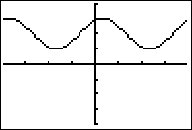 B.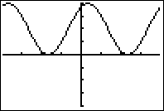  C. 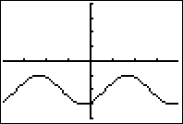 D.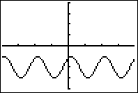  Answer: A

Reporting Category | Functions
Standard | Trigonometric Functions
Benchmark Number | MAFS.912.F-TF.2.6
Benchmark | Understand that restricting a trigonometric function to a domain on which it is always increasing or always decreasing allows its inverse to be constructed.
Also Assesses | MAFS.K12.MP.5, 7 and 8
Item Types | Selected Response (Multiple Choice), Gridded Response, Short Answer
Benchmark Clarification | Students will be able to sketch one cycle of inverse functions, given an appropriate domain.  Students will be able to determine the value of the 6 inverse trigonometric functions with an appropriate domain.
Content Limits | Angles must be in degrees or radians with two or less decimal places.  Graphs will be in radian measure.
Stimulus Attributes | Items may be set in real world or mathematical context.
Response Attributes | Output from inverse functions will be an exact or rounded rational number to two decimal places.

Sample Item | - Which of these is the graph of y = 2cos⁻¹ (x + $\frac{π}{2}$ )  Pictured Below: Graphs of the cosine function  A. 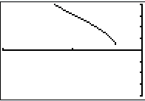 B.  C. D.  Answer: A

Reporting Category | Functions
Standard | Trigonometric Functions
Benchmark Number | MAFS.912.F-TF.2.7
Benchmark | Use inverse functions to solve trigonometric equations that arise in modeling contexts; evaluate the solutions using technology, and interpret them in terms of the context.
Also Assesses | MAFS.K12.MP.1, 2, 4, 5, and 6
Item Types | Selected Response (Multiple Choice), Gridded Response, Short Answer
Benchmark Clarification | Students will use technology to solve inverse trigonometric equations.
Content Limits | Angles must be in degrees or radians with two or less decimal places.  Graphs will be in radian measure.
Stimulus Attributes | Items must be set in real world setting.
Response Attributes | Output from inverse functions will be an exact or rounded rational number to two decimal places.
Sample Item | 1. A tennis ball leaves a racket and heads towards a net 40 feet away. The height of the net is the same height as the initial height of the tennis ball.  If the ball is hit at 50 feet per second, neglecting air resistance, using the formula  d = $\frac{1}{32}$ v₀² sin 2θ, what is the interval of possible angles of the ball needed to clear the net?  Answer: 15.4 ˚, 74.6 ˚

Reporting Category | Functions
Standard | Trigonometric Functions
Benchmark Number | MAFS.912.F-TF.3.8
Benchmark | Prove the Pythagorean identity sin²(θ) + cos²(θ) = 1 and use it to find sin(θ), cos(θ), or tan(θ) given sin(θ), cos(θ), or tan(θ) and the quadrant of the angle.
Also Assesses | MAFS.K12.MP.1, 2, 3 and 7
Item Types | Selected Response (Multiple Choice), Gridded Response, Short Answer
Benchmark Clarification | Students will prove the Pythagorean identity given the three sides of a right triangle.  Students will then use the identity to find trigonometric functions.
Content Limits | Angle measures will be in degrees.  Items may require multiple steps.
Stimulus Attributes | Graphics may be given to enhance the item, or students may be expected to make a sketch to assist in giving a response.
Response Attributes | Angle measures will be in degrees.  Selected Response and Gridded Response will be in decimal form.

Sample Item | 1. θ is an acute angle and the sine of θ is given. Use the Pythagorean identity,  sin²θ +cos²θ=1, what is cos θ if sin θ = $\frac{1}{4}$ ?  A. $\frac{\sqrt{15}}{5}$ B. 4 C.$\frac{\sqrt{15}}{4}$ D. $\frac{4\sqrt{15}}{5}$  Answer: C  2. Given a right triangle, if sin θ = $\frac{7}{25}$, sin $θ$ > 0 and cos θ < 0, what is cot θ?  Answer: $\frac{24}{7}$  3. Given a right triangle, sec θ = $\frac{\sqrt{29}}{5}$, where sin θ > 0. What is the exact value of  tan θ?  A. $\frac{2\sqrt{29}}{29}$ C. $\frac{2}{5}$  B. $\frac{5\sqrt{29}}{29}$ D. $\frac{5}{2}$  Answer: C

Reporting Category | Functions
Standard | Trigonometric Functions
Benchmark Number | MAFS.912.F-TF.3.9
Benchmark | Prove the addition and subtraction formulas for sine, cosine, and tangent and use them to solve problems.
Also Assesses | MAFS.K12.MP.1, 2, and 7
Item Types | Selected Response (Multiple Choice), Gridded Response, Short Answer
Benchmark Clarification | Students will use sum, difference, double-angle, and half-angle formulas to simplify, verify and solve trigonometric expressions and equations.  These formulas will be provided on the reference sheet.
Content Limits | Angle measures may be in degrees or radians.
Stimulus Attributes | Angle notation will be the same throughout the identity.
Response Attributes | Response must be in radians if problem is in radians.
Sample Item | 1. What is the exact value of cos $\frac{5π}{18}$· cos $\frac{π}{9}$ + sin$\frac{5π}{18}$· sin$\frac{π}{9}$ ?  Answer: $\frac{\sqrt{3}}{2}$  2. What is the exact value of cos 75˚?  A. $\sqrt{6}$ + $\sqrt{2}$ B. $\sqrt{6}$ - $\sqrt{2}$  4 4  C. 2 - $\sqrt{3}$ D. 2 + $\sqrt{3}$  Answer: B

Reporting Category | Geometry
Standard | Similarity, Right Triangles and Trigonometry
Benchmark Number | MAFS.912.G-SRT.3.7
Benchmark | Explain and use the relationship between the sine and cosine of complementary angles.
Also Assesses | MAFS.912.F-TF.1.2  MAFS.K12.MP.5 and 6
Item Types | Selected Response (Multiple Choice), Gridded Response, Short Answer
Benchmark Clarification | Students will determine the cofunction of an angle using the relationship of complementary angles.  Students will verify cofunction identities.
Content Limits | Degrees must be stated as an integer.  Radians must be written in terms of π or decimal.
Stimulus Attributes | Item should be set in mathematical context.
Response Attributes | Response must be in radians if problem is in radians.
Sample Item | If sin x = - 0.35, what is cos (x - $\frac{π}{2}$ )?  Answer: - 0.35

Reporting Category | Geometry
Standard | Similarity, Right Triangles and Trigonometry
Benchmark Number | MAFS.912.G-SRT.3.8
Benchmark | Use trigonometric ratios and the Pythagorean Theorem to solve right triangles in applied problems.
Also Assesses | MAFS.K12.MP.4, 5 and 6
Item Types | Selected Response (Multiple Choice), Gridded Response, Short Answer
Benchmark Clarification | Students will solve right triangles using Pythagorean Theorem.  Students will solve real-world problems involving right triangles using calculators as needed.  Students will be required to provide a length or an angle measure.  Students may be asked to solve problems involving angles of elevation, angles of depression, bearings, or other types of real-world problems.
Content Limits | Angle measures will be in degrees.  Items may require multiple steps.  Items may require the use of calculators to find lengths and angle measures.
Stimulus Attributes | Items must be set in real-world contexts or math context.  Graphics may be given to enhance the item, or students may be expected to make a sketch to assist in giving a response.  Items will specify the nature of the response, if the response is not an integer.
Response Attributes | Angle measures will be in degrees.  Selected Response and Gridded Response will be in fraction or decimal form.

Sample Item | - What is the value of sec θ?  8  θ  Pictured: Right triangle with side measures of 8 and 15.  15  - $\frac{8}{15}$  B. $\frac{15}{17}$  C. $\frac{17}{8}$  D. $\frac{17}{15}$  Answer: D

Reporting Category | Geometry
Standard | Similarity, Right Triangles and Trigonometry
Benchmark Number | MAFS.912.G-SRT.4.10
Benchmark | Prove the Laws of Sines and Cosines and use them to solve problems.
Also Assesses | MAFS.K12.MP.1, 2, 4 and 5
Item Types | Selected Response (Multiple Choice), Gridded Response, Short Answer
Benchmark Clarification | Students will solve real-world problems involving oblique triangles by applying the Law of Sines or the Law of Cosines which will be provided on the Trigonometry Reference Sheet.  Students may be required to provide a length or an angle measure.  Students may be required to find side lengths before using the Law of Sines or Law of Cosines to solve the real-world problems.
Content Limits | Angles measures will be in degrees.  Items may require multiple steps.  Items may require the use of calculators to find lengths and angle measures.
Stimulus Attributes | Items must be set in real-world contexts.  Graphics may be given to enhance the item, or students may be expected to make a sketch to assist in giving a response.  Items will specify the nature of the response, if the response is not an integer.
Response Attributes | Angle measures will be in degrees.  Selected Response answer choices will be in decimal form.

Sample Item | 1. Two planes leave an airport on different runways at the same time. The runways intersect at an included angle of 100°. One plane travels at 350 miles per hour on a straight flight path, and the other plane travels at 425 miles per hour. How far apart, to the nearest mile, are the planes after 3 hours?  A. 225 miles  B. 684 miles  C. 1504 miles  D. 1787 miles  Answer: D

Reporting Category | Geometry
Standard | Similarity, Right Triangles and Trigonometry
Benchmark Number | MAFS.912.G-SRT.4.9
Benchmark | Derive the formula A = 1/2 ab sin(C) for the area of a triangle by drawing an auxiliary line from a vertex perpendicular to the opposite side.
Also Assesses | MAFS.K12.MP.5 and 6
Item Types | Selected Response (Multiple Choice), Short Answer
Benchmark Clarification | Students will solve real-world problems by finding the area of a triangle by using Heron's Formula, the area of a triangle formula using the sine function, the basic area of a triangle formula, or other means using trigonometric functions when given two sides and an angle or three sides of a triangle.  Heron's Formula and the area of a triangle formula using the sine function will be provided on the Trigonometry Reference Sheet.
Content Limits | Angle measures will be in degrees.  Items may require multiple steps.  Items will require the use of calculators with trigonometric functions.
Stimulus Attributes | Items must be set in real-world contexts.  Graphics may be given to enhance the item, or students may be expected to make a sketch to assist in giving a response.  Items will specify the nature of the response, if the response is not an integer.
Response Attributes | Angle measures will be in degrees.  Selected Response and Gridded Response will be in decimal form.

Sample Item | 1. What is the area, to the nearest square foot, of a triangular piece of land that measures 275 feet by 400 feet by 425 feet?  A. 6837 square feet  B. 42,482 square feet  C. 53,254 square feet  D. 160,351 square feet  Answer: C

Reporting Category | Number and Quantity
Standard | Complex Number System
Benchmark Number | MAFS.912.N-CN.1.3
Benchmark | Find the conjugate of a complex number; use conjugates to find moduli and quotients of complex numbers.
Also Assesses | MAFS.K12.MP.7 and 8
Item Types | Selected Response (Multiple Choice), Gridded Response, Short Answer
Benchmark Clarification | Students will find conjugates of complex numbers which are written in a + bi form.  Students will use the conjugates for find quotients of complex numbers.  Students will find the moduli of complex numbers.
Content Limits | All points must be expressed in a + bi form.
Stimulus Attributes | Items may be set in mathematical or real-world contexts.
Response Attributes | All solutions must be expressed in a + bi form.
Sample Item | 1. What is the conjugate of 4 – 5i?  A. 4 + 5i B. – 4 – 5i  C. – 4 + 5i D. 5i  Answer: A  2. What is the modulus of 7 + 3i?  Answer: $\sqrt{58}$  3. Simplify $\frac{6+2i}{3-4i}$  Answer: 2 + 6i  5

Reporting Category | Number and Quantity
Standard | Complex Number System
Benchmark Number | MAFS.912.N-CN.2.4
Benchmark | Represent complex numbers on the complex plane in rectangular and polar form (including real and imaginary numbers), and explain why the rectangular and polar forms of a given complex number represent the same number.
Also Assesses | MAFS.K12.MP.6 and 7
Item Types | Selected Response (Multiple Choice), Short Answer
Benchmark Clarification | Students will define polar coordinates.  Students will recognize a graph of a point in polar coordinates in a polar coordinate system.  Students will name polar coordinates by examining a point in a polar coordinate system.  Students will convert polar coordinates to Cartesian coordinates and vice versa with and without calculators.
Content Limits | Items may be solved using calculators that will convert between polar coordinates and Cartesian coordinates.  Items may include points in polar coordinates that have both positive and negative r values.  Angle measures may be in degree or radian measures between -1080° (-6π) and 1080° (6π).
Stimulus Attributes | Items may be set in mathematical or real-world contexts.  Graphics may be given to enhance the item, or students may be expected make a sketch to assist in giving a response.
Response Attributes | Angle measures may be given in degrees or radians.  Points will be listed in ordered pairs.

Sample Item | 1. The polar coordinates of a point are (-4, 270°). Which ordered pair represents the same point in Cartesian coordinates?  A. (-4,0)  B. (0,4)  C. (-4,4)  D. (-4,-4)  Answer: B

Reporting Category | Number and Quantity
Standard | Complex Number System
Benchmark Number | MAFS.912.N-CN.2.5
Benchmark | Represent addition, subtraction, multiplication, and conjugation of complex numbers geometrically on the complex plane; use properties of this representation for computation. For example, (–1 + $\sqrt{3}$ i)³ = 8 because (–1 + $\sqrt{3}$ i) has modulus 2 and argument 120°.
Also Assesses | MAFS.K12.MP.7 and 8
Item Types | Selected Response (Multiple Choice), Gridded Response, Short Answer
Benchmark Clarification | Students will find powers of complex numbers written in rectangular form or in trigonometric form by applying DeMoivre's Theorem.
Content Limits | Angle measures may be in degree or radian measures between 0° (0π) and 360° (2π).
Stimulus Attributes | Items must be set in a mathematical context.  Items will only include problems whose solutions include angles found on the unit circle.  Complex numbers may be written in either rectangular form or trigonometric form.
Response Attributes | Complex numbers may be written in rectangular or trigonometric form.  Complex numbers will be written in standard form.  Responses will be exact values.
Sample Item | What is (1 + $\sqrt{3}$ i) ⁴ expressed in rectangular form?  A. 8 + 8$\sqrt{3}$ i  B. - 8 + 8$\sqrt{3}$ i  C. 8 - 8$\sqrt{3}$ i  D. - 8 - 8$\sqrt{3}$ i  Answer: D

Reporting Category | Number and Quantity
Standard | Complex Number System
Benchmark Number | MAFS.912.N-CN.2.6
Benchmark | Calculate the distance between numbers in the complex plane as the modulus of the difference, and the midpoint of a segment as the average of the numbers at its endpoints.
Also Assesses | MAFS.K12.MP.5 and 6
Item Types | Short Answer
Benchmark Clarification | Students will use vector parallelogram method to graphically find the distance between numbers in the complex plane.
Content Limits | Points are in the form a + bi.
Stimulus Attributes | Items may be set in real world or mathematical context.
Response Attributes | Graph responses are in the complex plane.

Sample Item | - Given z = 5 + 2i, w = 1 + 3i, briefly explain how you could illustrate the distance between z and w, graphically. Then provide the distancce.  Pictured: Graph of ray w and ray z on coordinate plane.  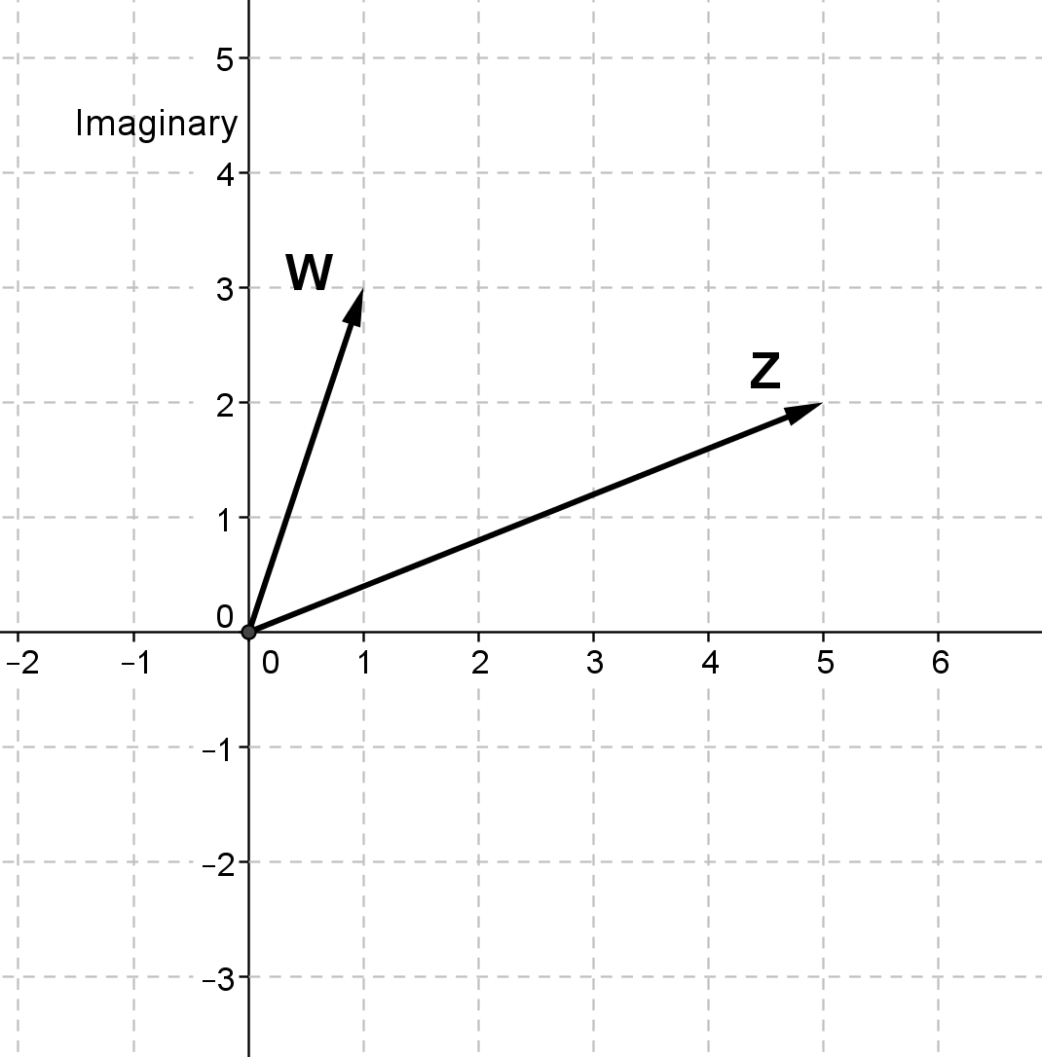  Sample Full Credit Response:  One possible answer: Draw –w then use parallelogram method to add that to z. Length of resultant vector is the distance. Distance is$\sqrt{17}$.  Second is to simply make a vector between the endpoints of w and z. Same Distance.  Third is draw –z and follow steps of first answer, add to w. Same Distance results.  2 Points:  - The response indicates that the student has a complete understanding of the concept embodied in the task.  - The student has provided a response that is accurate, complete, and fulfills all the requirements of the task.  - Necessary support and/or examples are included, and the information given is clearly text-based.  1 Point:  - The response indicates that the student has a partial understanding of the concept embodied in the task.  - The student has provided a response that includes information that is essentially correct and text-based but the information is too general or too simplistic.  - Some of the support and/or examples may be incomplete or omitted.  0 Points:  - The response indicates that the student does not demonstrate and understanding of the reading concept embodied in the task.  - The student has provided a response that is inaccurate or contains only irrelevant text-based information.  - The response has an insufficient amount of information to determine the student’s understanding of the task or the student has failed to respond to the task.

Reporting Category | Number and Quantity
Standard | Vector and Matrix Quantities
Benchmark Number | MAFS.912.N-VM.1.1
Benchmark | Recognize vector quantities as having both magnitude and direction. Represent vector quantities by directed line segments, and use appropriate symbols for vectors and their magnitudes (e.g., v, |v|, ||v||, v).
Also Assesses | MAFS.K12.MP.5 and 6
Item Types | Selected Response (Multiple Choice), Gridded Response, Short Answer
Benchmark Clarification | Students will demonstrate an understanding of the geometric interpretation of vectors and vector operations.  Students will be able to identify the vector.
Content Limits | Problems will be written with rational numbers.
Stimulus Attributes | Items may be set in real world or mathematical context.
Response Attributes | Response may be pictures or values.
Sample Item | What is the vector in terms of i and j given the magnitude and directional  ǁvǁ = 10, θ = 120°?  Answer: v = -5i + 5$\sqrt{2}$j

Reporting Category | Number and Quantity
Standard | Vector and Matrix Quantities
Benchmark Number | MAFS.912.N-VM.1.2
Benchmark | Find the components of a vector by subtracting the coordinates of an initial point from the coordinates of a terminal point.
Also Assesses | MAFS.K12.MP.6 and 7
Item Types | Selected Response (Multiple Choice), Gridded Response, Short Answer
Benchmark Clarification | Students will subtract x and y coordinates of two given points to find the components of a vector.
Content Limits | Ordered pairs will be integers only.
Stimulus Attributes | Items may be set in either real world or mathematical context.
Response Attributes | Responses must be given in correct vector form.
Sample Item | What is the component form of vector AB, if it has initial point A, (- 4, 2), and terminal point B, (3, - 5)?  A. (7, - 7)  B. ( - 7, 7)  C. (- 1, - 3)  D. (1, 3)  Answer A

Reporting Category | Number and Quantity
Standard | Vector and Matrix Quantities
Benchmark Number | MAFS.912.N-VM.1.3
Benchmark | Solve problems involving velocity and other quantities that can be represented by vectors.
Also Assesses | MAC.912.N-VM.1.1  MAC.912.N-VM.1.2  MAFS.K12.MP.1, 2, 4, 5, and 6
Item Types | Selected Response (Multiple Choice), Gridded Response, Short Answer
Benchmark Clarification | Students will solve real world problems quantities that can be represented by vectors.  Students will solve real world problems involving velocity.
Content Limits | Scalars will be rational numbers only.
Stimulus Attributes | Items will be set in real world context.
Response Attributes | Responses may include pictures or values.
Sample Item | 1. The vector d represents the displacement of a wagon that is pulled with the force F. The work done, W (scalar), in moving the wagon in the direction of d is defined to be the component of F in the direction of d times the distance the wagon moves. How much work is done if F = (10,3) and d = (25,0)?  Answer: 250  2. A 10,000-pound boulder sits on a mountain at an incline of 60 ˚. Ignoring the force of friction, what force is required to keep the boulder from rolling down the mountain?  Answer: 8660.3 lb.

Reporting Category | Number and Quantity
Standard | Vector and Matrix Quantities
Benchmark Number | MAFS.912.N-VM.2.4
Benchmark | Add and subtract vectors. a. Add vectors end-to-end, component-wise, and by the parallelogram rule. Understand that the magnitude of a sum of two vectors is typically not the sum of the magnitudes. b. Given two vectors in magnitude and direction form, determine the magnitude and direction of their sum. c. Understand vector subtraction  v – w as v + (–w), where –w is the additive inverse of w, with the same magnitude as w and pointing in the opposite direction. Represent vector subtraction graphically by connecting the tips in the appropriate order, and perform vector subtraction component-wise.
Also Assesses | MAC.912.N-VM.1.1  MAFS.K12.MP.5 and 7
Item Types | Selected Response (Multiple Choice), Gridded Response, Short Answer
Benchmark Clarification | Students will solve problems with algebraic representation of vectors including adding and subtracting vectors.
Content Limits | Scalars will be rational numbers only.
Stimulus Attributes | Items may be set in either real world or mathematical context.
Response Attributes | Responses may include graphics.
Sample Item | Using the vectors below, which is the sketch of 2u + 2v?  u  v  A. B.  C. D.  Pictured: Vectors u and v and four answer choices with sketches of vectors.  Answer: C

Reporting Category | Number and Quantity
Standard | Vector and Matrix Quantities
Benchmark Number | MAFS.912.N-VM.2.5
Benchmark | Multiply a vector by a scalar. a. Represent scalar multiplication graphically by scaling vectors and possibly reversing their direction; perform scalar multiplication component-wise, e.g., as c Missing Image Here from Benchmark b. Compute the magnitude of a scalar multiple cv using ||cv|| = |c|v. Compute the direction of cv knowing that when |c|v ≠ 0, the direction of cv is either along v (for c > 0) or against v (for c < 0).
Also Assesses | MAC.912.N-VM.1.1  MAFS.K12.MP.5 and 6
Item Types | Selected Response (Multiple Choice), Gridded Response, Short Answer
Benchmark Clarification | Students will solve problems with algebraic representation of vectors including scalar multiplication.
Content Limits | Scalars will be rational numbers only.
Stimulus Attributes | Items may be set in either real world or mathematical context.
Response Attributes | Responses may include pictures.
Sample Item | 1. If v = -10i + 5j, what is ǁ9vǁ?  Answer: 45$\sqrt{5}$  2. If u = (2, 3), v = (- 1, 4), and w = (8, - 5), what is (u • v) + (w • v)?  A. – 2 C. 15  B. – 18 D. 38  Answer: B

