CENTRAL FLORIDA ASSESSMENT COLLABORATIVE

Individual Test Item
Specifications

Sociology

2014
The contents of this document were developed under a grant from the United States Department of Education. However, the content does not necessarily represent the policy of the United States Department of Education, and you should not assume endorsement by the federal government.

Table of Contents

I. Guide to the Individual Benchmark Specifications ..................................................................... 1

Benchmark Classification System............................................................................................... 1

Definitions of Benchmark Specifications ................................................................................... 3

II. Individual Benchmark Specifications ........................................................................................ 4

I. Guide to the Individual Benchmark Specifications

Content specific guidelines are given in the Individual Benchmark Specifications for each course. The Specifications contains specific information about the alignment of items with the NGSSS and the Florida Standards. It identifies the manner in which each benchmark is assessed, provides content limits and stimulus attributes for each benchmark, and gives specific information about content, item types, and response attributes.

Benchmark Classification System

Each NGSSS benchmark is labeled with a system of letters and numbers.
• The two letters in the first position of the label identify the Subject Area.

• The number(s) in the second position represents the Grade Level.

• The letter in the third position represents the Strand or Body of Knowledge.

• The number in the fourth position represents the Standard.

• The number in the last position identifies the specific Benchmark.
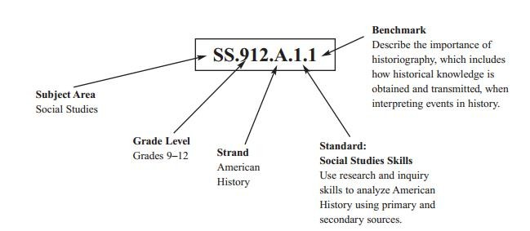

Each MAFS benchmark is labeled with a system of letters and numbers.

• The four letters in the first position of the label identify the Subject.

• The number(s) in the second position represents the Grade Level.

• The letter(s) in the third position represents the Category.

• The number in the fourth position shows the Domain.

• The number in the fifth position identifies the Cluster.

• The number in the last position identifies the specific Benchmark.

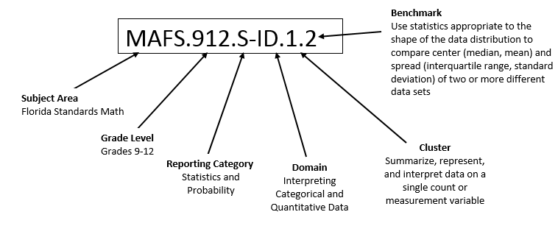
Definitions of Benchmark Specifications

The Individual Benchmark Specifications provides standard-specific guidance for assessment item development for CFAC item banks. For each benchmark assessed, the following information is provided.

Reporting Category | is a grouping of related benchmarks that can be used to summarize and report achievement.
Standard | refers to the standard statement presented in the NGSSS or in the Florida Standards.
Benchmark  Also Assesses | refers to the benchmark statement presented in the NGSSS or standard statement in the Florida Standards. In some cases, two or more related benchmarks are grouped together because the assessment of one benchmark addresses another benchmark. Such groupings are indicated in the Also Assesses statement.  refers to the benchmarks that are closely related to the benchmark (see description above)
Item Types  Cognitive  Complexity | are used to assess the benchmark or group of benchmark.  ideal level at which item should be assessed.
Benchmark Clarifications | explain how achievement of the benchmark will be demonstrated by students. In other words, the clarification statements explain what the student will do when responding to questions.
Content Limits | define the range of content knowledge and that should be assessed in the items for the benchmark.
Stimulus Attributes | define the types of stimulus materials that should be used in the items, including the appropriate use of graphic materials and item context or content.
Response Attributes  Content Focus | define the characteristics of the answers that a student must choose or provide.  defines the content measured by each test item. Content focus addresses the broad content and skills associated with the examples found in the standards, benchmarks, or benchmark clarifications.
Sample Items | are provided for each type of question assessed. The correct answer for all sample items is provided.

II. Individual Benchmark Specifications

Reporting Category | Sociology
Standard | Foundations of Sociology as a Social Science/Identify methods and strategies of research and examine the contributions of sociology to the understanding of social issues.
Benchmark | SS.912.S.1.2 Identify early leading theorists within social science.
Also Assesses | Not Applicable
Item Types | Selected Response
Cognitive Complexity Level | Low
Benchmark  Clarification | Students will be able to demonstrate their familiarity with the work of key figures in sociology and apply their concepts.
Content Limits | Limited to theorists in sociology and, in some cases, psychology.
Stimulus Attributes | First and last names should be used for theorists.  May include text/passages, images, or charts/graphs.
Response Attributes | None Specified
Content Focus | These terms are given in addition to those found in the standards, benchmarks, and benchmark clarifications. Additional items may include, but are not limited to, the following: Auguste Comte, Emile Durkheim, Herbert Spencer, Max Weber, Harriet Martineau, W.E.B. DuBois, Karl Marx, and B.F. Skinner.
Sample Item | Which early leading theorist, considered a founder of sociology, wrote Suicide (1897), a study of suicide rates in Catholic and Protestant populations, which served to distinguish social science?  A. Auguste Comte  B. Emile Durkheim  C. Karl Marx  D. B. F. Skinner  Correct Answer: B

Reporting Category | Sociology
Standard | Foundations of Sociology as a Social Science/Identify methods and  strategies of research and examine the contributions of sociology to the understanding of social issues.
Benchmark | SS.912.S.1.5 Evaluate various types of sociologic research methods.
Also Assesses | Not Applicable
Item Types | Selected Response
Cognitive Complexity Level | Low
Benchmark Clarifications | Students will understand the fundamental concepts of sociological research, including, but not limited to, experiments, surveys, and observations.  Students will know which types of research are most appropriate for investigating various topics in the field.
Content Limits | Limited to research methods used specifically in sociology, not other disciplines.
Stimulus Attributes | May include text/passages, images, or charts/graphs.
Response Attributes | None Specified
Content Focus | These terms are given in addition to those found in the standards,  benchmarks, and benchmark clarifications. Additional items may include, but are not limited to, the following: participation, unobtrusive measures, controlled experiment, field experiment, survey, hypothesis, variable, independent variable, dependent variable, operational definitions, validity, reliability, content analysis, replication, population, sample, random sample, stratified respondents, questionnaires, interview, rapport, participant observation, generalizability, secondary analysis, and causation.
Sample Item | A student is conducting research on the importance of teenagers taking driver's education. Before you begin collecting data, you write down the following:  "Teenagers who have taken driver's education will have fewer accidents in their first three years of driving than teenagers who have not taken driver's education."  Which of the following best describes this statement?  A. It is a hypothesis.  B. It is impossible to test.  C. It is a spurious correlation.  D. It states an analysis of the results of the research.  Correct Answer: A

Reporting Category | Sociology
Standard | Foundations of Sociology as a Social Science/Identify methods and  strategies of research and examine the contributions of sociology to the understanding of social issues.
Benchmark | SS.912.S.1.7 Determine cause-and-effect relationship issues among events as they relate to sociology.
Also Assesses | Not Applicable
Item Types | Selected Response
Cognitive Complexity Level | Moderate
Benchmark Clarifications | Students will understand the experiment process used to determine causal effects among variables as opposed to correlational or descriptive results from other research methods that show a relationship, but not a causal relationship.
Content Limits | Limited to cause-and-effect relationships, not correlational.
Stimulus Attributes | May include text/passages, images, or charts/graphs.
Response Attributes | None Specified
Content Focus | These terms are given in addition to those found in the standards,  benchmarks, and benchmark clarifications. Additional items may include, but are not limited to, the following: dependent variables, independent variables, extraneous variables, confounding of variables, and experiments.
Sample Item | In July 2012, there were several forest fires in Milltown. During this  time, there was a severe drought and seven consecutive days where the temperature reached over 100 degrees. At each forest fire in Milltown a red fire truck was present.  What was the effect of the drought and extreme heat?  A. presence of a red fire truck  B. seven consecutive days of over 100 degree temperatures  C. several forest fires  D. a state of emergency was declared  Correct Answer: C

Reporting Category | Sociology
Standard | Culture/Examine the influence on the individual and the way cultural  transmission is accomplished.
Benchmark | SS.912.S.2.1 Define the key components of a culture, such as knowledge, language and communication, customs, values, norms, and physical objects.
Also Assesses | Not Applicable
Item Types | Selected Response
Cognitive Complexity Level | Low
Benchmark Clarifications | Students will recognize the most fundamental features that shape and influence any given culture and understand how this influences the individual and the group.
Content Limits | None Specified
Stimulus Attributes | May include text/passages, images, or charts/graphs.
Response Attributes | None Specified
Content Focus | These terms are given in addition to those found in the standards, benchmarks, and benchmark clarifications. Additional items may include, but are not limited to, the following: culture, subculture, counterculture, material culture, nonmaterial culture, culture shock, ethnocentrism, cultural relativism, symbolic culture, symbol, gestures, culture contact, pluralistic society, knowledge, language and communication, customs, values, norms and physical objects.
Sample Item | Which is not a component of the Navajo culture?  A. Baby’s First Laugh Ceremony  B. Sierra-Nevada Mountain Range  C. Southern Athabaskan Language  D. Squash Blossom Necklace  Correct Answer: B

Reporting Category | Sociology
Standard | Culture/Examine the influence on the individual and the way cultural  transmission is accomplished.
Benchmark | SS.912.S.2.2 Explain the differences between a culture and a society.
Also Assesses | Not Applicable
Item Types | Selected Response, Short Answer
Cognitive Complexity Level | Moderate
Benchmark Clarifications | Students will identify the differences between a culture and a society by being able to differentiate between the characteristics of each while also having an understanding of the sociological descriptions of their composition and the practices of the people.
Content Limits | None Specified
Stimulus Attributes | May include text/passages, images, or charts/graphs.
Response Attributes | None Specified
Content Focus | These terms are given in addition to those found in the standards,  benchmarks, and benchmark clarifications. Additional items may include, but are not limited to, the following: culture, material culture, nonmaterial culture, culture shock, ethnocentrism, cultural relativism, symbolic culture, culture contact, subculture, counterculture, and pluralistic society.
Sample Item | The Berlin Conference of 1884-1885 allowed the European powers to  super-impose a political division of 50 irregularly shaped nations on top of over 1,000 indigenous cultures and regions of Africa.  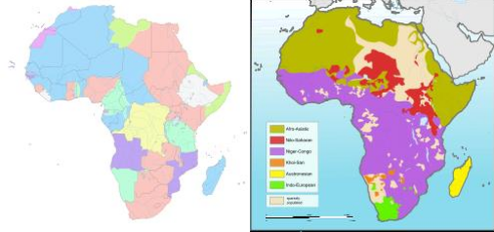  Compare the political map of Africa with the language distribution map of Africa. http://en.wikipedia.org/wiki/Africa. Which nation could be considered a society with its own distinct culture?  A. Kenya  B. Madagascar  C. Namibia  D. Niger  Correct Answer: B

Reporting Category | Sociology
Standard | Culture/Examine the influence on the individual and the way cultural  transmission is accomplished.
Benchmark | SS.912.S.2.3 Recognize the influences of genetic inheritance and culture on human behavior.
Also Assesses | Not Applicable
Item Types | Selected Response
Cognitive Complexity Level | High
Benchmark Clarifications | Students will understand how the genetic makeup of individuals plays a role in their behavior and interaction in society.  Students will understand how the culture of an individual influences their behavior and their understanding of the world and other people within and outside their own culture.
Content Limits | None Specified
Stimulus Attributes | May include text/passages, images, or charts/graphs.
Response Attributes | None Specified
Content Focus | These terms are given in addition to those found in the standards,  benchmarks, and benchmark clarifications. Additional items may include, but are not limited to, the following: cultural universal, sociobiology, animal culture, social environment, feral children, isolated children, institutionalized children, id, ego, superego, and nature vs. nurture.
Sample Item | Analyze the tabula rasa (“blank slate”) theory of John Locke and  determine where it falls in the nature vs. nurture debate.  From where did John Locke believe that humans acquire nearly all of their behavioral traits?  A. both the environment and genetic influences  B. the environment  C. genetic influences  D. neither the environment nor genetic influences  Correct Answer: B

Reporting Category | Sociology
Standard | Culture/Examine the influence on the individual and the way cultural  transmission is accomplished.
Benchmark | SS.912.S.2.4 Give examples of subcultures and describe what makes them unique.
Also Assesses | SS.912.S.2.5 Compare social norms among various subcultures.
Item Types | Selected Response, Short Answer
Cognitive Complexity Level | Moderate
Benchmark Clarifications | Students will identify subcultures.  Students will describe what makes subcultures distinctive.  Students will compare social norms among various subcultures.
Content Limits | None Specified
Stimulus Attributes | May include text/passages, images, or charts/graphs
Response Attributes | None Specified
Content Focus | These terms are given in addition to those found in the standards,  benchmarks, and benchmark clarifications. Additional items may include, but are not limited to, the following: values, norms, taboo, counterculture, folkways, mores, and assimilation.
Sample Item | Rock 'n' roll music was part of the teenage subculture of the 1950s and 1960s. This genre of music has assimilated into the mainstream. Rap music is part of the teenage subculture of today. Which characteristic would not distinguish people of this subculture from the mainstream?  A. distinctive dress  B. family values  C. style of music  D. use of language  Correct Answer: B

Reporting Category | Sociology
Standard | Culture/Examine the influence on the individual and the way cultural  transmission is accomplished.
Benchmark | SS.912.S.2.5 Compare social norms among various subcultures.
Also Assesses | Not Applicable
Item Types | Selected Response
Cognitive Complexity Level | Moderate
Benchmark Clarifications | Students will be able to identify similarities and patterns of behavior amongst various subcultures.
Content Limits | None Specified
Stimulus Attributes | May include text/passages, images, or charts/graphs.
Response Attributes | None Specified
Content Focus | These terms are given in addition to those found in the standards,  benchmarks, and benchmark clarifications. Additional items may include, but are not limited to, the following: values, norms, taboo, counterculture, folkways, and mores.
Sample Item | What values of a traditional Chinese American would conflict with mainstream American society?  A. Chinese Americans value education.  B. Chinese Americans value hard work.  C. Chinese Americans value family members.  D. Chinese Americans value interdependence.  Correct Answer: D

Reporting Category | Sociology
Standard | Culture/Examine the influence on the individual and the way cultural  transmission is accomplished.
Benchmark | SS.912.S.2.6 Identify the factors that promote cultural diversity  within the United States.
Also Assesses | SS.912.S.2.7 Explain how various practices of the culture create differences within group behavior.
Item Types | Selected Response, Short Answer
Cognitive Complexity Level | Moderate
Benchmark Clarifications | Students will be able to recognize and/or describe the various conditions within the United States that encourage the growth of minority cultures.
Content Limits | Content should be limited to diversity within the United States, not other parts of the world.
Stimulus Attributes | May include text/passages, images, or charts/graphs.
Response Attributes | None Specified
Content Focus | These terms are given in addition to those found in the standards,  benchmarks, and benchmark clarifications. Additional items may include, but are not limited to, the following: immigration, religion, social class, and political orientation.
Sample Item | Explain how the First Amendment of the US Constitution promotes  cultural diversity.  sample full credit response:  The First Amendment allows the citizens of the country to exercise  their right to practice (or not) a religion of their choosing. This  encourages tolerance and acceptance of people who have various  religious backgrounds and varying spiritual beliefs and rituals.  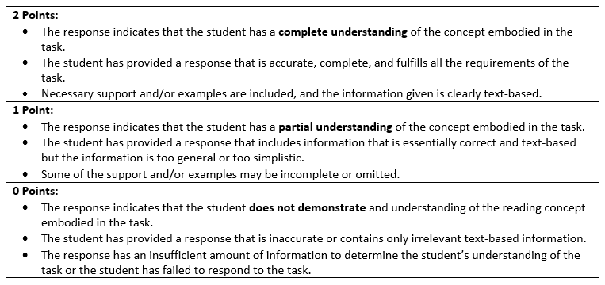

Reporting Category | Sociology
Standard | Culture/Examine the influence on the individual and the way cultural  transmission is accomplished.
Benchmark | SS.912.S.2.8 Compare and contrast different types of societies, such as hunting and gathering, agrarian, industrial, and post-industrial.
Also Assesses | Not Applicable
Item Types | Selected Response
Cognitive Complexity Level | Moderate
Benchmark Clarifications | Students will be able to identify common patterns among different societies, as well as recognize the different aspects of each type of society, and understand how these various ways of living impact the individual.
Content Limits | Content should be limited to the types of societies listed in content  focus section.
Stimulus Attributes | May include text/passages, images, or charts/graphs
Response Attributes | None Specified
Content Focus | These terms are given in addition to those found in the standards,  benchmarks, and benchmark clarifications. Additional items may include, but are not limited to, the following: hunting and gathering societies, pastoral and horticultural societies, agricultural societies, industrial societies, and postindustrial societies.
Sample Item | How did pastoral and horticultural societies differ from agricultural society?  A. An agricultural society was based on large-scale agriculture which depended on plows drawn by animals.  B. A pastoral society settled in one place and raised animals to eat, while an agricultural society was based on the production of crops.  C. A horticultural society required its settlers to gather vegetation, while agricultural societies finally allowed settlers to build permanent settlements.  D. An agricultural society was based on several new inventions, whereas the pastoral and horticultural societies were only based on one invention.  Correct Answer: A

Reporting Category | Sociology
Standard | Culture/Examine the influence on the individual and the way cultural  transmission is accomplished.
Benchmark | SS.912.S.2.10 Demonstrate democratic approaches to managing disagreements and resolving conflicts within a culture.
Also Assesses | Not Applicable
Item Types | Selected Response
Cognitive Complexity Level | High
Benchmark Clarifications | Students will identify both rights and responsibilities the individual has to a group.
Content Limits | None Specified
Stimulus Attributes | May include text/passages, images, or charts/graphs
Response Attributes | None Specified
Content Focus | These terms are given in addition to those found in the standards,  benchmarks, and benchmark clarifications. Additional items may  include, but are not limited to, the following: primary groups, secondary groups, in-groups, out-groups, reference groups, clique, social network, dyad, triad, leader, instrumental leader, expressive leader, authoritarian leader, democratic leader, and laissez-faire leader.
Sample Item | How does democratic leadership affect the way groups perform?  A. These leaders require members to keep them informed of every  detail of the group’s activity.  B. These leaders are most effective when group members are  knowledgeable and motivated.  C. These leaders can be ineffective because they demand strict compliance from group members.  D. These leaders are the most effective because they offer guidance and include members in decision-making.  Correct Answer: D

Reporting Category | Sociology
Standard | Social Status/Identify how social status influences individual and group behaviors and how that status relates to the position a person occupies within a social group.
Benchmark | SS.912.S.3.2 Explain how roles and role expectations can lead to role conflict.
Also Assesses | Not Applicable
Item Types | Selected Response
Cognitive Complexity Level | Moderate
Benchmark Clarifications | Students will understand how miscommunication between individuals and groups regarding their responsibilities in their respective roles can lead to role conflict and discourage group cohesiveness.
Content Limits | None Specified
Stimulus Attributes | May include text/passages, images, or charts/graphs.
Response Attributes | None Specified
Content Focus | These terms are given in addition to those found in the standards, benchmarks, and benchmark clarifications.  Additional items may include, but are not limited to, the following: work and family, gender roles, behavior linked to age, role conflict, role strain, ascribed status, achieved status, and master status.
Sample Item | How do gender roles create conflict and strain in individuals?  A. They deny individuals basic personal liberties.  B. They are always passively accepted by children and adolescents.  C. They eliminate the stress of making decisions about short and long-term goals.  D. They set expectations about appropriate behaviors, careers, and interests that restrict individual preferences.  Correct Answer: D

Reporting Category | Sociology
Standard | Social Groups/Explore the impact of social groups on individual and  group behavior.
Benchmark | SS.912.S.4.3 Examine the ways that groups function, such as roles, interactions, and leadership.
Also Assesses | Not Applicable
Item Types | Selected Response
Cognitive Complexity Level | High
Benchmark Clarifications | Students will examine the ways that groups function.  Students will examine the different roles people have within groups.  Students will examine the interactions between people within groups.  Students will examine the different types of leadership skills and qualities within groups.
Content Limits | None Specified
Stimulus Attributes | Text/passages, images, or charts/graphs
Response Attributes | None Specified
Content Focus | These terms are given in addition to those found in the standards,  benchmarks, and benchmark clarifications. Additional items may include, but are not limited to, the following: primary groups, secondary groups, in-groups, out-groups, reference groups, group conformity, clique, social network, dyad, triad, leader, instrumental leader, expressive leader, authoritarian leader, democratic leader, laissez-faire leader, aggregate, networking, and coalition.
Sample Item | People watching a football game on television typically act rowdy and yell louder when they are with a group of rowdy friends than if they are alone. What best describes this behavior?  A. group conformity  B. positivism  C. social dynamics  D. social statics  Correct Answer: A

Reporting Category | Sociology
Standard | Social Groups/Explore the impact of social groups on individual and  group behavior.
Benchmark | SS.912.S.4.6 Identify the various types of norms (folkways, mores, laws, and taboos) and explain why these rules of behavior are considered important to society.
Also Assesses | Not Applicable
Item Types | Selected Response, Short Answer
Cognitive Complexity Level | Low
Benchmark Clarifications | Students will identify the various types of norms, focusing on folkways, mores, laws, and taboos.  Students will explain why these rules of behavior are considered important to society.
Content Limits | None Specified
Stimulus Attributes | May include text/passages, images, or charts/graphs.
Response Attributes | None Specified
Content Focus | These terms are given in addition to those found in the standards,  benchmarks, and benchmark clarifications. Additional items may include, but are not limited to, the following: values, norms, sanction, positive sanction, negative sanction, folkways, mores, laws, taboo, subculture, and counterculture.
Sample Item | In the United States, most people believe that every child is entitled to an education. This an example of what?  A. a law  B. a norm  C. a taboo  D. a value  Correct Answer: D

Reporting Category | Sociology
Standard | Social Groups/Explore the impact of social groups on individual and  group behavior.
Benchmark | SS.912.S.4.7 Discuss the concept of deviance and how society both encourages and discourages deviant behavior using social control.
Also Assesses | Not Applicable
Item Types | Selected Response
Cognitive Complexity Level | High
Benchmark Clarifications | Students will be able to identify how deviant behaviors on the part of the individual or of a group are influenced and controlled by government agencies, family units, and peer groups.
Content Limits | None Specified
Stimulus Attributes | May include text/passages, images, or charts/graphs.
Response Attributes | None Specified
Content Focus | These terms are given in addition to those found in the standards,  benchmarks, and benchmark clarifications. Additional items may include, but are not limited to, the following: types of groups, group dynamics, peer groups, boundaries, initiation rites, primary groups, secondary groups, leaders, social processes, conflict, cooperation, competition, and deviance.
Sample Item | In the United States, deviance refers to all violations of social rules.  Which behavior is not considered deviant in our society?  A. public drunkenness  B. taking hallucinogenic drugs  C. underage alcohol use  D. using medicinal marijuana  Correct Answer: D

Reporting Category | Sociology
Standard | Social Groups/Explore the impact of social groups on individual and group behavior.
Benchmark | SS.912.S.4.12 Determine the cultural patterns of behavior within such social groups as rural/urban or rich/poor.
Also Assesses | Not Applicable
Item Types | Selected Response
Cognitive Complexity Level | Moderate
Benchmark Clarifications | Students will be able to distinguish behavior patterns among individuals based on their socioeconomic status.
Content Limits | None Specified
Stimulus Attributes | May include text/passages, images, or charts/graphs.
Response Attributes | None Specified
Content Focus | These terms are given in addition to those found in the standards,  benchmarks, and benchmark clarifications. Additional items may include, but are not limited to, the following: socioeconomic status, education, entertainment, etiquette, poverty, welfare, and social programs.
Sample Item | Which would not cause differences in patterns of behavior in different social groups?  A. economic status  B. eye color  C. geographic location  D. race  Correct Answer: B

Reporting Category | Sociology
Standard | Social Institutions/Identify the effects of social institutions on individual and group behavior.
Benchmark | SS.912.S.5.1 Identify basic social institutions and explain their impact on individuals, groups and organizations within society and how they transmit the values of society.
Also Assesses | Not Applicable
Item Types | Selected Response
Cognitive Complexity Level | High
Benchmark Clarifications | Students will understand how religious organizations, educational systems, sports organizations, entertainment industries, and other social institutions communicate what the values of a given society are and influence the behavior of individuals.
Content Limits | None Specified
Stimulus Attributes | May include text/passages, images, or charts/graphs.
Response Attributes | None Specified
Content Focus | These terms are given in addition to those found in the standards,  benchmarks, and benchmark clarifications. Additional items may include, but are not limited to, the following: familial, religious, educational, economic, and political institutions.
Sample Item | A child learns how to behave within her family by watching how her parents judge her behavior and then judging herself accordingly. What did Charles Horton Cooley called this process?  A. desocialization  B. the looking glass self  C. the play stage  D. resocialization  Correct Answer: B

Reporting Category | Sociology
Standard | Social Institutions/Identify the effects of social institutions on individual and group behavior.
Benchmark | SS.912.S.5.6 Identify the factors that influence change in social norms over time.
Also Assesses | Not Applicable
Item Types | Selected Response
Cognitive Complexity Level | High
Benchmark Clarifications | Students will be able to recognize how events, circumstances, technological innovations, and people influence and reshape the norms of a society over a period of time.
Content Limits | None Specified
Stimulus Attributes | May include text/passages, images, or charts/graphs.
Response Attributes | None Specified
Content Focus | These terms are given in addition to those found in the standards,  benchmarks, and benchmark clarifications. Additional items may include, but are not limited to, the following: education, media, technology, cultural paradigms, natural resources, values, family dynamics, economics, and government structure.
Sample Item | Which statement identifies a norm that has changed over time?  A. Smoking changed from a glamorous activity to a deviant activity.  B. States implemented a minimum age for obtaining a driver’s license.  C. The government stresses the importance of education for children.  D. Students are required to take standardized tests to show progress and growth.  Correct Answer: A

Reporting Category | Sociology
Standard | Social Institutions/Identify the effects of social institutions on individual and group behavior.
Benchmark | SS.912.S.5.7 Use various resources to interpret information about cultural life in the United States and other world cultures, both in the past and today.
Also Assesses | Not Applicable
Item Types | Selected Response
Cognitive Complexity Level | High
Benchmark Clarifications | Students will be able to use primary source documents, maps, graphs, charts, and other various tools to understand contemporary and past cultural aspects of the United States and other cultures.
Content Limits | None Specified
Stimulus Attributes | May include text/passages, images, or charts/graphs.
Response Attributes | None Specified
Content Focus | These terms are given in addition to those found in the standards,  benchmarks, and benchmark clarifications. Additional items may include, but are not limited to, the following: various world religions, different government structures, empires, tribes, and ancient cultures (Egypt, Rome, Greece), Paleolithic, and Neolithic.
Sample Item | Which type of building will a Muslim who lives in Iraq enter in order to attend religious services?  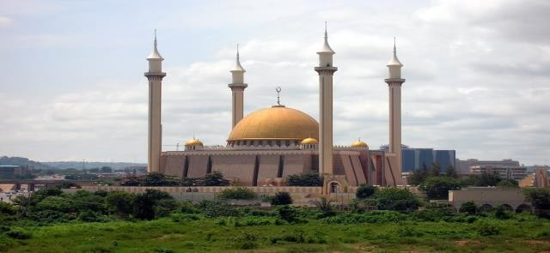  Author: Shiraz Chakera http://en.wikipedia.org/wiki/File:AbujaNationalMosque.jpg  A. cathedral  B. church  C. mosque  D. temple  Correct Answer: C

Reporting Category | Sociology
Standard | Social Institutions/Identify the effects of social institutions on  human behavior.
Benchmark | SS.912.S.5.5 Define ethnocentrism and explain how it can be beneficial or destructive to a culture.
Also Assesses | Not Applicable
Item Types | Selected Response, Short Answer
Cognitive Complexity Level | Moderate
Benchmark Clarifications | Students will understand the concept of ethnocentrism and recognize circumstances when this can be helpful and promote societal goals, and when it can be detrimental to a culture.
Content Limits | None Specified
Stimulus Attributes | May include text/passages, images, or charts/graphs.
Response Attributes | None Specified
Content Focus | These terms are given in addition to those found in the standards,  benchmarks, and benchmark clarifications. Additional items may include, but are not limited to, the following: ethnocentrism and cultural relativism.
Sample Item | Which scenario best describes the concept of cultural relativism?  A. a college student takes a course on cultural diversity  B. an Egyptian artist protests, demanding the removal of culture minister  C. a European tourist visits the United States and takes his family to visit Disney World  D. an American appreciates the cultural importance of bullfighting while visiting Spain  Correct Answer: D

Reporting Category | Sociology
Standard | Social Institutions/Identify the effects of social institutions on human  behavior.
Benchmark | SS.912.S.5.9 Identify both rights and responsibilities the individual has to primary and secondary groups.
Also Assesses | Not Applicable
Item Types | Selected Response
Cognitive Complexity Level | Moderate
Benchmark Clarifications | Students will understand the roles and responsibilities of individuals in both primary and secondary groups, as well as the rights afforded to them because of their membership within the group.  .
Content Limits | None Specified
Stimulus Attributes | May include text/passages, images, or charts/graphs
Response Attributes | None Specified
Content Focus | These terms are given in addition to those found in the standards,  benchmarks, and benchmark clarifications. Additional items may include, but are not limited to, the following: family, education, economy, religion, and government.
Sample Item | Many of the residents of a small town have joined together to create a neighborhood park. What does this collection of people represent?  A. primary group  B. secondary group  C. social aggregate  D. social category  Correct Answer: B

Reporting Category | Sociology
Standard | Social Change/Examine the changing nature of society.
Benchmark | SS.912.S.6.2 Examine various social influences that can lead to immediate and long-term changes.
Also Assesses | Not Applicable
Item Types | Selected Response
Cognitive Complexity Level | High
Benchmark Clarifications | Students will recognize factors that contribute to the short-term and long-term evolution of a society.
Content Limits | None Specified
Stimulus Attributes | May include text/passages, images, or charts/graphs.
Response Attributes | None Specified
Content Focus | These terms are given in addition to those found in the standards,  benchmarks, and benchmark clarifications. Additional items may include, but are not limited to, the following: natural and man-made disasters, spatial movement of people, technology, urbanization, industrialization, immigration, war, challenge to authority, laws, diffusion of cultural traits, discrimination, discoveries and inventions, and scientific exploration.
Sample Item | Which is not likely to bring about significant social change?  A. climate change  B. development of cell phone technology  C. Gay Rights Movement  D. new brand of computer  Correct Answer: D

Reporting Category | Sociology
Standard | Social Change/Examine the changing nature of society.
Benchmark | SS.912.S.6.7 Distinguish major differences between social movements and collective behavior with examples from history and the contemporary world.
Also Assesses | Not Applicable
Item Types | Selected Response
Cognitive Complexity Level | High
Benchmark Clarifications | Students will be able to recognize the distinguishing aspects of various social movements from current events and historical events.
Content Limits | None Specified
Stimulus Attributes | May include text/passages, images, or charts/graphs.
Response Attributes | None Specified
Content Focus | These examples are given in addition to those found in the standards,  benchmarks, and benchmark clarifications. Additional items may include, but are not limited to, the following: the March on Washington (1963) vs. 1960s race riots.
Sample Item | 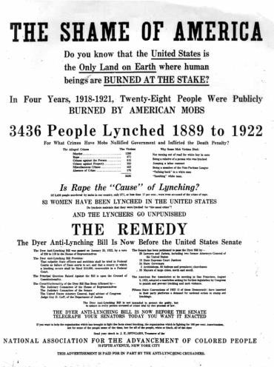  The image above was circulated in 1934 by the National Association for the Advancement of Colored People (NAACP). What was the purpose of the document?  A. to accuse African Americans of crimes  B. to promote collective action  C. to raise money for the NAACP  D. to support a social movement  Correct Answer: D

Reporting Category | Sociology
Standard | Social Change/Examine the changing nature of society.
Benchmark | SS.912.S.6.6 Describe how the role of the mass media has changed over time and project what changes might occur in the future.
Also Assesses | Not Applicable
Item Types | Selected Response
Cognitive Complexity Level | High
Benchmark Clarifications | Students will have an understanding of how the media's coverage of various topics and events has changed over time impacting the perspective of the masses.  Students will be able to make assumptions about the direction of the media in the future based on current trends.
Content Limits | None Specified
Stimulus Attributes | May include text/passages, images, or charts/graphs.
Response Attributes | None Specified
Content Focus | These examples are given in addition to those found in the standards,  benchmarks, and benchmark clarifications. Additional items may include, but are not limited to, the following: media influence on political elections, norms of language in television, and applications of technology in the future.
Sample Item | 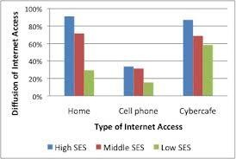  Based on the chart above, what impact has the Internet had on social stratification?  A. It has created equality since everyone has access to the internet.  B. It has made all people more knowledgeable about social problems.  C. It has provided more advantages to those in low socioeconomic social levels.  D. It has reinforced social stratification because access is not evenly distributed across socioeconomic levels.  Correct Answer: D

Reporting Category | Sociology
Standard | Social Problems/Analyze a range of social problems in today's world.
Benchmark | SS.912.S.7.1 Identify characteristics of a social problem, as opposed to an individual problem.
Also Assesses | Not Applicable
Item Types | Selected Response
Cognitive Complexity Level | Moderate
Benchmark Clarifications | Students will be able to differentiate between issues that are regarded  as social problems, and therefore on a larger scale that should be addressed by society as a whole, and issues that are the result of an individual's problems with living and are not influenced by larger social issues.
Content Limits | None Specified
Stimulus Attributes | May include text/passages, images, or charts/graphs.
Response Attributes | None Specified
Content Focus | These terms are given in addition to those found in the standards,  benchmarks, and benchmark clarifications. Additional items may include, but are not limited to, the following: unemployment, family relationships, careers, peer relationships, education, crime, deviance, and poverty.
Sample Item | John Smith has been unemployed for six months. Which social problem may be contributing to his unemployment?  - John has not used his social media network.  - John lives in a town with no immediate family.  - John has not used his connections from college.  - John lives in a town with a high unemployment rate.  Correct Answer: D  Correct Answer: D

