central florida assessment collaborative
Individual Test Item Specifications
Pre-Calculus
2013

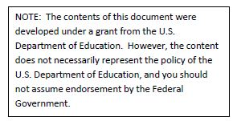

Table of Contents

I. Guide to the Individual Benchmark Specifications 2
Benchmark Classification System 2
Definitions of Benchmark Specifications 4
II. Individual Benchmark Specifications 5
MAFS.912.C.1.2 5
MAFS.912.C.1.3 7
MAFS.912.C.1.4 8
MAFS.912.C.1.5 10
MAFS.912.A-APR.4.6 12
MAFS.912.F-BF.2.4 14
MAFS.912.F-TF.1.2 16
MAFS.912.F-TF.1.3 17
MAFS.912.F-TF.2.5 19
MAFS.912.F-TF.2.6 22
MAFS.912.F-TF.3.8 24
MAFS.912.F-TF.3.9 26
MAFS.912.G-GPE.1.1 28
MAFS.912.G-GPE.1.2 30
MAFS.912.G-GPE.1.3 31
MAFS.912.G-SRT.3.8 33
MAFS.912.G-SRT.4.9 35
MAFS.912.G-SRT.4.10 36
MAFS.912.N-CN.1.3 38
MAFS.912.N-CN.2.4 40
MAFS.912.N-CN.2.5 42
MAFS.912.N-CN.3.9 44
MAFS.912.N-VM.1.1 45
MAFS.912.N-VM.1.2 47
MAFS.912.N-VM.1.3 48
MAFS.912.N-VM.2.4 50
MAFS.912.N-VM.2.5 52

I. Guide to the Individual Benchmark Specifications

Content specific guidelines are given in the Individual Benchmark Specifications for each course. The Specifications contains specific information about the alignment of items with the Florida Standards. It identifies the manner in which each benchmark is assessed, provides content limits and stimulus attributes for each benchmark, and gives specific information about content, item types, and response attributes.

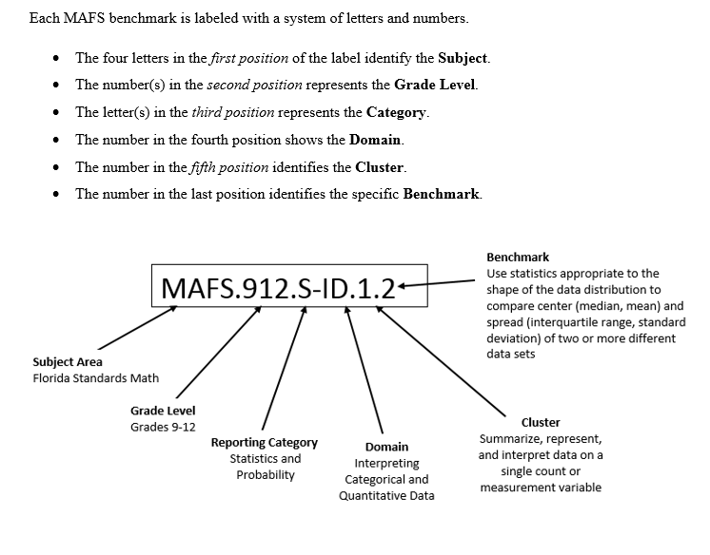

Definitions of Benchmark Specifications
The Individual Benchmark Specifications provides standard-specific guidance for assessment item development for CFAC item banks. For each benchmark assessed, the following information is provided:

Reporting Category | is a grouping of related benchmarks that can be used to summarize and report achievement.
Standard | refers to the standard statement presented in the Florida Standards.
Benchmark  Also Assesses | refers to the benchmark statement presented in the standard statement in the Florida Standards. In some cases, two or more related benchmarks are grouped together because the assessment of one benchmark addresses another benchmark. Such groupings are indicated in the Also Assesses statement.  refers to the benchmarks that are closely related to the benchmark (see description above).
Item Types  Cognitive Complexity Level | are used to assess the benchmark or group of benchmark.  ideal level at which the item should be assessed.
Benchmark Clarifications | explain how achievement of the benchmark will be demonstrated by students. In other words, the clarification statements explain what the student will do when responding to questions.
Content Limits | define the range of content knowledge and that should be assessed in the items for the benchmark.
Stimulus Attributes | define the types of stimulus materials that should be used in the items, including the appropriate use of graphic materials and item context or content.
Response Attributes | define the characteristics of the answers that a student must choose or provide.
Sample Items | are provided for each type of question assessed. The correct answer for all sample items is provided.

II. Individual Benchmark Specifications

Reporting Category | Calculus
Standard | Limits and Continuity
Benchmark Number | MAFS.912.C.1.2
Benchmark | Find limits by substitution.
Also Assesses | MAFS.912.C.1.11
Item Types | Selected Response (Multiple Choice), Gridded Response, Short Answer
Cognitive Complexity Level | Low
Benchmark Clarification | Students will demonstrate their knowledge of evaluating limits by substituting values within the functions.
Content Limits | The function must be defined at the value the limit is to be evaluated on the real number system.
Stimulus Attributes | Items may be set in real world or mathematical context.  Graphs of the function may be provided but are not required.  Functions may include polynomial, trigonometric, rational, logarithmic, and exponential.
Response Attributes | None Specified

Sample Items | - Evaluate the following: $\lim_{x→6}{\frac{6}{x+2}}$  Correct Answer: $\frac{3}{4}$  - Evaluate the following: $\lim_{x→\frac{2π}{3}}{\tan{x}}$  Correct Answer: -$\sqrt{3}$  - Which of the following limits are undefined?  - $\lim_{x→2}{\frac{x-6}{x-2}}$  - $\lim_{x→6}{\frac{x-6}{x-2}}$  - $\lim_{x→3}{\frac{x-6}{x-2}}$  - i only  - ii only  - i and ii  - i, ii, and iii  Correct Answer: A

Reporting Category | Calculus
Standard | Limits and Continuity
Benchmark Number | MAFS.912.C.1.3
Benchmark | Find limits of sums, differences, products, and quotients.
Also Assesses | MAFS.912.C.1.1
Item Types | Selected Response (Multiple Choice), Gridded Response, Short Answer
Cognitive Complexity Level | Low
Benchmark Clarification | Students will be able to use and apply the properties of limits to find the limit of various functions.
Content Limits | Items should not require analytical estimation.  Items should not have function in denominator equal to zero.
Stimulus Attributes | Items may be set in real world or mathematical context.  Graphs of the function may be provided but are not required.  Functions may include polynomial, trigonometric, rational, logarithmic, and exponential.
Response Attributes | None Specified
Sample Items | - Using the given information, what is the value for each limit?  $$\lim_{x→c}{f\left(x\right)=7 \text{and} \lim_{x→c}{g\left(x\right)=-2}}$$  - $\lim_{x→c}{{\left[f\left(x\right)+g\left(x\right)\right]}^{3}}$  - $\lim_{x→c}\left[-3f\left(x\right)g\left(x\right)\right]$  Correct Answer: A: 125 B: 42

Reporting Category | Calculus
Standard | Limits and Continuity
Benchmark Number | MAFS.912.C.1.4
Benchmark | Find limits of rational functions that are undefined at a point.
Also Assesses | MAFS.912.C.1.9  MAFS.912.C.1.10  MAFS.912.C.1.11
Item Types | Selected Response (Multiple Choice), Gridded Response, Short Answer
Cognitive Complexity Level | Low
Benchmark Clarification | Students will be able to find, evaluate, and apply the limits of various functions in terms of a rational function.  Students will generalize end behavior based on a function  Students will differentiate between continuous and discontinuous behavior.  Students will differentiate between the types of discontinuities and how those differences relate to limits.  Students will determine continuity in terms of limits
Content Limits | Answers of infinity should not be used on Gridded Response type items.
Stimulus Attributes | Item should be set in mathematical context.  Graphs of the function may be provided but are not required.  Functions may include polynomial, trigonometric, rational, logarithmic, and exponential.
Response Attributes | None Specified

Sample Items | - Evaluate the following:  $\lim_{x→5}{\frac{5-x}{x^{2}-25}}$  - $\frac{1}{10}$  - $\frac{-1}{10}$  - 0  - ∞  Correct Answer: B  - Luis was evaluating the following function:  $f\left(x\right)=\frac{x+2}{x^{2}-4}$  He determined there were discontinuities at $x=±2$. Which of the following correctly identifies the justification for the discontinuity?  - $x=2 \text{is removeable because} \lim_{x→2}{f(x)} \text{exists.}$  - $x=2 \text{is non-removeable because} \lim_{x→2}{f(x)} \text{exists.}$  - $x=-2 \text{is removeable because} \lim_{x→-2}{f(x)} \text{exists.}$  - $x=-2 \text{is non-removeable because} \lim_{x→-2}{f(x)} \text{exists.}$  Correct Answer: C

Reporting Category | Calculus
Standard | Limits and Continuity
Benchmark Number | MAFS.912.C.1.5
Benchmark | Find one-sided limits.
Also Assesses | MAFS.912.C.1.9
Item Types | Selected Response (Multiple Choice), Gridded Response, Short Answer
Cognitive Complexity Level | Low
Benchmark Clarification | Students will estimate limits graphically, algebraically, or numerically from one side of a defined point.  This can also extend to using limits to determine continuity, decide whether a function is continuous at a point, and to find types of discontinuities.
Content Limits | Items should not require analytical estimation.  Answers of infinity should not be used on Gridded Response type items.  Limits that are to be estimated numerically must be provided with a table of necessary values.  Limits that are to be estimated graphically must be provided with a clearly labeled graph.
Stimulus Attributes | Item should be set in mathematical context.
Response Attributes | Responses may include pictures or values.

Sample Items | - What is $\lim_{x→4^{-}}{ \sqrt{4-x}}$ ?  Correct Answer: 0  - Consider the following graph of $g(x)$:  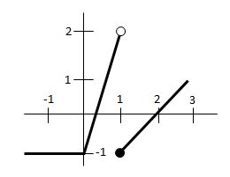  Description: Piecewise function graphed with an approximate domain of [-2, 3] and range of [-1, 2). The graph is horizontal at y=-1 on the interval (-2, 0) then increases linearly to y=2 at x=1 with an open dot. The function has a non-removable discontinuity and resumes with a closed dot at y=-1 at x=1 and increases linearly to y=1 and x=3.  Evaluate $\lim_{x→1^{+}}{g(x)}$  - 2  - -1  - 0  - Undefined  Correct Answer: B

Reporting Category | Algebra
Standard | Arithmetic with Polynomials and Rational Expressions
Benchmark Number | MAFS.912.A-APR.4.6
Benchmark | Rewrite simple rational expressions in different forms; write $\frac{a(x)}{b(x)}$ in the form  $q(x) + \frac{r(x)}{b(x)}$, where $a(x)$, $b(x)$, $q(x)$, and $r(x)$ are polynomials with the degree of $r(x)$ less than the degree of $b(x)$, using inspection, long division, or, for the more complicated examples, a computer algebra system.
Also Assesses | MAFS.912.A-APR.4.7
Item Types | Selected Response (Multiple Choice), Gridded Response
Cognitive Complexity Level | Moderate
Benchmark Clarification | Students will apply various theorems to find complex zeros of polynomial functions.  Students will divide polynomials and relate the result to the remainder and factor theorem.  Student will utilize the Fundamental Theorem of Algebra to determine the number of zeros, and find the rational zeros of a polynomial using Descartes’ Rule of Signs.
Content Limits | Polynomials must be factorable using factoring, graphing, synthetic division (with both a zero remainder and # value remainders), grouping, or finding the greatest common factor.
Stimulus Attributes | Items may be set in either mathematical contexts or real-world applications.
Response Attributes | Selected Response answers may have complex factors for the polynomial.  Selected Response answers may have number value remainders for synthetic division.

Sample Items | - What is the remainder after simplifying the following?  $$\left(9x^{2}-42x-6\right)÷(x-4)$$  - -26  - -14  - 4  - 14  Correct Answer: A  - What are the roots of the following polynomial equation?  $x^{3}-2x^{2}+10x+136$  - $-3±5i, -4$  - $3±5i, -4$  - $-3±i. 4$  - $3±i, 4$  Correct Answer: B

Reporting Category | Functions
Standard | Building Functions
Benchmark Number | MAFS.912.F-BF.2.4
Benchmark | Find inverse functions.  - Solve an equation of the form $f\left(x\right)=c$ for a simple function f that has an inverse and write an expression for the inverse.  For example, $f(x)=2x³$ or $f(x)=\frac{(x+1)}{(x-1)} \text{for} x≠1$.  - Verify by composition that one function is the inverse of another.  - Read values of an inverse function from a graph or a table, given that the function has an inverse.  - Produce an invertible function from a non-invertible function by restricting the domain.
Also Assesses | N/A
Item Types | Selected Response (Multiple Choice), Gridded Response, Short Answer
Cognitive Complexity Level | Moderate
Benchmark Clarification | Students will be able to find the inverse of a function and verify they are in fact inverses by showing the composition of the functions is equal to x.  Students will understand and demonstrate how a function is invertible algebraically, graphically, and numerically (through a table).  Students will understand the relationship between a function’s range and domain with the inverse’s range and domain.
Content Limits | Functions should be limited to those types in which an inverse can be found by algebraic means (without technology) if asked to do so algebraically.
Stimulus Attributes | Items may be set in real world or mathematical context.  Functions may be presented algebraically, graphically, or numerically (with a table).  Domains and Ranges should be provided when asking students to graph inverses where appropriate.
Response Attributes | Domains and Ranges can be expressed through set notation, interval notation, or through the use of inequalities.
Sample Items | - The function $f(x)$ is defined as follows:  $f\left(x\right)=3x-2$  Find $f^{-1}\left(2\right)$.  - $\frac{1}{4}$  - $\frac{4}{3}$  - $4$  - $-4$  Correct Answer: B  - Selected values for a function $f\left(x\right)$ are provided below:  x $$f(x)$$  0 -10  1 -2  2 0  3 2  4 3  Find $f^{-1}\left(3\right)$  - $4$  - $2$  - $-2$  - $-4$  Correct Answer: A

Reporting Category | Functions
Standard | Trigonometric Functions
Benchmark Number | MAFS.912.F-TF.1.2
Benchmark | Explain how the unit circle in the coordinate plane enables the extension of trigonometric functions to all real numbers, interpreted as radian measures of angles traversed counterclockwise around the unit circle.
Also Assesses | MAFS.912.F-TF.1.1
Item Types | Selected Response (Multiple Choice), Gridded Response, Short Answer
Cognitive Complexity Level | Moderate
Benchmark Clarification | Students will demonstrate an understanding of co-terminal angles in order to find values of trigonometric equations at angle values greater than $2π$ radians or less than $-2π$ radians.
Content Limits | When asked to find exact values of trigonometric functions, angles will be limited to multiples of $0, \frac{π}{6}, \frac{π}{4}, \frac{π}{3}, \frac{π}{2}, \text{or} π$ radians.
Stimulus Attributes | Items may be set in real world or mathematical context.  Angles should be expressed in radians but can be expressed in degrees.
Response Attributes | Responses should be given in exact (radical) form where appropriate.
Sample Items | - Selected values for $f\left(θ\right)=\sin{θ}$ are provided in the table below:  $$θ$$ $$f\left(θ\right)$$  $$r$$ $$0$$  $$s$$ $$\frac{1}{2}$$  $$t$$ $\sqrt{3}$/2  $$u$$ $$1$$  Evaluate $f\left(t+12π\right)$  - 0  - $\frac{1}{2}$  - $\sqrt{3}$/2  - 1  Correct Answer: C
Reporting Category | Functions
Standard | Trigonometric Functions
Benchmark Number | MAFS.912.F-TF.1.3
Benchmark | Use special triangles to determine geometrically the values of sine, cosine, tangent for $\frac{π}{3}$, $\frac{π}{4}$, and $\frac{π}{6}$, and use the unit circle to express the values of sine, cosine, and tangent for $π–x$, $π+x$, and $2π–x$ in terms of their values for $x$, where $x$ is any real number.
Also Assesses | N/A
Item Types | Selected Response (Multiple Choice), Short Answer
Cognitive Complexity Level | Moderate
Benchmark Clarification | Students will be able to use the special right triangle relationships (45-45-90 and 30-60-90) to determine the values of sine, cosine, and tangent at multiples of 30, 45, 60, and 90 degrees.  Students will be able to extend these values to evaluate reciprocal trigonometric functions.
Content Limits | Items should only assess multiples of 30, 45, 60, and 90 degrees.
Stimulus Attributes | Items may be set in real world or mathematical context.  Items should stress the geometric approach to finding values of trigonometric functions rather than a memorization of the unit circle.  Angles may be measured in degrees or radians.
Response Attributes | Answers must be in exact radical form rather than decimal form.  Answers do not necessarily have to be in simplest radical form.
Sample Items | - Which of the following graphs correctly shows the evaluation of $\sin{\frac{5π}{6}}$?  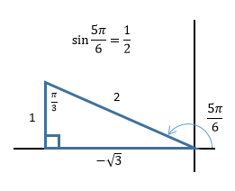  Description: A right triangle drawn with the hypotenuse as the terminal side of an angle measuring $\frac{5π}{6}$ radians drawn in standard position. The hypotenuse has a length of 2. At the end of the hypotenuse, the leg is drawn vertically to the x axis with a length of 1. The third side has a length of $-\sqrt{3}$.  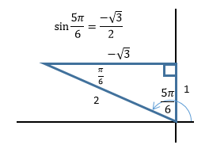  Description: A right triangle drawn with the hypotenuse as the terminal side of an angle measuring $\frac{5π}{6}$ radians drawn in standard position. The hypotenuse has a length of 2. At the end of the hypotenuse, the leg is drawn horizontally to the y axis with a length of $-\sqrt{3}$. The third side has a length of 1.  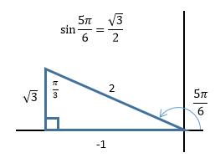  Description: A right triangle drawn with the hypotenuse as the terminal side of an angle measuring $\frac{5π}{6}$ radians drawn in standard position. The hypotenuse has a length of 2. At the end of the hypotenuse, the leg is drawn vertically to the x axis with a length of $\sqrt{3}$. The third side has a length of -1.  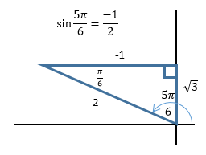  Description: A right triangle drawn with the hypotenuse as the terminal side of an angle measuring $\frac{5π}{6}$ radians drawn in standard position. The hypotenuse has a length of 2. At the end of the hypotenuse, the leg is drawn horizontally to the y axis with a length of -1. The third side has a length of $\sqrt{3}$.  Correct Answer: A

Reporting Category | Functions
Standard | Trigonometric Functions
Benchmark Number | MAFS.912.F-TF.2.5
Benchmark | Choose trigonometric functions to model periodic phenomena with specified amplitude, frequency, and midline.
Also Assesses | MAFS.912.F-TF.1.4
Item Types | Selected Response (Multiple Choice), Short Answer
Cognitive Complexity Level | Moderate
Benchmark Clarification | Students will be able to determine a trigonometric function used to model a mathematical or real world situation given the amplitude, frequency, and midline.  Students will be able to write a function notation for a trigonometric function or identify parts of that function that models a problem situation or its amplitude, frequency, or midline.
Content Limits | Items may not ask for more than two periods to be graphed by the student.
Stimulus Attributes | Items should be set in a real world context.  Graphs of reciprocal trigonometric equations may be used.  Angles may be measured in degrees or radians.
Response Attributes | When asking for graphs to be drawn by the student, a domain for the function to be graphed over will be provided.

Sample Items | - The graph of the function $f\left(θ\right)=a∙sin\left(b∙θ\right)+c$ is shown below.  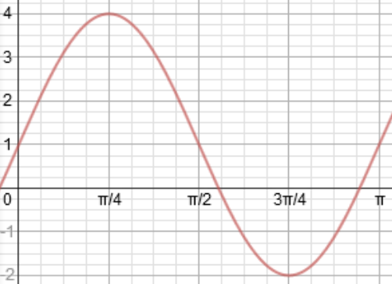  Description: A sinusoidal function graphed on the domain (o, π). There is a maximum at $\left(\frac{π}{4},4\right)$ and a minimum at $\left(\frac{3π}{4},-2\right)$. The midline is at $y=1$.  What is the value of $a$?  - 1  - 2  - 3  - 4  Correct Answer: C

- Which of the following graphs shows a sinusoidal graph with an amplitude of 2?

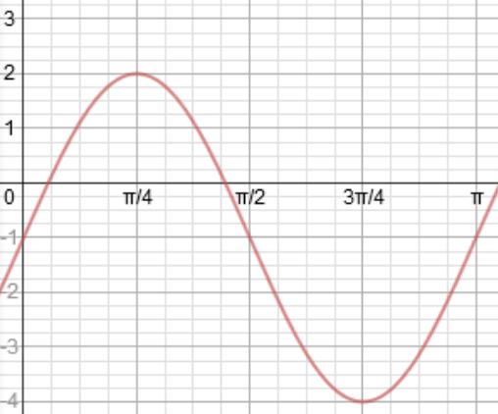
Description: A sinusoidal function graphed on the domain (o, π). There is a maximum at $\left(\frac{π}{4},2\right)$ and a minimum at $\left(\frac{3π}{4},-4\right)$. The midline is at $y=-1$.

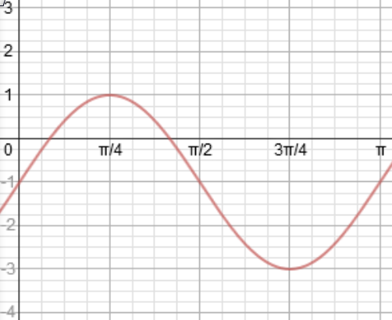
Description: A sinusoidal function graphed on the domain (o, π). There is a maximum at $\left(\frac{π}{4},1\right)$ and a minimum at $\left(\frac{3π}{4},-3\right)$. The midline is at $y=-1$.

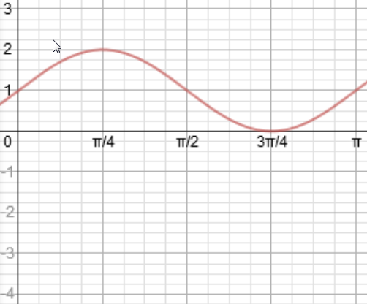

Description: A sinusoidal function graphed on the domain (o, π). There is a maximum at $\left(\frac{π}{4},2\right)$ and a minimum at $\left(\frac{3π}{4},0\right)$. The midline is at $y=1$.

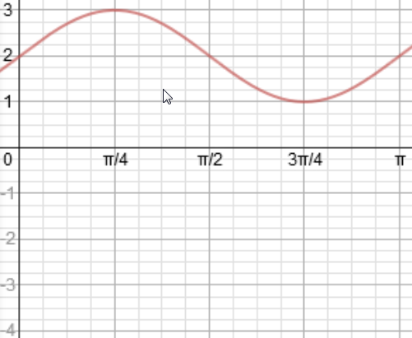

Description: A sinusoidal function graphed on the domain (o, π). There is a maximum at $\left(\frac{π}{4},3\right)$ and a minimum at $\left(\frac{3π}{4},1\right)$. The midline is at $y=2$.

Correct Answer: B

Reporting Category | Functions
Standard | Trigonometric Functions
Benchmark Number | MAFS.912.F-TF.2.6
Benchmark | Understand that restricting a trigonometric function to a domain on which it is always increasing or always decreasing allows its inverse to be constructed.
Also Assesses | MAFS.912.F-TF.2.7
Item Types | Selected Response (Multiple Choice), Gridded Response, Short Answer
Cognitive Complexity Level | Moderate
Benchmark Clarification | Students will understand that inverse trigonometric functions are restricted to specific domains. Additionally, they will understand the relationship between a function and its inverse in terms of switching the domain and range (thus the need for restricting a trigonometric function’s domain to where it is always increasing or decreasing).  Students will be able to use inverse trigonometric functions to solve mathematical and real world problems with the use of technology and be able to interpret the meaning of the solutions.
Content Limits | None Specified
Stimulus Attributes | Items may be set in real world or mathematical context.  Angles may be measured in degrees or radians.
Response Attributes | Domains and Ranges can be expressed through set notation, interval notation, or through the use of inequalities.  Outputs from inverse functions should have no more than three decimal places.

Sample Items | - Over what domain should the function $f\left(x\right)=\sin\left(x-\frac{π}{4}\right)$ be restricted in order for $f^{-1}\left(x\right)$ to exist?  - $\left[0, π\right]$  - $\left[\frac{π}{2},\frac{3π}{2}\right]$  - $\left[\frac{π}{4},\frac{5π}{4}\right]$  - $\left[\frac{3π}{4},\frac{7π}{4}\right]$  Correct Answer: D

Reporting Category | Functions
Standard | Trigonometric Functions
Benchmark Number | MAFS.912.F-TF.3.8
Benchmark | Prove the Pythagorean identity $\sin^{2}{θ} + \cos^{2}{θ} = 1$ and use it to find trigonometric ratios.
Also Assesses | N/A
Item Types | Selected Response (Multiple Choice), Gridded Response, Short Answer
Cognitive Complexity Level | Moderate
Benchmark Clarification | Students will be able to use the relationship expressed through the Pythagorean identity to help solve trigonometric problems.  Students will be able to reconstruct triangles based on the given$\sin{θ}$, $\cos{θ}$, or $\tan{θ}$ and the quadrant of the angle and use that information in conjunction with the Pythagorean identity to solve trigonometric problems.
Content Limits | Items should not involve identities beyond the Pythagorean identity other than $\tan{θ}=\frac{\sin{θ}}{\cos{θ}}$.
Stimulus Attributes | Angles may be measured in radians or degrees.  Reciprocal trigonometric functions may be used.  Graphics may be provided.
Response Attributes | Items may require the use of the identity $\tan{θ}=\frac{\sin{θ}}{\cos{θ}}$ or $\cot{θ}=\frac{\cos{θ}}{\sin{θ}}$.

Sample Items | - If $\sin{θ}=\frac{1}{4}$ and $θ$ lies in the second quadrant, what is $\cos{θ}$ equal to?  - $\frac{\sqrt{15}}{4}$  - $\frac{-\sqrt{15}}{4}$  - $\frac{\sqrt{17}}{4}$  - $\frac{-\sqrt{17}}{4}$  Correct Answer: B  - Given a right triangle, if $\sin{θ}= \frac{7}{25}$ and $\cos{θ}<0$, evaluate $\tan{θ}$ leaving your answer in exact form.  Correct Answer: $-\frac{7}{24}$

Reporting Category | Functions
Standard | Trigonometric Functions
Benchmark Number | MAFS.912.F-TF.3.9
Benchmark | Prove the addition and subtraction formulas, half-angle, and double-angle formulas for sine, cosine, and tangent and use them to solve problems.
Also Assesses | N/A
Item Types | Selected Response (Multiple Choice), Short Answer
Cognitive Complexity Level | High
Benchmark Clarification | Students should not be required to develop a formal proof for the formulas in their entirety. Additionally, proofs should focus on an algebraic approach rather than the use of complex exponentials and the Euler formula.  Students will be able to use the addition and subtraction, half-angle, and double-angle formulas to find the values of trigonometric functions at angles that are not necessarily multiples of 30, 45, 60, or 90 degrees.
Content Limits | None Specified
Stimulus Attributes | Items may be set in real world or mathematical context.  Angle measures may be in degrees or radians.  Items should be assessed without the use of technology.
Response Attributes | Answers must be in exact radical form rather than decimal form.  Answers do not necessarily have to be in simplest radical form.

Sample Items | - What is the exact value of cos $\frac{5π}{18}$· cos $\frac{π}{9}$ + sin$\frac{5π}{18}$· sin$\frac{π}{9}$ ?  Correct Answer: $\frac{\sqrt{3}}{2}$  - What is the exact value of cos 75˚?  - $\frac{\sqrt{6}+\sqrt{2}}{4}$  - $\frac{\sqrt{6}-\sqrt{2}}{4}$  - $2-\sqrt{3}$  - $2+\sqrt{3}$  Correct Answer: B

Reporting Category | Geometry
Standard | Expressing Geometric Properties with Equations
Benchmark Number | MAFS.912.G-GPE.1.1
Benchmark | Derive the equation of a circle of given center and radius using the Pythagorean Theorem; complete the square to find the center and radius of a circle given by an equation.
Also Assesses | N/A
Item Types | Selected Response (Multiple Choice), Gridded Response, Short Answer
Cognitive Complexity Level | Moderate
Benchmark Clarification | Students will understand the relationship between the Pythagorean Theorem and the distance formula and how they both relate to the equation of a circle.  Students will be able to find the center and radius of a circle from an equation given in standard form.  Students will be able to complete the square for an equation given in the form $Ax^{2}+{By}^{2}+Cx+Dy+E=0$ where $A \text{and} B$ are not equal to 0 to find the center and radius of the circle.
Content Limits | The rotation of axis for conic sections, degenerate conic sections, and eccentricity for conic sections will not be assessed.
Stimulus Attributes | Items may be set in real world or mathematical context.  Equations for circles do not necessarily have to be given in standard form.  The type of conic section need not be specified if the equation is provided.
Response Attributes | None Specified

Sample Items | - What is the center and radius of the circle given by the equation:  ${\left(x-2\right)}^{2}+{\left(y-1\right)}^{2}=4$  - Center: $\left(-2, -1\right)$ Radius: 4  - Center: $\left(-2, -1\right)$ Radius: 2  - Center: $\left(2, 1\right)$ Radius: 4  - Center: $\left(2, 1\right)$ Radius: 2  Correct Answer: D  - What is the y-coordinate for the center of the circle given by the equation:  $$x^{2}+y^{2}-2x+6y+1=0$$  Correct Answer: $-3$

Reporting Category | Geometry
Standard | Expressing Geometric Properties with Equations
Benchmark Number | MAFS.912.G-GPE.1.2
Benchmark | Derive the equation of a parabola given a focus and directrix.
Also Assesses | N/A
Item Types | Selected Response (Multiple Choice), Gridded Response, Short Answer
Cognitive Complexity Level | Moderate
Benchmark Clarification | Students will be able to find the equation of a parabola given the vertex, focus and/or directrix as well as the vertex, focus, and/or directrix given the equation of a parabola.  Students will be able to complete the square for an equation given in the form $Ax^{2}+{By}^{2}+Cx+Dy+E=0$ where $A \text{or} B$ is equal to 0 to find the vertex, focus, and directrix of the parabola.
Content Limits | The rotation of axis for conic sections, degenerate conic sections, and eccentricity for conic sections will not be assessed.
Stimulus Attributes | Items may be set in real world or mathematical context.  Parabolas may open upward, downward, to the left, or to the right.  Equations for parabolas do not necessarily have to be given in standard form.  The type of conic section need not be specified if the equation is provided.
Response Attributes | None Specified
Sample Items | - Which of the following is the equation for the parabola that has a vertex at $\left(2, -1\right)$ and a focus at $\left(2, 3\right)$?  - ${\left(x-2\right)}^{2}=16\left(y+1\right)$  - ${\left(x+2\right)}^{2}=16\left(y-1\right)$  - ${\left(x-2\right)}^{2}=4\left(y+1\right)$  - ${\left(x+2\right)}^{2}=4\left(y-1\right)$  Correct Answer: A

Reporting Category | Geometry
Standard | Expressing Geometric Properties with Equations
Benchmark Number | MAFS.912.G-GPE.1.3
Benchmark | Derive the equations of ellipses and hyperbolas given the foci and directrices.
Also Assesses | N/A
Item Types | Selected Response (Multiple Choice), Gridded Response, Short Answer
Cognitive Complexity Level | High
Benchmark Clarification | Students will be able to find the equation of an ellipse or hyperbolas given the vertex, focus and/or directrix as well as the vertex, focus, and/or directrix given the equation of an ellipse or hyperbola. Students will understand the relationship between the focal length and distance between vertices.  Students will be able to complete the square for an equation given in the form $Ax^{2}+{By}^{2}+Cx+Dy+E=0$ to find the vertex, focus, and directrix of the ellipse or hyperbola.  Students will be able to find the length and direction of the major and minor axis of an ellipse as well as the length and direction of the transverse and conjugate axis and the equations of the asymptotes of a hyperbola.  The major axis of an ellipses may be parallel to the x-axis or the y-axis. Likewise, the transverse axis of a hyperbola may be parallel to the x-axis or the y-axis.
Content Limits | The rotation of axis for conic sections, degenerate conic sections, and eccentricity for conic sections will not be assessed.
Stimulus Attributes | Items may be set in real world or mathematical context.  Equations for ellipses and hyperbolas do not necessarily have to be given in standard form.  The type of conic section need not be specified if the equation is provided.
Response Attributes | None Specified
Sample Items | - Identify the type of conic section that is represented by the following equation:  $$4x^{2}+y^{2}-32x+4y+32=0$$  - Circle  - Parabola  - Ellipse  - Hyperbola  Correct Answer: C  - Consider the graph represented by the following equation:  $$\frac{{\left(x-1\right)}^{2}}{9}-\frac{{\left(y+2\right)}^{2}}{4}=1$$  What are the coordinates of the two foci?  - $\left(1±\sqrt{13}, -2\right)$  - $\left(1, -2±\sqrt{13}\right)$  - $\left(1±\sqrt{5}, -2\right)$  - $\left(1, -2±\sqrt{5}\right)$  Correct Answer: A

Reporting Category | Geometry
Standard | Similarity, Right Triangles and Trigonometry
Benchmark Number | MAFS.912.G-SRT.3.8
Benchmark | Use trigonometric ratios and the Pythagorean Theorem to solve right triangles in applied problems.
Also Assesses | N/A
Item Types | Selected Response (Multiple Choice), Gridded Response, Short Answer
Cognitive Complexity Level | Moderate
Benchmark Clarification | Students will solve real-world problems involving right triangles using the Pythagorean Theorem and trigonometric ratios.  Students may be asked to solve problems involving angles of elevation, angles of depression, bearings, or other types of real-world problems.
Content Limits | Triangles to be solved must be right triangles.  Trigonometric equations should be limited to sine, cosine, and tangent.  Items may require the use of calculators to find lengths and angle measures. If an item is written to be solved without the use of a calculator, the acute angles of the right triangle must be 30, 45 or 60 degrees (or the equivalent radians).
Stimulus Attributes | Items must be set in a real-world context.  Angle measures will be in radians or degrees.  Graphics may be given to enhance the item, or students may be expected to make a sketch to assist in giving a response.
Response Attributes | Angle measures will be in degrees or radians.  Items written to be solved without the use of a calculator will have responses written in simplest radical form.

Sample Items | - Frank is painting the side of a building. He needs to know the area of the wall to know how much paint he should buy, however, the height is too high for him to measure. He has a 15-foot ladder that reaches the top of the building when he leans it against the building at a $68°$ angle  15-foot ladder  Side of building  30 feet  $$68°$$  Description: a rectangular area labeled “Side of building” with a line segment leaning against the building representing the 15 foot ladder. It is at a 68 degree angle with the building. The width of the building is 30 feet.  If the back side of the building is 30 feet wide, what is the area Frank needs to paint rounded to the nearest tenth?  Correct Answer: 417.2 square feet

Reporting Category | Geometry
Standard | Similarity, Right Triangles and Trigonometry
Benchmark Number | MAFS.912.G-SRT.4.9
Benchmark | Derive the formula $A=\frac{1}{2}ab\sin\left(c\right)$ for the area of a triangle by drawing an auxiliary line from a vertex perpendicular to the opposite side.
Also Assesses | MAFS.912.G-SRT.3.8
Item Types | Selected Response (Multiple Choice), Gridded Response, Short Answer
Cognitive Complexity Level | Moderate
Benchmark Clarification | Students will solve real-world problems by finding the area of a triangle by using the area of a triangle formula: $A=\frac{1}{2}ab\sin\left(c\right)$.
Content Limits | Items can require the use of calculators with trigonometric functions. However, items written to be solved without the use of calculators must have angles that are multiples of 30, 45, or 60 degrees (or the equivalent radians).
Stimulus Attributes | Items must be set in real-world contexts.  Graphics may be given to enhance the item, or students may be expected to make a sketch to assist in giving a response.  Angles may be in degrees or radians.
Response Attributes | None Specified
Sample Items | 1. What is the area, to the nearest square foot, of a triangular piece of land that measures 275 feet by 400 feet by 425 feet?  A. 6837 square feet  B. 42,482 square feet  C. 53,254 square feet  D. 160,351 square feet  Answer: C

Reporting Category | Geometry
Standard | Similarity, Right Triangles and Trigonometry
Benchmark Number | MAFS.912.G-SRT.4.10
Benchmark | Prove the Laws of Sines and Cosines and use them to solve problems.
Also Assesses | N/A
Item Types | Selected Response (Multiple Choice), Gridded Response, Short Answer
Cognitive Complexity Level | High
Benchmark Clarification | Students will solve real-world and mathematical problems involving oblique triangles by applying the Law of Sines or the Law of Cosines.  Students will not have to provide the entire derivation proof of the Law of Sines or Law of Cosines but may be asked to provide missing steps or understand the requirements needed.
Content Limits | None Specified
Stimulus Attributes | Items may set in real-world or mathematical contexts.  Angles may be in degrees or radians.  Graphics may be given to enhance the item, or students may be expected to make a sketch to assist in giving a response.
Response Attributes | None Specified

Sample Items | 1. Two planes leave an airport on different runways at the same time. The runways intersect at an included angle of 100°. Plane A travels at 425 miles per hour on a straight flight path, and the other plane travels at 350 miles per hour. How far apart, to the nearest mile, are the planes after 3 hours?  Description: Two arrows connected on their initial point extending apart at an angle of 100 degrees. Each arrow represents a different airplane.  Plane A: 425 mph  100◦  Plane B: 350 mph  A. 225 miles  B. 684 miles  C. 1504 miles  D. 1787 miles  Answer: D

Reporting Category | Number and Quantity
Standard | Complex Number System
Benchmark Number | MAFS.912.N-CN.1.3
Benchmark | Find the conjugate of a complex number; use conjugates to find moduli and quotients of complex numbers.
Also Assesses | N/A
Item Types | Selected Response (Multiple Choice), Gridded Response, Short Answer
Cognitive Complexity Level | Low
Benchmark Clarification | Students will find conjugates of complex numbers written in $a + bi$ form.  Students will use the conjugates to find quotients of complex numbers.  Students will find the moduli or absolute value of complex numbers.
Content Limits | All points must be expressed in $a + bi$ form.
Stimulus Attributes | Items may be set in mathematical or real-world contexts.
Response Attributes | Responses representing complex numbers must be expressed in $a + bi$ form.  Responses representing moduli may be represented in radical form or to a specified number of decimal points.

Sample Items | 1. What is the conjugate of $4 – 5i$?  - $0+5i$  - $4 + 5i$  B) $–4 – 5i$  C) $–4 + 5i$  Correct Answer: B  2. What is the modulus of $7 + 3i$ rounded to the nearest tenth?  Correct Answer: 7.6  3. Write the quotient of $\frac{6+2i}{3-4i}$ in standard form.  Correct Answer: $\frac{2}{5}+\frac{6}{5}i$  Scoring Rubric:  2 – Student is able to find the correct quotient.  1 – Student is unable to find the quotient but shows correct working, such as the correct method of multiplying both the numerator and denominator by the correct conjugate.  0 – Student is unable to find the quotient or show any correct working.

Reporting Category | Number and Quantity
Standard | Complex Number System
Benchmark Number | MAFS.912.N-CN.2.4
Benchmark | Represent complex numbers on the complex plane in rectangular and polar form (including real and imaginary numbers), and explain why the rectangular and polar forms of a given complex number represent the same number.
Also Assesses | N/A
Item Types | Selected Response (Multiple Choice), Short Answer
Cognitive Complexity Level | Moderate
Benchmark Clarification | Students will be able to plot points in the complex plane using both the rectangular form and polar (trigonometric) form of complex numbers.  Students will convert between the polar and rectangular forms of complex numbers with and without calculators.
Content Limits | Items may be solved using calculators that will convert between polar coordinates and Cartesian coordinates. Items written to be solved without the use of a calculator should have arguments that are multiples of 30, 45, 60, or 90 degrees. Items may include points in polar coordinates that have both positive and negative $r$ values.  Arguments may be in degree or radian measures between -720° (-4π radians) and 720° (4π radians).  Polar forms of complex numbers may be written in $r\left(\cos{θ}+i\sin{θ}\right)$ form or $r\operatorname{cis}{θ}$ form.  Exponential form of complex numbers will not be used or assessed.
Stimulus Attributes | Items may be set in mathematical or real-world contexts.  Graphics may be given to enhance the item, or students may be expected make a sketch to assist in giving a response.  Arguments may be measured in degrees or radians.
Response Attributes | Arguments may be given in degrees or radians unless specified by the question.  Responses do not necessarily have to be in simplest radical form.
Sample Items | - The polar coordinates of a point are (-4, 270°). Which ordered pair represents the same point in Cartesian coordinates?  A. $(-4, 0)$  B. $(0, 4)$  C. $(-4, 4)$  D. $(-4,-4)$  Correct Answer: B

Reporting Category | Number and Quantity
Standard | Complex Number System
Benchmark Number | MAFS.912.N-CN.2.5
Benchmark | Represent addition, subtraction, multiplication, and conjugation of complex numbers geometrically on the complex plane; use properties of this representation for computation. For example, ${\left(-1+\sqrt{3}i\right)}^{3}=8$ because $(-1+\sqrt{3}i)$ has modulus 2 and argument 120°.
Also Assesses | N/A
Item Types | Selected Response (Multiple Choice), Gridded Response, Short Answer
Cognitive Complexity Level | Moderate
Benchmark Clarification | Students will find powers of complex numbers written in rectangular form or in polar (trigonometric form) by applying DeMoivre's Theorem.
Content Limits | Arguments may be in degree or radian measures between $0°$ (0π) and $360°$ (2π). Items written to be solved without the use of a calculator should have arguments that are multiples of 30, 45, 60, or 90 degrees.  Exponential form of complex numbers will not be used or assessed.
Stimulus Attributes | Items must be set in a mathematical context.  Complex numbers may be written in either rectangular form or polar (trigonometric) form.  Polar forms of complex numbers may be written in $r\left(\cos{θ}+i\sin{θ}\right)$ form or $r\operatorname{cis}{θ}$ form.
Response Attributes | Complex numbers may be written in standard, rectangular, or polar (trigonometric) form.  Responses should be written in radical form where appropriate but do not necessarily have to be in simplest radical form.

Sample Items | - What is ${(1+\sqrt{3}i)}^{4}$ expressed in rectangular form?  A) $8+8\sqrt{3}i$  B) $-8+8\sqrt{3}i$  C) $8-8\sqrt{3}i$  D) $-8-8\sqrt{3}i$  Correct Answer: D

Reporting Category | Number and Quantity
Standard | Complex Number System
Benchmark Number | MAFS.912.N-CN.3.9
Benchmark | Know the Fundamental Theorem of Algebra; show that it is true for quadratic polynomials.
Also Assesses | N/A
Item Types | Selected Response (Multiple Choice), Gridded Response, Short Answer
Cognitive Complexity Level | Low
Benchmark Clarification | Students will understand that a polynomial function of degree $n$ has $n$ complex roots, that these roots may be real or imaginary, and that these roots may be repeated.  Students will understand the connections between the complex roots (or solutions), zeros, and factors of a polynomial.
Content Limits | Complex numbers must be expressed in standard $a + bi$ form and not in polar (trigonometric) form.
Stimulus Attributes | Items may be set in a mathematical or real world context.
Response Attributes | Responses representing complex numbers must be expressed in standard $a + bi$ form.  Responses representing moduli may be represented in radical form or to a specified number of decimal points.
Sample Items | - Find a polynomial function of minimum degree in standard form with real coefficients whose zeroes include the following: $\left(2+3i\right)$ and $\left(2-3i\right)$.  Correct Answer: $x^{2}-4x+13$  Scoring Rubric:  2 – Student is able to multiple the two factors correctly and obtain the correct polynomial.  1 – Student recognizes the need to multiple the two factors together but does not obtain the correct polynomial.  0 – Student does not recognize the need to multiply the two factors together and does not obtain the correct polynomial.

Reporting Category | Number and Quantity
Standard | Vector and Matrix Quantities
Benchmark Number | MAFS.912.N-VM.1.1
Benchmark | Recognize vector quantities as having both magnitude and direction. Represent vector quantities by directed line segments, and use appropriate symbols for vectors and their magnitudes (e.g., $v, |v|, ||v||, \overset{⃑}{v}$).
Also Assesses | N/A
Item Types | Selected Response (Multiple Choice), Short Answer
Cognitive Complexity Level | Low
Benchmark Clarification | Students will demonstrate an understanding of the geometric interpretation of vectors and vector operations.  Students will be able to translate between the algebraic and geometric representations of a vector.  Students will be able to resolve the vector using a magnitude and angle to find the component form of a vector.
Content Limits | None Specified
Stimulus Attributes | Items may be set in real world or mathematical context.
Response Attributes | Response may be pictures or values.  Vectors may be represented in component vector form, unit vector form, or column vector form. Components should be given in exact form where possible but may be rounded to a specified number of decimal places.  Magnitudes will be represented in radical form but do not necessarily have to be in simplest radical form.

Sample Items | - Given the vector $v$ with $\left\|v\right\|=10$ and a direction angle of 120°:  - Write the vector in unit vector form.  - Represent $v$ in the coordinate plane below.  Description: Coordinate plane with domain and range of [8, -8].  Answer: a) $v = -5i + 5\sqrt{3}j$  b)  Description: Coordinate plane with vector v drawn starting at the origin and having a terminal point at $\left(-5, 5\sqrt{2}\right)$.  $$\overset{⃑}{v}$$  Scoring Rubric:  2 – Student is able to find the unit vector form for $v$ and correctly sketch the diagram.  1 – Student is able to find the unit vector form for $v$ or correctly sketch the diagram.  0 – Student incorrectly finds the unit vector form for $v$ and incorrectly sketches the diagram.

Reporting Category | Number and Quantity
Standard | Vector and Matrix Quantities
Benchmark Number | MAFS.912.N-VM.1.2
Benchmark | Find the components of a vector by subtracting the coordinates of an initial point from the coordinates of a terminal point.
Also Assesses | N/A
Item Types | Selected Response (Multiple Choice), Gridded Response, Short Answer
Cognitive Complexity Level | Low
Benchmark Clarification | Students will subtract x and y coordinates of two given points to find the components of a vector.
Content Limits | Ordered pairs will be integers only.
Stimulus Attributes | Items may be set in either real world or mathematical context.  Items may be set in an algebraic representation through the use of the component form of vectors or through a geometric representation through the use of vectors drawn on a Cartesian coordinate plane.
Response Attributes | Vectors may be represented in component vector form, unit vector form, or column vector form. Components should be given in exact form where possible but may be rounded to a specified number of decimal places.
Sample Items | 1. What is the component form of $\overset{⃑}{AB}$, given the coordinate points $A\left(-4, 2\right)$ and $B\left(3, -5\right)$?  A. $〈7, -7〉$  B. $〈-7, 7〉$  C. $〈-1, -3〉$  D. $〈1, 3〉$  Correct Answer: A

Reporting Category | Number and Quantity
Standard | Vector and Matrix Quantities
Benchmark Number | MAFS.912.N-VM.1.3
Benchmark | Solve problems involving velocity and other quantities that can be represented by vectors.
Also Assesses | MAFS.912.N-VM.1.1  MAFS.912.N-VM.1.2
Item Types | Selected Response (Multiple Choice), Gridded Response, Short Answer
Cognitive Complexity Level | Moderate
Benchmark Clarification | Students will solve real world problems involving velocity and other rates that can be represented by vectors.
Content Limits | Scalars will be rational numbers only.
Stimulus Attributes | Items will be set in real world context and may include graphs and/or pictures.
Response Attributes | Responses may include pictures or values.  Vectors may be represented in component vector form, unit vector form, or column vector form. Components should be given in exact form where possible but may be rounded to a specified number of decimal places.

Sample Items | 1. A swimmer is able to swim with a speed of 2 m/s in still water. This same swimmer goes swimming in a river which has a current flowing due East with a constant speed of 6 m/s. What would be the swimmer’s resultant velocity and bearing if she tried to swim due North?  - 5.66 m/s at 18° East of North  - 5.66 m/s at 72° East of North  - 6.32 m/s at 72° East of North  - 6.32 m/s at 18° East of North  Correct Answer: C  2. A basketball is shot at a 65° angle with the horizontal direction with an initial speed of 10 m/s. What is the component form of the initial velocity?  - $〈4.23, 9.06〉$  - $〈9.06, 4.32〉$  - $〈23.7, 11.0〉$  - $〈11.0, 23.7〉$  Correct Answer: A

Reporting Category | Number and Quantity
Standard | Vector and Matrix Quantities
Benchmark Number | MAFS.912.N-VM.2.4
Benchmark | Add and subtract vectors.  a. Add vectors end-to-end, component-wise, and by the parallelogram rule. Understand that the magnitude of a sum of two vectors is typically not the sum of the magnitudes.  b. Given two vectors in magnitude and direction form, determine the magnitude and direction of their sum.  c. Understand vector subtraction $v – w$ as $v + (-w)$, where $–w$ is the additive inverse of $w$, with the same magnitude as $w$ and pointing in the opposite direction. Represent vector subtraction graphically by connecting the tips in the appropriate order, and perform vector subtraction component-wise.
Also Assesses | MAFS.912.N-VM.1.1  MAFS.912.N-VM.1.2  MAFS.912.N-VM.1.3
Item Types | Selected Response (Multiple Choice), Gridded Response, Short Answer
Cognitive Complexity Level | Moderate
Benchmark Clarification | Students will solve problems with algebraic and geometric representations of vectors including adding and subtracting vectors.
Content Limits | Scalars will be rational numbers only.
Stimulus Attributes | Items may be set in either real world or mathematical context.  Items may require a student to resolve the vector using the magnitude and directional angle.  Items may be set in an algebraic representation through the use of the component form of vectors or through a geometric representation through the use of vectors drawn on a Cartesian coordinate plane.
Response Attributes | Items may ask the student to represent a vector on a grid.  Vectors may be represented in component vector form, unit vector form, or column vector form. Components should be given in exact form where possible but may be rounded to a specified number of decimal places

Sample Items | - Given the vectors $\overset{⃑}{B}=〈-1, -6〉$ and $\overset{⃑}{F}=〈3, 3〉$  - What is sum of $\overset{⃑}{B}$ and $\overset{⃑}{F}$?  - Sketch $\overset{⃑}{B}$and $\overset{⃑}{F}$end to end, and then sketch resulting vector sum on the coordinate plane below.  Description: Coordinate plane with domain and range of [8, -8].  Correct Answer: a) $〈2, -3〉$  b)  Note: This diagram may be located anywhere in the coordinate plane.  $$\overset{⃑}{B}+\overset{⃑}{F}$$  Description: Coordinate plane with vector B extending from origin to a terminal point of (-1,-6). Vector F starts at this point and has a terminal point at (2,-3). The resultant vector starts at the origin and has a terminal point at (2, -3).  $$\overset{⃑}{B}$$  $$\overset{⃑}{F}$$  Scoring Rubric:  2 – Student is able to find the sum and correctly sketch the diagram.  1 – Student is able to find the sum or correctly sketch the diagram.  0 – Student incorrectly finds the sum or incorrectly sketches the diagram.

Reporting Category | Number and Quantity
Standard | Vector and Matrix Quantities
Benchmark Number | MAFS.912.N-VM.2.5
Benchmark | Multiply a vector by a scalar.  a. Represent scalar multiplication graphically by scaling vectors and possibly reversing their direction; perform scalar multiplication component-wise, e.g., as $c\left(v_{x},v_{y}\right)=\left({cv}_{x},{cv}_{y}\right)$.  b. Compute the magnitude of a scalar multiple cv using $||cv|| = |c|v$. Compute the direction of $cv$ knowing that when $|c|v≠0$, the direction of $cv$ is either along $v$ (for $c>0$) or against v (for $c<0$).
Also Assesses | MAFS.912.N-VM.1.1  MAFS.912.N-VM.1.2  MAFS.912.N-VM.1.3
Item Types | Selected Response (Multiple Choice), Gridded Response, Short Answer
Cognitive Complexity Level | Low
Benchmark Clarification | Students will solve problems with algebraic representation of vectors including scalar multiplication.  Students will have a firm grasp of the geometric representations of vectors including the effects of multiplying both positive and negative scalars.
Content Limits | Scalars will be rational numbers only.
Stimulus Attributes | Items may be set in either real world or mathematical context.  Items may use component vector form, unit vector form, or column vector form when representing the components of vectors.
Response Attributes | Responses may include pictures.  Answers may be written in component vector form, unit vector form, or column vector form.
Sample Items | 1. If v = -10i + 5j, what is $\left\|9v\right\|$ ?  Correct Answer: $100.6$  2. If v = $〈-1, 4〉,$what is $-3v$ ?  A. $〈-4, 1〉$  B. $〈3, -12〉$  C. $〈2, 7〉$  D. $〈\frac{1}{3}, -\frac{4}{3}〉$  Correct Answer: B

