To Receive Help:
IBTP Questions: FLDOE-RTTTA@fldoe.org
SSO Questions: FLDOE-SSO@fldoe.org
Test Naming Conventions:

Naming Convention: CFAC.Subject.Course#.TestType.ItemType

Example:
- CFAC.Math.1202340.EOY.MCGR
- CFAC.ELA.1009320.INT1.ALL
- CFAC.SCI.2003310.EOY.MC
Test Type:
- EOY - End of Year
- INT - Interim/Progress Monitoring
Number after INT indicates order of interim assessments: INT1 = 1st interim to be administered as Pretest/Baseline/Quarter 1, INT 2 = 2nd interim to be administered, etc.
Item Type:
- MC - Multiple Choice (Auto Score)
- GR = Gridded Response (Auto Score)
- ALL = Includes Some Items Requiring Manual Score, like Open Response Items
Subject:
- Math = Math
- SCI = Science
- ELA = English Language Arts
- PFA = Performing Fine Arts (Dance, Music, Theatre, etc.)
- VA = Visual Arts
- SS = Social Studies
- JROTC = JROTC
- CTE = Career/Technical Education
- PEH = Physical Education & Health
Test Development Process:
1. Create, Edit, or Confirm Appropriateness of Test Blueprints.
2. Add (if using existing template) or fill in (if using blank template) Item Number column, as test items are added.
3. E-mail to Heather Wright at heather.wright@polk-fl.net the following:
a. Test Name
b. Test Blueprint (attach to e-mail)
c. Team members (names & districts) who worked on the assessment

Resources for Test Blueprints:
1. Osceola SharePoint: http://sp.osceola.k12.fl.us/Depts/REA/Assessments/SitePages/Home.aspx
2. CFAC Site: http://cfacteam.weebly.com/test-blueprints--directions.html
Test Settings:
1. After clicking on Create: Manual Test or Create: Express Test, check the following options:
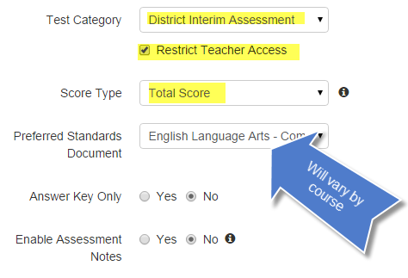
2. Under Test Item Settings, check the following:
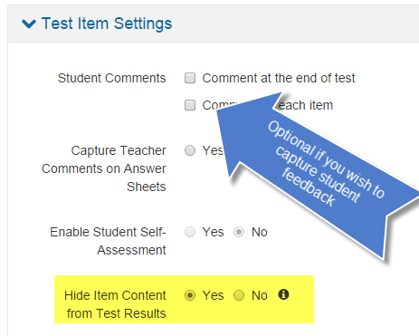
3. Use Description, under the Optional section, to add any notes to others who might use this test, like administration instructions, ideal length of test time, etc.

