`

Justin Seabolt, M.Ed.
CFAC Website: www.cfacteam.weebly.com

GUIDE FOR WRITING AND REVIEWING IN EDUPHORIA AND OTHER RESOURCES
Table of Contents

How to Sign Up for Items to Write (Using the Item Writer Sign Up Sheet) Pages 2-9
How to Write Multiple Choice Items in Eduphoria Pages 10-19
How to Write Gridded Response Items in Eduphoria Pages 20-21
How to Write Constructed Response (Short Answer,
Extended Response, Performance Task Items in Eduphoria Pages 22-24
How to Check the Status of a Submitted Item Page 25
When and How to Upload a Resource for Use in Eduphoria Pages 26-30
How to Add an Audio File Pages 31-36
If Benchmarks aren’t Available/Missing Page 37
How to Review an Item in Eduphoria Pages 38-41
How to Review an Item with an Attached Resource for Use on Multiple Items Page 42
Finding your Unique Identification Number/Item Number (UIN) Page 43

Additional Item Writing and Reviewing Resources
Item Writer and Reviewer Checklist Pages 44-45
Guide for Level 2 Reviewing in Eduphoria Pages 46-50
How to Correctly Cite Sources Pages 51-55
Multiple Choice Answer Choice Guidelines Page 56
Generic Constructed Response Rubrics Pages 57-58
Readability Statistics Page 59
Personal Item Writing and Reviewing Tracking Sheet Pages 60-61
Performance Based Test Item Example Page 62
Webb’s Depth of Knowledge Wheel Page 63
How to Sign Up for Items to Write (Using the Item Writer Sign Up Sheet)
- If you do not yet have access to the sign-up sheet needed for your course(s), you should first contact Justin Seabolt at seaboltj@osceola.k12.fl.us. You will need to provide him with a Gmail account or any email address that you know will work to access Google Drive. If you aren’t sure about whether an email account will work or not, please go ahead and create a new Gmail account.

- Once you have provided Justin with a Gmail account, please go to www.drive.google.com.

- Once you are in Google Drive, on the left side of the screen, you should see the following:

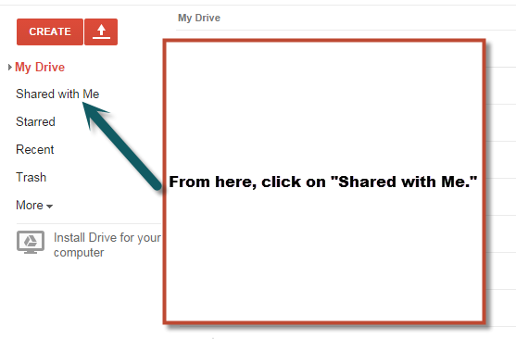

- Once you click on “Shared with Me,” you should see any and all Item Writer Sign Up Sheets that have been shared with you.

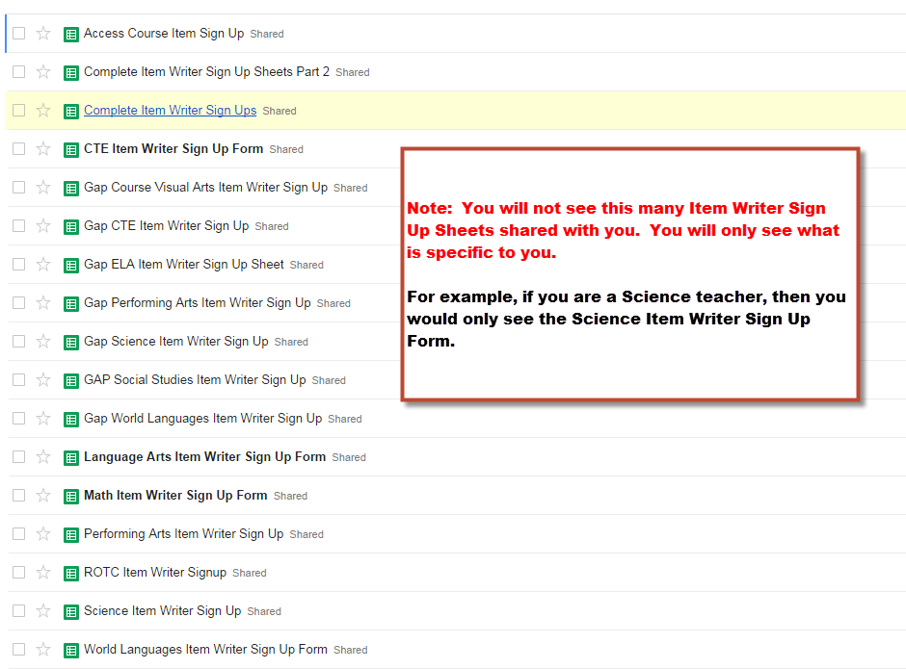

- Next, click on the sign-up sheet you are trying to open. For this first example, I am using the GAP Performing Arts Sign Up Sheet.
- Once open, notice at the bottom of the screen, you will see multiple tabs with different courses. This is where you will browse to find the course you are looking for.
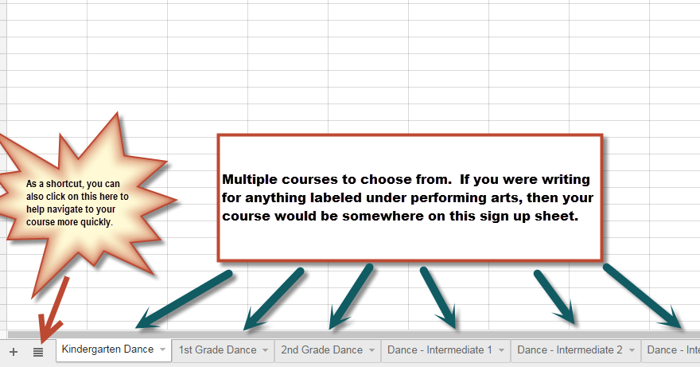

- At this point, you should keep in mind that sign-up sheets can look differently but they all serve the same purpose; which is to sign up for items to write for your course(s).
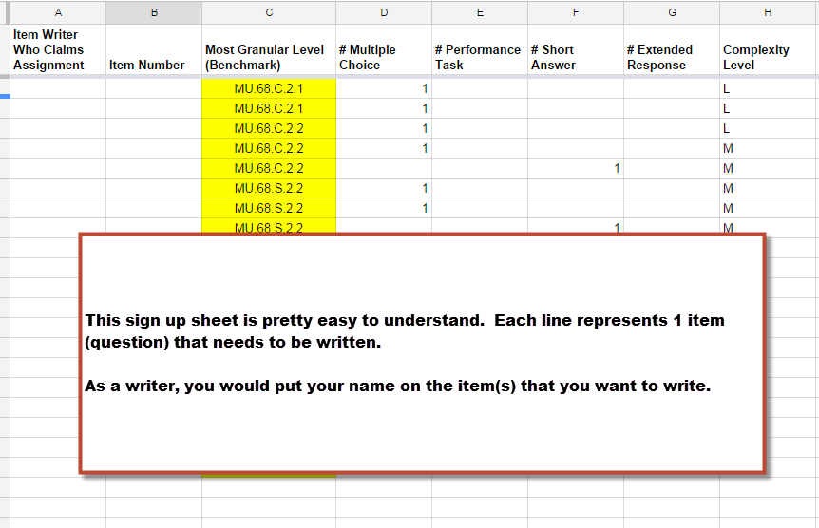
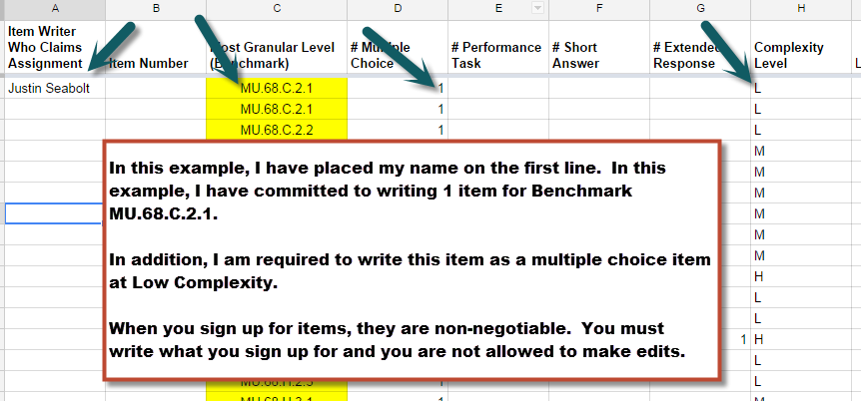

Not all sign-up sheets are created equal so here are a couple examples of different looking sign-up sheets. Regardless of how they look, they are all used in the same way.
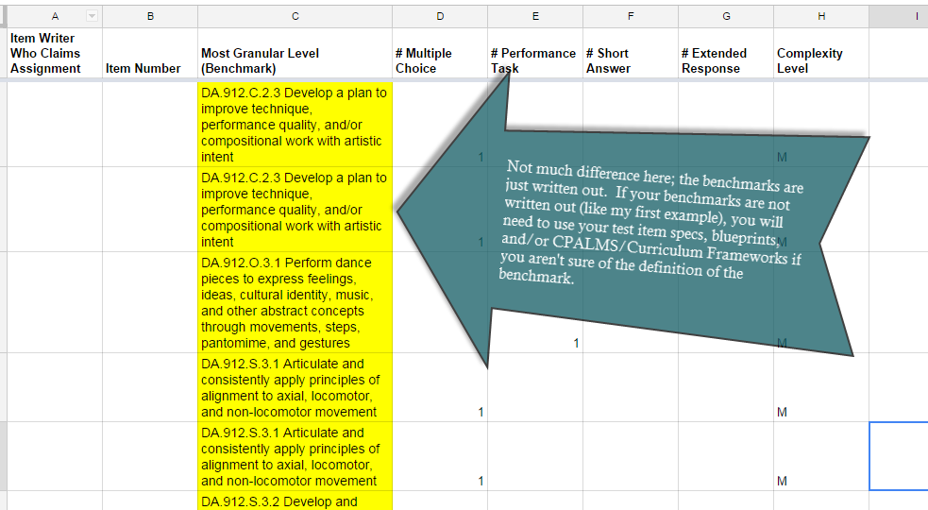
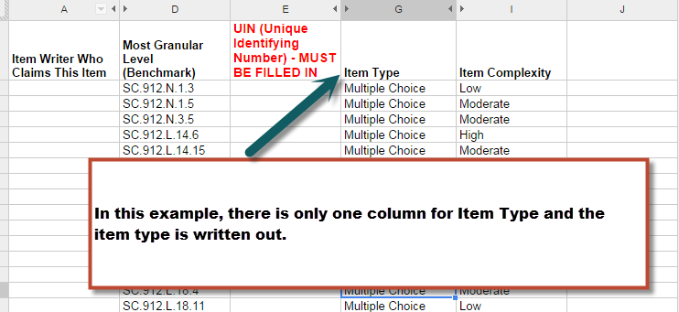

- Once you actually sign up for an item, the process is pretty straightforward:
  - Login to Eduphoria and write the item
  - Once the item has been submitted in Eduphoria, return to the sign-up sheet and enter the Item Number (UIN – Unique Identification Number)

Note: I cannot stress the importance of inputting the Item Number (UIN) into the sign-up sheet. This is our tracking system and this is how we know what work has been completed and what still needs to be done. Every time you submit an item in Eduphoria, the system will automatically generate an Item Number for you. If you are having a difficult time locating this Item Number, there is a section later in this guide titled “Finding my Unique Identification Number (UIN)” that I strongly encourage you to read. If your Item Number (UIN) is not correctly written in the sign-up sheet, your items will not be approved because our level 2 editors and proofreaders are required to verify that Item Numbers in Eduphoria match what is on the sign-up sheets.
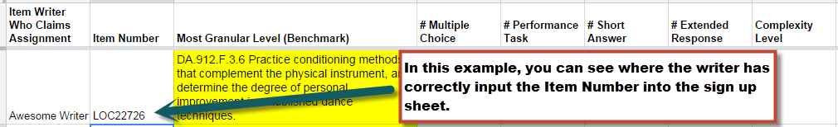

One more note: All Item Numbers (UINs) are unique, meaning no two Item Numbers will be the same. With each item submitted into Eduphoria, the system will generate a new Item Number (UIN) that will correlate to that specific item.

Last note: Please make sure that you put the Item Number (UIN) into the sign-up sheet immediately after you write each question.

- You may notice on some sign-up sheets that people are signed up to write more than one item at a time and there is no Item Number (UIN) currently written. We do allow you to sign up for up to 10 items at a time as long as you are committed to completing the work. The same rules apply as above, however. Each time you write an item, you would still be expected to return to the sign-up sheet to input the Item Number (UIN). It’s very easy to lose track of which Item Numbers (UINs) go with what benchmark you signed up for, so I strongly encourage you to not forget this step.
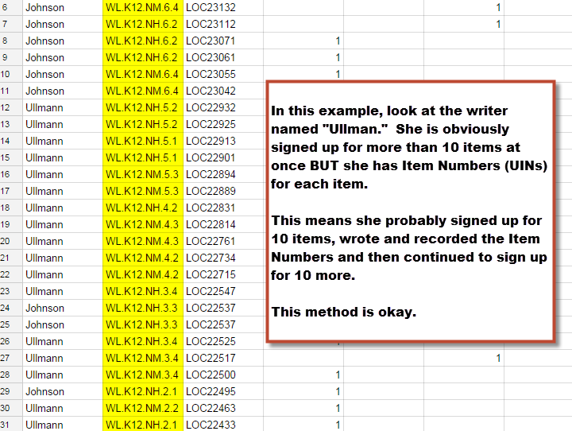
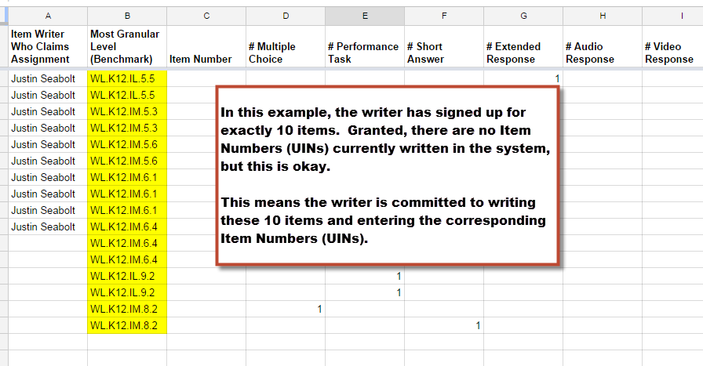
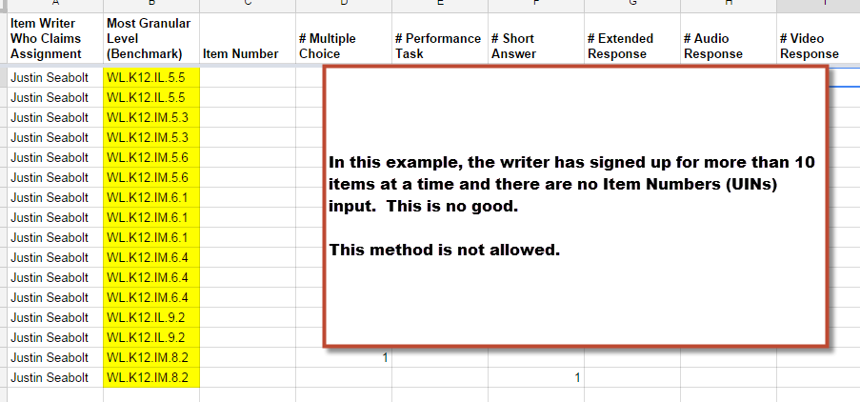

How to Write Multiple Choice Items in Eduphoria

- Log into https://cfac.schoolobjects.com or https://sac.schoolobjects.com
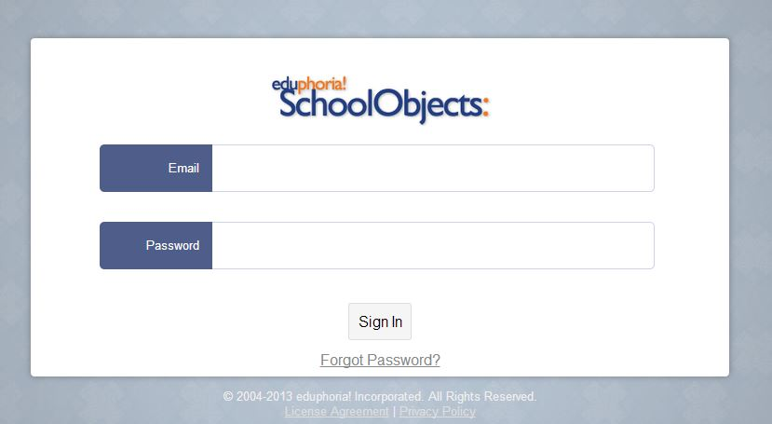

- This step may not apply to everyone. Please select an organization and login. If you are working on CFAC courses, choose CFAC. If you are working on anything else, choose SAC courses. If “Please select an organization and login” doesn’t appear on your screen, then you are defaulted to only working on CFAC courses and you may skip this step. SAC courses are currently only for a select few counties who are working on courses outside the scope of CFAC.

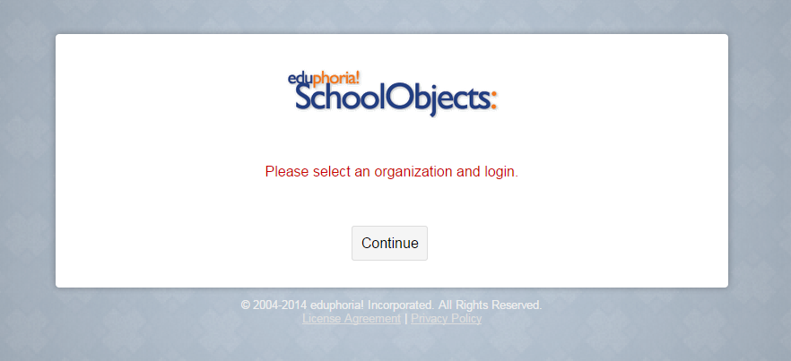

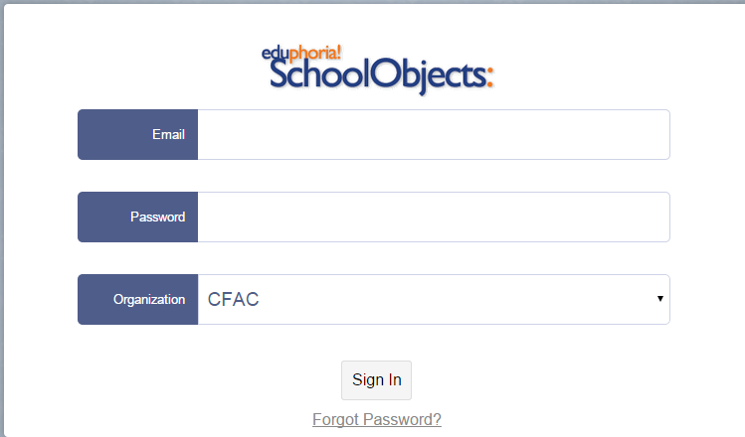

OR
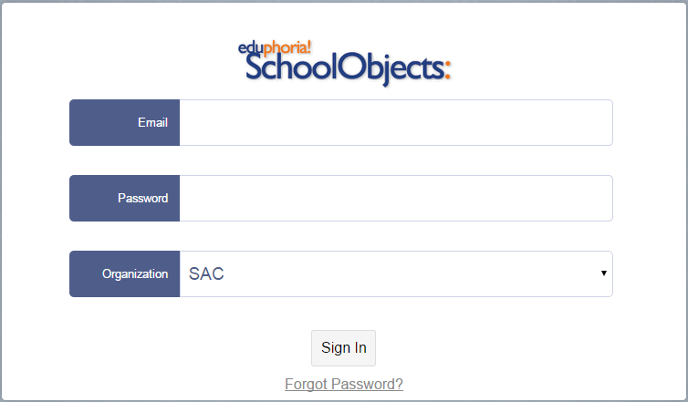

- Click on “aware.”
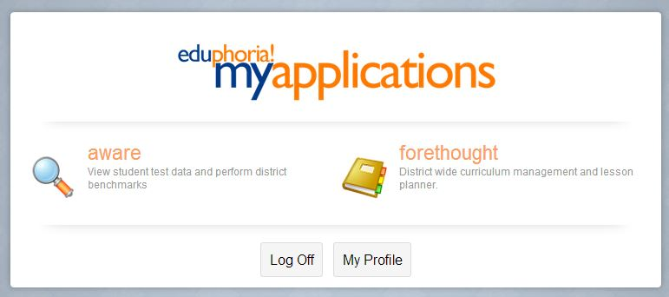

- In the upper left of your screen, make sure you have the “Item Bank” tab chosen click on your Content Area’s folder. For training purposes, we will use Math.
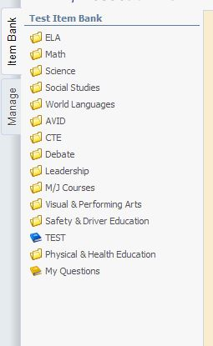
Note: Please choose your own content area from the list provided.
- Upon clicking on your Content Area’s folder, a list will show which courses are available to choose from. In our case, we are going to choose Analytic Geometry.
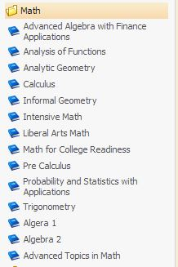

- Next, a list of benchmarks will appear. You will click on the benchmark that you are writing an item for. For training purposes, we will choose MA.912.A.4.9.
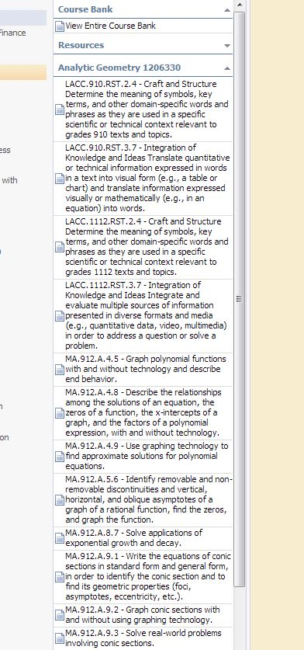

- After clicking on the appropriate benchmark, you will click on “Add Question” at the top of your screen.

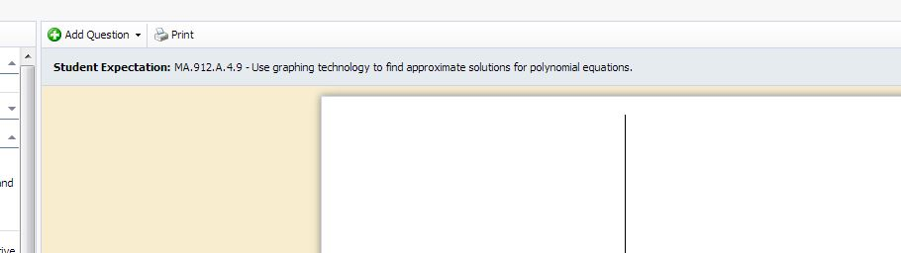

- After clicking on “Add Question,” you will need to choose what type of item you are going to write. For training purposes, we will choose “Selected Response.” Note that Multiple Choice and Selected Response are synonyms in regards to Eduphoria.

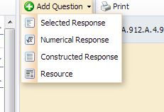

- After choosing “Selected Response” you will begin writing your item and entering your multiple choice answer choices.

New Multiple Choice Question Textbox: This is where you will write your question.
Response Textbox: This is where you will write your answer choices.
Rationale Textbox: This is where you will write your distractors/rationales for your answer. choices. You must provide a reason for why your incorrect answers are plausible.

Note: When writing multiple choice questions, you must have one clear answer and three plausible distractors.

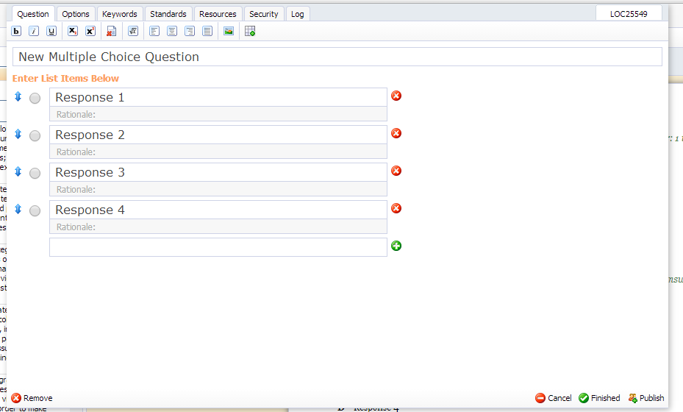

- When entering items, you must remember to follow all the rules and guidelines that you learned in training. This applies to the answer choices as well. If you need assistance, please refer to the Multiple Choice Answer Choice Guidelines section.

- Let’s take a look at the item I have created and review it.

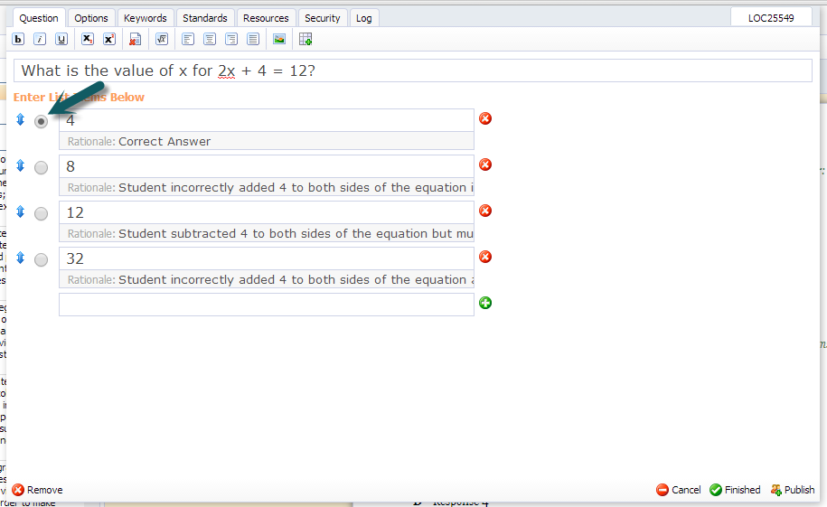
In the example provided, I have asked:
What is the value of x for 2x+4=12? (All Multiple Choice Items should be in the form of a question)

Next, I followed the rules for my answer choices. In this case, I ordered my answer choices from least to greatest. (I was able to use my Multiple Choice Answer Choice Guidelines to help with this)

I have also provided 3 plausible distractors with rationales for each one. You cannot see the entire rationale in the picture above but you will be able to see the entire rationale when logged into Eduphoria. For this example, my rationales are as follows for my answer choices:

8: Student incorrectly added 4 to both sides of the equation and then divided by 2.
12: Student subtracted 4 to both sides of the equation but then multiplied by 2.
32: Student incorrectly added 4 to both sides of the equation and then multiplied by 2.

Notice how each one of my rationales is clearly written in a manner that explains why my rationale is a good distractor. It’s extremely important that you are able to write plausible “wrong answers.”

- Next, I will choose my complexity level from the “Options” tab at the top of the screen.
On this tab, the only field that should be changed is “Complexity.” Eduphoria defaults to “Low” but you must remember to change this to Medium (Moderate) or High, if necessary.

There is a Webb’s Depth of Knowledge Wheel located at the very end of this document. You will notice that Webb’s DOK has 4 levels but in Eduphoria, you can only choose from Low, Medium, and High.

Level 1 Webb’s DOK = Low in Eduphoria
Level 2 Webb’s DOK = Medium in Eduphoria
Level 3 & 4 Webb’s DOK = High in Eduphoria

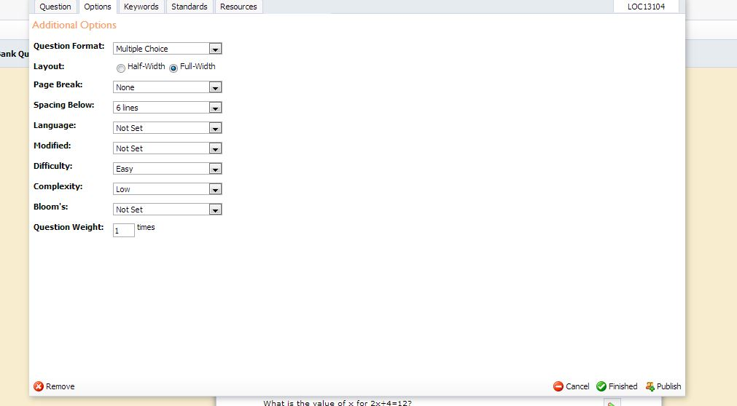

- Once everything is complete, you will click “Publish” at the bottom of the screen.

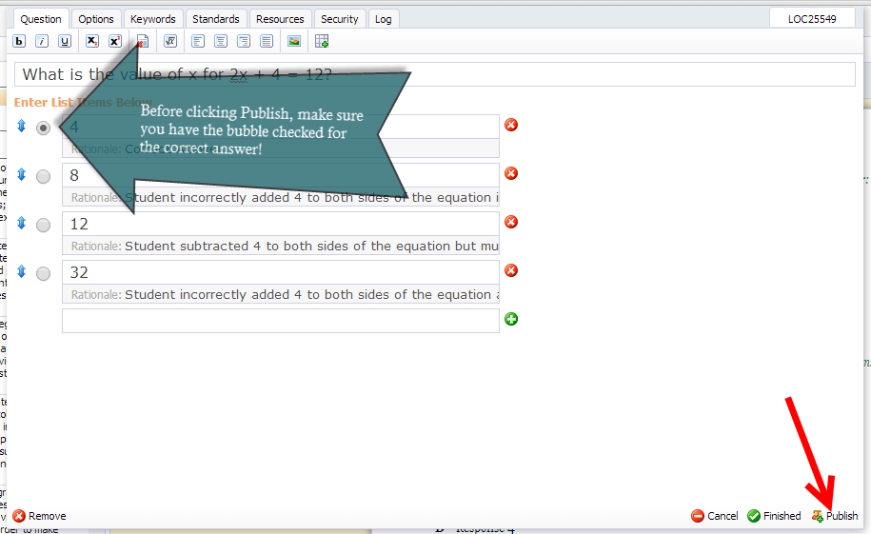

Note: If you have a resource such as a passage or graphic that you would like to assess with multiple questions, it will first need to be uploaded into system as a resource. Please see the section on “When and How to Upload a Resource for Use in Eduphoria.”

How to Write Gridded Response Items in Eduphoria

Gridded Response Items are input in the same manner that Multiple Choice Items are input. If needing detailed instructions, please refer to the “How to Write Multiple Choice Items in Eduphoria” section of this manual. This section will only cover the subtle differences between screen shots of Gridded Response Items in comparison to Multiple Choice Items.

- Once you have selected “Gridded Response” from the “Add Question” drop-down, your screen should look like this:

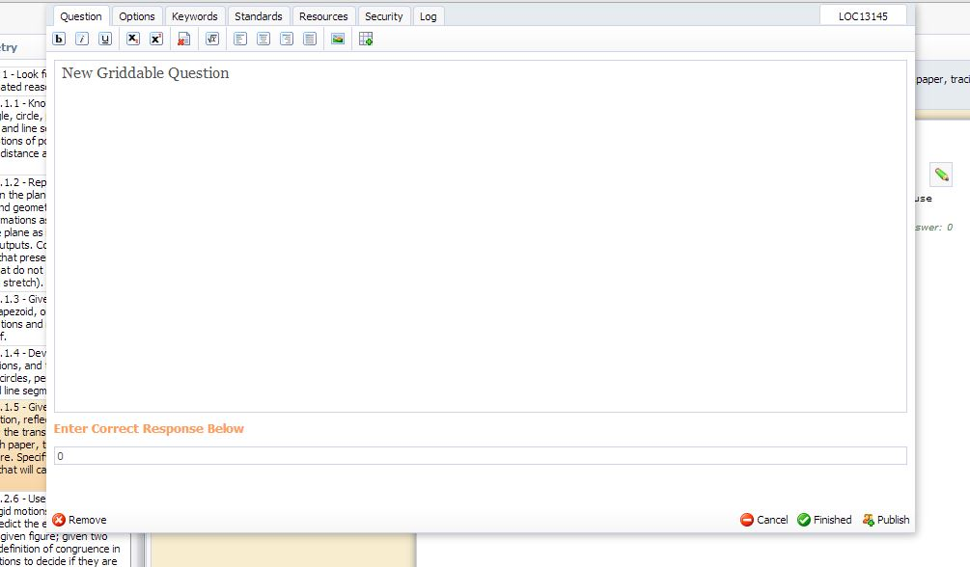

- For training purposes, we will use the same question used in the Multiple Choice section. You will type your question into the box that says “New Griddable Question.” You answer will go in the box that says “Enter Correct Response Below.” (as seen below)

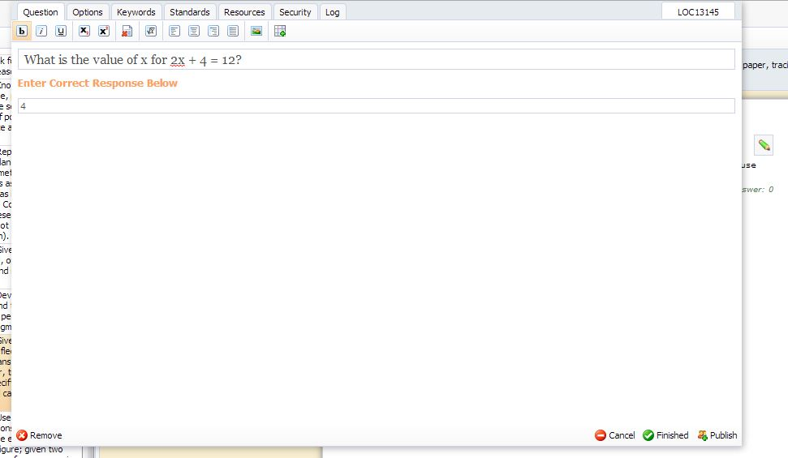

- After your question has been input, please make sure you remember to choose the complexity level (as covered in the Multiple Choice section of this manual).
NOTE: Rationales do not need to be entered for a Gridded Response Item.
Once your item has been input and you ready to submit, please click “Publish” in the bottom right hand of the screen.

How to Write Constructed Response (Short Answer, Extended Response, Performance Task) Items in Eduphoria

Constructed Reponses Items are input in the same manner that Multiple Choice Items are input. If you need detailed instructions, please refer to the “How to Write Multiple Choice Items in Eduphoria” section of this manual. This section will only cover the subtle differences between screen shots of Constructed Response Items in comparison to Multiple Choice Items.

- Once you have selected “Constructed Response” from the “Add Question” drop-down, your screen should look like this:

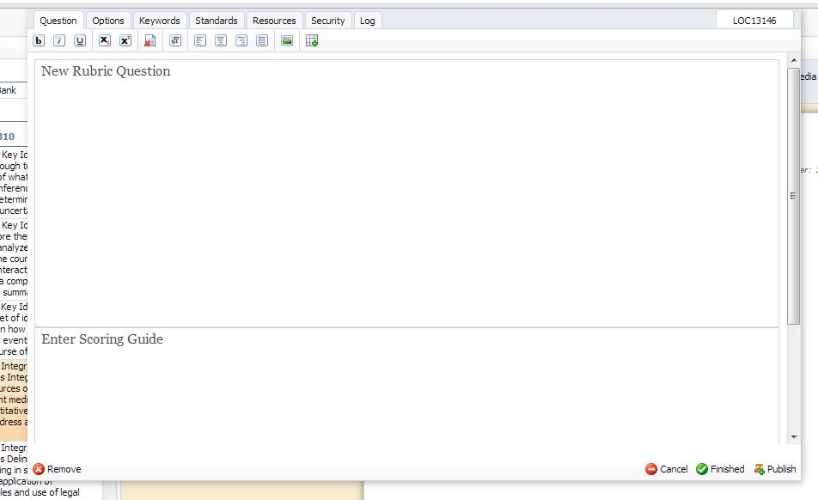

- You will type your question into the box that says “New Rubric Question.” You answer will go in the box that says “Enter Scoring Guide.” (as seen below)
NOTE: When entering Constructed Response Items, you are required to input your scoring rubric.
Short Answer Items use a 3-point scale ranging from 0-2 and you must provide a sample full credit response in order for a student to obtain a score of 2.
Extended Response Items use a 5-point scale ranging from 0-4 and a sample full credit response is not required. If you are writing for an English/Language Arts Course, you may opt to use the 6-point rubric ranging from 1-6 to model what is used in FCAT Writes.
Performance Task Items use a 5-point scale ranging from 0-4 and a sample full credit response is not required.
Please see the section on Generic Constructed Response Rubrics for example rubrics that are available for use.
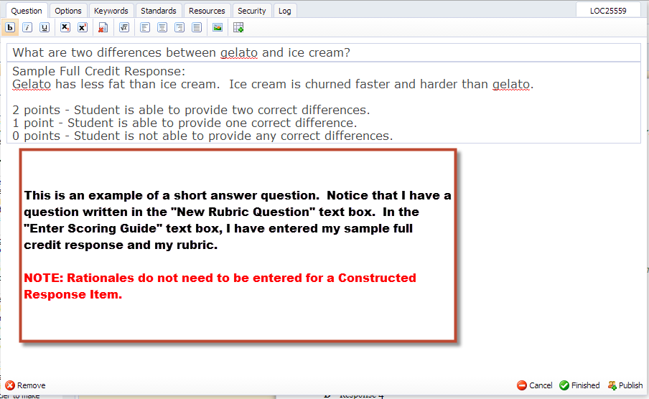

- After your question has been entered, click on the “Options” tab.

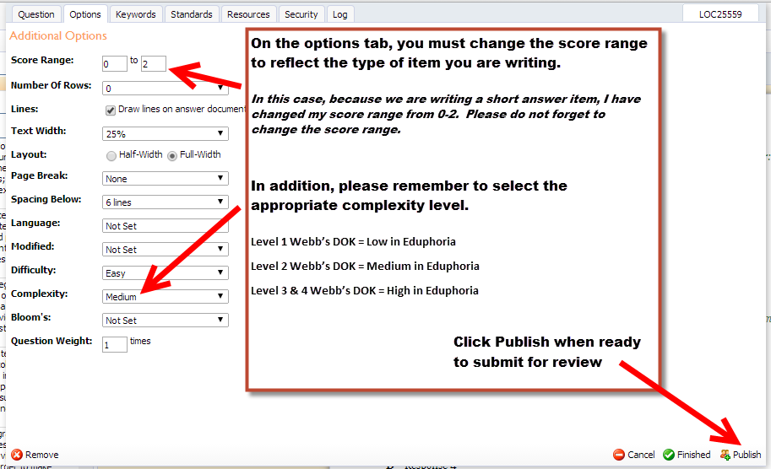

How to Check the Status of a Submitted Item

Once submitted, you will be able to click on “My Questions” on the left side of the screen to check the progress.
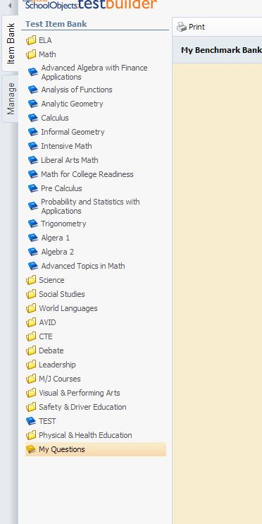

You will know that your item has been officially accepted once the status changes to “published.” In the picture below, the item I just submitted has not been approved yet therefore it will not say “published.”

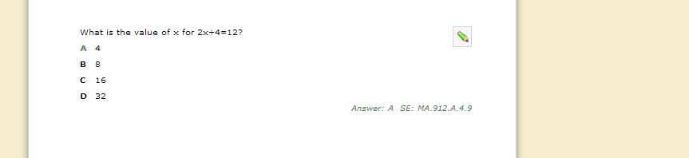
Click here if you need to edit your item.

When and How to Upload a Resource for Use in Eduphoria

If you have a graphic or passage that you would like to writer several questions for, you will need to first create it as a resource. Remember, all resources should be cited when necessary.

Steps for adding a resource to be used for multiple questions

- Once you click on the “Add Question” drop-down, choose “Resource.”

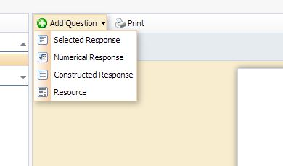

- Next, enter the title of your resource in the “Enter Resource Title Below” box. Now you can upload or paste your resource into the “Enter Resource Text” box. When finished, click “Publish.” Doing this will add this resource to your list of resources. Think of this as uploading pictures to a folder on your home computer (they are only there for your private viewing).

Click this icon to upload an image file

Click this icon to insert a table

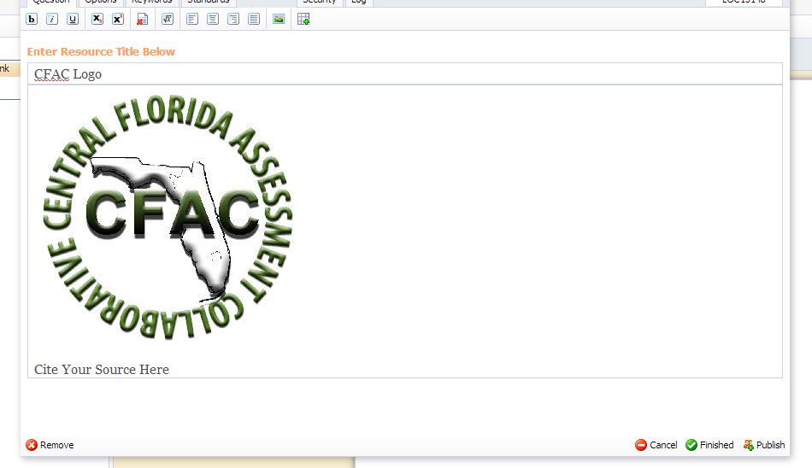
Click “Publish” when finished adding your resource

NOTE: If necessary, please remember to site your source below your resource (as seen in the illustration above). This should be done whether you are using the resource on one item or multiple items. Please see section on How to Cite Sources for more information.

- When you are ready to attach your resource to a question you are writing, click on “Add Question” (see section on How to Write Multiple Choice Items in Eduphoria for instructions) and then use the “Resources” tab to attach your resource.

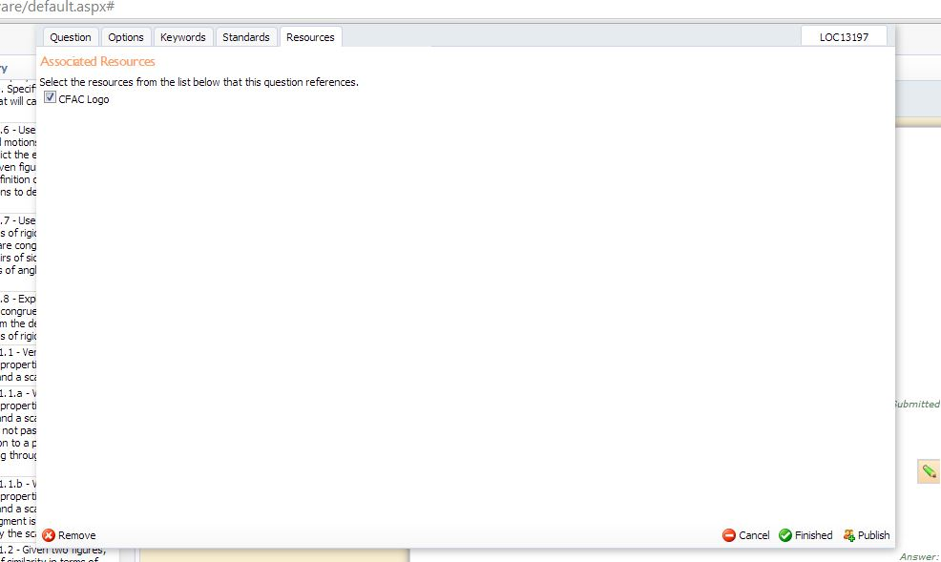
Make sure you check the box beside the resource that you want to use

- Once you have selected the appropriate resource for your item from your list of resources and you have finalized your item and are ready to publish it, you will click “Publish.”

See below for an example from a Creative Writing course where this method was used. In the example below, the passage has already been uploaded into the writers “Resources.”
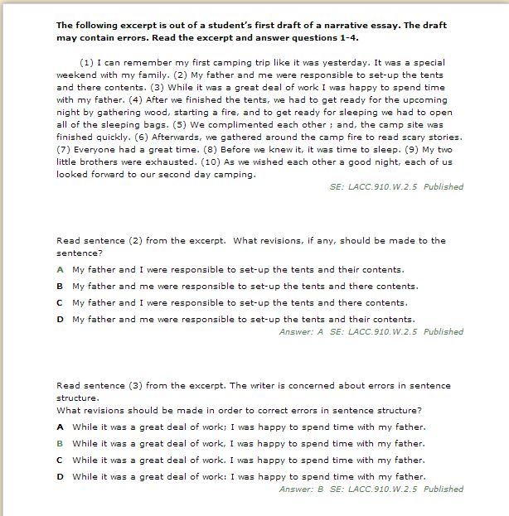
Step 3: The writer is following the same process as in Step 2 and continues to write items in regards to the passage above.
Step 2: The writer has once again clicked on “Add Question,” and has written a question in regards to the above passage by adding the appropriate resource from the “Resources” tab. Notice how the instruction in the passage above has instructed the test-taker to “Read the excerpt and answer questions 1-4.”
Step 1: The writer has clicked on “Add Question,” then clicked on “Resources,” chosen the passage and clicked “Publish.” You can see how their passage shows up as being published. The resource is now ready for use with future questions.

Steps for adding a resource to be used in a single question

If you only need to use a resource for one question at a time, it is not necessary to go through the process of uploading the resource as done in the previous example. You may simply add the resource in as you are writing your question.

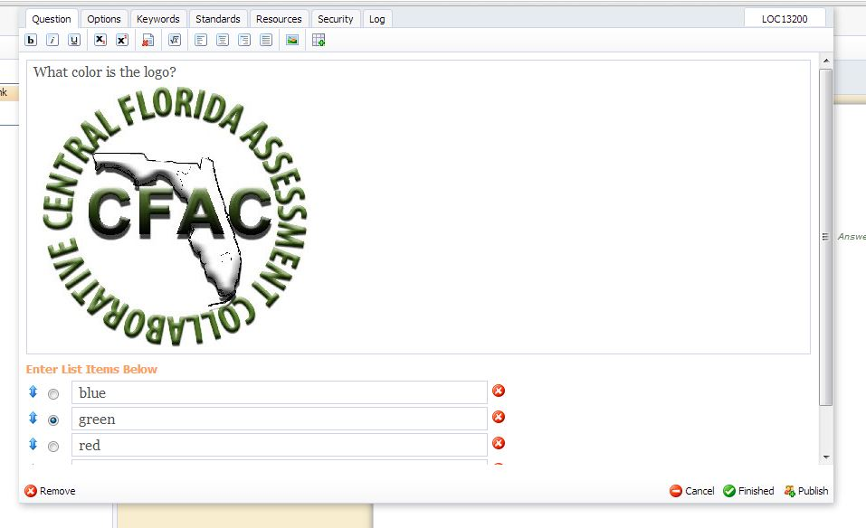
Use this tool bar to individually add pictures, graphs, tables, math symbols, etc.

Note: When using a resource for a single question, you must upload the resource AND write the question in the same text box (as shown above).

How to Add an Audio File
Eduphoria does not currently support audio files so any items that are written in Eduphoria that contain audio files have to be uploaded to our SharePoint site. Please see below for the steps on uploading audio files into SharePoint.
- Go to the following site: http://sp.osceola.k12.fl.us/Depts/REA/SitePages/Home.aspx

- Next, click Sign In in the top right hand corner. You will use your Active Directory to login.
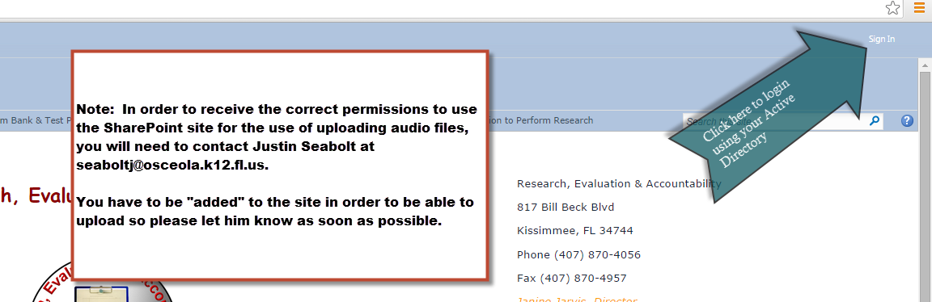

- Once you login, click Test Item Media.
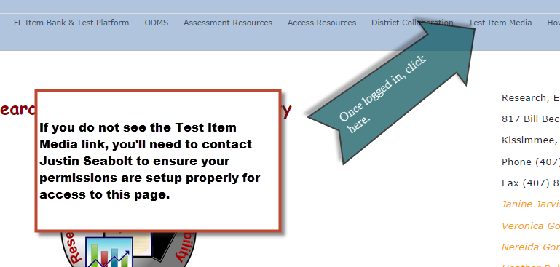

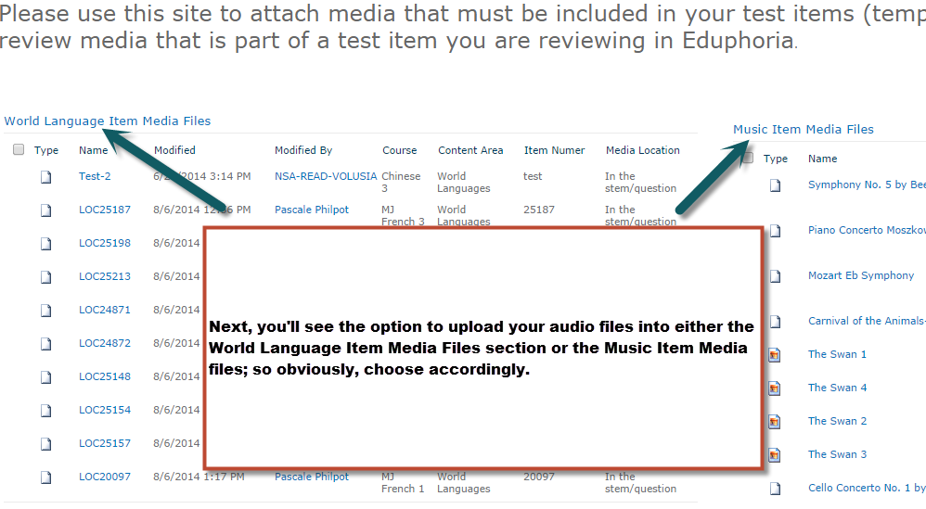

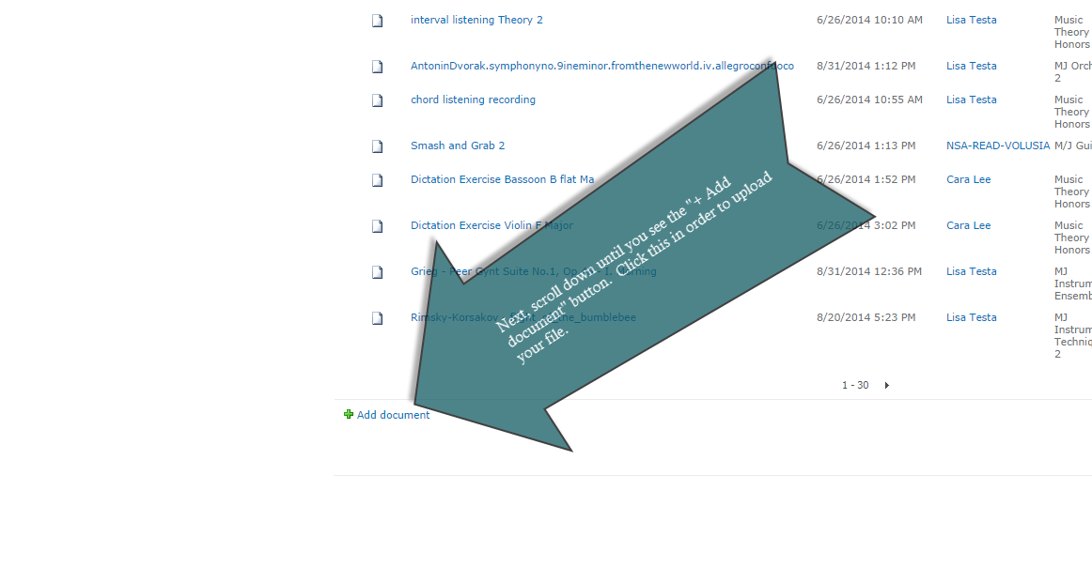
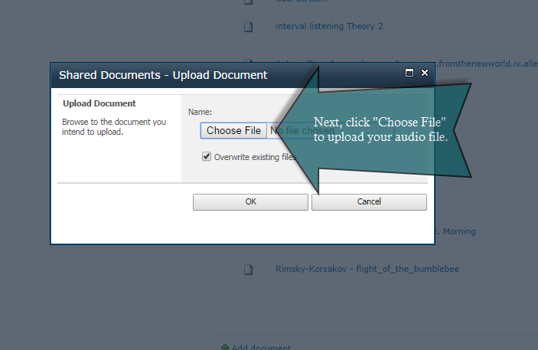

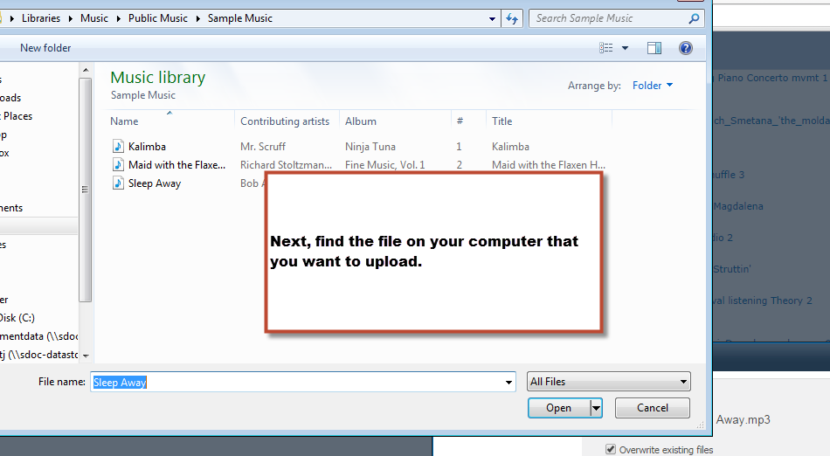

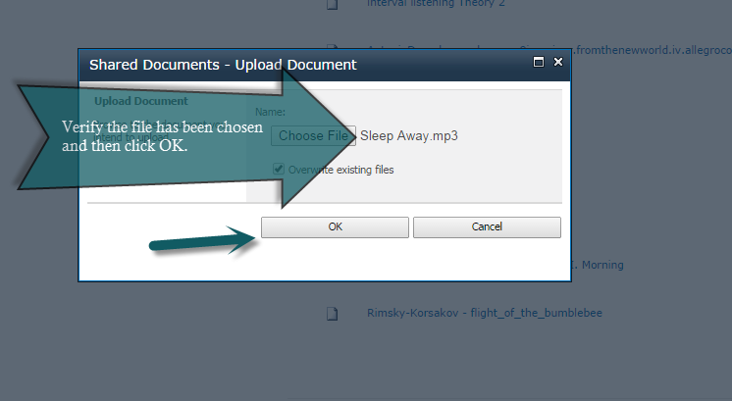
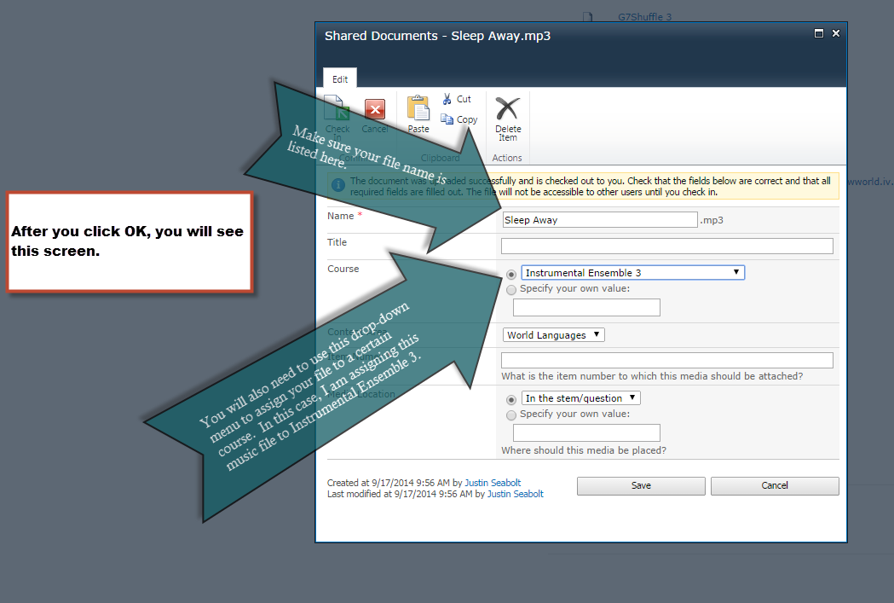

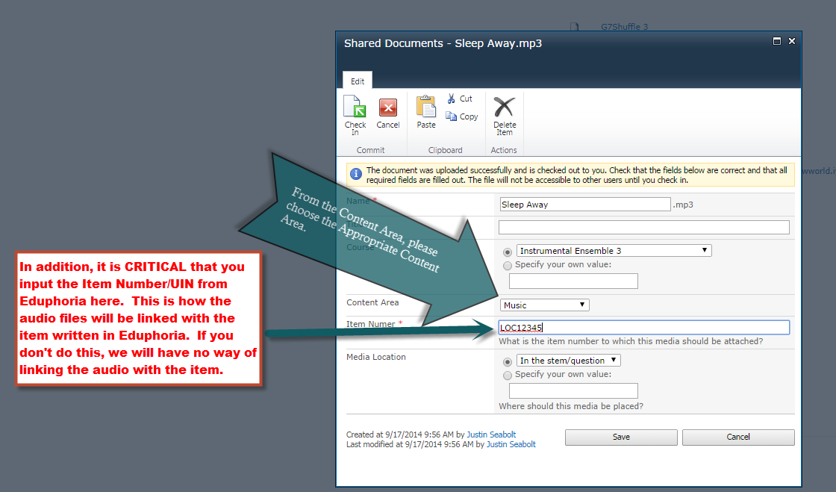
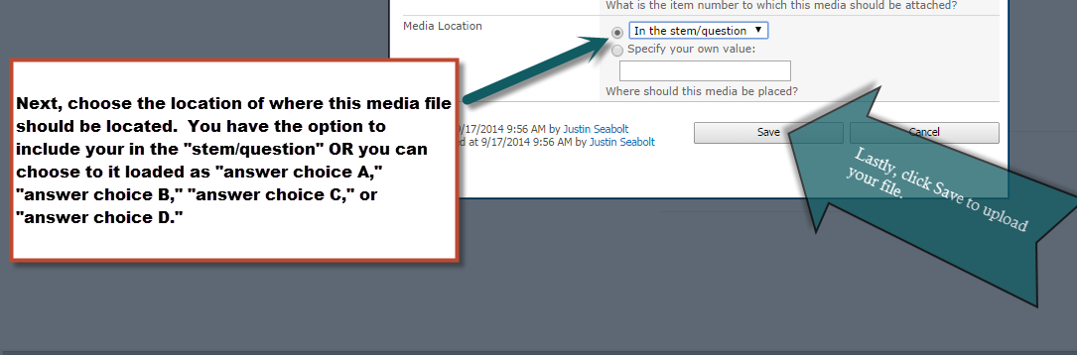
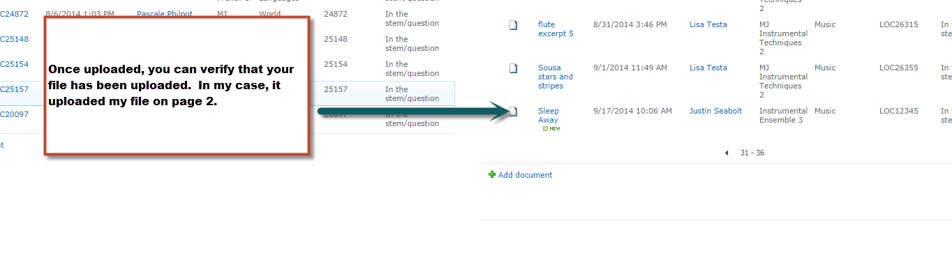

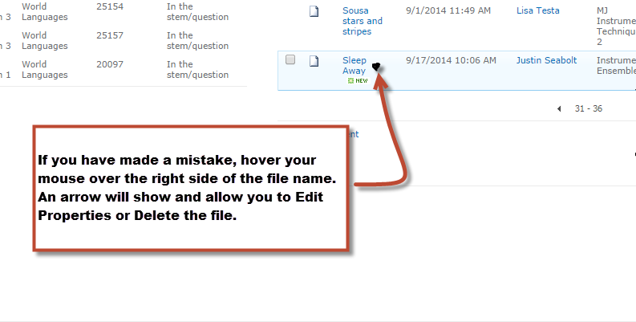

If you are reviewing items that include audio clips, you should also be checking the SharePoint site to ensure accuracy of the item you are reviewing. Please see the section on How to Review Items in Eduphoria for more detailed instructions.

What to do if No Benchmarks are Available or If They Are Missing

Some courses may not have their standards/benchmarks loaded into the course you are writing for yet.

Notice how there are no benchmarks listed here. If benchmarks were uploaded for this particular course, you would see a list of benchmarks here.
If this is the case, you should not write any items yet.
If your course does have benchmarks but one is listed, you should also not write any items for said benchmark.
Please contact Justin Seabolt if benchmarks are not available or are missing.

How to Review an Item in Eduphoria

- Click on “aware.”

- Click on the “Manage” tab.

NOTE: The “Manage” tab will ONLY appear when you have items to review. If you do not have a “Manage” tab, this means you have no items to currently review.

- In the lower left hand corner of your screen, you will click on “Approve Questions.”

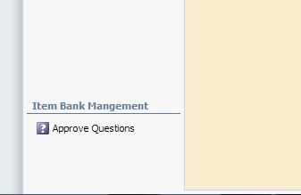

- Next, a list of courses that you are eligible to review for will pop up. You will choose the course that you want to review for at that particular time. Only courses that you are eligible to review for will show up.

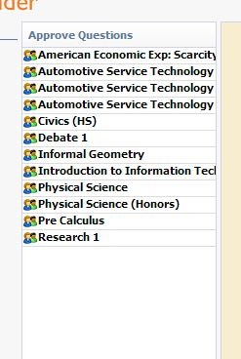
For training purposes, we are going to click on Civics.
- Once you choose your course, a list of submitted benchmark questions for approval will show up. When you hover your mouse pointer over the individual submitted questions, a little green pencil icon will show up. You will click the “green pencil icon” to review the item.

- Once the item is open, you will review it based on your training and either reject or approve the item clicking on the appropriate button.

When reviewing items, please use the “Item Writer and Reviewer Checklist” to ensure you are properly reviewing the item. This checklist can be found on pages 44-45 of this document.
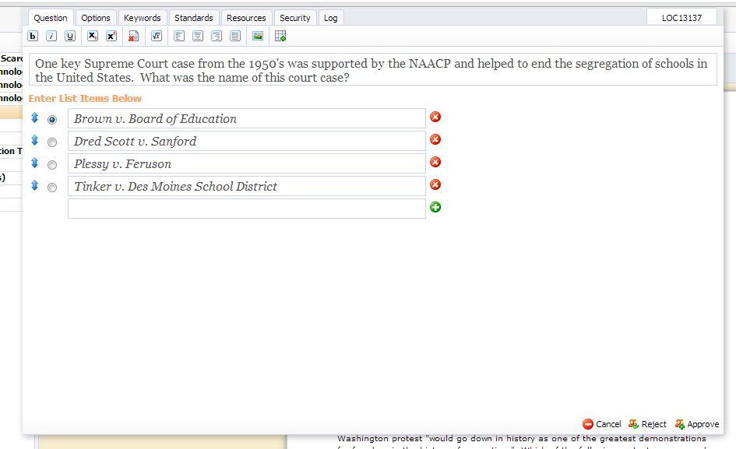
NOTE:
When rejecting a multiple choice item, reviewers should place their comments as a 5th multiple choice response and clicking the “green plus sign” before clicking “Reject.”
When rejecting a constructed response or extended response item, reviewers should place their comments in the “Keywords” tab before clicking “Reject.”

ALL REVIEWERS ARE REQUIRED TO PLACE COMMENTS WHEN REJECTING ANY ITEM FOR ANY REASON. YOU MUST PROVIDE THE REASON WHY AND A SUGGESTION FOR FIXING THE ITEM.
**Remember, if you can edit an item in under 15 minutes, please do that instead of rejecting the item.
How to Review an Item with an Attached Resource for Use on Multiple Items

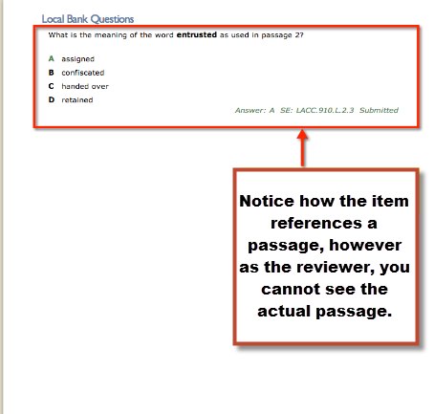

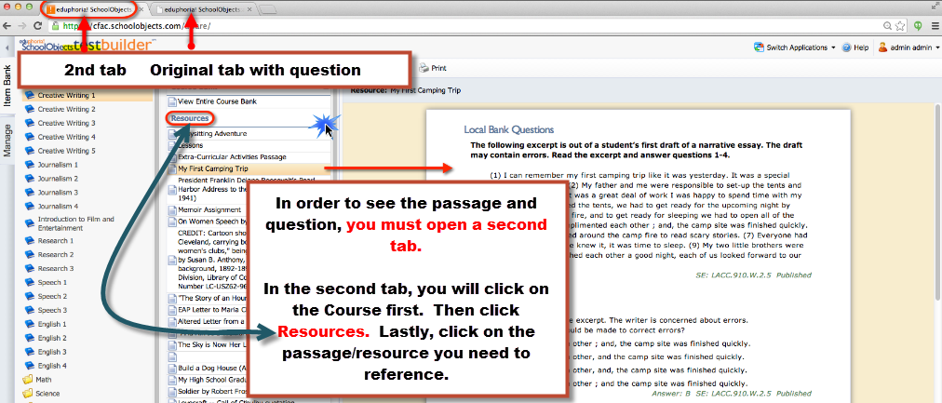
Finding your UIN (Unique Identification Number/Item Number) in Eduphoria

- Click “My Questions”
- Hover over your question until the green pencil shows up.
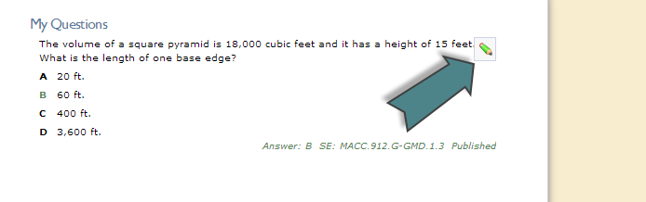
- Click the green pencil.
- In the top right corner, you will see your item number. Most times, this UIN starts with “LOC.”

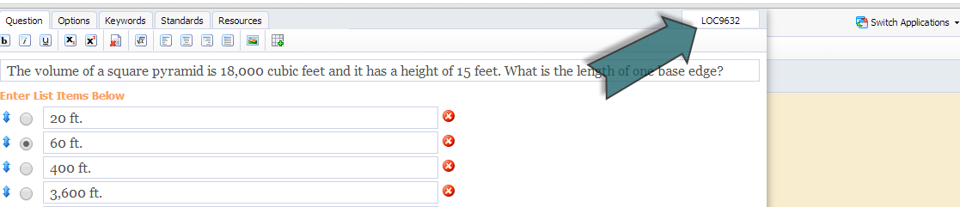

- Copy and paste this UIN (minus the LOC) into the corresponding line item on the Item Writer Signup.

Example: The LOC is the picture provided is LOC9632. In the Item Writer Signup, I would only write 9632. Do not write LOC.

Item Writer and Reviewer Checklist
All Item Writers and Reviewers should be referring to this at all times. This document can also be found on the CFAC website.
Item Writer's & Reviewer's Checklist
 | Yes | No
Overall Considerations
Does the item match the benchmark, and is it aligned to the benchmark in the platform? The content should not go beyond the content limits.
Does the cognitive complexity match the DOK indicated in the ITEM WRITER SIGN UP sheet?
Is the reading level at or below the lowest grade level listed in the standard (i.e. 9-12 standards should be written at or below 9th grade reading level), with the exception of vocabulary included in the benchmark or item specification?
Are clichés, textbook language, or jargon used?
Are words of emphasis like least, most, greatest, main, opposite, best, etc. in boldface? Are restrictive words like Not and Except All emphasized? Boldface preferred.
Are grammar, punctuation, and spelling correct?
Are reference/resource materials included if necessary? E.g., formula sheets, calculator, etc.
If images or passages are included, is the source cited and/or is the copyright status given?
Selected Response Items:
Are cue words used in the question stem?
Are there any grammatical hints in the questions to give it away?
Are absolutes used? (i.e. all of the above, none of the above, etc.)
Is one benchmark measured primarily?
Are terms repeated in the stem and responses?
Are there only four answers? (only three for grades K-2)
Are the answer choices in the proper order in regards to the Multiple Choice Answer Choice Guidelines?
Is the stem in the form of a question?
Is there only one true and defensible answer?
Are rationales provided for each of the three wrong answer choices? Rationales should be worded in a way that explain why that answer choice is a plausible distractor.
Are misconceptions and/or logical misinterpretations used purposefully as distractors?
Constructed Response Items: Short Answer Considerations
Does it ask the student to do or take two actions?
Does the Stimulus provide a clear and concise action or task?
Does the task appear as the final part of the stimulus?
Is the type of answer expected clearly stated?
Can the item be answered within 2 to 5 minutes?
Can the question be answered with a few words or few sentences?
Is there a three (3) point scoring guideline / rubric? (score points 0 - 1- 2).
In addition to a three point, rubric, short answer questions should have a SAMPLE FULL CREDIT RESPONSE. Does the item have this (in addition to) the rubric?
Does the rubric include scoring points that are not explicit in the prompt?
Constructed Response: Extended Response & Performance Task Considerations
Is the prompt clear, concise and focused?
Does the task appear as the final part of the stimulus?
Does the prompt tell the students the expectations for the format of their response?
Is there a five (5) point scoring guideline / rubric? (score points 0-4). Keep in mind that with extended response and performance task, a sample full credit response is NOT required. In addition, English/Language Arts courses may opt to use a rubric with scoring range 1-6 instead of 0-4.
Does the rubric include scoring points that are not explicit in the prompt? (I.e., use of correct conventions, spelling, etc.)
Does the prompt encourage an extended response or performance?
Explain, discuss, illustrate, etc.
Do the prompt and the rubric match expectations? I.e., use of correct conventions.

Guide for Level 2 Reviewing in Eduphoria
**This section is only for level 2 editors and proofreaders for Osceola County**

- The course being reviewed must show up in the SDOC Gap Courses spreadsheet.
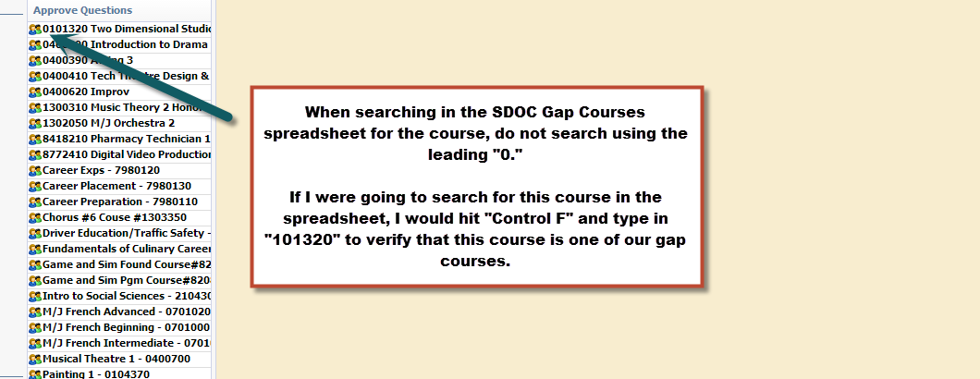

- Once the course has been verified in the SDOC Gap Courses spreadsheet, open the Item Writer Sign Up Sheet associated with the course. If you do not have access to the appropriate sign-up sheet, please email Justin Seabolt at seaboltj@osceola.k12.fl.us.
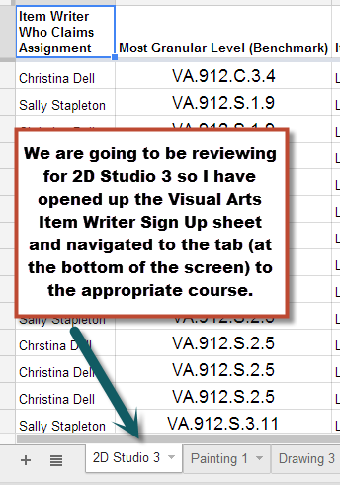
- When reviewing items at level 2, you will be cross checking the items in Eduphoria with the Item Writer Sign Up sheet. You will need to locate the UIN in Eduphoria as well as the Item Writer Sign Up sheet.
- To find the UIN/Item Number in Eduphoria, hover over the top right of the question until the “green pencil” icon appears. Click the “green pencil icon” to “edit the question.” You will see the UIN in the top right hand corner of the screen.
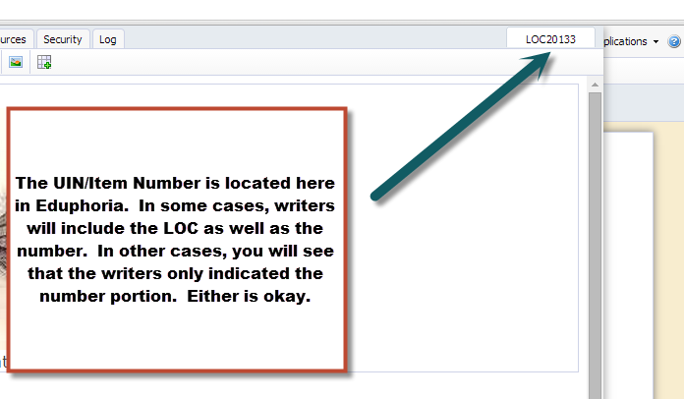
- To find the UIN/Item Number quickly in the sign-up sheet, hit “Control F” and type in the Number Portion of the UIN/Item Number you wish to find.
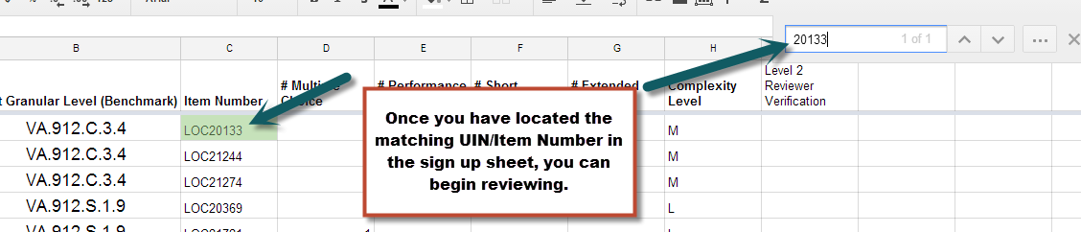

- Once you have found the corresponding UIN/Item Number in Eduphoria, you can use the checklist below to review the item.
NOTE: If you are reviewing an item in Eduphoria and you cannot find the UIN/Item Number in the Item Writer Sign Up sheet, please email the writer (and CC) Justin Seabolt immediately. Usually this means that the item writer has forgotten to update the sign-up sheet to include the UIN/Item Number. But this must be done first before reviewing the item.

Considerations/Checklist | Yes | No
Does the item written in Eduphoria match the item type signed up for in the sign-up sheet? If not, you will need to reject the item back to the writer. If you need to reject the item, please provide your comments (please see the Guide for Writing and Reviewing in Eduphoria on how to provide comments) AND follow up with an email to the item writer to let them know why you have rejected their item. | X
Click on the “Options” tab. Does the Complexity chosen match the Item Writer Sign Up sheet? If it doesn’t, please use the item writer sign-up sheet as the basis. You will need to email the item writer and ask them about the question. In a lot of cases, the item writers will forget to click on the Options tab and change to the appropriate complexity level.  For example, a writer may have signed up for AND written a moderate complexity question but left the complexity level indicated as low (the default for Eduphoria).  In addition, use the Webb’s DOK if there is a discrepancy before emailing the writer. There will be a DOK Chart you can use at the end of this document. Remember, Level 1 = Low Complexity, Level 2 = Moderate Complexity, and Level 3/4 = High Complexity.  *You can locate who the writer is by clicking on the “Log” tab. | X
Click on the Standards tab. Does the standard chosen match the Item Writer Sign Up sheet? If not, you will need to reject the item back to the writer. If you need to reject the item, please provide your comments (please see the Guide for Writing and Reviewing in Eduphoria on how to provide comments) AND follow up with an email to the item writer to let them know why you have rejected their item. | X
Are grammar, punctuation, and spelling correct? If not, fix it and approve the item. Items should never be rejected for anything regarding grammar, punctuation, spelling, etc. | X
If you are reviewing a multiple choice item, are the answer choices in the correct order? If not, fix it. You can use the Multiple Choice Answer Choice Guidelines at the end of this document to help you with this. | X
If you are reviewing a multiple choice item, are rationales provided for the three incorrect answer choices? If not, you will need to reject the item back to the writer. If you need to reject the item, please provide your comments (please see the Guide for Writing and Reviewing in Eduphoria on how to provide comments) AND follow up with an email to the item writer to let them know why you have rejected their item.
If you are reviewing a short answer item, is there a three point (score range 0-2) rubric provided? In addition, is there a sample full credit response provided? If either one of these are missing, you must reject the item. If you need to reject the item, please provide your comments (please see the Guide for Writing and Reviewing in Eduphoria on how to provide comments) AND follow up with an email to the item writer to let them know why you have rejected their item. | X
If you are reviewing a short answer item, click the “Options” tab again. Is the score range listed as “0 to 2?” If not, fix it. Eduphoria defaults the minimum score to a “1” so a lot of writers forget to change this when writing their items. | X
If you are reviewing a performance task or extended response, is there a five point (score range 0-4) rubric provided? Keep in mind that a sample full credit response is NOT required for performance tasks or extended responses…only a rubric. If the rubric is missing, you will need to reject the item back to the writer. If you need to reject the item, please provide your comments (please see the Guide for Writing and Reviewing in Eduphoria on how to provide comments) AND follow up with an email to the item writer to let them know why you have rejected their item.  NOTE: For English/Language Arts courses, you may see some rubrics that are 1-6 instead of 0-4. This is okay. But this is only okay for English/Language Arts courses. | X
If you are reviewing a performance task or extended response, click the “Options” tab again. Is the score range listed as “0 to 4?” If not, fix it. Eduphoria defaults the score range to “1 to 2” so a lot of writers forget to change this when writing their items. | X
Does the question written exhibit any bias or sensitivity that may be unfair to any student according to the Bias and Sensitivity Guide? If it does, you will need to reject the item back to the writer. If you need to reject the item, please provide your comments (please see the Guide for Writing and Reviewing in Eduphoria on how to provide comments) AND follow up with an email to the item writer to let them know why you have rejected their item. |  | X

- Once you have been able to approve an item, please initial in the Item Writer Sign Up Sheet under the column labeled “Level 2 Reviewer Verification.”
Note: If no such column exists, that means you are the first level 2 reviewer to review an item in this course. Please create this new column and initial accordingly.
Double Note: Do not forget the UIN/Item Number that you were just working on because as soon as you hit approve, it will disappear and you will not be able to find it again.
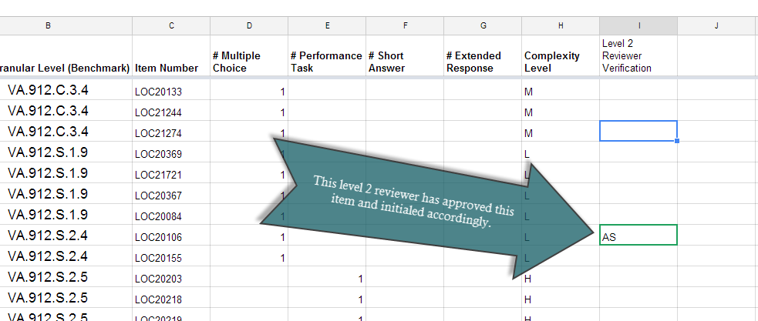

How to Correctly Cite Sources

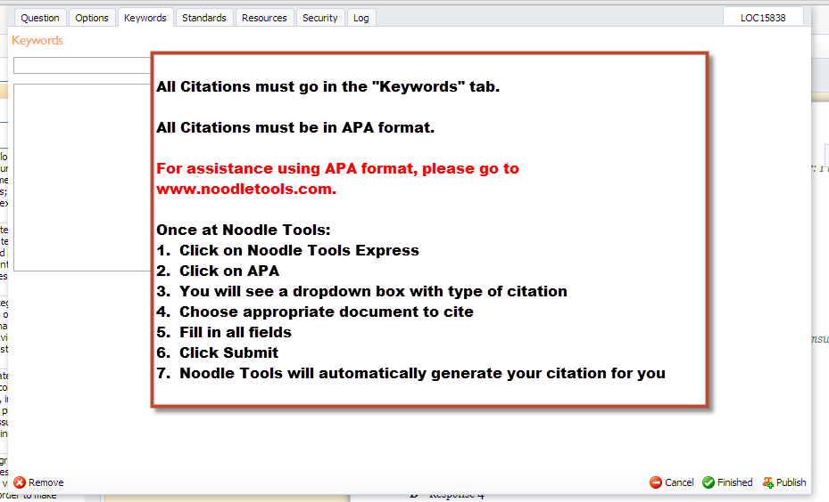

Creative Commons
- Creative Commons (Commercial Use) – Owner must be attributed, using APA format
- Copyright Free (Public Domain) – No need to attribute ownership
- Copyrighted item with permission from owner – Owner must be attributed, using APA format
- Student work with permission from the student and parent (if student is a minor) – Do not attribute ownership
- Please indicate in the Keywords or Notes what licensing rules apply (and citation if necessary)
- There are several sources for searching for images, passages, or multimedia clips that you can use in your test items. It’s important to understand the distinctions between these. An intellectual property that is available through a Creative Commons license means that the owner allows permission for the file to be used, as long as the ownership is properly attributed. Although we are not selling these assessments, test development is considered a commercial use, so you will need to pay attention to the type of Creative Commons license available. Some Creative Commons-licensed images allow for the user to make modifications, while others require you to use the original, unaltered image. In all cases, the owner must be attributed as the image source, using APA format.
- Copyright free means that there is no need to attribute ownership, and you are free to use the file as you see fit.
- If you do find a copyrighted item that you would really like to use, you have the option to request permission from the owner. It is your responsibility to request permission, using the form provided as a resource in this module.
- And, finally, if you would like to use student work in your test item, you may do so as long as you request permission from the student and, if the student is a minor, from the parent as well. There is a form provided on the CFAC website you can use for requesting permission. If you do use either student work or copyrighted work with permission by the owner, you will need to submit these permission forms to the project lead before your item will be approved.
- All stimuli that you use must fall into one of these categories, since our project does not have the funding to pay fees to the file owners. If your item uses an image, passage, or multimedia clip, you will need to include in the notes section what licensing rules apply to the file that you are using, as well as any necessary source citations.
- And, finally, a word about fair use. As teachers, most of you are used to being able to take advantage of fair use guidelines, so that you can use excerpts of copyrighted materials in your classroom. However, because assessment development is considered to be commercial use, the fair use rule does not apply. Thus, every piece of material used in your test items that was not created by you must either be creative commons licensed for commercial use, copyright free, copyrighted with appropriate permission form filed, or student work with appropriate permission form filed.
- When you create an item that uses an image, text, or video, you will need to indicate in the Keywords section where the material came from. If you created your own graphic or passage, please just indicate that it was author-created, original work, so that the item reviewers do not reject the item because of uncertainty about its origins.

Wikipedia
- Most images are copyright-free or Creative Commons licensed
- Click on the image to view permissions
- Wikipedia is a good source for images, since most images from here are copyright-free or available through Creative Commons licensing. If you find an image that you would like to use, you should simply click on the image to view its permissions.

BING
- Click on the image to view permissions
- Bing Images- filter to find public domain images
- When we go to www.bing.com, you can see the word Images on the navigation bar. Bing will allow you to search by license type. If you click on the word “License,” you see several options. The options that we are looking for are Public domain, Free to share and use commercially, and free to modify, share, and use commercially.

Library of Congress
- Most images are copyright-free
- See individual image for specific copyright information
- Most images in the library of congress are copyright-free. However, you may need to dig a bit to find the copyright status. For example, you can browse to www.loc.gov; here is the Library of Congress site. Click on Prints and Photographs, then on Ansel Adam’s Photographs of Japanese-American Internment at Manzanar. Now, in the left-hand column, you can see a link called “Rights and Restrictions.” If you click on that, it will open a second browser page that describes these rights. In this case, there are no known restrictions on use, so these fall into the category of images that we could use in our assessment items.

New Stories
- http://www.newsusa.com/ (requires registration, but registration is free & gives guidelines for attribution)
- http://www.aracontent.com/printsite/Default.aspx (no registration required - it’s ARA, but has articles on a variety of topics – see Sections on the left-hand side)
- http://en.wikinews.org/wiki/Wikinews:Copyright (read this page first for attribution guidelines)
- In addition to images, you may want to find passages to use as stimuli in your items. These are sources of news articles that are either copyright-free or Creative Commons licensed. Be sure to check the guidelines for each of these sites before using their materials.

Project Gutenberg
- Copyright-expired books
- Project Gutenberg has a large collection of copyright-expired books, so you can feel free to make use of any materials that you find on this site. Just be sure to indicate in the Keywords section what the status is for any passages that you use from this site. In this case, they would be public domain, so no need to do a complete APA citation.

OPENclipart
- Another source for copyright free images is Openclipart.org
- This is a public domain clipart site; each artist who posts images on this site releases all rights to the images. When using a clipart, or any other images, consider how the image will look for students taking the test on computer, as well as for students taking the test on paper.
- Other things to look out for when using images are blurred or small text that might not be readable, depending on the browser or quality of printing.

FLIKR
- Creative Commons License
- Check the individual image for licensing terms
- Flickr is a good source of images that have Creative Commons licenses.
- The steps for searching for Creative Commons licensed images, as well as show you how to check the individual image for its licensing terms are as follows. Type your search term into the search box. For this example, we will type the word “brain.” Once we’ve done that, the word “Advanced Search” will appear underneath the search box. Click on that, and look at the fifth search category, Creative Commons. First, check the “Only search within Creative Commons-licensed content” box, then check the Find content to use commercially box. When you’ve finished, hit Search. You can now use any of these images, as long as you cite it appropriately, using APA format, and indicate in the keywords or notes section that it is creative commons licensed for commercial use.

Google
- Google is a good source for finding copyright-free or creative commons licensed materials
- Simply input these terms in along with your search keywords, and verify that the resulting search returns are indeed copyright-free or creative commons-licensed.

Pixabay
- Pixabay is a good source with 100% public domain images

Other
- As an item writer, you can develop your own image, passage, or multimedia file, with the understanding that your compensation for the creation of the item includes the right for the Central Florida Assessment Collaborative to use this image, passage, or multimedia file, in perpetuity, for this assessment bank.

Multiple Choice Answer Choice Guidelines
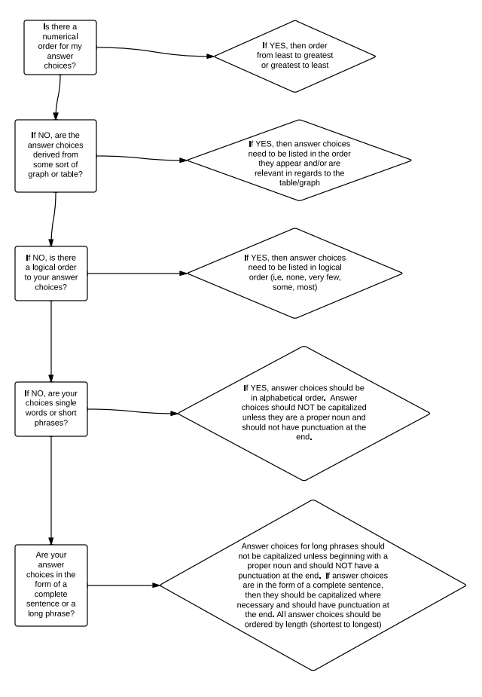
Generic Constructed Response Rubrics
As a writer, you may use these generic rubrics when writing your short and extended response items. Short response items use the 3-point scale (2,1,0) and extended response uses the 5-point scale (4,3,2,1,0).
Note: For short response items only, you must provide an example of the minimum response a student is required to provide in order to obtain a score of 2.

Short Response Scoring Guideline Template
2 Points:
- The response indicates that the student has a complete understanding of the concept embodied in the task.
- The student has provided a response that is accurate, complete, and fulfills all the requirements of the task.
- Necessary support and/or examples are included, and the information given is clearly text-based.
1 Point:
- The response indicates that the student has a partial understanding of the concept embodied in the task.
- The student has provided a response that includes information that is essentially correct and text-based but the information is too general or too simplistic.
- Some of the support and/or examples may be incomplete or omitted.
0 Points:
- The response indicates that the student does not demonstrate and understanding of the reading concept embodied in the task.
- The student has provided a response that is inaccurate or contains only irrelevant text-based information.
- The response has an insufficient amount of information to determine the student’s understanding of the task or the student has failed to respond to the task.

Extended Response Scoring Guideline Template
4 Points:
- The response indicates that the student has a thorough understanding of the concept embodied in the task.
- The student has provided a response that is accurate, complete, and fulfills all the requirements of the task.
- Necessary support and/or examples are included, and the information is clearly text-based.
3 Points:
- The response indicates that the student has an understanding of the concept embodied in the task.
- The student response has provided a response that is accurate and fulfills all the requirements of the task.
- The required support and/or details are not complete or clearly text-based.
2 Points:
- The response indicates that the student has a partial understanding of the concept embodied in the task.
- The student has provided a response that includes information that is essentially correct and text-based, but the information is too general or too simplistic.
- Some of the support and/or examples and requirements of the task may be incomplete or omitted.
1 Point:
- The response indicates that the student has a very limited understanding of the concept embodied in the task.
- The response is incomplete, may exhibit many flaws, and may not address all requirements of the task.
0 Points:
- The response indicates that the student does not demonstrate an understanding of the concept embodied in the task.
- The student has provided a response that is inaccurate or contains only irrelevant text-based information.
- The response has insufficient amount of information to determine the student’s understanding of the task or the student has failed to respond to the task.

In the table below are three examples of labels for the degree to which the student can demonstrate mastery of the benchmarks that are being assessed:

Score = 1 | Score = 2 | Score = 3 | Score= 4
Beginning | Developing | Accomplished | Exemplary
Unacceptable | Lacking | Adequate | Outstanding
Falls far below | Approaches | Meets | Exceeds

Readability Statistics

Go to www.readability-score.com
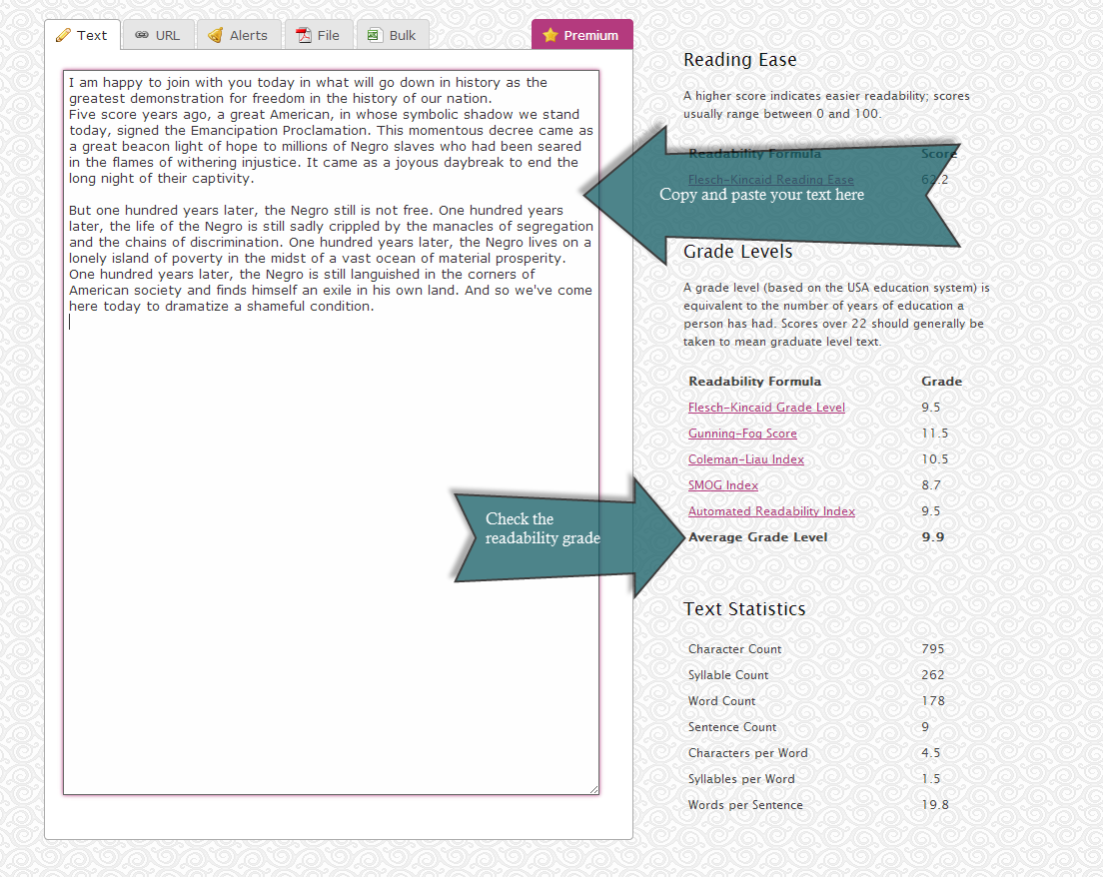

Note: The readability (average grade level) must be at or below the grade level indicated on the benchmark.
Example: If the benchmark is LAFS.910.SL.1.2, the highest allowable “average grade level” is 10.9.

Personal Item Writing and Reviewing Tracking Sheet
Benchmark |  | Item Difficulty | Item Complexity |  | Item Number | Date Completed | Course |  |  | Items Reviewed
SS.912.A.2.4 |  | Average | Moderate |  | 02-2106350-00010 | 1/17/2014 | Law Studies |  |  | Date | Total
 |  |  |  |  |  |  |  |  |  | 1/22/2014 | 8
 | Items Reviewed
 | Date | Total
 | 1/22/2014 | 8

Performance Based Test Item Example
If you are involved in a course where performances based items are required, please see the example below as a general guideline.
Notes:
Performance based items will change depending on the course so this is only to be used as a general guideline.
All performance based items should have a rubric with a score range of 0-4
Course Name: Foundations of Web Design
Benchmark(s): 6.01 – Create basic webpages
Also Assesses: Not Applicable
Performance Task: Create Three HTML pages on the given topic using structure tags (including page title), heading tags, paragraph tags, line breaks, and appropriate attributes.

Rubric:

4 points
- Each page had Doctype HTML, Head, Title, and Body Tags with proper nesting.
- Each page used headings h1-h6 (must be within the body tag).
- Each page included at least one paragraph tag (must be within the body tag).
- Each page properly uses a line break and has an element attribute.

3 points
- Only three of the items listed above are included

2 points
- Only two of the items listed above is included.

1 point
- Only one of the items listed above is included.

0 points
- Student did not complete the project – or – none of the items listed above are included in the project.

Other Information: This standard should be used in conjunction with the the Portfolio Assessments in Benchmarks 6.01, 6.02, 6.03, 6.04, 7.03, 7.05, 8.04, 9.01, 11.07, 1.10, and 14.02 to create a website on a given topic. Each benchmark will add to the website.

Webb’s Depth of Knowledge Wheel
