CENTRAL FLORIDA ASSESSMENT COLLABORATIVE
Individual Test Item Specifications
Business Keyboarding
2014
The contents of this document were developed under a grant from the United States Department of Education. However, the content does not necessarily represent the policy of the United States Department of Education, and you should not assume endorsement by the federal government.

Table of Contents

I. Guide to the Individual Benchmark Specifications 1
Benchmark Classification System 1
Definitions of Benchmark Specifications 3
II. Individual Benchmark Specifications 4

I. Guide to the Individual Benchmark Specifications

Content specific guidelines are given in the Individual Benchmark Specifications for each course. The Specifications contains specific information about the alignment of items with the Florida Standards. It identifies the manner in which each benchmark is assessed, provides content limits and stimulus attributes for each benchmark, and gives specific information about content, item types, and response attributes.

Benchmark Classification System
- Each Career and Technical Education course has its own set of course standards. The benchmarks are organized numerically, with two numbers separated by a decimal point. The first number is the standard number, and the second number is the benchmark number. You will see these numbers on the Item Specifications for each course.

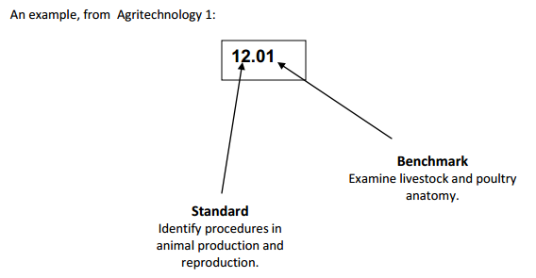

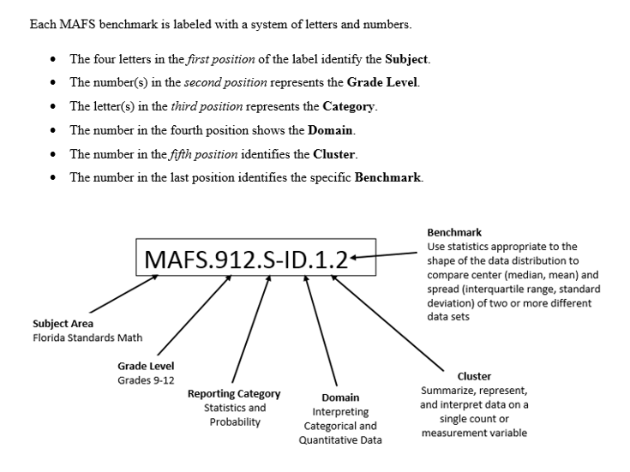

Definitions of Benchmark Specifications

The Individual Benchmark Specifications provides standard-specific guidance for assessment item development for CFAC item banks. For each benchmark assessed, the following information is provided.

Reporting Category | is a grouping of related benchmarks that can be used to summarize and report achievement.
Standard | refers to the standard statement presented in the Florida Standards.
Benchmark | refers to the benchmark statement presented in the standard statement in the Florida Standards. In some cases, two or more related benchmarks are grouped together because the assessment of one benchmark addresses another benchmark. Such groupings are indicated in the Also Assesses statement.
Item Types  Cognitive  Complexity | are used to assess the benchmark or group of benchmark.  ideal level at which item should be assessed.
Benchmark Clarifications | explain how achievement of the benchmark will be demonstrated by students. In other words, the clarification statements explain what the student will do when responding to questions.
Content Limits | define the range of content knowledge and that should be assessed in the items for the benchmark.
Stimulus Attributes | define the types of stimulus materials that should be used in the items, including the appropriate use of graphic materials and item context or content.
Response Attributes | define the characteristics of the answers that a student must choose or provide.
Sample Items | are provided for each type of question assessed. The correct answer for all sample items is provided.

II. Individual Benchmark Specifications
Benchmark Number | 01.01
Standard | - Develop and apply keyboarding skills utilizing current technology.
Benchmark | Demonstrate proper keyboarding techniques using correct ergonomic habits.
Also Assesses | 1.03
Knowledge/ Performance/ Both | Both
Item Types | Selected Response, Performance Task
Cognitive Complexity | Moderate
Benchmark Clarification | The student will use proper body posture and typing technique using home row keys and reach zones.
Content Limits | Limited to a QWERTY keyboard layout using a desktop or laptop. Should not use a tablet, mobile device, or touchscreen.
Stimulus Attributes | May include diagrams, illustrations, charts, and documents.
Response Attributes | None specified

Sample Item | Using correct body position and keyboarding techniques, place your fingers on the home row keys and type the paragraph below without looking down at the keyboard.  “There are many word processing applications in the market today. All users should test them before buying one. Users should compare the software and choose the one that best fits their needs. By testing each software, you will be able to find the features needed for projects, and ultimately, make an informed decision on the word processing software that is right for you.”  4 Point Rubric:  4 Points  - Student correctly demonstrated the proper hand position  - Keyboard was centered and at edge of the desk  - Student’s feet are flat on the floor  - Palms of hands were not touching the keyboard or desk  - Student was sitting up straight using the chair’s backrest  3 Points  - Only 4 items above were demonstrated  2 Points  - Only 2-3 items above were demonstrated  1 Point  - Only 1 item above was demonstrated  0 Points  - Student did not complete the assignment or did not demonstrate any item above  *Note: Teacher should observe student while keying.

Benchmark Number | 01.02
Standard | - Develop and apply keyboarding skills utilizing current technology.
Benchmark | Demonstrate safety and respect for all tools, equipment, and materials in total lab.
Also Assesses | 1.01
Knowledge/ Performance/ Both | Knowledge
Item Types | Selected Response
Cognitive Complexity | Low, Moderate
Benchmark Clarification | The student will use classroom computer and equipment while maintaining a respectful and safe environment.
Content Limits | Limited to using a desktop or laptop computer keyboard illustration; not a tablet or mobile device, nor a touchscreen. Only PC components should be considered.
Stimulus Attributes | Illustrations and diagrams may be used.
Response Attributes | None specified
Sample Item | What document is used to inform students and staff concerning the safe and proper use of computers?  A. Acceptable Use Policy  B. Media Release Form  C. Parent/Teacher Contract  D. Syllabus  Correct Answer: A

Benchmark Number | 01.03
Standard | - Develop and apply keyboarding skills utilizing current technology.
Benchmark | Demonstrate proper techniques for keyboarding while keeping fingers on home row keys.
Also Assesses | 1.01
Knowledge/ Performance/ Both | Performance
Item Types | Performance Task
Cognitive Complexity | Moderate
Benchmark Clarification | The student will use proper ergonomics and typing technique using home row keys and reach zones.
Content Limits | Limited to a QWERTY keyboard layout using a desktop or laptop. Should not use a tablet, mobile device, or touchscreen.
Stimulus Attributes | Images, diagrams, and documents may be used.
Response Attributes | None Specified

Sample Item | Open a blank document in a word-processing application. Place your fingers on the home row keys then key the following line of text using proper keyboarding technique:  The quick brown fox jumps over the lazy dog.  4 Point Rubric:  4 Points  - Student correctly demonstrated the proper hand technique.  - Student used correct finger strokes per key.  - Student did not look down at keyboard.  3 Points  - Student made 1-2 error while keying the line.  2 Points  - Student made 3 errors while keying the line above.  1 Point  - Student made 4 or more errors while keying the line above.  0 Points  - Student did not complete the assignment or did not use correct hand techniques.  *Note: Teacher should observe students while keyboarding.

Benchmark Number | 02.02
Standard | - Develop and apply word processing skills utilizing current technology.
Benchmark | Demonstrate ability to use and recognize the word-processing window including menus, toolbars, dialog boxes and commands.
Also Assesses | 02.03 02.05 2.11 2.12  02.06 02.07 2.14 2.15  02.08 02.10
Knowledge/ Performance/ Both | Both
Item Types | Selected Response, Performance Task
Cognitive Complexity | Low, Moderate
Benchmark Clarification | The student will be able to identify visual aspects of a word processing window including, but not limited to, menus, toolbars, dialog boxes, and commands.
Content Limits | Limited to aspects of word processing windows that are found in most versions of word processing programs.
Stimulus Attributes | Images and screenshots may be used.
Response Attributes | None Specified
Sample Item | Which toolbar contains the commands most often used, such as Save, Undo, and Redo?  A. Access Screen  B. Quick Access Toolbar  C. Ribbon  D. Toolbar  Correct Answer: B

Benchmark Number | 02.05
Standard | - Develop and apply word processing skills utilizing current technology.
Benchmark | Utilize the Undo and Redo commands
Also Assesses | 2.02
Knowledge/ Performance/ Both | Performance
Item Types | Performance Task
Cognitive Complexity | Moderate, High
Benchmark Clarification | The student will be able to use the undo and redo command buttons to reverse actions.
Content Limits | Limited to aspects of word processing windows that are found in most word processing programs.
Stimulus Attributes | A document containing several paragraphs should be used. Document files, images and screenshots may be used.
Response Attributes | The student may use the command or keyboard shortcut (CTRL+Z).

Sample Item | Using Microsoft Word, open the document specified by the instructor (or have document already opened for student to use).  Positition the insertion point at the beginning of the second paragraph. Click and drag until the entire paragraph is selected. Press the delete key to delete the selection.  After realizing that the wrong paragraph was deleted, click on the appropriate command in order to reverse the last action.  4 Point Rubric:  4 Points  - Student correctly demonstrated the technology skills required to select the paragraph and complete the task.  - Student opened the document specified  - Student selected the paragraph specified  - Student deleted the selected paragraph  - Student reversed the last action by using the Undo command  3 Points  - Only 3 items above were completed successfully  2 Points  - Only 2 items above were completed successfully  1 Point  - Only 1 item above were completed successfully  0 Points  - Student did not complete the task.  *Note: teacher should observe the student while completing this task.  **Document: http://copyright.gov/help/faq/faq-general.html

Benchmark Number | 02.07
Standard | 02.0 Develop and apply word processing skills utilizing current technology.
Benchmark | Understand the difference between Save and Save As.
Also Assesses | 2.02, 2.06
Knowledge/ Performance/ Both | Knowledge
Item Types | Selected Response
Cognitive Complexity | Low
Benchmark Clarification | The student will be able to distinquish the difference between using "save" and "save as" to save a file.
Content Limits | Items should be limited to Word Processing files.
Stimulus Attributes | Describe the differences between the two processes or give a justification for using Save or Save As.
Response Attributes | None Specified
Sample Item | Which command would be used in order to store a new version of a file over an older version with the same file name?  - save  - save as  - store  - store as  Correct Answer: B

Benchmark Number | 02.08
Standard | 02.0 Develop and apply word processing skills utilizing current technology.
Benchmark | Utilize Print Preview and demonstrate printing capabilities.
Also Assesses | 2.02
Knowledge/ Performance/ Both | Performance
Item Types | Performance Task
Cognitive Complexity | Moderate, High
Benchmark Clarification | The student will be able to utilize print preview to view the document.  The student will use backstage view to demonstrate printing capabilites such as choosing a specific printer, print specific pages, and number of copies.
Content Limits | None Specified
Stimulus Attributes | A word-processing document containing 5 pages or more should be used.
Response Attributes | Limited to Microsoft Word.
Sample Item | Using Microsoft Word, open the document specified by the instructor (or have a document with 9 pages or more open for student to use).  Use backstage view to print 2 copies of only page numbers 5, 7, and 9.  4 Point Rubric:  4 Points  - Student demonstrated the ability to complete the task correctly.  - Student used backstage view.  - Student printed the correct number of copies.  - Student printed the correct page numbers.  3 Points  - Only 3 items above were completed successfully.  2 Points  - Only 2 items above were completed successfully.  1 Point  - Only 1 item above was completed successfully.  0 Points  - Student did not demonstrate the technology skills necessary to complete the task or none of the items above were completed.

Benchmark Number | 02.09
Standard | 02.0 Develop and apply word processing skills utilizing current technology.
Benchmark | Identify methods of moving the insertion point, i.e. short cut keys, arrow keys, backspace, and delete.
Also Assesses | 2.02
Knowledge/ Performance/ Both | Knowledge
Item Types | Selected Response
Cognitive Complexity | Low
Benchmark Clarification | The student will be able to describe the keystrokes used to move the insertion point in a word processing document such as Home, Ctrl+Home, End, Ctrl+End, Page Up, Page Down, and the difference between backspace and delete.
Content Limits | In order to accomodate the use of Macs in the classroom (no backspace key) this should be limited to the delete key, arrow keys, and short cut keys.  The distinction should also be made between using the Control key on Macs and right clicking on a PC.
Stimulus Attributes | None Specified
Response Attributes | None Specified
Sample Item | What is the keyboard shortcut (command) to move the insertion point to the beginning of a document?  A. ctrl + home  B. end  C. home  D. shift + up arrow  Correct Answer: A

Benchmark Number | 02.10
Standard | 02.0 Develop and apply word processing skills utilizing current technology.
Benchmark | Understand different views of document and using the zoom function.
Also Assesses | 2.02
Knowledge/ Performance/ Both | Knowledge
Item Types | Selected Response
Cognitive Complexity | Low, Moderate
Benchmark Clarification | The student will develop and apply word processing skills, understanding different views of a document and using the zoom function.
Content Limits | Limited to aspects of the view ribbon/windows that are found in most word processing programs such as the Zoom comman, 100%, One Page, Two Pages, Print Layout, and Web Layout.
Stimulus Attributes | Images and screenshots may be used.
Response Attributes | None Specified
Sample Item | Which view is optimal to make an entire page visible in a window?  A. 100%  B. 200%  C. one page  D. two pages  Correct Answer: C

Benchmark Number | 02.12
Standard | 02.0 Develop and apply word processing skills utilizing current technology.
Benchmark | Use spell/grammar check and thesaurus programs properly.
Also Assesses | 2.02
Knowledge/ Performance/ Both | Performance
Item Types | Performance Task
Cognitive Complexity | Moderate
Benchmark Clarification | The student will be able to use spell/grammar check and thesaurus programs effectively.
Content Limits | Limited to a one-page report with five paragraphs.
Stimulus Attributes | The student must use Spelling and Grammar and the Thesaurus feature to make changes.
Response Attributes | Responses should demonstrate a knowledge of the possible problems associated with spell and grammar check. The student must be able to choose the correct replacement word and/or explain why one replacement or correction is the best one for the example.
Sample Item | Using a word-processing application, key the following line of text:  “Dan was excited to sit behind the screen and play the new video game for the first time.”  Next, use the Thesaurs to replace the word excited to another word with a similar meaning.  4 Point Rubric:  4 Points  - Student demonstrated the ability to complete the task correctly.  - Student selected the specified word to replace  - Student used the Review Tab, right-click feature, or Alt+click to replace the desired word with a synonym  - Student replaced the desired word with a synonym  2 Points  - Only 3 items above were completed successfully  2 Points  - Only 2 items above was completed successfully  1 Point  - Only 1 item above was completed successfully  0 Points  - Student did not demonstrate the technology skills necessary to complete the task or none of the items above were completed  *Note: Teacher should observe the student while completing this task in order to ensure that the thesaurus was used.

Benchmark Number | 02.13
Standard | 02.0 Develop and apply word processing skills utilizing current technology.
Benchmark | Select and replace text: insert/overwrite modes.
Also Assesses | 2.14
Knowledge/ Performance/ Both | Performance
Item Types | Performance Task
Cognitive Complexity | Moderate
Benchmark Clarification | The student will be able to develop and apply word processing skills; select and replace text while insert/overwrite mode.
Content Limits | Limited to a 2 row/column table with numeric data.
Stimulus Attributes | None Specified
Response Attributes | None Specified

Sample Item | Using a word-processing software, turn on overwrite mode and change the numeric data in the table below to Boys 12 and Girls 9.  Ms. Brown’s Class Number of Students  Boys 8  Girls 10  4 Point Rubric:  4 Points  - Student demonstrated the ability to complete the task correctly.  - Student pressed the insert key to turn overwrite mode on.  - Student used the overwrite feature while keying the correct numeric amount specified in the girls column.  - Student used the overwrite feature while keying the correct numeric amount specified in the boys column.  3 Points  - Only 3 items above were completed successfully.  2 Points  - Only 2 items above were completed successfully.  1 Points  - Only 1 item above was completed successfully.  0 Points  - Student did not use the overwrite feature to replace text. Student did not demonstrate the technology skills necessary to complete the task or none of the items above were completed.  Note: Teacher should observe student while completing this task to make sure the overwrite feature was used.

Benchmark Number | 02.14
Standard | 02.0 Develop and apply word processing skills utilizing current technology.
Benchmark | Move text in a document using the copying/cutting/pasting text commands.
Also Assesses | 2.13
Knowledge/ Performance/ Both | Performance
Item Types | Performance Task
Cognitive Complexity | Moderate
Benchmark Clarification | The student will be able to develop and apply word processing skills moving text in a document using the copying/cutting/pasting text commands.
Content Limits | Limited to a one-page report with five paragraphs.
Stimulus Attributes | Documents, images and screenshots may be used.
Response Attributes | The student must use the command or keyboard shortcut (CTRL+X and CTRL+V)

Sample Item | Using a word processing application, open the document specified by the instructor (or have document already opened for student to use).  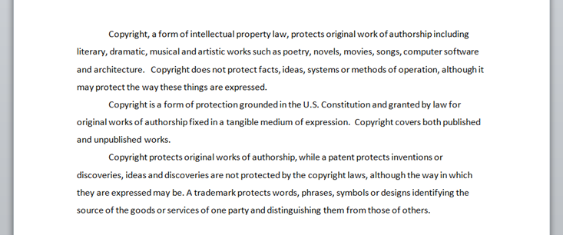  Position the insertion point at the beginning of the second paragraph. Select the entire paragraph, cut and paste as the first paragraph of the document using command keys (Keyboard shortcuts).  4 Point Rubric:  4 Points  - Student demonstrated the ability to complete the task correctly.  - Student used the specified document to complete the task.  - Student selected the specified paragraph to move.  - Student used the cut command.  - Student used the paste command to move the sentence to the specified location.  3 Points  - Only 3 items above were completed successfully.  2 Points  - Only 2 items above were completed successfully.  1 Points  - Only 1 item above was completed successfully.  0 Points  - Student did not use the cut and paste commands to move the sentence. Student did not demonstrate knowledge of the technology skills needed to complete the task or none of the items above were completed.  Note: Teacher should observe student while completing this task to make sure the cut and paste commands were used.

Benchmark Number | 02.15
Standard | 02.0 Develop and apply word processing skills utilizing current technology.
Benchmark | Format text by changing the font, font style, size, color, and effects.
Also Assesses | 2.02
Knowledge/ Performance/ Both | Performance
Item Types | Performance Task
Cognitive Complexity | Moderate, High
Benchmark Clarification | The student will be able to alter the text in a word processing program by changing the font, font style (bold, italic, underlined), size, color, and effects.
Content Limits | None Specified
Stimulus Attributes | Documents, images, and screenshots may be used.
Response Attributes | None Specified
Sample Item | Using Microsoft Word, open the document specified by the instructor (or have document already opened for student to use).  Select the document title. Change the font to 12 points, in a red bold and underlined.  4 Point Rubric:  4 Points  - Student demonstrated the ability to complete the task correctly.  - Student selected the text specified  - Student changed the specified text to size 12 points  - Student changed the specified text color to red  - Student changed the specified text is bold  - Student changed the specified text to be underlined  3 Points  - Only 3 items above were completed successfully  2 Points  - Only 2 items above were completed successfully  1 Points  - Only 1 item above was completed successfully  0 Points  - Student did not demonstrate the technology skills necessary to complete the task or none of the items above were completed successfully.

Benchmark Number | 03.03
Standard | 03.0 Develop and apply electronic presentation skills utilizing current technology.
Benchmark | Identify menus and toolbars of presentation software and their function.
Also Assesses | Not Applicable
Knowledge/ Performance/ Both | Knowlege
Item Types | Selected Response
Cognitive Complexity | Low, Moderate
Benchmark Clarification | The student will be able to identify visual aspects of a presentation software window including, but not limited to the following tabs: Home, Insert, Design, Animations, Transitions, and Slide Show.
Content Limits | Limited to aspects of Presentation windows that are found in most Presentation software.
Stimulus Attributes | Images and screenshots may be used.
Response Attributes | None Specified
Sample Item | Which button should be used to add a slide to a presentation?  A. edit slide  B. new slide  C. slide layout  D. title slide  Correct Answer: B

Benchmark Number | 03.04
Standard | - Develop and apply electronic presentation skills utilizing current technology.
Benchmark | Select design layout, background, template and color scheme.
Also Assesses | 3.03
Knowledge/ Performance/ Both | Both
Item Types | Selected Response, Performance Task
Cognitive Complexity | Low, Moderate, High
Benchmark Clarification | The student will be able to choose a design layout, background, template, and color scheme for a presentation; choices should reflect the intent of the presentation.
Content Limits | Content should be presented in full color to help in the decision making process.
Stimulus Attributes | Images and screenshots may be used.
Response Attributes | None Specified
Sample Item | You have been asked to create a PowerPoint presentation using only your school colors. In order to set up a slide with specific colors, which tool should be used?  A. add color  B. color scheme  C. page layout  D. shape color  Correct Answer: B

Benchmark Number | 03.05
Standard | 03.0 Develop and apply electronic presentation skills utilizing current technology.
Benchmark | Format text and graphics.
Also Assesses | 3.03
Knowledge/ Performance/ Both | Performance
Item Types | Performance Task
Cognitive Complexity | Moderate, High
Benchmark Clarification | The student will be able to identify possible problems with graphic design within a presentation when given specific examples.
Content Limits | Directly manipulating graphics would be difficult to do in a testing situaion. In the absence of that ability content should be limited to examples of graphic design in the context of a presentation.
Stimulus Attributes | Images, screenshots, data files and visual examples may be used.
Response Attributes | None Specified
Sample Item | Using Microsft PowerPoint, open the presentation specified by the insturctor (or have the presentation already open for student use).  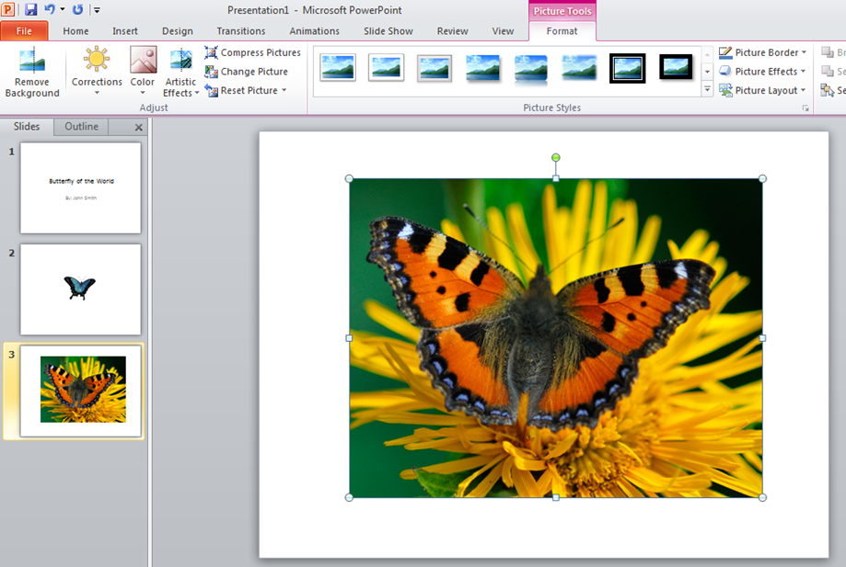  On slide 3 of the presentation, using the remove background feature remove the backgorund of the image leaving only the butterfly.  4 Point Rubric:  4 Points  - Student demonstrated the ability to complete the task correctly.  - Student used the correct presentation and slide to complete the task.  - Student used the remove background feature  - Student removed the background leaving only the image specified.  3 Points  - Only 3 items above were completed successfully.  2 Points  - Only 2 items above were completed successfully  1 Points  - Only 1 item above was completed successfully  0 Points  - Student did not demonstrate the technology skills necessary to complete the task or none of the items above were completed successfully.

Benchmark Number | 03.07
Standard | 03.0 Develop and apply electronic presentation skills utilizing current technology.
Benchmark | Select order of frames.
Also Assesses | 3.02, 3.05
Knowledge/ Performance/ Both | Both
Item Types | Selected Response, Performance
Cognitive Complexity | Low, Moderate
Benchmark Clarification | The student will be able to correctly order slides in a slide show.
Content Limits | Limited to presentation software.
Stimulus Attributes | A presentation with several slides should be used. Images and screenshots may be used.
Response Attributes | The student may be asked to organize the slides in the correct order by re-arranging them.
Sample Item | Which view would be optimal to re-arrange the order of slides in a presentation?  A. Backstage View  B. Normal View  C. Presentation View  D. Slide Sorter View  Correct Answer: D

Benchmark Number | 04.01
Standard | 04.0 Identify and understand computer hardware.
Benchmark | Define and identify the parts and functions of a computer.
Also Assesses | 1.02, 4.02
Knowledge/ Performance/ Both | Knowledge
Item Types | Selected Response
Cognitive Complexity | Low
Benchmark Clarification | The student will be able to identify a computer part such as CPU, monitor, keyboard, mouse, speakers, hard drive and printer, and also define it's function when given a visual representation of the part.
Content Limits | Only PC components should be considered.
Stimulus Attributes | Images and diagrams may be used.
Response Attributes | None Specified
Sample Item | Which part of the computer stores information such as programs and files?  A. hard disk  B. memory card  C. optical disk  D. thumb drive  Correct Answer: A

Benchmark Number | 05.02
Standard | 05.0 Perform activities using the World Wide Web
Benchmark | Introduce basic Internet vocabulary.
Also Assesses | 5.01, 5.03
Knowledge/ Performance/ Both | Knowledge
Item Types | Selected Response
Cognitive Complexity | Low
Benchmark Clarification | The student will be able to recognize and define basic internet vocabulary such as Internet, World Wide Web, web browser, uniform resource locator (URL), Internet service provider (ISP), electronic mail (e-mail), and spam .
Content Limits | Content should be limited to basic internet vocabulary.
Stimulus Attributes | Vocabulary word or a definition may be used.
Response Attributes | The student will need to match the vocabulary word with the definition.
Sample Item | What does it mean to 'download' a file?  A. erase the file  B. open it up in a browser  C. save it to your computer  D. send it to someone else  Correct Answer: C

Benchmark Number | 05.03
Standard | 05.0 Perform activities using the World Wide Web
Benchmark | Familiarize students with browser window.
Also Assesses | 5.02
Knowledge/ Performance/ Both | Knowledge
Item Types | Selected Response
Cognitive Complexity | Low, Moderate
Benchmark Clarification | The student will be able to identify aspects of a browser window including, but not limited to, title bar, address bar, navigation toolbar, and status bar.
Content Limits | Content should be limited to menus, buttons, and toolbars that are easily recognizable and common accross different browsers such as Firefox, Internet Explorer, and Google Chrome.
Stimulus Attributes | Images and screenshots may be used.
Response Attributes | None Specified
Sample Item | What is the page that appears when a browser is initially opened?  A. first page  B. home page  C. initial page  D. start page  Correct Answer: B

Benchmark Number | 05.05
Standard | 05.0 Perform activities using the World Wide Web
Benchmark | Understand Net addresses.
Also Assesses | 5.01, 5.02, 5.03
(K)nowledge (P)erformance or (B)oth | Knowledge
Item Types | Selected Response
Cognitive Complexity | Low, Moderate
Benchmark Clarification | The student will be able to understand the different parts of an internet address and be able to make distinctions between them; discern information about a website based solely on its net address.
Content Limits | Limited to Net addresses originating in the United States.
Stimulus Attributes | Authentic website addresses should be used.
Response Attributes | None Specified
Sample Item | Which website address is most likely to be associated with a charity organization?  A. www.ussenate.gov  B. www.helpinghands.org  C. www.imatreehugger.com  D. www.makingmoney.com  Correct Answer: B

