Central florida assessment collaborative
Individual Test Item Specifications
Anthropology
2013

Table of Contents

I. Guide to the Individual Benchmark Specifications ..................................................................... 1

Benchmark Classification System............................................................................................... 1

Definitions of Benchmark Specifications ................................................................................... 3

II. Individual Benchmark Specifications ........................................................................................ 4

I. Guide to the Individual Benchmark Specifications

Content specific guidelines are given in the Individual Benchmark Specifications for each course. The Specifications contains specific information about the alignment of items with the NGSSS and the Florida Standards. It identifies the manner in which each benchmark is assessed, provides content limits and stimulus attributes for each benchmark, and gives specific information about content, item types, and response attributes.

Benchmark Classification System

Each NGSSS benchmark is labeled with a system of letters and numbers.
• The two letters in the first position of the label identify the Subject Area.

• The number(s) in the second position represents the Grade Level.

• The letter in the third position represents the Strand or Body of Knowledge.

• The number in the fourth position represents the Standard.

• The number in the last position identifies the specific Benchmark.
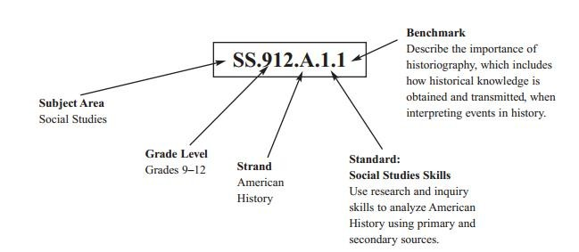

Each MAFS benchmark is labeled with a system of letters and numbers.

• The four letters in the first position of the label identify the Subject.

• The number(s) in the second position represents the Grade Level.

• The letter(s) in the third position represents the Category.

• The number in the fourth position shows the Domain.

• The number in the fifth position identifies the Cluster.

• The number in the last position identifies the specific Benchmark.

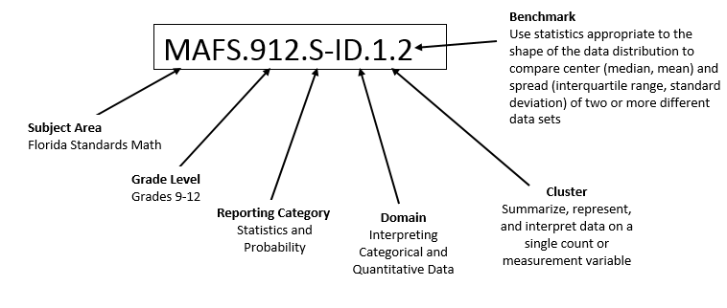
Definitions of Benchmark Specifications

The Individual Benchmark Specifications provides standard-specific guidance for assessment item development for CFAC item banks. For each benchmark assessed, the following information is provided.

Reporting Category | is a grouping of related benchmarks that can be used to summarize and report achievement.
Standard | refers to the standard statement presented in the NGSSS or in the Florida Standards.
Benchmark  Also Assesses | refers to the benchmark statement presented in the NGSSS or standard statement in the Florida Standards. In some cases, two or more related benchmarks are grouped together because the assessment of one benchmark addresses another benchmark. Such groupings are indicated in the Also Assesses statement.  refers to the benchmarks that are closely related to the benchmark (see description above)
Item Types  Cognitive  Complexity | are used to assess the benchmark or group of benchmark.  ideal level at which item should be assessed.
Benchmark Clarifications | explain how achievement of the benchmark will be demonstrated by students. In other words, the clarification statements explain what the student will do when responding to questions.
Content Limits | define the range of content knowledge and that should be assessed in the items for the benchmark.
Stimulus Attributes | define the types of stimulus materials that should be used in the items, including the appropriate use of graphic materials and item context or content.
Response Attributes  Content Focus | define the characteristics of the answers that a student must choose or provide.  defines the content measured by each test item. Content focus addresses the broad content and skills associated with the examples found in the standards, benchmarks, or benchmark clarifications.
Sample Items | are provided for each type of question assessed. The correct answer for all sample items is provided.

II. Individual Benchmark Specifications

Reporting Category | American History
Standard | Understand the rise and continuing international influence of the United States as a world leader and the impact of contemporary social and political movements on American life.
Benchmark Number | SS.912.A.7.11
Benchmark | Analyze the foreign policy of the United States as it relates to Africa, Asia, the Caribbean, Latin America, and the Middle East.
Also Assesses | Not Applicable
Item Types | Selected Response, Short Answer
Benchmark Clarifications | Students will analyze the foreign policy of the United States as it relates to Africa, Asia, the Caribbean, Latin America, and the Middle East.
Content Limits | None Specified
Stimulus Attribute | None Specified
Content Focus | Examples may include, but are not limited to Haiti, Bosnia-Kosovo, Rwanda, Grenada, Camp David Accords, Iran Hostage Crisis, Lebanon, Iran-Iraq War, Reagan Doctrine, Iran-Contra Affair, and the Persian Gulf War.
Sample Item | Which of the following are FOUR critical areas of United States Foreign Policy with Latin America?  A. energy security, inequality, poverty, migration  B. democracy, energy security, poverty and citizenship  C. public security, inequality, trade and poverty  D. trade, democracy, migration and drugs  Answer: D.

Reporting Category | American History
Standard | Understand the rise and continuing international influence of the United States as a world leader and the impact of contemporary social and political movements on American life.
Benchmark Number | SS.912.A.7.12
Benchmark | Analyze political, economic, and social concerns that emerged at the end of the 20th century and into the 21st century.
Also Assesses | Not Applicable
Item Types | Selected Response, Short Answer, Extended Response
Benchmark Clarifications | Students will analyze political, economic, and social concerns that emerged at the end of the 20th century and into the 21st century.
Content Limits | None Specified
Stimulus Attribute | None Specified
Content Focus | Examples may include, but are not limited to, AIDS, Green Revolution, outsourcing of jobs, global warming, and human rights violations.
Sample Item | The global opium economy has funded a weapons buildup for warlords and fortunes for those who traffic drugs to Europe and North America.  Which country is responsible for the poppy trade and opium generated capital that funds militias and armed ethnic conflict?  A. Afghanistan  B. China  C. Iraq  D. Thailand  Answer: D.

Reporting Category | American History
Standard | Understand the rise and continuing international influence of the United States as a world leader and the impact of contemporary social and political movements on American life.
Benchmark Number | SS.912.A.7.14
Benchmark | Review the role of the United States as a participant in the global economy (trade agreements, international competition, impact on American labor, environmental concerns).
Also Assesses | Not Applicable
Item Types | Selected Response, Short Answer, Extended Response
Benchmark Clarifications | Students will review the role of the United States as a participant in the global economy.
Content Limits | None Specified
Stimulus Attribute | Items may include images, charts, pictures, and passages.
Content Focus | Examples may include, but are not limited to NAFTA and the World Trade Organization.
Sample Item | Author: Frank van Mierlo created this graph from 2004 data supplied by the US IEA in their 2006 report.  http://www.eia.doe.gov/pub/international/iealf/tablee1p.xls  Please credit the author if you use this image.  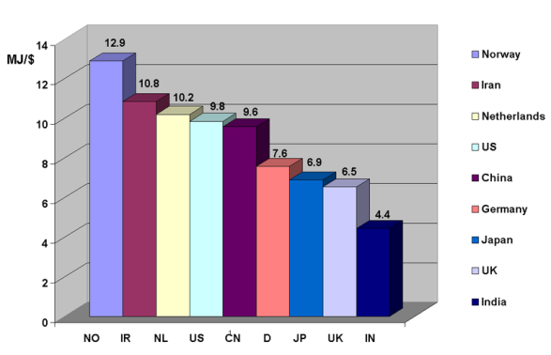  Which of these countries is the most energy efficient?  A. China  B. Germany  C. Japan  D. U.K.  Answer: D

Reporting Category | American History
Standard | Understand the rise and continuing international influence of the United States as a world leader and the impact of contemporary social and political movements on American life.
Benchmark Number | SS.912.A.7.15
Benchmark | Analyze the effects of foreign and domestic terrorism on the American people.
Also Assesses | Similar to SS.912.W.9.7
Item Types | Selected Response
Benchmark Clarifications | Students will analyze the effects of foreign and domestic terrorism on the American people.
Content Limits | None Specified
Stimulus Attribute | Images, Charts, Pictures, Text/Passages
Content Focus | Examples may include, but are not limited to, Oklahoma City bombing, attack of September 11, 2001, Patriot Act, wars in Afghanistan and Iraq.
Sample Item | Terrorism may be defined as the use of threatened or actual violence in the pursuit of political goals.  Which of the following is NOT an essential element of terrorism?  A. the belief that intimidation and violence are legitimate tools to achieve their aims  B. terrorist acts are deliberately and purposely planned  C. participants reject all of the standards of morality and channels of negotiation  D. they are protected by democratic political institutions  Answer: D.

Reporting Category | American History
Standard | Understand the rise and continuing international influence of the United States as a world leader and the impact of contemporary social and political movements on American life.
Benchmark Number | SS.912.A.7.16
Benchmark | Examine changes in immigration policy and attitudes toward immigration since 1950.
Also Assesses | Not Applicable
Item Types | Selected Response
Benchmark Clarifications | Students will examine changes in immigration policy and attitudes toward immigration since 1950.
Content Limits | None Specified
Stimulus Attribute | Images, Charts, Pictures, Text/Passages
Content Focus | Examples may include, but are not limited to, internal migration, external migration, globalization, ethnic minorities, indigenous peoples, human rights, global migrations, refugees, migrants, diasporic communities.
Sample Item | Analyze the Cuban Adjustment Act or Public Law 89-732 to determine why Cubans were allowed to emigrate to the United States in far greater numbers than those from other Latin American Countries. (Click on the link below or read document)  http://www.state.gov/www/regions/wha/cuba/cuba_adjustment_act.html  Fact Sheet:  The Cuban Adjustment Act  As released by the Office of Cuban Affairs, Bureau of Western Hemisphere Affairs, Department of State, March 16, 2000  Public Law 89-732  The Cuban Adjustment Act (CAA), Public Law 89-732, was enacted on November 2, 1966. The law applies to any native or citizen of Cuba who has been inspected and admitted or paroled into the United States after January 1, 1959 and has been physically present for at least one year; and is admissible to the United States for Permanent Residence.  Legal Migration to the United States  Cubans in Cuba can legally migrate to the U.S. through various migration programs that include immigrant visa issuance, refugee admission, the diversity lottery, and the Special Cuban Migration Program (SCMP), otherwise known as the Cuban lottery.  Immigrant visas are issued to the parents, spouses and children (unmarried and under 21 years of age) of U.S. citizens as soon as the immigrant visa petition is approved by INS.  Immigrant visas are also available to a range of persons who can qualify for family or employment-based visas under the preference system that controls numerically limited immigration to the United States.  The preference system allows US citizens to bring their siblings and their adult married children to the United States. Lawful permanent residents of the United States can petition for petition for their spouses, minor children, and unmarried adult children). The waiting period for preference visas varies by category.  Those who have been persecuted in Cuba, or who fear persecution (on the basis of race, religion, nationality, membership in a particular social group, or political opinion), may apply for U.S. resettlement through our in country refugee processing unit at the U.S. Interests Section in Havana.  The diversity visa program is also available in Cuba. There are 55,000 visas available annually to eligible applicants from around the world. For the three years that we have statistics, the success rate for Cuban applicants is quite high. In 1996 approximately 67% of those registered were issued visas, in 1997 the success rate was 69% and in 1998 a total of 73% of Cuban applicants who applied for the diversity visa program were issued visas.  The Special Cuban Migration Program, or "Cuban lottery," is open to all adult Cubans between the ages of 18 and 55 years of age who are resident in Cuba regardless of whether they qualify for our immigrant visa or refugee programs. The lottery provides an avenue of legal migration to a diverse group of Cubans, including those who might not have close relatives in the United States. The last registration period was held from June 15- July 15, 1998. The next registration period has not yet been determined but we anticipate that it will take place in 2001.  [End of Document]  Why are Cubans given preferential treatment in the immigration process?  A. Many Cubans have degrees from the University in science and engineering.  B. Many Cubans have money to invest in American business ventures.  C. Many Cubans are seeking protection from political persecution.  D. Many Cubans are related to prominent American families.  Answer: C.

Reporting Category | Civics and Government
Standard | Evaluate the roles, rights, and responsibilities of the United States citizens and determine methods of active participation in society, government, and the political system.
Benchmark Number | SS.912.C.2.12
Benchmark | Explain the changing roles of television, radio, press, and Internet in political communication.
Also Assesses | Not Applicable
Item Types | Selected Response
Benchmark Clarifications | Students will explain the changing roles of television, radio, press, and internet in political communication.
Content Limits | None Specified
Stimulus Attribute | Images, Charts, Pictures, Text/Passages
Content Focus | Examples may include, but are not limited to media, television, radio, internet, commercialism, big business, mega corporations, communication satellites, CNN, Al Jazeera.
Sample Item | Ronald Reagan has been called the Great Communicator. Ronald Reagan was able to manipulate the media to his advantage.  What is a strategy that he did NOT use to keep public opinion favorable?  A. control the flow of information  B. limit access of reporters  C. repeat the same message  D. stay on the defensive  Answer: D.

Reporting Category | Civics and Government
Standard | Demonstrate an understanding of contemporary issues in world affairs, and evaluate the role and impact of United States foreign policy.
Benchmark Number | SS.912.C.4.1
Benchmark | Explain how the world's nations are governed differently.
Also Assesses | Not Applicable
Item Types | Selected Response
Benchmark Clarifications | Students will explain how the world's nations are governed differently.
Content Limits | None Specified
Stimulus Attribute | None Specified
Content Focus | Examples may include, but are not limited to, democracy, representative democracy, monarchy, oligarchy, theocracy, dictatorship, communism, socialism, band, tribe and chiefdoms.
Sample Item | There is a type of government in which is founded on the principles of equality of opportunity, equitable distribution of wealth and public responsibility for those unable to provide for themselves.  What is the name of this concept of government in which the state plays a key role in the protection and promotion of the economic and social well-being of its citizens?  A. capitalism  B. communism  C. feudal state  D. welfare state  Answer: D.

Reporting Category | Civics and Government
Standard | Demonstrate an understanding of contemporary issues in world affairs, and evaluate the role and impact of United States foreign policy.
Benchmark Number | SS.912.C.4.2
Benchmark | Evaluate the influence of American foreign policy on other nations and the influences of other nations on American policies and society.
Also Assesses | Not Applicable
Item Types | Selected Response
Benchmark Clarifications | Students will evaluate the influence of American foreign policy on other nations. Students will evaluate the influences of other nations on American policies and society.
Content Limits | None Specified
Stimulus Attribute | Images, Charts, Graphs, Text/Passages
Content Focus | Examples may include, but are not limited to, political organization, maintenance of order, internalized controls, externalized controls, social control through law, punishing crimes, settling disputes, restorative justice, conflict resolution and warfare.
Sample Item | Indonesia has the world’s largest Islamic population and one that honors and respects religious diversity.  Why is this country an important ally for the United States.?  A. Indonesia is an example of how a developing nation can embrace social uniformity.  B. Indonesia is an example of how a developing nation can embrace democracy and diversity.  C. Indonesia is an example of how a developing nation can embrace political extremists.  D. Indonesia is an example of how a developing nation can embrace religious fundamentalism.  The correct answer is B.

Reporting Category | Civics and Government
Standard | Demonstrate an understanding of contemporary issues in world affairs, and evaluate the role and impact of United States foreign policy.
Benchmark Number | SS.912.C.4.3
Benchmark | Assess human rights policies of the United States and other countries.
Also Assesses | Not Applicable
Item Types | Selected Response, Short Answer, Extended Response
Benchmark Clarifications | Students will assess human rights policies of the United States and other countries.
Content Limits | None Specified
Stimulus Attribute | None Specified
Content Focus | Examples may include, but are not limited to, Universal Declaration on Human  Rights, human rights abuses, indigenous people’s struggles, ethnic minorities, crimes against humanity, ethnocide, genocide, globalization.
Sample Item | War is not a universal phenomenon. There are societies that do not condone warfare as we know it. Examples of people from various parts of the world that do not condone warfare are the Pygmy people of Africa, the Arapesh of New Guinea, and the Jain of India.  Which of the following North American societies does not practice warfare?  A. The Amish  B. The Apache  C. The Aztec  D. The Sioux  Answer: A.

Reporting Category | Economics
Standard | Understand the fundamental concepts and interrelationships of the United States economy in the international marketplace.
Benchmark Number | SS.912.E.3.5
Benchmark | Compare the current United States economy with other developed and developing nations.
Also Assesses | Not Applicable
Item Types | Selected Response, Short Answer
Benchmark Clarifications | Students will compare the current United States economy with other developed and developing nations.
Content Limits | None Specified
Stimulus Attribute | Images, Charts, Graphs, Text/Passages
Content Focus | Examples may include, but are not limited to, standard of living, exchange rates, productivity, gross domestic product.
Sample Item | [http://www.imf.org/external/pubs/ft/weo/2005/01/data/dbginim.cfm  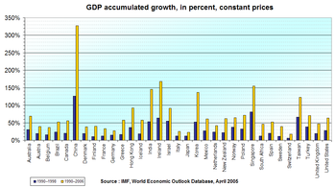  According to the chart, which one of the five (5) countries that is demonstrating the greatest percentage of growth is NOT part of Asia?  A. Belgium  B. Greece  C. Ireland  D. Poland  Answer: C

Reporting Category | Geography
Standard | Understand how to use maps and other geographic representations, tools, and technology to report information.
Benchmark Number | SS.912.G.1.4
Benchmark | Analyze geographic information from a variety of sources including primary sources, atlases, computer, and digital sources, Geographic Information Systems (GIS), and a broad variety of maps.
Also Assesses | Not Applicable
Item Types | Selected Response
Benchmark Clarifications | Students will analyze geographic information from a variety of sources including primary sources, atlases, computer, and digital sources, Geographic Information Systems (GIS), and a broad variety of maps.
Content Limits | None Specified
Stimulus Attribute | Images, Charts, Graphs, Maps, Text/Passages
Content Focus | Examples may include, but are not limited to, thematic, contour, and dot-density.
Sample Item | http://en.wikipedia.org/wiki/File:Karte_Mesopotamien.png  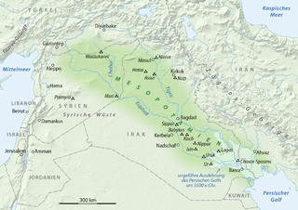  Six thousand years ago the world's first cities grew out of Neolithic Villages in Mesopotamia. Four basic cultural changes mark the transition from Neolithic village life to life in a civilized urban center. They are agricultural innovation, diversification of labor, a centralized government and social stratification.  Which geographic features near these urban centers made these cultural changes possible?  A. the two deserts  B. the two mountains  C. the two plateau  D. the two rivers  Answer: D.

Reporting Category | Geography
Standard | Understand physical and cultural characteristics of places.
Benchmark Number | SS.912.G.2.1
Benchmark | Identify the physical characteristics and the human characteristics that define and differentiate regions.
Also Assesses | Not Applicable
Item Types | Selected Response
Benchmark Clarifications | Students will identify the physical characteristics and the human characteristics that define and differentiate regions.
Content Limits | None Specified
Stimulus Attribute | Images, Charts, Graphs, Maps, Text/Passages
Content Focus | Examples of physical characteristics are climate, terrain, resources; Examples of human characteristics are religion, government, economy, demography.
Sample Item | Which physical characteristic creates a natural border between the subcontinent of India and the rest of Asia?  A. The Eastern and Western Ghats  B. The Brahmaputra River  C. The Himalayan Mountain Range  D. The Deccan Plateau  Answer: C

Reporting Category | Geography
Standard | Understand physical and cultural characteristics of places.
Benchmark Number | SS.912.G.2.2
Benchmark | Describe the factors and processes that contribute to the differences between developing and developed regions of the world.
Also Assesses | Not Applicable
Item Types | Selected Response
Benchmark Clarifications | Students will describe the factors and processes that contribute to the differences between developing and developed regions of the world.
Content Limits | None Specified
Stimulus Attribute | Images, Charts, Graphs, Maps, Text/Passages
Content Focus | Examples include but are not limited to, population, birth rate, death rate, poverty, food foraging, slash and burn cultivation, agriculture, industrial food production, barter, money, market exchange, conspicuous consumption, economic system, band, tribe, nation, state, transportation, communication, technology.
Sample Item | 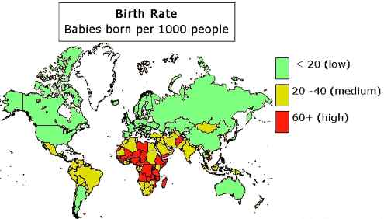  According to the map, how is the birth rate in developed countries different than those in developing countries?  A. In developed countries, the birth rate is high.  B. In developed countries, the birth rate is low.  C. In developing countries, the birth rate is moderate.  D. In developing countries, there is no data about the birth rate.  Answer: A.

Reporting Category | Geography
Standard | Understand the characteristics, distribution, and migration of human populations.
Benchmark Number | SS.912.G.4.1
Benchmark | Interpret population growth and other demographic data for any given place.
Also Assesses | Not Applicable
Item Types | Selected Response
Benchmark Clarifications | Students will interpret population growth and other demographic data for any given place.
Content Limits | None Specified
Stimulus Attribute | Images, Charts, Graphs, Maps, Text/Passages
Content Focus | Examples include but are not limited to, population, population growth, birth rate, death rate, demographic data, demographic trends, gender, age, ethnicity, language, disability, mobility, generational cohorts.
Sample Item | 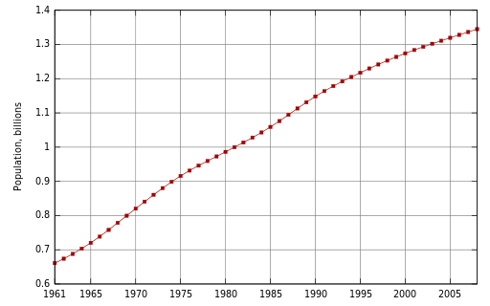  Analyze the demographic chart of China above.  Which of the following statements is true?  A. China’s population declined after 1980.  B. China’s population increased until 1961.  C. China’s population has increased over the last 45 years.  D. China’s population has decreased over the last 45 years.  Answer: C.

Reporting Category | Geography
Standard | Understand the characteristics, distribution, and migration of human populations.
Benchmark Number | SS.912.G.4.2
Benchmark | Use geographic terms and tools to analyze the push/pull factors contributing to human migration within and among places.
Also Assesses | SS.912.G.4.3
Item Types | Selected Response
Benchmark Clarifications | Students will use geographic terms and tools to analyze the push/pull factors contributing to human migration within and among places.
Content Limits | None Specified
Stimulus Attribute | Images, Charts, Graphs, Maps, Text/Passages
Content Focus | Examples may include, but are not limited to: push factors: not enough jobs, few opportunities, primitive conditions, desertification, famine or drought, political fear or persecution, slavery or forced labor, poor medical care, loss of wealth, natural disasters, death threats, lack of political or religious freedom, pollution, poor housing, landlord/tenant issues, bullying  discrimination, poor chances of marrying, condemned housing (radon gas, etc.), war. Pull Factors: job opportunities, better living conditions, political and/or religious freedom, enjoyment, education, better medical care, attractive climates, security, family links, industry, better chances of marrying
Sample Item | Joseph and his wife have been moving in unpredictable ways over the past two years in order to stay ahead of rebels that are destroying their country.  What is this type of migration called?  A. Chain migration  B. Cyclical migration  C. Forced migration  D. Emigration  Answer: C

Reporting Category | Geography
Standard | Understand the characteristics, distribution, and migration of human populations.
Benchmark Number | SS.912.G.4.7
Benchmark | Use geographic terms and tools to explain cultural diffusion throughout places, regions, and the world.
Also Assesses | Not Applicable
Item Types | Selected Response
Benchmark Clarifications | Students will use geographic terms and tools to explain cultural diffusion throughout places, regions, and the world.
Content Limits | None Specified
Stimulus Attribute | Images, Charts, Graphs, Maps, Text/Passages
Content Focus | Examples may include, but are not limited to:  society, culture, prehistory, kinship and descent, gender, race, ethnicity, development, colonialism, post colonialism, religion, ideas.
Sample Item | 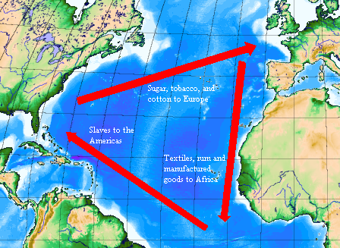  The image above depicts the Triangular Trade route between Africa, the Americas, and Europe.  Which statement is the correct example of diffusion being portrayed?  A. Indirect diffusion through the trading of sugar, tobacco, and cotton between the Americas and Europe.  B. Indirect diffusion through the trading of slaves to the Americas from Africa.  C. Forced diffusion through the trading of sugar, tobacco, and cotton between the Americas and Europe.  D. Forced diffusion through the trading of slaves to the Americas from Africa.  Answer: D

Reporting Category | Humanities
Standard | Identify and analyze the historical, social, and cultural contexts of the arts.
Benchmark Number | SS.912.H.1.4
Benchmark | Explain philosophical beliefs as they relate to works in the arts.
Also Assesses | Not Applicable
Item Types | Selected Response, Short Answer, Extended Response
Benchmark Clarifications | Students will explain philosophical beliefs as they relate to works in the arts.
Content Limits | None Specified
Stimulus Attribute | None Specified
Content Focus | Examples may include, but are not limited to, classical architecture, protest music, Native American dance, Japanese Noh.
Sample Item | In the 20th century, music was used as a platform to express ideas for social change by many artists.  Which of the following is NOT among the social movements typically associated with protest songs?  A. Anti-War  B. Civil Rights  C. Family Values  D. Women’s Suffrage  Answer: C.

Reporting Category | World History
Standard | Utilize historical inquiry skills and analytical processes.
Benchmark Number | SS.912.W.1.5
Benchmark | Compare conflicting interpretations or schools of thought about world events and individual contributions to history (historiography).
Also Assesses | Not Applicable
Item Types | Selected Response
Benchmark Clarifications | Students will compare conflicting interpretations or schools of thought about world events and individual contributions to history.
Content Limits | None Specified
Stimulus Attribute | None Specified
Content Focus | Examples include but are not limited to, evidence, motivations, decision-making process, feminist historians, ethnic minority historians, paradigm, and paradigm shift.
Sample Item | Historical revisionism can present conflicting interpretations of past events. They may be legitimate scholarly re-examination of existing thoughts or illegitimate distortions of the historical records for self-serving reasons.  Which of the following would be described as a legitimate revision?  A. denial of historical crimes against humanity  B. manipulating statistics to support a point of view  C. conducting historical research at a university  D. deliberate mistranslation of texts  Answer: C

Reporting Category | World History
Standard | Recognize significant events, figures, and contributions of Islamic, Meso and South American, and Sub-Saharan African civilizations.
Benchmark Number | SS.912.W.3.2
Benchmark | Compare the major beliefs and principles of Judaism, Christianity, and Islam.
Also Assesses | Not Applicable
Item Types | Selected Response
Benchmark Clarifications | Students will compare the major beliefs and principles of Judaism, Christianity, and Islam.
Content Limits | None Specified
Stimulus Attribute | Images, Charts, Graphs, Text/Passages
Content Focus | Example include but are not limited to, Judaism, Christianity, Islam, sacred  scripture, Torah, Bible, Koran, sacred place, Jerusalem, Bethlehem, Mecca, prophecy, Moses, Jesus, Muhammad priest, rabbi, imam, monotheism, prayer.
Sample Item | Judaism, Christianity, and Islam share which common belief?  A. Karma  B. Monotheism  C. Polytheism  D. Reincarnation  Answer: B.

Reporting Category | World History
Standard | Recognize significant events and people from the post World War II and Cold War eras.
Benchmark Number | SS.912.W.8.7
Benchmark | Compare post-war independence movements in African, Asian, and Caribbean countries.
Also Assesses | Not Applicable
Item Types | Selected Response
Benchmark Clarifications | Students will compare post-war independence movements in African, Asian, and Caribbean countries.
Content Limits | None Specified
Stimulus Attribute | Images, Charts, Graphs, Text/Passages
Content Focus | Examples include but are not limited to Mahatma Gandhi , India, Nelson Mandela, South Africa, Aung San Suu Kyi, Myanmar, Ghana, Indonesia, Viet Nam, Egypt, decolonization, Soviet Union, United States, nonaligned nations, Bandung Conference of 1955, UN Assembly, globalization, modernization, multiculturalism, structural power, hard power, soft power, global corporations , traditionalism, religious fundamentalism.
Sample Item | Which statement best describes the impact of Globalization in the time since the end of the Cold War?  A. Countries like China and the United States have become Super Powers  B. The Super Powers have increased their economic aid to African countries  C. Latin American and Caribbean nations have less of a need for security and defense  D. The European Union was dissolved due to many conflicts in the region  Answer: A.

Reporting Category | World History
Standard | Recognize significant events and people from the post-World War II and Cold War eras.
Benchmark Number | SS.912.W.8.10
Benchmark | Explain the impact of religious fundamentalism in the last half of the 20th century, and identify related events and forces in the Middle East over the last several decades.
Also Assesses | Not Applicable
Item Types | Selected Response, Short Answer, Extended Response
Benchmark Clarifications | Students will explain the impact of religious fundamentalism in the last half of the 20th century, and identify related events and forces in the Middle East over the last several decades.
Content Limits | None Specified
Stimulus Attribute | None Specified
Content Focus | Examples may include, but are not limited to, Iranian Revolution, Mujahideen in Afghanistan, Persian Gulf War.
Sample Item | What was the impact of Islamic Fundamentalists on the events in the Middle East over the last several decades?  A. Terrorism in the area was on the decline in many Islamic Nations  B. Peace keeping in the Middle East was encouraged by President H. W. Bush  C. The Middle Eastern Nations formed a peaceful coalition and helped one another economically  D. The United States and the United Nations had stepped up military action in the area.  Answer: D.

Reporting Category | World History
Standard | Identify major economic, political, social, and technological trends beginning in the 20th century.
Benchmark Number | SS.912.W.9.1
Benchmark | Identify major scientific figures and breakthroughs of the 20th century, and assess their impact on contemporary life.
Also Assesses | Not Applicable
Item Types | Selected Response
Benchmark Clarifications | Students will identify major scientific figures and breakthroughs of the 20th century, and assess their impact on contemporary life.
Content Limits | None Specified
Stimulus Attribute | None Specified
Content Focus | Examples may include, but are not limited to, Marie Curie, Albert Einstein, Enrico Fermi, Sigmund Freud, Wright Brothers, Charles R. Drew, mass vaccination, atomic energy, transistor, microchip, space exploration, Internet, discovery of DNA, Human Genome Project.
Sample Item | Which of the following statements is factual?  A. Lab work by Albert Einstein is the main way for scientists to discover new ideas today  B. Technology in weaponry in the 20th century was the major breakthrough impacting contemporary life  C. Scientific figures of the 20th century used many ways to discover things used in our contemporary world  D. Sigmund Freud developed the Theory of Relativity which opened the door for the creation of the atom bomb.  Answer: C.

Reporting Category | World History
Standard | Identify major economic, political, social, and technological trends beginning in the 20th century.
Benchmark Number | SS.912.W.9.4
Benchmark | Describe the causes and effects of twentieth century nationalist conflicts.
Also Assesses | Also Assesses SS.912.W.1.1
Item Types | Selected Response
Benchmark Clarifications | Students will describe the causes and effects of twentieth century nationalist conflicts.
Content Limits | None Specified
Stimulus Attribute | None Specified
Content Focus | Examples may include, but are not limited to, Cyprus, Kashmir, Tibet, Northern Ireland.
Sample Item | In what way did scientific discoveries impact the nationalist conflicts of the twentieth century?  A. Regional warfare was on the decline  B. Global conflicts impacted the lives of social classes worldwide  C. Technology reduced the clashes between nations  D. World Wars enabled societies to remain at peace  Answer: B.

Reporting Category | World History
Standard | Identify major economic, political, social, and technological trends beginning in the 20th century.
Benchmark Number | SS.912.W.9.7
Benchmark | Describe the impact of and global response to international terrorism.
Also Assesses | Similar to SS.912.A.7.15
Item Types | Selected Response
Benchmark Clarifications | Students will describe the impact of international terrorism. / Students will describe the global response to international terrorism.
Content Limits | None Specified
Stimulus Attribute | None Specified
Content Focus | Examples include but are not limited to 9/11, Afghanistan, Iraq, Pakistan, Patriot Act, FBI, CIA, TSA, al Qaeda, Taliban, Osama bin Laden, counterterrorism, homeland security, war on terror.
Sample Item | How has the global response to terrorism changed in the post 9/11 era?  A. laws being passed could infringe on personal civil liberties  B. privacy has exceeded the need for safety  C. the process of traveling globally has become easier  D. security at public events has been reduced  Answer: A.

