CENTRAL FLORIDA ASSESSMENT COLLABORATIVE
Individual Test Item Specifications
Analysis of Functions
2013

Table of Contents

I. Guide to the Individual Benchmark Specifications 3
Benchmark Classification System 3
Definitions of Benchmark Specifications 5
Individual Benchmark Specifications 6
MAFS.912.A-APR.2.2 6
MAFS.912.A-APR.4.6 7
MAFS.912.F-BF.1.1 9
MAFS.912.F-BF.2.4 11
MAFS.912.F-BF.2.5 13
MAFS.912.F-IF.3.8 15
MAFS.912.F-LE.1.4 16
MAFS.912.F-TF.1.3 17
MAFS.912.F-TF.1.4 18
MAFS.912.F-TF.2.5 19
MAFS.912.F-TF.2.6 22
MAFS.912.F-TF.2.7 24
MAFS.912.F-TF.3.8 25
MAFS.912.N-CN.3.9 26

I. Guide to the Individual Benchmark Specifications

Content specific guidelines are given in the Individual Benchmark Specifications for each course. The Specifications contains specific information about the alignment of items with the Florida Standards. It identifies the manner in which each benchmark is assessed, provides content limits and stimulus attributes for each benchmark, and gives specific information about content, item types, and response attributes.

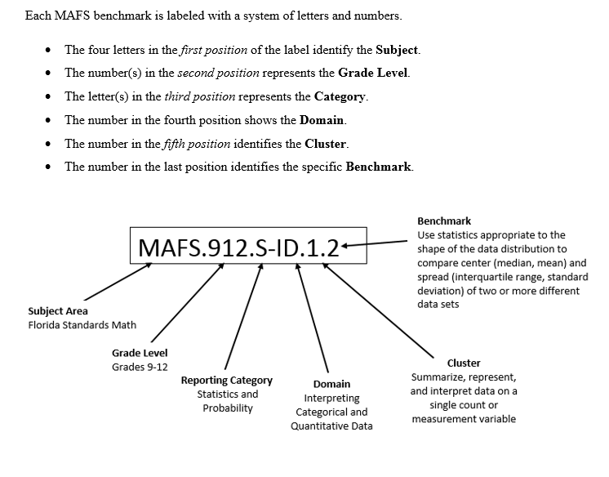

Definitions of Benchmark Specifications
The Individual Benchmark Specifications provides standard-specific guidance for assessment item development for CFAC item banks. For each benchmark assessed, the following information is provided:

Reporting Category | is a grouping of related benchmarks that can be used to summarize and report achievement.
Standard | refers to the standard statement presented in the Florida Standards.
Benchmark | refers to the benchmark statement presented in the standard statement in the Florida Standards. In some cases, two or more related benchmarks are grouped together because the assessment of one benchmark addresses another benchmark. Such groupings are indicated in the Also Assesses statement.
Also Assesses | refers to the benchmarks that are closely related to the benchmark (see description above).
Item Types | are used to assess the benchmark or group of benchmark.
Cognitive Complexity Level | ideal level at which the item should be assessed.
Benchmark Clarifications | explain how achievement of the benchmark will be demonstrated by students. In other words, the clarification statements explain what the student will do when responding to questions.
Content Limits | define the range of content knowledge and that should be assessed in the items for the benchmark.
Stimulus Attributes | define the types of stimulus materials that should be used in the items, including the appropriate use of graphic materials and item context or content.
Response Attributes | define the characteristics of the answers that a student must choose or provide.
Sample Items | are provided for each type of question assessed. The correct answer for all sample items is provided.

Individual Benchmark Specifications
Reporting Category | Algebra
Standard | Arithmetic with Polynomials and Rational Expressions.
Benchmark Number | MAFS.912.A-APR.2.2
Benchmark | Know and apply the Remainder Theorem: For a polynomial p(x) and a number a, the remainder on division by x – a is p(a), so p(a) = 0 if and only if (x – a) is a factor of p(x).
Also Assesses | N/A
Item Types | Selected Response (Multiple Choice), Gridded Response
Cognitive Complexity Level | Low
Benchmark Clarification | Students will understand that factors of a polynomial can be set equal to 0 and solved to obtain the zeroes of the polynomial. Additionally, if a linear factor is divided into the polynomial and the remainder is 0, that linear factor is a factor of the polynomial.
Content Limits | Polynomials must be factorable using factoring, graphing, synthetic division (with both a zero remainder and # value remainders), grouping, or finding the greatest common factor.
Stimulus Attributes | Items may be set in either mathematical contexts or real-world applications.
Response Attributes | None Specified

Sample Item | - What remainder value indicates that a given expression is a factor of a polynomial expression?  Correct Answer: 0  - When $f\left(x\right)=3x^{3}-2x^{2}+3x+5$ is divided by $\left(x-1\right)$, a remainder of 3 is left. What does this information reveal about $\left(x-1\right)$ in relation to $f(x)$?  - $\left(x-1\right)$ is a factor of $f(x)$  - $\left(x-1\right)$ is not a factor of $f(x)$  - $\left(x-1\right)$ is a factor of $f\left(x\right)+3$  - $\left(x-1\right)$ is not a factor of $f\left(x\right)+3$  Correct Answer: B

Reporting Category | Algebra
Standard | Arithmetic with Polynomials and Rational Expressions.
Benchmark Number | MAFS.912.A-APR.4.6
Benchmark | Rewrite simple rational expressions in different forms; write a(x)/b(x) in the form q(x) + r(x)/b(x), where a(x), b(x), q(x), and r(x) are polynomials with the degree of r(x) less than the degree of b(x), using inspection, long division, or, for the more complicated examples, a computer algebra system.
Also Assesses | MAFS.912.A-APR.4.7- understand the rational expression form a system analogous to the rational numbers closed under addition, subtraction, multiplication, and division by a nonzero rational expression; add, subtract, multiply, and divide rational expressions.
Item Types | Selected Response (Multiple Choice)
Cognitive Complexity Level | Moderate
Benchmark Clarification | Students will apply various theorems to find complex zeros of polynomial functions  Students will divide polynomials and relate the result to the remainder and factor theorem.  Student will utilize the Fundamental Theorem of Algebra to determine the number of zeros, and find the rational zeros of a polynomial using Descartes’ Rule of Signs.
Content Limits | Polynomials must be factorable using factoring, graphing, synthetic division (with both a zero remainder and # value remainders), grouping, or finding the greatest common factor.
Stimulus Attributes | Items may be set in either mathematical contexts or real-world applications.
Response Attributes | Selected Response answers may have complex factors for the polynomial.  Selected Response answers may have number value remainders for synthetic division

Sample Item | - Simplify the following expression.  $$\left(9x^{2}-41x-6\right)÷\left(x-4\right)$$  - $\left(9x-5\right), R\left(-26\right)$  - $\left(9x-5\right), R\left(-14\right)$  - $\left(9x-41\right), R\left(4\right)$  - $\left(9x+5\right), R\left(14\right)$  Correct Answer: A  - Find the roots of the following polynomial equation:  $f\left(x\right)=x^{3}-2x^{2}+10x+136$  - $-3±5i$, −4  - $3±5i$, −4  - $-3±i$, 4  - $3±i$, 4  Correct Answer: B  - If $\left(x+4\right)$ is a factor of $f(x)$, find the remaining factor of the polynomial.  $$f\left(x\right)=-14x^{3}+14x-840$$  - $-14x^{2}+56x-210$  - $14x^{2}-56x+210$  - $-14x^{2}-56x+238,R-1680$  - $14x^{2}+56x-238,R 1680$  Correct Answer: A

Reporting Category | Functions
Standard | Building Functions
Benchmark Number | MAFS.912.F-BF.1.1
Benchmark | Build a function that models a relationship between two quantities.
Also Assesses | N/A
Item Types | Selected Response (Multiple Choice)
Cognitive Complexity Level | High
Benchmark Clarification | Students will write a function that describes a relationship between two quantities through one of the following:  - Determine an explicit expression, a recursive process, or steps for calculation from a context.  - Combine standard function types using arithmetic operations.  - Compose functions.
Content Limits | Tasks may involve linear functions, quadratic functions, and exponential functions.
Stimulus Attributes | Item should be set in mathematical context or real world.
Response Attributes | None Specified

Sample Item | - Given the following sequence, find the 6th term.  Sequence: 4096, 256, 16…  A. 1 B. 16 C. 0.0625 D. 0.00391  Correct Answer: D  - Based on the table below, determine an expression that governs the relationship between the two values.  Description: T-table of X values with corresponding Y values. The following are paired up in the form (X,Y): (-2, -14), (1, -15), (0, -12), (1, -5), (2, 6), (3, 21), (4, 40).  X Y  -2 -14  1 -15  0 -12  1 -5  2 6  3 21  4 40  - $3x-12$  - $2x^{2} + 5x -12$  - -12$∙{\frac{1}{2}}^{x}$  - $2x^{3} - 5x^{2} – x – 12$  Correct Answer: B

Reporting Category | Functions
Standard | Building Functions
Benchmark Number | MAFS.912.F-BF.2.4
Benchmark | Find inverse functions.  - Solve an equation of the form $f\left(x\right)=c$for a simple function $f$ that has an inverse and write an expression for the inverse. For example, $f\left(x\right)=2x^{3}$or $f\left(x\right)=\frac{x+1}{x-1}$, for $x≠1$.  - Verify by composition that one function is the inverse of another.  - Read values of an inverse function from a graph or a table, given that the function has an inverse.  - Produce an invertible function from a non-invertible function by restricting the domain.
Also Assesses | N/A
Item Types | Selected Response (Multiple Choice)
Cognitive Complexity Level | Moderate
Benchmark Clarification | Students will solve an equation that has an inverse and verify by composition that they are inverses of each other.  Students will read values of an inverse function from a graph or table.
Content Limits | The focus will be functions where the domain of the function must be restricted in order for the inverse to exist, such as $f\left(x\right)=x^{2}, x>0$.
Stimulus Attributes | Item should be set in mathematical context.
Response Attributes | None Specified

Sample Item | - Find the inverse of the given function.  $$f\left(x\right)=\frac{7x-3}{16}$$  - $f^{-1}\left(x\right)=\frac{16x-3}{7}$  - $f^{-1}\left(x\right)=\frac{16x+3}{7}$  - $f^{-1}\left(x\right)=\frac{7x+16}{3}$  - $f^{-1}\left(x\right)=\frac{7x-16}{3}$  Correct Answer: B  2. Determine whether the following pairs of equations are inverses of each other: Pair 1: $f\left(x\right)=\frac{11x+4}{4}$ and $g\left(x\right)=\frac{4x-4}{11}$  Pair 2: $y=x-8$ and $y=x+8$  - Only Pair 1 are inverses of each other.  - Only Pair 2 are inverses of each other.  - Both Pair 1 and Pair 2 are inverses of each other.  - Neither Pair 1 nor Pair 2 are inverses of each other.  Correct Answer: A

Reporting Category | Functions
Standard | Building Functions
Benchmark Number | MAFS.912.F-BF.2.5
Benchmark | Understand the inverse relationship between exponents and logarithms and use this relationship to solve problems involving logarithms and exponents.
Also Assesses | N/A
Item Types | Selected Response (Multiple Choice), Gridded Response, Short Response
Cognitive Complexity Level | Moderate
Benchmark Clarification | Students will be able to solve logarithms not just based solely on rules, but with the emphasis that a logarithm is an exponent.
Content Limits | Items are limited to exponents and logarithms.
Stimulus Attributes | Item should be set in mathematical context.
Response Attributes | None Specified

Sample Item | - Which of the following exponential expressions are equivalent to this logarithmic expression: 4 = log_{x} 24?  - $x^{4}=24$  - $x^{24}=4$  - $4^{24}=x$  - ${24}^{4}=x$  Correct Answer: A  - The domain of a logarithmic function has been defined as the inverse of an exponential function. Describe this relationship in terms of the domain and range of a logarithmic function.  Correct Answer: The domain of a logarithmic function is equal to the range of an exponential function. The range of a logarithmic function is equal to the domain of an exponential function.  Scale:  Score 2: Identify logarithmic function domain equal to range of exponential function and range of logarithmic function equal to the domain of an exponential function  Score 1: Identify one inverse from above.  Score 0: Neither function described correctly.

Reporting Category | Functions
Standard | Functions: Interpreting Functions
Benchmark Number | MAFS.912.F-IF.3.8
Benchmark | Write a function defined by an expression in different but equivalent forms to reveal and explain different properties of the function.
Also Assesses | N/A
Item Types | Selected Response (Multiple Choice)
Cognitive Complexity Level | Moderate
Benchmark Clarification | Students will be able to:  - Use the process of factoring and completing the square in a quadratic function to show zeros, extreme values, and symmetry of the graph, and interpret these in terms of a context.  - Use the properties of exponents to interpret expressions for exponential functions.
Content Limits | Tasks may involve quadratic functions and exponential functions.
Stimulus Attributes | Item should be set in mathematical context. Formulas for exponential decay and growth should be provided.
Response Attributes | None Specified
Sample Item | - The benefits of writing quadratic functions in vertex form are to easily identify the vertex of the parabola as well as determine which direction the parabola opens. Convert this quadratic function from standard form to vertex form: $y=x^{2}-8x+12$  - $y={\left(x-4\right)}^{2}-4$  - $y={\left(x-8\right)}^{2}-12$  - $y={\left(x-12\right)}^{2}+8$  - $y={\left(x+4\right)}^{2}-8$  Correct Answer: A

Reporting Category | Functions
Standard | Functions: Linear, Quadratic, & Exponential Models
Benchmark Number | MAFS.912.F-LE.1.4
Benchmark | For exponential models, express as a logarithm the solution to ${a∙b}^{ct} = d$ where $a, c,$ and $d$are numbers and the base b is 2, 10, or e; evaluate the logarithm using technology.
Also Assesses | N/A
Item Types | Selected Response (Multiple Choice)
Cognitive Complexity Level | Moderate
Benchmark Clarification | Students will be able to solve exponential equations using logarithms.
Content Limits | Tasks may involve linear functions, quadratic functions, and exponential functions. A scientific calculator with the number e function is required.
Stimulus Attributes | Item should be set in mathematical or real world context.
Response Attributes | Monetary amounts should be rounded to the hundredths place and utilize appropriate symbols.
Sample Item | The formula for compounding interest continuously is $A=P∙e^{rt}$, where $A$ is the amount of money after a period of time given an initial deposit $P$, with an interest rate of $r$, and a time of $t$ years. Using a logarithm, express the equation that shows the amount of time it would take an initial deposit of $10,000 at an interest rate of 4.25% to equal $11,135.98.  - $t=\frac{1}{.0425}∙\ln{\frac{10,000}{11,135.98}}$  - $t=\frac{1}{.0425}∙\ln{\frac{11,135.98}{10,000}}$  - $t=.0425∙\ln{\frac{10,000}{11,135.98}}$  - $t=.0425∙\ln{\frac{11,135.98}{10,000}}$  Correct Answer: B

Reporting Category | Functions
Standard | Trigonometric Functions
Benchmark Number | MAFS.912.F-TF.1.3
Benchmark | Use special triangles to determine geometrically the values of sine, cosine, tangent for $\frac{π}{3}, \frac{π}{4}, \text{and} \frac{π}{6}$, and use the unit circle to express the values of sine, cosine, and tangent for $π-x, π+x, \text{and} 2π-x$ in terms of their values for x, where x is any real number.
Also Assesses | MAFS.912.F-TF.1.1, MAFS.912.F-TF.1.2
Item Types | Selected Response (Multiple Choice), Gridded Response
Cognitive Complexity Level | Moderate
Benchmark Clarification | Students will determine the value of the 6 trigonometric functions in terms of degrees with in multiples of 30, 45, 60, 90, and 180 degrees or radians with in multiples of $\frac{π}{6}$, $\frac{π}{3}$ , $\frac{π}{4}$, $\frac{π}{2}$ and π.
Content Limits | Content is limited to determining the value of the 6 trigonometric functions in terms of degrees with in multiples of 30, 45, 60, 90, and 180 degrees or radians with in multiples of $\frac{π}{6}$, $\frac{π}{3}$ , $\frac{π}{4}$, $\frac{π}{2}$ and π.
Stimulus Attributes | Item should be set in mathematical context.
Response Attributes | None Specified

Sample Item | - What is the cosine of 300 ˚?  - $\frac{1}{2}$  - $-\frac{1}{2}$  - $\frac{\sqrt{3}}{2}$  - $-\frac{\sqrt{3}}{2}$  Correct Answer: A  - Evaluate $\sin\left(\frac{-2π}{3}\right)$.  Correct Answer: $\frac{-\sqrt{3}}{2}$

Reporting Category | Functions
Standard | Trigonometric Functions
Benchmark Number | MAFS.912.F-TF.1.4
Benchmark | Use the unit circle to explain symmetry (odd and even) and periodicity of trigonometric functions.
Also Assesses | MAFS.912.F-TF.1.2, MAFS.912.F-TF.1.3
Item Types | Selected Response (Multiple Choice), Gridded Response
Cognitive Complexity Level | Moderate
Benchmark Clarification | Students will be able to determine the value of negative angles (symmetry) and describe how adding/subtracting 2π to a sine/cosine function, or π to a tangent function, produces the same function (periodicity).
Content Limits | $θ$may be stated in terms of degrees or radians.  $θ$can be determined through multiple rotations around the unit circle .
Stimulus Attributes | Items may be set in real world or mathematical context
Response Attributes | Responses must be in simplified form
Sample Item | 1. Given that trigonometric functions are periodic, what is the exact value of $\tan\left(\frac{19π}{6}\right)$  Correct Answer: $\frac{\sqrt{3}}{3}$  2. Given that trigonometric functions are periodic, what is the exact value of $\sin{390°}$  A. 2 B. -2 C. ½ D. -½  Correct Answer: C  3. If $\cos{θ=x}$, determine $\cos{-θ}$ in terms of x.  Correct Answer: -x

Reporting Category | Functions
Standard | Trigonometric Functions
Benchmark Number | MAFS.912.F-TF.2.5
Benchmark | Choose trigonometric functions to model periodic phenomena with specified amplitude, frequency, and midline.
Also Assesses | N/A
Item Types | Selected Response (Multiple Choice), Short Answer, Gridded Response
Cognitive Complexity Level | Moderate
Benchmark Clarification | Students will be able to identify the domain, range, intercepts, period, amplitude, transformations, and asymptotes of trigonometric functions or their graphs.  Students will be able to solve problems based on trigonometric functions or their graphs.
Content Limits | None Specified
Stimulus Attributes | Items should be set in numerical contexts with or without graphics.
Response Attributes | None Specified

Sample Item | 1. Determine the range of the function $f\left(x\right)=5\cos\left(2x-\frac{π}{3}\right)+1$.  Correct Answer: [-5,5]  2. Which of the following best represents the graph of the function $g\left(x\right)=\sin\left(x+\frac{π}{3}\right)+2$  Description: Cartesian Coordinate plane with a periodic function graphed. Range is [1, 3] with a period of 2π. Sine graph has a phase shift of $\frac{π}{3}$ units to the left.  A. 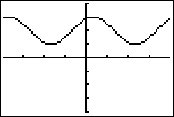  1  2  B.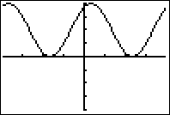  Description: Cartesian Coordinate plane with a periodic function graphed. Range is [0, 4] with a period of 8. Sine graph has a phase shift of $\frac{π}{3}$ units to the left.  1  2  C. 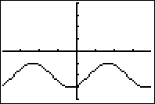  Description: Cartesian Coordinate plane with a periodic function graphed. Range is [-3, -1] with a period of 2π. Sine graph has a phase shift of $\frac{π}{3}$ units to the right.  1  2  D.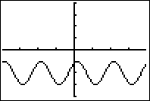  2  1  Description: Cartesian Coordinate plane with a periodic function graphed. Range is [-3, -1] with a period of π. Sine graph has a phase shift of $\frac{π}{3}$ units to the left.  Correct Answer: A  3. The number of hours of daylight varies through the year in any location in the form of a sinusoidal wave. In a certain location the longest day of 14 hours is on Day 175 and the next shortest day of 10 hours is on Day 355. Identify a possible equation for this function.  Correct Answer: $D(t)=2\sin\left(\frac{π}{90}\left(t-85\right)\right)+12$

Reporting Category | Functions
Standard | Trigonometric Functions
Benchmark Number | MAFS.912.F-TF.2.6
Benchmark | Understand that restricting a trigonometric function to a domain on which it is always increasing or always decreasing allows its inverse to be constructed.
Also Assesses | N/A
Item Types | Selected Response (Multiple Choice), Gridded Response
Cognitive Complexity Level | Moderate
Benchmark Clarification | Students will be able to sketch one cycle of an inverse function, given an appropriate domain.  Students will be able to determine the value of the 6 inverse trigonometric functions with an appropriate domain.
Content Limits | Angles must be in degrees or radians with two or less decimal places. Graphs will be in radian measure.
Stimulus Attributes | Items may be set in real world or mathematical context.
Response Attributes | Output from inverse functions will be an exact or rounded rational number to two decimal places.

Sample Item | 1. Which of the following best represents the graph of y = 2cos⁻¹ (x + $\frac{π}{2}$ )?  Description: Cartesian Coordinate plane with a function graphed. Range is [0, 2π] and the domain is $\left[\left(-\frac{π}{2}-1\right),\left(-\frac{π}{2}+1\right)\right]$.  - 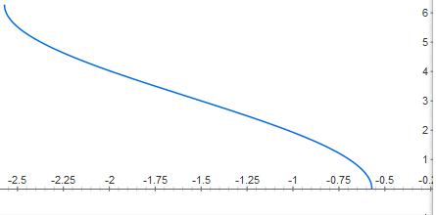  Description: Cartesian Coordinate plane with a function graphed. Range is [0, 2π] and the domain is $\left[\left(\frac{π}{2}-1\right),\left(\frac{π}{2}+1\right)\right]$.  - 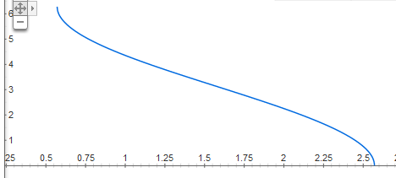  - 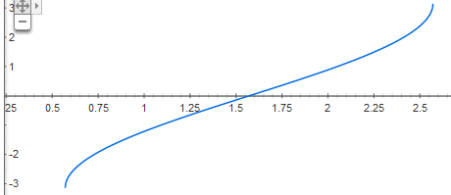  Description: Cartesian Coordinate plane with a function graphed. Range is [-π, π] and the domain is $\left[\left(\frac{π}{2}-1\right),\left(\frac{π}{2}+1\right)\right]$.  - 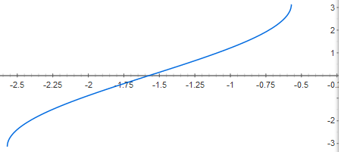  Description: Cartesian Coordinate plane with a function graphed. Range is [-π, π] and the domain is $\left[\left(-\frac{π}{2}-1\right),\left(-\frac{π}{2}+1\right)\right]$.  Correct Answer: A

Reporting Category | Functions
Standard | Trigonometric Functions
Benchmark Number | MAFS.912.F-TF.2.7
Benchmark | Use inverse functions to solve trigonometric equations that arise in modeling contexts; evaluate the solutions using technology, and interpret them in terms of the context.
Also Assesses | N/A
Item Types | Selected Response (Multiple Choice), Gridded Response, Short Answer
Cognitive Complexity Level | Moderate
Benchmark Clarification | Students will use technology to solve inverse trigonometric equations.
Content Limits | Angles must be in degrees or radians with two or less decimal places. Graphs will be in radian measure.
Stimulus Attributes | Items must be set in real world setting.
Response Attributes | Output from inverse functions will be an exact or rounded rational number to two decimal places.
Sample Item | 1. Tonya is playing tennis with a friend. She hits a tennis ball with her racket towards a net 40 feet away. The height of the net is the same height as the initial height of the tennis ball at the exact moment she hits the ball.  If the ball is hit at 50 feet per second, neglecting air resistance, use the formula  d = $\frac{1}{32}$ v₀² sin 2θ where d represents the distance travelled, v₀ represents the initial velocity, and θ represents the angle in degrees to find the interval of possible angles of the ball needed to clear the net. Round your answer to the nearest tenth of a degree.  Correct Answer: 15.4 ˚, 74.6 ˚

Reporting Category | Functions
Standard | Trigonometric Functions
Benchmark Number | MAFS.912.F-TF.3.8
Benchmark | Prove the Pythagorean identity sin²(θ) + cos²(θ) = 1 and use it to calculate trigonometric ratios.
Also Assesses | N/A
Item Types | Selected Response (Multiple Choice), Gridded Response, Short Answer
Cognitive Complexity Level | Moderate
Benchmark Clarification | Students will use the Pythagorean identity to find trigonometric ratios given the three sides of a right triangle.
Content Limits | Angle measures will be in degrees.  Items may require multiple steps.
Stimulus Attributes | Graphics may be given to enhance the item, or students may be expected to make a sketch to assist in giving a response.
Response Attributes | Angle measures will be in degrees.
Sample Item | 1. θ is an acute angle in the first quadrant. Given that sin θ = ¼, use the Pythagorean identity sin²θ +cos²θ=1 to find cos θ.  A. $\frac{\sqrt{15}}{5}$ B. 4 C.$\frac{\sqrt{15}}{4}$ D. $\frac{4\sqrt{15}}{5}$  Correct Answer: C  2. Given a right triangle, if sin θ = $\frac{7}{25}$, sin $θ$ > 0 and cos θ < 0, find cot θ.  Correct Answer: $-\frac{24}{7}$  3. Given a right triangle, sec θ = $\frac{\sqrt{29}}{5}$, where sin θ > 0. Find the exact value of tan θ.  A. $\frac{2\sqrt{29}}{29}$ B. $\frac{2}{5}$ C. $\frac{5\sqrt{29}}{29}$ D. $\frac{5}{2}$  Correct Answer: B
Reporting Category | Number and Quantity
Standard | The Complex Number System
Benchmark Number | MAFS.912.N-CN.3.9
Benchmark | Know the Fundamental Theorem of Algebra; show that it is true for quadratic polynomials.
Also Assesses | N/A
Item Types | Selected Response (Multiple Choice), Gridded Response
Cognitive Complexity Level | Moderate
Benchmark Clarification | Students will find the conjugate to find moduli and quotients of a complex number.  Students will use complex numbers in polynomial identities and equations.  Students will apply various theorems to find complex zeros of polynomial functions.  Student will utilize the Fundamental Theorem of Algebra to determine the number of zeros.
Content Limits | Polynomials must be factorable using factoring, graphing, synthetic division (with both a zero remainder and # value remainders), grouping, or finding the greatest common factor.
Stimulus Attributes | Items must be set in a mathematical context. Items may require multiple steps.
Response Attributes | Complex numbers will be written in standard form.  Responses will be exact values.  Selected Response answers may have complex factors for the polynomial.
Sample Item | - Write a polynomial function f of least degree that has rational coefficients, a leading coefficient of 1, and roots of -4 and $5-\sqrt{2}$.  - ${f\left(x\right)=x}^{3}-4x^{2}-16x+52$ C.${f\left(x\right)=x}^{3}-4x^{2}+16x-52$  - $f\left(x\right)=x^{3}-6x^{2}+17x-92$ D.$f\left(x\right)=x^{3}-6x^{2}-17x+92$  Correct Answer: D  - Find all zeros of the polynomial function:  $${f\left(x\right)=x}^{3}+7x^{2}+15x+9$$  - -3,-3,-1  - 3, 3, 1  - -3, 3, 1  - -3, 3, -1  Correct Answer: A

