CENTRAL FLORIDA ASSESSMENT COLLABORATIVE

Individual Test Item
Specifications
Advanced Algebra with
Financial Applications
2013

Note: The contents of this document were developed under a grant from the U.S. Department of Education. However, the content does not necessarily represent the policy of the U.S. Department of Education, and you should not assume endorsement by the Federal Government.

Table of Contents
I. Guide to the Individual Benchmark Specifications ..................................................................... 1

Benchmark Classification System............................................................................................... 1

Definitions of Benchmark Specifications ................................................................................... 3

II. Individual Benchmark Specifications for................................................................................... 4

Advanced Algebra with Financial Applications ............................................................................. 4

MA.912.F.1.1 .............................................................................................................................. 4

MA.912.F.1.2 .............................................................................................................................. 8

MA.912.F.2.1 .............................................................................................................................. 9

MA.912.F.2.2 ............................................................................................................................ 11

MA.912.F.3.2 ............................................................................................................................ 12

MA.912.F.3.3 ............................................................................................................................ 14

MA.912.F.3.5 ............................................................................................................................ 16

MA.912.F.3.6 ............................................................................................................................ 18

MA.912.F.3.10 .......................................................................................................................... 20

MA.912.F.3.13 .......................................................................................................................... 22

MA.912.F.4.1 ............................................................................................................................ 25

MA.912.F.4.3 ............................................................................................................................ 27

MA.912.F.4.5 ............................................................................................................................ 29

MAFS.912.A-CED.1.3 ............................................................................................................. 32

MAFS.912.F-BF.1.1a, b ........................................................................................................... 36

MAFS.912.F-IF.2.4 .................................................................................................................. 40

MAFS.912.S-ID.2.6 ................................................................................................................. 43

Appendix A: Reference Sheet for Advanced Algebra with Financial Applications .................... 45
I. Guide to the Individual Benchmark Specifications

Content specific guidelines are given in the Individual Benchmark Specifications for each course. The Specifications contains specific information about the alignment of items with the NGSSS and MAFS. It identifies the manner in which each benchmark is assessed, provides content limits and stimulus attributes for each benchmark, and gives specific information about content, item types, and response attributes.

Benchmark Classification System

Each NGSSS benchmark is labeled with a system of letters and numbers.

• The two letters in the first position of the label identify the Subject Area.

• The number(s) in the second position represents the Grade Level.

• The letter in the third position represents the Strand or Body of Knowledge.

• The number in the fourth position represents the Standard.

• The number in the last position identifies the specific Benchmark.

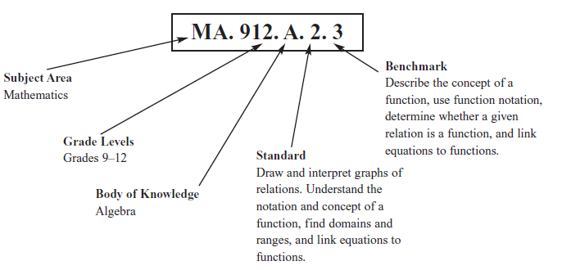

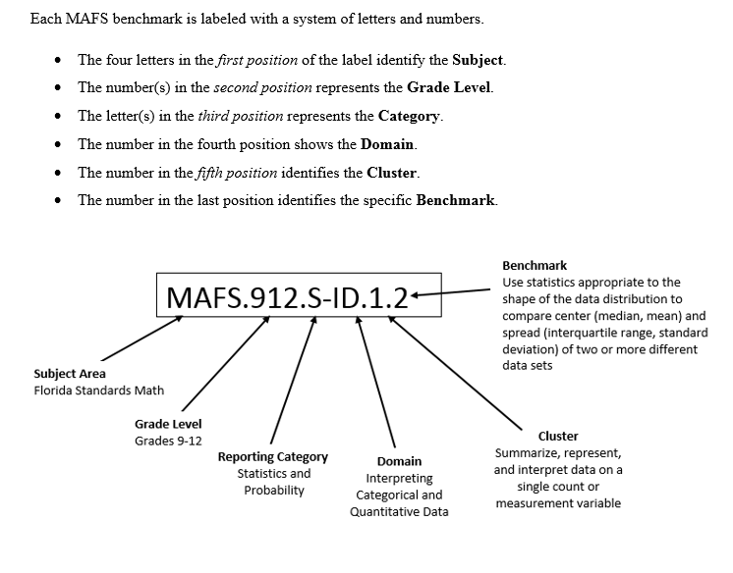
Definitions of Benchmark Specifications

The Individual Benchmark Specifications provides standard-specific guidance for assessment item development for CFAC item banks. For each benchmark assessed, the following information is provided:

Reporting Category | is a grouping of related benchmarks that can be used to summarize and report achievement.
Standard | refers to the standard statement presented in the NGSSS or the Florida Standards.
Benchmark  Also Assesses | refers to the benchmark statement presented in the standard statement in the NGSSS or the Florida Standards. In some cases, two or more related benchmarks are grouped together because the assessment of one benchmark addresses another benchmark. Such groupings are indicated in the Also Assesses statement.  refers to the benchmarks that are closely related to the benchmark (see description above).
Item Types  Cognitive Complexity Level | are used to assess the benchmark or group of benchmark.  ideal level at which the item should be assessed.
Benchmark Clarifications | explain how achievement of the benchmark will be demonstrated by students. In other words, the clarification statements explain what the student will do when responding to questions.
Content Limits | define the range of content knowledge and that should be assessed in the items for the benchmark.
Stimulus Attributes | define the types of stimulus materials that should be used in the items, including the appropriate use of graphic materials and item context or content.
Response Attributes | define the characteristics of the answers that a student must choose or provide.
Sample Items | are provided for each type of question assessed. The correct answer for all sample items is provided.

II. Individual Benchmark Specifications for
Advanced Algebra with Financial Applications

Course Number: 1200500

MA.912.F.1.1

Reporting  Category | Financial Literacy
Standard | Simple and Compound Interest
Benchmark  Number | MA.912.F.1.1
Benchmark | Explain the difference between simple and compound interest.
Also Assesses | MA.912.F.1.3, MA.912.F.1.4, MAFS.912.A-CED.1.1, MAFS.912.F-IF.3.7a, e  MAFS.K12.MP.1.1, 2.1, 4.1, 5.1, 6.1,.7.1
Item Types | Selected-Response, Gridded-Response, Short-Response
Benchmark  Clarification | Students will compare and contrast simple and compound interest.  Students will understand the relationship between simple interest and linear growth.  Students will understand the relationship between compound interest and exponential growth.  Students will be able to graph simple and compound interest problems.
Content  Limits | Students will be provided a reference sheet that includes the formulas for simple and compound interest.  Continuous compounding will not be assessed under this benchmark.

Stimulus  Attributes | Principal, annual rate of interest, time, form of compounding (if applicable)  must be provided.  Items requiring students to create and/or solve an equation in one variable must involve simple interest.  Students may be asked to identify the graph that models a given scenario. Items should be set in a real-world context.
Response  Attributes | Monetary answers should be rounded to the nearest hundredth unless specified otherwise.
Sample Item 1 | How much more, in dollars, would $1000 earn in 5 years in an account compounded daily than an account earning simple interest, if the interest rate on both accounts is 3%?  Answer: 11.83
Sample Item 2 | Which of the following statements about simple interest and compound interest is not true?  A. Simple interest is only added to an account once a year, while compound interest may be added numerous times throughout the year.  B. Both simple interest and compound interest are computed using the original principal balance. *  C. Over time compound interest pays more than simple interest because compounding pays interest on the interest earned.  D. The Simple Interest Formula is an example of a linear equation, while the  Compound Interest Formula is an example of an exponential equation.

Page | 5
Sample Item 3
Manuela deposited $2,5000 into a saving account which pays 6.5% annual interest, compounded monthly. If she makes no additional deposits, which of the following graphs models the balance in Manuela’s account over a 20-year period?

A.
Manuela's Savings Account

6000
Account Balance, in dollars
5750
5500
5250
5000
4750
4500
4250
4000
3750
3500
3250
3000
2750
2500
0 5 10 15 20

Time, in years

B.
Manuela's Savings Account

5500

Account Balance, in dollars
5250
5000
4750
4500
4250
4000
3750
3500
3250
3000
2750
2500
0 5 10 15 20
Time, in years
C.*

Manuela's Savings Account

9500

Account Balance, in dollars
9000
8500
8000
7500
7000
6500
6000
5500
5000
4500
4000
3500
3000
2500
0 5 10 15 20
Time, in years

D.
Manuela's Savings Account

7500
Account Balance, in dollars

7000

6500

6000

5500

5000

4500

4000

3500

3000

2500
0 5 10 15 20

Time, in years

Reporting  Category | Financial Literacy
Standard | Simple and Compound Interest
Benchmark  Number | MA.912.F.1.2
Benchmark | Solve problems involving compound interest.
Also Assesses | MAFS.K12.MP.1.1, 2.1, 4.1, 5.1, 6.1,.7.1
Item Types | Selected-Response, Gridded-Response, Short-Response
Benchmark  Clarification | Students will solve problems involving compound interest, to include continuous compounding.
Content  Limits | Students will be provided a reference sheet that includes the formulas for compound interest.  Items may require students to calculate the principal, amount of interest earned, or ending balance. Calculation of the interest rate, time, or number of compounding will not be assessed.
Stimulus  Attributes | Items should be set in a real-world context.
Response  Attributes | Monetary answers should be rounded to the nearest hundredth unless specified otherwise.
Sample Item 1 | You invest $1000 in an account at an annual rate of 2.5%, compounded quarterly. You made no additional deposits. How much money, in dollars, is in your account at the end of 3 years?  Answer: 1077.63
Sample Item 2 | At the end of 10 years you have a total of $1500 in your savings account. The account paid an annual rate of 3%, compounded monthly. If no additional deposits were made, what was the amount, in dollars, of your original deposit?  Answer: 1111.64

Page | 8

Reporting  Category | Financial Literacy
Standard | Net Present and Net Future Value (NPV and NFV)
Benchmark  Number | MA.912.F.2.1
Benchmark | Calculate the future value of a given amount of money with and without technology.
Also Assesses | MAFS.K12.MP.1.1, 2.1, 3.1, 4.1, 5.1, 6.1, 7.1
Item Types | Selected-Response, Gridded-Response, Short-Response
Benchmark  Clarification | Student will be able to calculate the net future value of an investment.
Content  Limits | Students will be provided a reference sheet that includes the formulas for future value for both single and periodic deposits.  Items may require students to calculate the periodic investment, amount of interest earned, or ending balance. Calculation of the interest rate, time, or number of compounding will not be assessed.
Stimulus  Attributes | Items should be set in a real-world context.
Response  Attributes | Monetary answers should be rounded to the nearest hundredth unless specified otherwise.
Sample Item 1 | Each month your parents deposit $50 into your college fund. The account pays an annual rate of 3.5%, compounded monthly. To the nearest whole dollar, how much will be in your college fund after 18 years?  Answer: 31815

Page | 9
Sample Item 2 Taylor will be attending college in 3 years and would like to save $1000 to help with expenses. She will deposit money in a savings account that pays 1.75% interest annually, compounded monthly. How much should she deposit each month to meet her goal?

A. $21.74
B. $22.96
C. $26.37
D. $27.08*

Page | 10

Reporting  Category | Financial Literacy
Standard | Net Present and Net Future Value (NPV and NFV)
Benchmark  Number | MA.912.F.2.2
Benchmark | Calculate the present value of a certain amount of money for a given length of time in the future with and without technology.
Also Assesses | MAFS.K12.MP.1.1, 2.1, 3.1, 4.1, 5.1, 6.1, 7.1
Item Types | Selected-Response, Gridded-Response, Short-Response
Benchmark  Clarification | Student will be able to calculate the present value and net present value of an investment.
Content  Limits | Students will be provided a reference sheet that includes the formulas for present value for both single and periodic deposits.  Items may require students to calculate the periodic investment, amount of interest earned, or initial investment. Calculation of the interest rate, time, or number of compounding will not be assessed.
Stimulus  Attributes | Items should be set in a real-world context.
Response  Attributes | Monetary answers should be rounded to the nearest hundredth unless specified otherwise.
Sample Item 1 | Alyssa is opening a savings account with an annual interest rate of 3.5%, compounded monthly. At the end of 5 years, she would like to have $10,000 in her account. If she plans to make no additional deposits, how much should Alyssa deposit today, in dollars, in order to reach her goal?  Answer: 8396.71
Sample Item 2 | Alexander would like to buy a used car and needs a total of $5000. He is opening a savings account with an annual interest rate of 6%, compounded monthly. If Alexander plans to make equal monthly deposits for the next 3 years, how much will he need to deposit each month, in dollars, to reach his goal?  Answer: 127.11

Page | 11

Reporting  Category | Financial Literacy
Standard | Loans and Financing
Benchmark  Number | MA.912.F.3.2
Benchmark | Analyze credit scores and reports.
Also Assesses | MAFS.K12.MP.1.1, 2.1, 3.1, 4.1, 5.1, 6.1, 7.1
Item Types | Selected-Response, Gridded-Response, Short-Response
Benchmark  Clarification | Student will understand how past payment history, amount of debt, public records, length of credit history, and the number of recent credit inquires impact credit scores.  Students will understand how credit scores affect the cost of making a loan.
Content  Limits | Not applicable
Stimulus  Attributes | Items should be set in a real-world context.
Response  Attributes | Monetary answers should be rounded to the nearest hundredth unless specified otherwise.
Sample Item 1 | Which of the following is not a way of improving your credit score?  A. Pay all of your bills on time each month.  B. Open several new accounts to show that you can get credit.*  C. Check your credit report regularly and correct any inaccuracies.  D. Keep accounts with long credit histories open when they have zero balance.

Page | 12
Sample Item 2 Delano and Omario plan to purchase an automobile. They both plan to take out a loan for $5,200 towards the vehicle cost financed over a period of 36 months.

Purchasers | Credit Score | Annual  Interest Rate
Delano | 700 | 4.784%
Omario | 605 | 15.539%

Based on the chart, how much money, to the nearest whole dollar, will Delano save compared to Omario over the life of the loan?

Answer: 946

Page | 13

Reporting  Category | Financial Literacy
Standard | Loans and Financing
Benchmark  Number | MA.912.F.3.3
Benchmark | Calculate the finance charges and total amount due on a credit card bill.
Also Assesses | MA.912.F.3.1, MA.912.F.4.4  MAFS.K12.MP.1.1, 4.1, 5.1, 6.1, 7.1
Item Types | Selected-Response, Gridded-Response, Short-Response
Benchmark  Clarification | Students will calculate the monthly finance charges on a credit card bill.  Students will calculate the minimum monthly payment required on a credit card bill.  Students will calculate the minimum payment required to pay off a debt in a specified period of time.  Students will compare paying for a purchase with cash versus with a credit card over time.
Content Limits | Interest rates will be given as annual percentage rate (APR).
Stimulus  Attributes | Items required students to calculate the minimum payment required or time required to pay off a credit card balance must:  • state that no additional charges are made.  • be based on APR (annual rate = periodic rate x number of periods).  • have constant annual and periodic interest rates.  • assume payments are made at the end of the period.  Items should be set in a real-world context.
Response  Attributes | Monetary answers should be rounded to the nearest hundredth unless specified otherwise.

Page | 14

Sample Item 1 | A credit card has an annual percentage rate of 23.988%. The balance owed is  $1500.00. Assuming no additional charges are made, what is the minimum monthly payment, in dollars, required to pay off the balance in 12 months?  Sample Answer: 154.99
Sample Item 2 | A credit card has annual percentage rate of 18.9%. The required minimum monthly payment is 10% of the balance, plus the monthly finance charge. If the balance on the card is $1000.00, what is the required minimum monthly payment, in dollars?  Answer: 115.75
Sample Item 3 | Chris got a new credit card and was eager to use it. He went to the mall and charged $500 in purchases. He has enough money saved to make a payment of  $350. The annual percentage rate is 17%. In dollars, how much will he pay in finance charges this month?  Answer: 2.13
Sample Item 4 | Carlos wants to purchase a computer for $1049 plus 7% sales tax. He can afford to pay $80 per month to purchase the computer. He can save $80 per month and purchase the computer with cash later, or he can purchase the computer now using a credit card that charges a 14.9% annual percentage rate. To the nearest hundredth, which method will take longer, and how much longer will it take?  A. Saving enough money to purchase the computer will take 1.29 months longer than paying off the credit card balance.  B. Paying off the credit card balance will take 1.29 months longer than saving enough money to purchase the computer.  C. Saving enough money to purchase the computer will take 1.48 months longer than paying off the credit card balance.  D. Paying off the credit card balance will take 1.48 months longer than saving enough money to purchase the computer. *
Sample Item 5 | Callie fills her 22.5-gallon gas tank and pays with her credit card. Gas is  $3.159 per gallon, and the credit card charges an annual percentage rate of  13.8%. She will pay $10 each month and will make no additional charges until the balance is paid in full. How much more, in dollars, will Callie pay for the gas by using her credit card instead of paying cash?  Answer: 3.50

Page | 15

Reporting  Category | Financial Literacy
Standard | Loans and Financing
Benchmark  Number | MA.912.F.3.5
Benchmark | Calculate deferred payments.
Also Assesses | MA.912.F.3.4  MAFS.K12.MP.1.1, 2.1, 3.1, 4.1, 5.1, 6.1, 7.1
Item Types | Selected-Response, Gridded-Response, Short-Response
Benchmark  Clarification | Students will be able to calculate the actual costs of deferred payment plans  Students will be able to compare the advantages and disadvantages of deferred payments.
Content Limits | Not Applicable
Stimulus  Attributes | Items will NOT require that students find the original purchase price, interest rate, or deferment term.  Items must state whether interest rate applies retroactively to the original purchase or to remaining balance after the deferment period.  Items may present multiple deferment plans and require student to select the most advantageous.  Items should be set in a real-world context.
Response  Attributes | Monetary answers should be rounded to the nearest hundredth unless specified otherwise.

Page | 16

Sample Item 1 | Anthony purchased a big screen television for $2499 including sales tax. The  electronics company offered a 2 year deferred payment plan. After 2 years, the company charges a 20% annual interest applied retroactively to the original purchase. He made no payments the first year. During the second year, he made payments totaling $2100. Assuming that Anthony pays the account balance in full at the beginning of the third year, how much, in dollars, did the television actually cost?  Answer: 3598.56
Sample Item 2 | Jackie wants to purchase a set of furniture for her living room that costs $3999. The sales tax on the purchase is 7%. The furniture company is offering an 18- month deferred payment plan with a minimum payment of $20 per month. After 18 months, the company will charge a 28.99% annual interest on the remaining balance. If Jackie makes only the required minimum monthly payments, how much, in dollars, will be subject to the 28.99% annual interest rate?  Answer: 3918.93

Page | 17

Reporting  Category | Financial Literacy
Standard | Loans and Financing
Benchmark  Number | MA.912.F.3.6
Benchmark | Calculate total cost of purchasing consumer durables over time given different down payments, financing options, and fees.
Also Assesses | MA.912.F.3.9  MAFS.K12.MP.1.1, 2.1, 3.1, 4.1, 5.1, 6.1, 7.1
Item Types | Selected-Response, Gridded-Response, Short-Response
Benchmark  Clarification | Students will be able calculate the actual cost of purchasing durable goods.  Students will calculate the total amount to be paid over the life of a fixed rate loan.
Content  Limits | Students will be provided a reference sheet that includes the monthly payment formula.  Deferred payment plans will not be assessed under this benchmark.
Stimulus  Attributes | Items will NOT require that students find the original purchase price, interest rate, or loan term.  Items will NOT require the use of an amortization table.  Items may present multiple payment plans and require student to select the most advantageous.  Items can be set in a mathematical or real-world context.
Response  Attributes | Monetary answers should be rounded to the nearest hundredth unless specified otherwise.

Page | 18

Sample Item 1 | A car dealership is offering a 4% APR for 60 months with no down payment  required. You would like to purchase a car that costs $14,900 including taxes, tag, and title. If you take advantage of the offer, what is the actual cost of the car, in dollars?  Sample Answer: 16464.37 [range of acceptable answers 16464.00-16465.00]
Sample Item 2 | Sam wants to buy a car that costs $24,900 including taxes, tag, and title. The dealership is offering a 5% APR for 72 months with a 15% down payment. If Sam takes advantage of the offer, what is the actual cost of the car, in dollars?  Sample Answer: 28276.98 [range of acceptable answers 28276.00-28278.00]
Sample Item 3 | What is the total amount paid for a $210,000 fixed rate loan at 4.875% annual interest over a 30-year period, rounded to the nearest dollar?  A. $400,081* B. $401,094  C. $402,523  D. $403,889

Page | 19

Reporting  Category | Financial Literacy
Standard | Loans and Financing
Benchmark  Number | MA.912.F.3.10
Benchmark | Calculate the effects on the monthly payment in the change of interest rate based on an adjustable rate mortgage.
Also Assesses | MAFS.K12.MP.1.1, 2.1, 4.1, 5.1, 6.1, 7.1
Item Types | Selected-Response, Gridded-Response, Short-Response
Benchmark  Clarification | Students will be able to calculate monthly mortgage payments.  Student will be able to calculate changes in monthly mortgage payments caused by changes in interest rates.
Content  Limits | Students will be provided a reference sheet that includes the monthly payment formula.
Stimulus  Attributes | Items will not require the use of an amortization table.  Items should be set in a real-world context.
Response  Attributes | Monetary answers should be rounded to the nearest hundredth unless specified otherwise.
Sample Item 1 | Ximena is considering an adjustable rate mortgage. She plans to borrow  $245,000 using a 30-year, 1-year ARM indexed to the 1-year Treasury security with a 2.75 % margin and 2/6 caps (2% per year and 6% lifetime). The initial interest rate on this loan is 2.75%. What is the initial monthly payment for principal and interest, in dollars, on this mortgage?  Sample Answer: 1000.19 [range of acceptable answers 1000.00-1001.00]

Page | 20
Sample Item 2 Paul took out a $250,000, 15-year adjustable rate mortgage with an initial rate of 6%. After the first year, the interest rate increased by 0.75%. The loan balance was $239,395.86. How much did Paul’s mortgage payment increase as a result of the change in interest rate?

A. | $2,702.36
B. | $2,118.44
C. | $592.72
D. | $8.80

Page | 21
MA.912.F.3.13

Reporting  Category | Financial Literacy
Standard | Loans and Financing
Benchmark  Number | MA.912.F.3.13
Benchmark | Calculate the total amount paid for the life of a loan for a house including the down payment, points, fees, and interest.
Also Assesses | MA.912.F.3.7, MA.912.F.3.11, MA.912.F.3.12, MA.912.F.3.14  MAFS.K12.MP.1.1, 2.1, 4.1, 5.1, 6.1, 7.1
Item Types | Selected-Response, Gridded-Response, Short-Response
Benchmark  Clarification | Student will calculate fees associated with obtaining a mortgage (e.g, discount points, origination fee, maximum brokerage fee on a net or gross loan, documentary stamps, and prorated expenses (interest, county and/or city property taxes, and mortgage on an assumed mortgage)).  Students will be able to calculate the total cost involved when purchasing a house including the down payment, points, fees, and interest.  Students will compare the cost of paying higher interest rates and lower points with the cost of paying lower interest rates and higher points.  Students will be able to calculate the final pay out amount of a balloon mortgage.  Students will compare the total cost of fixed rate and balloon mortgages. Students will understand the benefits and risks of fixed rate, adjustable rate, and  balloon mortgages.
Content  Limits | Students will be provided a reference sheet that includes the monthly payment formula.

Page | 22
Stimulus
Attributes
Items will not require that students find the original purchase price, interest rate, or loan term.

Items will not require students to find the total cost of an adjustable rate mortgage.

Items will not require the use of an amortization table.

Items may ask students to identify or compare the benefits and/or risks of different mortgage types.

Items should be set in a real-world context.

Response
Attributes
Monetary answers should be rounded to the nearest hundredth unless specified otherwise.

Sample Item 1 A $185,340 loan has an annual interest rate of 5.625%. Using the 365 day method, how much interest, in dollars, would a buyer owe for the 25 days remaining for a May closing?

Answer: 714.07

Sample Item 2 Yoshiko is calculating the cost, before interest, of purchasing her first home.
The HUD statement shows a breakdown of fees as shown below.

Fee | Amount
Purchase Price | $200, 000
Points | 2
Origination Fee | $1,250
Broker Fee | $2,000
Documentary Stamps | $750
Prorated Expenses | $560

To the nearest whole dollar, what is the total cost of the fees that Yoshiko must pay, excluding principal and interest?

Answer: 8560

Sample Item 3 Briana’s new home has a purchase price of $250,000. She has a down payment of $50,000. The lender is charging 2 points, and the remaining fees total $2500. If she obtains a fixed rated 30-year mortgage with a 2.75% annual interest rate, what is the total amount Briana will pay for her home? Round your answer to the nearest whole dollar.

Answer: 350434

Page | 23

Sample Item 4 | Theodore is considering financing a house for $500,000. His monthly payment  would be $2604.17. His mortgage broker told him that if he purchased one point (for one percent of the amount financed) he could lower his monthly payment to $2447.92.  What is the minimum number of months Theodore would need to own the house for it to be beneficial to purchase one point?  Answer: 32
Sample Item 5 | Mercedes is considering purchasing 3 points on a $400,000 home mortgage for  30 years. If she purchases the 3 points, at a cost of 1 percent per point, her monthly mortgage would be approximately $2,147. If she decides not to purchase any points, Mercedes’ monthly payment would be approximately  $2,271. How much money will Mercedes save over the life of the loan if she purchases the three points?  A. $32,640* B. $36,640  C. $40,640  D. $44,640
Sample Item 6 | Jeong is purchasing a home and plans to take out a mortgage for $125,000. He is considering two options.  Option 1: a 30-year, fixed rate mortgage with a rate of 6.35%  Option 2: a 10-year interest-only balloon mortgage with a rate of 5.5%  Assume that Jeong can pay the final balloon payout in full. How much will he save, to the nearest whole dollar, for the total cost of purchasing the home if he chooses option 2?  Answer: 117217

Page | 24
MA.912.F.4.1

Reporting  Category | Financial Literacy
Standard | Personal Financial Planning
Benchmark  Number | MA.912.F.4.1
Benchmark | Develop personal budgets that fit within various income brackets.
Also Assesses | MA.912.F.4.2  MAFS.K12.MP.1.1, 2.1, 4.1, 5.1, 6.1, 7.1.
Item Types | Selected-Response, Gridded-Response, Short-Response
Benchmark  Clarification | Students will solve problems related to personal budgets.  Students will understand cash management strategies including debit accounts, checking accounts, and savings accounts.
Content  Limits | Use of tax tables to determine income tax will not be assessed under this benchmark.
Stimulus  Attributes | Tax rate or tax amount must be provided for items requiring the calculation of net income.  Items should be set in a real-world context.
Response  Attributes | Monetary answers should be rounded to the nearest hundredth unless specified otherwise.

Page | 25
Sample Item 1 According to the U.S. Department of Labor, consumers had the following spending patterns in 2011:

Item | % of Gross Income
Housing | 26.4
Transportation | 13.0
Food | 10.1
Personal Insurance & Pensions | 8.5
Other | 5.3
Health Care | 5.2
Entertainment | 4.0
Apparel & Services | 2.7
Cash Contributions | 2.7

You spend $750 each month on housing. Based on the chart, how much, in dollars, should you budget for transportation expenses?

Answer: 369.32

Sample Item 2 Kim earns an annual salary of $30,000. Her federal income tax bracket is 20%.
She also must pay 7.65% in Social Security and Medicare taxes. She plans to deposit 10% of her net income into a savings account. How much, in dollars, will she save annually?

Answer: 2170.50

Sample Item 3 Sharon has a savings account with a minimum balance requirement of $1000 which pays 3.75% simple interest annually. She is charged a $10 monthly fee each time her balance is below the minimum. Over a period of 4 months, she maintained a balance of $900. How much interest did Sharon earn during the 4 months, and how much was she charged in fees?

A. Interest $33.75; Fees $10
B. Interest $8.44; Fees $10
C. Interest $33.75; Fees $40
D. Interest $8.44; Fees $40*

Page | 26
MA.912.F.4.3

Reporting  Category | Financial Literacy
Standard | Personal Financial Planning
Benchmark  Number | MA.912.F.4.3
Benchmark | Calculate net worth.
Also Assesses | MAFS.K12.MP.1.1, 2.1, 4.1, 5.1, 6.1, 7.1
Item Types | Selected-Response, Gridded-Response, Short-Response
Benchmark  Clarification | Students will calculate net worth.
Content  Limits | Not Applicable
Stimulus  Attributes | Items should be set in a real-world context.
Response  Attributes | Net worth values can be negative.  Monetary answers should be rounded to the nearest hundredth unless specified otherwise.

Page | 27
Sample Item 1 Shane is retired and owns a home. Below is a summary of his current assets and liabilities:

Assets | Liabilities
Home $375, 000 | Mortgage balance $65,000
Car $18,750 | Combined credit card debt $12,500
Cash and checking $55,000
Savings $90,000

Last year Shane’s net worth was $456,000. What was his percent of increase or decrease in his net worth from last year to this year?

A. 1.15% decrease B. 1.15% increase* C. 11.5% decrease D. 11.5% increase

Sample Item 2 The Smith family has assets and liabilities as shown below.

Assets  Monetary Assets |  | Liabilities  Current Liabilities
Cash/Checking | $1,000 | Visa/Mastercard | $500
Savings/CDs | $5,000 | Other credit cards | $200
Investments |  | Long Term Liabilities
Stocks/Bonds | $1000 | Auto loan | $500
Mutual Funds | $1500 | Student loans | $3000
Retirement Plans
401k, 403b, 457 | $1200
IRAs | $500
Automobiles | $3500
Personal Property | $750

What is the family’s net worth? A. $24,720
B. $14,450
C. $10,250* D. $ 4,250

Page | 28
MA.912.F.4.5

Reporting  Category | Financial Literacy
Standard | Individual Financial Planning
Benchmark  Number | MA.912.F.4.5
Benchmark | Develop and apply a variety of strategies to use tax tables, and to determine, calculate, and complete yearly federal income tax.
Also Assesses | MAFS.K12.MP.1.1, 2.1, 4.1, 5.1, 7.1
Item Types | Selected-Response, Gridded-Response, Short-Response
Benchmark  Clarification | Student will determine tax liability based on income, deductions, and filing status.
Content  Limits | Not Applicable.
Stimulus  Attributes | Tax tables should be provided as a graphic as needed.  Items should be set in a real-world context.
Response  Attributes | Monetary answers should be rounded to the nearest hundredth unless specified otherwise.

Page | 29
Sample Item 1
Below are excerpts from the 2012 Federal Income Tax Table.

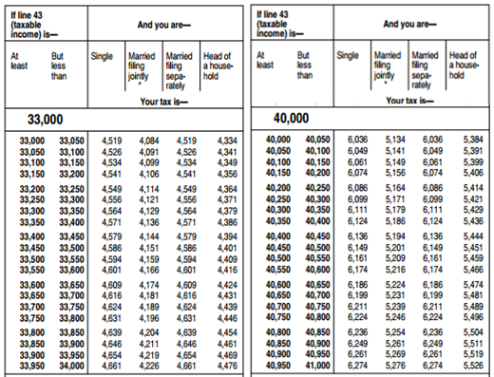

Justin is filing his federal income taxes as a single person. He earned $40,000 in 2012 and has deductions totaling $6,240. According to the tax table, how much federal income tax will he pay this year?

Answer: 4331

Sample Item 2

Below is an excerpt from the 2012 Federal Income Tax Table.

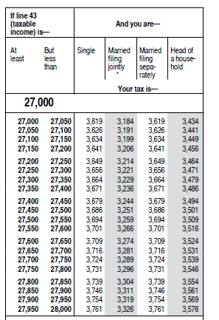

Mary’s filing status for her federal income taxes is Head of Household. In 2012, she had an adjustable gross income of $27,561 and paid in $3,230 in federal income tax. Based on the tax table, what will be the amount, in whole dollars, of Mary’s tax refund?

Answer: 286
MAFS.912.A-CED.1.3

Reporting  Category | Algebra
Standard | Creating Equations
Benchmark  Number | MAFS.912.A-CED.1.3
Benchmark | Represent constraints by equations or inequalities, and by systems of equations and/or inequalities, and interpret solutions as viable or nonviable options in a modeling context.
Also Assesses | MAFS.912.A-CED.1.2, MAFS.912.A-REI.3.8, MAFS.912.A-REI.3.9  MAFS.K12.MP.1.1, 2.1, 4.1, 5.1, 6.1, 7.1
Item Types | Selected-Response, Gridded-Response, Short-Response, Extended-Response
Benchmark  Clarification | Students will create and/or solve systems of linear equations or inequalities in two variables.  Students will interpret solutions as viable or non-viable options in a business modeling context.
Content  Limits | Items will not specify a method for solving systems of equations, such as substitution, elimination, or graphing.  Students may choose to solve systems of equation using a matrix, but items will not ask students to represent a system of equation using a matrix or specify that they solve a system of equations using the inverse of a matrix.  Items will not assess non-linear systems of equations or inequalities.  Items will not assess systems of equations or inequalities in three or more variables.
Stimulus  Attributes | Items should be set in a business or economics context (e.g., supply and demand, breakeven analysis, revenue and expense, etc).
Response  Attributes | Gridded-response or short-response items may ask students to provide the x- or  y-coordinate of the solution.  Items may require students to graph an equation, inequality, or system of equations or inequalities.

Page | 32

Sample Item 1 | The demand function for step stools manufactured by U-Step is  q = −370 p + 21, 500 . Given the revenue formula R = pq , what is the revenue if the price per step stool is $16?  A. $94,720  B. $15,580  C. $249,280* D. $344,000
Sample Item 2 | To produce a new line of shirts, Custom Shirt Company must pay a one-time design fee of $85.00 plus $3.50 per shirt. The shirts are then sold for $7.50 each. What is the minimum number of shirts Custom Shirt Company has to sell in order to make a profit?  Answer: 22
Sample Item 3 | The supply curve for a certain widget is given by the equation P = 20 + 2Q . The demand curve for the same widget is given by the equation P = 80 − Q where P represents the price of the widget, in dollars, and Q represents the quantity sold.  Part A  Graph the supply and demand curves on the same coordinate plane.  Part B  What is the equilibrium quantity?  Part C  What is the equilibrium price?  Suggested materials: graph paper, ruler

Page | 33

Scoring Rubric
4 | Work demonstrates a clear and complete understanding of the  mathematical concepts and/or procedures required by the task. Appropriate strategy is shown with clear and complete explanations and interpretations.
3 | Response demonstrates a clear understanding of the mathematical concepts  and/or procedures but is not complete. Appropriate strategy is shown, but explanation or interpretation has minor flaws.  OR  Response is incorrect because of calculation errors. Work and strategy indicate a clear understanding of the mathematical concepts and/or procedures required by the task.
2 | Response demonstrates a partial understanding of the mathematical  concepts and/or procedures. Appropriate strategy is shown, but explanation or interpretation has minor flaws.
1 | Response shows minimal understanding of the mathematical concepts  and/or procedures or provides no explanation or interpretation for the solution or shows major flaws.
0 | Response is irrelevant, inappropriate, or not provided.

Page | 34

Scoring Exemplar
Maximum Points – 4
Part A – 2 points
Student creates a graph similar to the one below that includes all appropriate labels. The scale
on the x- and/or y-axis may vary, but should be appropriate to the situation. Labels may vary, but should be appropriate to the situation.
Part B – 1 point
Student indicates that the equilibrium quantity is 20 units.
Part C – 1 point
Student indicates that the equilibrium price is $60.

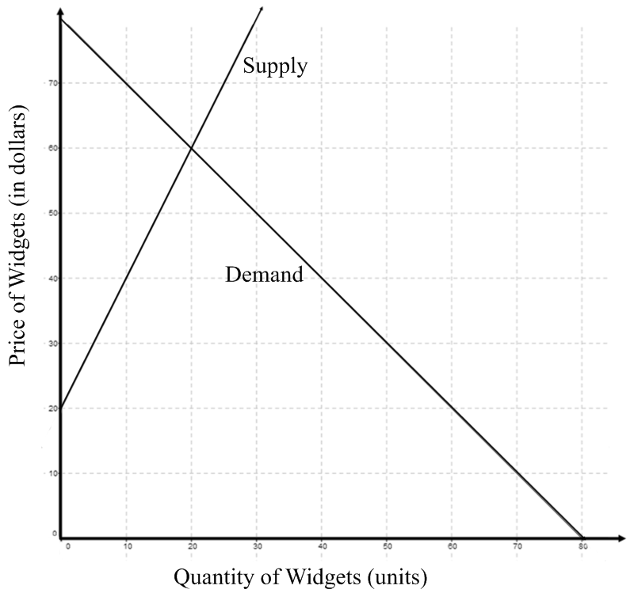
Page | 35
MAFS.912.F-BF.1.1a, b

Reporting  Category | Functions
Standard | Building Functions
Benchmark  Number | MAFS.912.F-BF.1.1a, b
Benchmark | Write a function that describes a relationship between two quantities.  a. Determine an explicit expression, a recursive process, or steps for calculations from a context.  b. Combine standard function types using arithmetic operations.
Also Assesses | MAFS.912.F-BF.1.2  MAFS.K12.MP.1.1, 2.1, 4.1, 5.1, 6.1, 7.1
Item Types | Selected-Response, Gridded-Response, Short-Response, Constructed- Response, Extended-Response
Benchmark  Clarification | Students will write a function that describes a given relationship between two variables.  Students will evaluate functions and interpret the meaning in the given context.  Students will add, subtract, multiply, and divide functions.
Content Limits | Items will assess linear, quadratic, or exponential relationships only.  Items may require students to write an explicit or recursive formula for an arithmetic or geometric sequence.  Items requiring students to find the finite sum of an arithmetic or geometric sequence may not exceed 5 terms. Summation notation will not be used.
Stimulus  Attributes | Items should be set in a real-world, preferably financial, context.
Response  Attributes | Not Applicable

Page | 36

Sample Item 1 | A company that manufactures tennis rackets has fixed costs of $78,490. It  costs $15 to produce each racket. If C( x) is a function that describes the total cost of manufacturing x number of tennis rackets, what is the value of C(2500)?  Answer: 115990
Sample Item 2 | A company that sells digital cameras has yearly fixed cost of $550,000. It costs the company $45 to produce each camera. Each camera will sell for  $75. The company’s cost and revenues are modeled by the following functions, where x represents the number of cameras produced and sold.  C(x) = 550, 000 + 45x  R(x) = 75x  What is (R − C)(30, 000) and what does it represent?  A. -350,000; company losses when 30,000 cameras are produced and sold  B. 350,000; company profits when 30,000 cameras are produced and sold *  C. 1,900,000; company costs when 30,000 cameras are produced  D. 2,225,000; company revenues when 30,000 cameras are sold
Sample Item 3 | You are considering two different employment opportunities. Company A offers $32,000 the first year. During the next 3 years, the salary is guaranteed to increase by 6% per year. Company B offers $34,000 the first year, with a guaranteed increase of 2% per year.  Part A  If an represents the salary after n years of employment, write an explicit or recursive formula for an for company A.  Part B  If an represents the salary after n years of employment, write an explicit or recursive formula for an for company B.  Part C  How does the salary for Company A compare to the salary for Company B in year 3? Which company offers the better total salary for a three-year contract?

Page | 37

Scoring Rubric
4 | Work demonstrates a clear and complete understanding of the  mathematical concepts and/or procedures required by the task. Appropriate strategy is shown with clear and complete explanations and interpretations.
3 | Response demonstrates a clear understanding of the mathematical concepts  and/or procedures but is not complete. Appropriate strategy is shown, but explanation or interpretation has minor flaws.  OR  Response is incorrect because of calculation errors. Work and strategy indicate a clear understanding of the mathematical concepts and/or procedures required by the task.
2 | Response demonstrates a partial understanding of the mathematical  concepts and/or procedures. Appropriate strategy is shown, but explanation or interpretation has minor flaws.
1 | Response shows minimal understanding of the mathematical concepts  and/or procedures or provides no explanation or interpretation for the solution or shows major flaws.
0 | Response is irrelevant, inappropriate, or not provided.
Scoring Exemplar
Maximum Points – 4
Part A – 1 point
Student response is equivalent to one of the following:

a = 32, 000(1.06)n−1 OR a1 = 32, 000
n a = a (1.06)
n n−1
Part B – 1 point
Student response is equivalent to one of the following:

a = 34, 000(1.02)n−1 OR a1 = 34, 000
n a = a (1.02)
n n−1
Part C – 2 points
Student response should indicate that the salary for Company A is greater in year 3.
Student response may or may not indicate the salary for Company A in year 3 is
$35,955.20 and the salary for Company B in year 5 is $35, 373.60. Student may round salaries to the nearest dollar.

Student response indicates that Company B offers the greatest total salary for a five year contract. Students may or may not indicate the sum of the salaries for Company A is $101,875.20 and the sum of the salaries for Company B is $104,053.60. Student may round sums to the nearest dollar.

Page | 38
Sample Item 4 A car was purchased for $18,500. The value of the car decreased by $2750 per year for the first five years.

Part A
Write a function, V ( x) , that describes the value of the car after x years
where 0 ≤ x ≤ 5.

Part B
What is V (3) and what does it represent?

Scoring Rubric
2 | Work demonstrates a clear and complete understanding of the concept  and/or procedures required by the task. Appropriate strategy is shown with clear and complete explanations and interpretations.
1 | Response demonstrates a partial understanding of the concepts and/or  procedures. Appropriate strategy is shown, but explanation or interpretation has minor flaws.  OR  Response is incorrect because of calculation errors. Work and strategy indicate a clear understanding of the concepts and/or procedures required by the task.
0 | Response is irrelevant, inappropriate, or not provided.

Scoring Exemplar
Maximum Points – 2
Part A – 1 point
Student writes a function equivalent to V (x) = 18, 500 − 2750x. Student may show that
the domain is restricted to 0 ≤ x ≤ 5 , but it is not necessary.
Part B – 1 point
Student response indicates that V (3) = 10, 250 (or correctly finds the value of V (3)
based on the function given in Part A), and that it represents the value of the car after
3 years.

Page | 39
MAFS.912.F-IF.2.4

Reporting  Category | Functions
Standard | Interpreting Functions
Benchmark  Number | MAFS.912.F-IF.2.4
Benchmark | For a function that models a relationship between two quantities, interpret  key features of graphs and tables in terms of the quantities, and sketch graphs showing key features given a verbal description of the relationship. Key features may include: intercepts; intervals where function is increasing or decreasing; positive, or negative; relative maximums and minimums, symmetries; end behavior; and periodicity.
Also Assesses | MAFS.912.F-IF.2.5  MAFS.K12.MP.1.1, 2.1, 4.1, 5.1, 6.1, 7.1
Item Types | Selected-Response, Gridded-Response, Short-Response, Extended-Response
Benchmark  Clarification | Given a function that models a relationship between two quantities, students will interpret key features of its graph.  Students will describe restrictions on domain and/or range given a real-world context.
Content Limits | Items will assess linear, quadratic, or exponential relationships only.  Items will not require students to create graphs.
Stimulus  Attributes | Items should be set in a business or economics context.  Functions should be provided.
Response  Attributes | Gridded-response or short-response items may ask students to provide the x-  or y-coordinate of an intercept.

Page | 40
Sample Item 1 The average number of miles per gallon for U.S. automobiles in the years between 1940 and 2000 can be modeled by the quadratic function
f (x) = 0.005x2 − 0.170x +14.817 where x represents the number of years after 1940. Based on the function, during what year was fuel efficiency at its lowest level?

A. 1940
B. 1957 * C. 1964
D. 1970

Sample Item 2 The ABC Toy company has completed a profit analysis of their newest product. The profit function for the new product was determined to be P(x) = −250x2 + 4500x − 22, 000 , where x is the unit price of the product.

Part A
What is an appropriate domain for

P( x) and why?

Part B
For which interval(s) in the domain is the profit increasing?

Part C
What price, in dollars, should ABC Toys charge for their new product, in order to achieve maximum profit?

Part D
What is the maximum profit that ABC toys will earn from sales of the new product?

Scoring Rubric
4 | Work demonstrates a clear and complete understanding of the  mathematical concepts and/or procedures required by the task. Appropriate strategy is shown with clear and complete explanations and interpretations.
3 | Response demonstrates a clear understanding of the mathematical concepts  and/or procedures but is not complete. Appropriate strategy is shown, but explanation or interpretation has minor flaws.  OR  Response is incorrect because of calculation errors. Work and strategy indicate a clear understanding of the mathematical concepts and/or procedures required by the task.
2 | Response demonstrates a partial understanding of the mathematical  concepts and/or procedures. Appropriate strategy is shown, but explanation

Page | 41

 | or interpretation has minor flaws.
1 | Response shows minimal understanding of the mathematical concepts  and/or procedures or provides no explanation or interpretation for the solution or shows major flaws.
0 | Response is irrelevant, inappropriate, or not provided.

Scoring Exemplar
Maximum Points – 4
Part A – 1 point
Student response indicates that domain is x ≥ 0 , as the price of a product cannot be negative. Alternatively, a domain of x > 0 is acceptable if the student explains that the
product could not be free nor have a negative price. The response could be stated as an
inequality, using set notation, or in words.
Part B – 1 point
Student response indicates that the profit is increasing in the interval 0 < x < 9. The response could be stated as an inequality, using set notation, or in words.
Part C – 1 point
Student response indicates that the profit is maximized when the price is $9.00.
Part D – 1 point
Student response indicates that the maximum profit is $18,050.

Page | 42
MAFS.912.S-ID.2.6

Reporting  Category | Statistics and Probability
Standard | Interpreting Categorical and Quantitative Data
Benchmark  Number | MAFS.912.S-ID.2.6.a, b, c
Benchmark | Represent data on two quantitative variables on a scatterplot, and describe how the variables are related.  a. Fit a function to the data; use function fitted to data to solve problems in the context of the data. Use functions or choose a function suggested by the context. Emphasize linear, quadratic, and exponential models.  b. Informally assess the fit of a function by plotting and analyzing residuals.  c. Fit a linear function for a scatter plot that suggest a linear association.
Also Assesses | MAFS.K12.MP.1.1, 2.1, 4.1, 5.1, 6.1, 7.1
Item Types | Multiple Choice, Gridded Response, Short-Response
Benchmark  Clarification | Students will identify scatterplots of given data.  Students will describe correlations based on scatterplots of given data. Students will find linear regression equations for given data.
Content  Limits | Items requiring students to given all or part of a regression equation are limited to linear regression.
Stimulus  Attributes | Items should be set in a business or economics context.
Response  Attributes | Not applicable.

Page | 43
Sample Item 1 The chart below shows the quantity of a product retailers would purchase at a given price.

Wholesale Price of a  Product (in dollars) | Quantity Retailers  would purchase
6.50 | 10,750
7.00 | 9,980
7.50 | 9,100
8.00 | 8,725
8.50 | 7,800
9.00 | 4,050
9.50 | 3,930
10.00 | 2,080

If the linear regression equation y = ax + b represents the retailer’s demand for the product at a given price, what is the value of a ?

Answer: -2547.98

Sample Item 2 The chart below shows the shoe sizes of test takers and their scores on a spelling test.

Shoe  Size | Spelling  Test  Score
3 | 80
5 | 90
2 | 75
6 | 80
7 | 90
1 | 50
2 | 65
7 | 85
1 | 40

Based on a scatterplot of the data, which of the following best describes the correlation between a test takers shoe size and spelling test scores?

A. no correlation
B. low correlation
C. perfect correlation
D. positive correlation*
Appendix A: Reference Sheet for Advanced Algebra with Financial Applications

Interest Formulas

Simple Interest

Compound Interest, ⎛ ⎞nt
r
Key

I = interest earned

P = principal amount

r = annual rate of interest

t = time, in years
n compoundings per year

Compound Interest, continuous
A = P ⎜1+ ⎟
⎝ ⎠
n

A = Pert

A = amount of money in account, including interest
n = number of compoundings per year

B = ending balance

M = monthly payment

⎝ ⎠
 | Net Future Value  Formulas | Net Present Value  Formulas
Single Deposit | nt  ⎛ r ⎞  FV = P ⎜1+ n ⎟ | PV = B  nt  ⎛ r ⎞  ⎜1+ ⎟  ⎝ n ⎠
Periodic Deposit | nt  P ⎛1+ r ⎞ −1  FV = ⎝ n ⎠  r  n | ⎛ r ⎞  PV = ⎝ ⎠  nt  ⎛1 + r ⎞ −1  ⎜ n ⎟  ⎝ ⎠

⎜ ⎟ B ⎜ n ⎟

Monthly Payment Formula

P ⎛ r ⎞ ⎛1+ r ⎞
⎜ ⎟ ⎜ ⎟
12t
M = ⎝ 12 ⎠ ⎝ 12 ⎠
(1+ r )12t −1
12

